Microbial synthesis of the plant natural product precursor
p-coumaric acid with Corynebacterium glutamicum

Mario Mutz^{1, 2}, Dominic Kösters^{1, 2}, Benedikt Wynands¹, Nick Wierckx¹, Jan Marienhagen^{1, 2 *}

¹ Institute of Bio- and Geosciences, IBG-1: Biotechnology, Forschungszentrum Jülich, D-52425 Jülich, Germany
² Institute of Biotechnology, RWTH Aachen University, Worringer Weg 3, D-52074 Aachen, Germany

e-mail / ORCID ID:
Mario Mutz: m.mutz@fz-juelich.de 0000-0003-1716-6931
Dominic Kösters: d.koesters@fz-juelich.de 0000-0003-0026-4121
Benedikt Wynands: b.wynands@fz-juelich.de 0000-0001-8599-3205
Nick Wierckx: n.wierckx@fz-juelich.de 0000-0002-1590-1210

* Corresponding author:
Prof. Dr. Jan Marienhagen, phone: +49 2461 61 2843, e-mail: j.marienhagen@fz-juelich.de, ORCID ID: 0000-0001-5513-3730
Tab. S1: Oligonucleotides used in this study
oligonucleotide | Sequence [5`3`]
pK19mobsacB check fwd | CAGAGGAAACAGCTATGACCATG
pK19mobsacB check rev | CGCCAGGCTTTTCCCAGTCACGAC
pMKEx2 check fwd | CCCTCAAGACCCGTTTAGAGGC
pMKEx2 check rev | TTAATACGACTCACTATAGGGGAATTGTGAGC
∆phdA check fwd | GAATCTGAGTGCTCGAGC
∆phdA check rev | AATACTCCACACTGTCCCTAGC
GTG-pheA Up fwd | ATCCCCGGGTACCGAGCTCGTCCGAAGAGTTCGGCTGC
GTG-pheA Up rev | TGAGCGACGCACCAACTG
GTG-pheA Down fwd | AACAGTTGGTGCGTCGCTCACGGTTACACAGCTTAACCCGCCGAACTAAGG
GTG-pheA Down rev | TTGTAAAACGACGGCCAGTGCCGACCAGCCCGCACGCG
GTG-pheA check fwd | CGGCGACATCATCAACAAGGCG
GTG-pheA check rev | TGCGTGGTTGAAGTGCGTGC
AroF-S188C Up fwd | ATCCCCGGGTACCGAGCTCGATGAGTTCTCCAGTCTCACTC
AroF-S188C Up rev | ACATCCCAGAAGCCAGCTG
AroF-S188C Down fwd | CCAGCTGGCTTCTGGGATGTGTATGCCAATTGGTTTCAAGAAC
AroF-S188C Down rev | TTGTAAAACGACGGCCAGTGTTACTTGGCTGCTGCTCG
AroF-S188C check fwd | AACAGAACCGGAGTCGAGCAGC
AroF-S188C check rev | TCATACACCGGGTACAGC
TrpE-P304S Up fwd | ATGAACTTTTTGGCGCATCCTCTGAGTCCAACCTCAAGTTC
TrpE-P304S Up rev | GGATGCGCCAAAAAGTTCATAGG
TrpE-P304S Down fwd | ATGAACTTTTTGGCGCATCCTCTGAGTCCAACCTCAAGTTC
TrpE-P304S Down rev | TTGTAAAACGACGGCCAGTGCTGGACAAACGCCGAACG
TrpE-P304S check fwd | GCCTCAGATGCGGTTGATGAGCG
TrpE-P304S check rev | GCAACGTCTCATCGGCTTCAGATTGAGG
∆phdT check fwd | GCAACTGTGCCTTTGATTACG
∆phdT check rev | CACCGACATCAAACTAGTGGACCCG
ATG-aroK check fwd | TGAGGCCGGAACCAATGTGGACATC
ATG-aroK check rev | CGTGAAACCTTGGGCGTGGAAGTGC
IGR9::aroF*_{EcCg} check fwd | TGCTGGCAGAATTCTCCTAATCCGGC
IGR9::aroF*_{EcCg} check rev | AGTGGACAGATATTCTTCGAGATCG
∆pyk check fwd | CCATTGGTTCAACGCTAAGG
∆pyk check rev | AGGGCATTGATGGAGAAACG
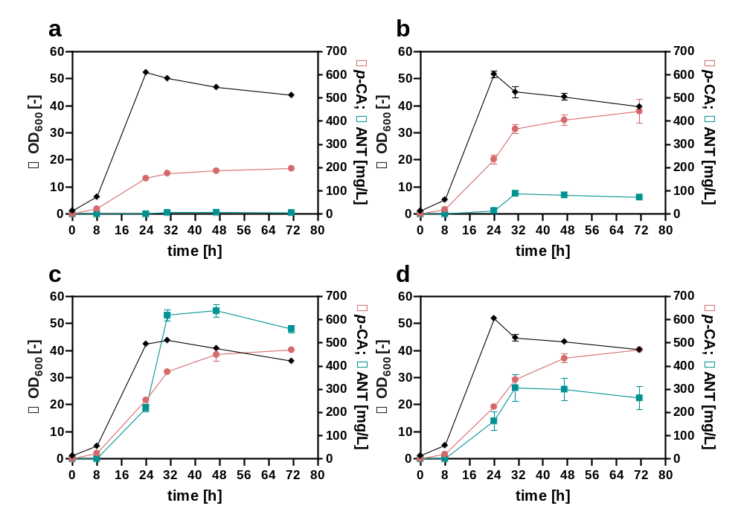
Fig. S1: Impact of (ATGGTG) start codon replacement of pheA and introduction of the point mutation into AroF (AroF-S188C) on growth and metabolite accumulation. Growth (OD₆₀₀) (diamonds), p-CA titer (circles), and ANT concentration (squares) of (a) C. glutamicum p-CA2, (b) C. glutamicum p-CA2 GTG-pheA, (c) C. glutamicum p-CA2 AroF-S188C and (d) C. glutamicum p-CA2 GTG-pheA AroF-S188C (p-CA3). All strains harbor the expression plasmid pEKEx3-aroH_{Ec}-tal_{FjCg} for p-CA production. The depicted data represent mean values and standard deviation of biological triplicates.
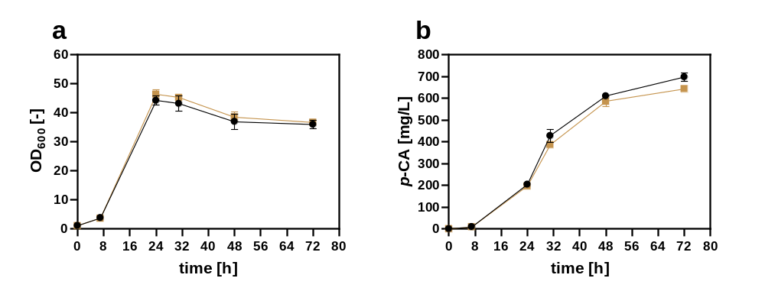
Fig. S2: Effect of an in-frame deletion of phdT on p-CA production. (a) Growth (OD₆₀₀) and (b) p-CA titer of C. glutamicum p-CA4 (control, circles) and C. glutamicum p-CA4 ∆phdT (p-CA5). (squares). Both strains harbor the expression plasmid pEKEx3-aroH_{Ec}-tal_{FjCg} for p-CA production. The depicted data represent mean values and standard deviation of biological triplicates.

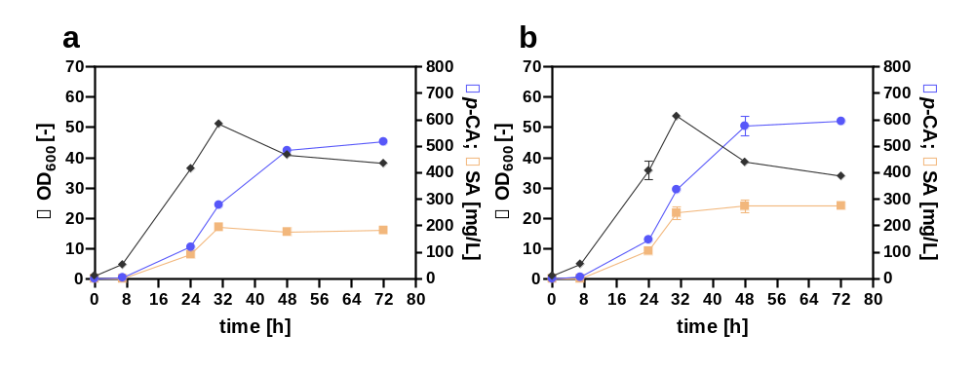
Fig. S3: Effect of (GTGATG) start codon replacement of aroK encoding SAK on p-CA titer and SA accumulation. Growth (OD₆₀₀, diamonds), p-CA (circles), and SA titer (squares) of (a) C. glutamicum p-CA5 (control) and (b) C. glutamicum p-CA5 ATG-aroK (p-CA6). Both strains harbor the expression plasmid pEKEx3-aroH_{Ec}-tal_{FjCg} for p-CA production. The depicted data represent mean values and standard deviation of biological triplicates.

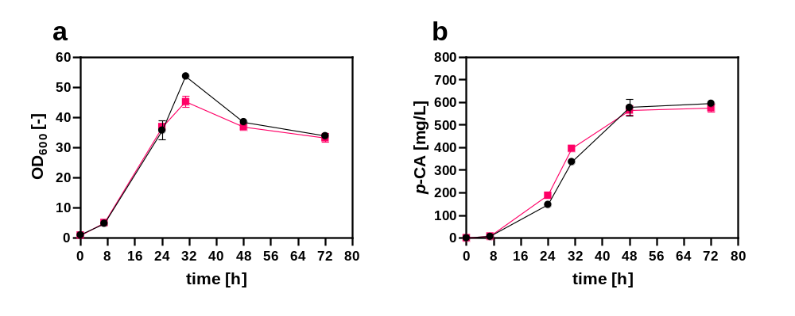
Fig. S4: Effect of genomic integration of codon-optimized gene aroF*_{EcCg} encoding a feedback-inhibition resistant DAHP synthase from E. coli on p-CA production. (a) Growth (OD₆₀₀), and (b) p-CA titer of C. glutamicum p-CA6 (control, circles) and C. glutamicum p-CA6 IGR9::aroF*_{EcCg} (p-CA7) with the integration of aroF*_{EcCg} between cg0432 and cg0435 in a non-coding region under the control of the constitutive dapA promotor variant A16 (squares). Both strains harbor the expression plasmid pEKEx3-aroH_{Ec}-tal_{FjCg} for p-CA production. The depicted data represent mean values and standard deviation of biological triplicates.

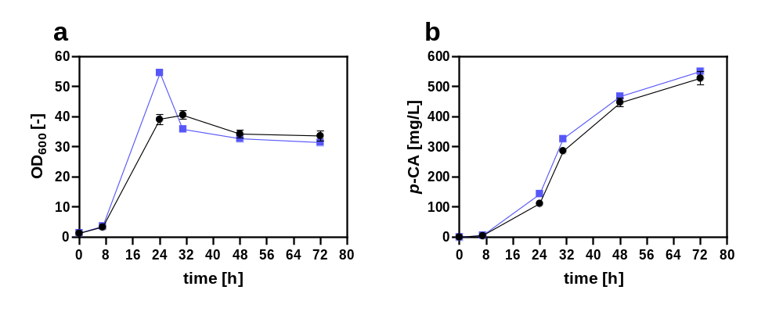
Fig. S5: Effect of an in-frame deletion of pyk encoding pyruvate kinase on p-CA production. (a) Growth (OD₆₀₀), and (b) p-CA titer of C. glutamicum p-CA7 (control, circles) and C. glutamicum p-CA7 ∆pyk (p-CA8) (squares). Both strains harbor the expression plasmid pEKEx3-aroH_{Ec}-tal_{FjCg} for p-CA production. The depicted data represent mean values and standard deviation of biological triplicates.
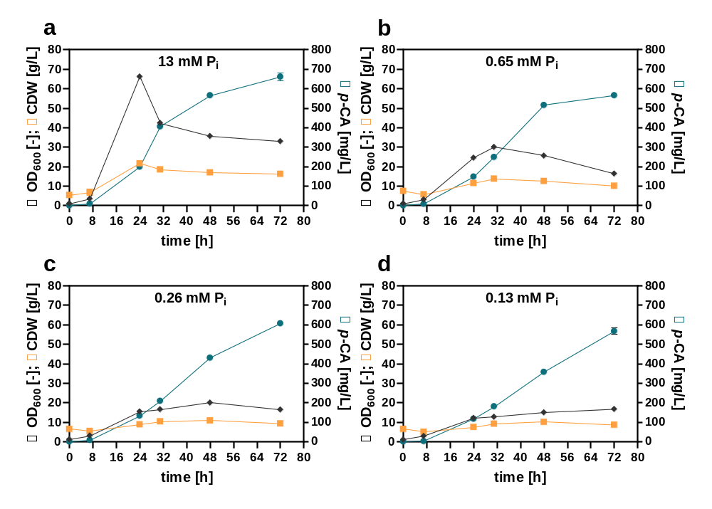
Fig. S6: Effect of P_{i} limitation on growth and p-CA production of C. glutamicum. Bacterial growth (OD₆₀₀ [-] (diamonds) and cell dry weight (CDW) [g/L]) (squares)) and p-CA titer (circles) is depicted of C. glutamicum p-CA8 cultivated in defined CGXII medium with varying P_{i} concentrations of (a) 13 mM, (b) 0.65 mM, (c) 0.26 mM, and (d) 0.13 mM. The strain harbors the expression plasmid pEKEx3-aroH_{Ec}-tal_{FjCg} for p-CA production. The depicted data represent mean values and standard deviation of biological triplicates.
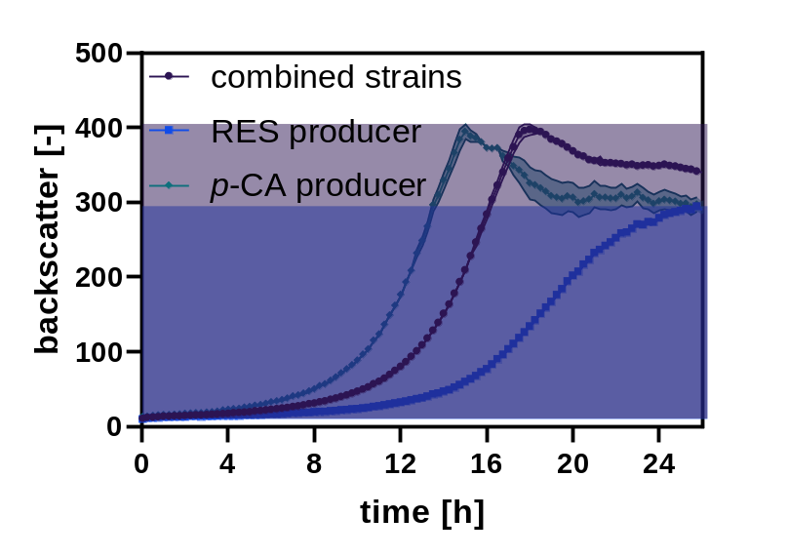
Fig. S7: Growth of the C. glutamicum p-CA8 and C. glutamicum-RES compared to a co-cultivation of both strains. C. glutamicum p-CA8 (diamonds), C. glutamicum-RES (squares), and both strains in co-cultivation (circles) were cultivated in microtiter plates. The depicted data represent the average and standard deviation of biological triplicates.

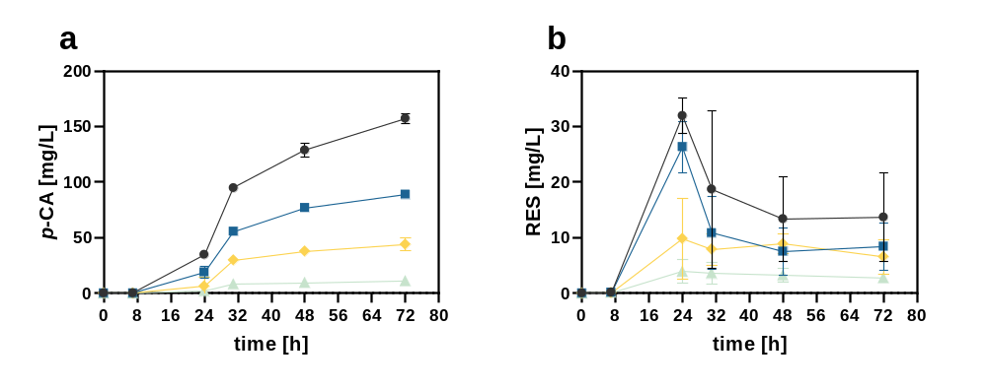
Fig. S8: Variation of the inoculation ratios of the p-CA- and RES-production strains in co-cultivations. (a) The p-CA (b) and RES titer of a co-culture of C. glutamicum p-CA8 and C. glutamicum RES was determined in shake flask cultivations. The inoculation ratios of the p-CA and RES production strains were adjusted to 1:1 (circles), 0.75:1.25 (squares), 0.5:1.5 (diamonds), and 0.2:1.8 (triangles). The depicted data represent the average and standard deviation of biological triplicates.

