Table S1. Experimental independent variables at two levels used for the production of melanin by ACT3 using Plackett Burman design.
Variables | Symbol | Level
Variables | Symbol | Low (−1) | High (+ 1)
Incubation period | A | 4 days | 10 days
pH | B | 5 | 7
Temperature | C | 30 °C | 40 °C
Inoculum size | D | 1 mL/L | 3 mL/L
Agitation speed | E | 100 rpm | 200 rpm
Yeast extract | F | 0.5 g/L | 1.5 g/L
Peptone | G | 3 g/L | 7 g/L
Peptic digest | sH | 10 g/L | 20 g/L
L-tyrosine | I | 1 g/L | 2.5 g/L
Copper sulphate | J | 0.05 g/L | 0.1 g/L
Ferric ammonium citrate | K | 0.3 g/L | 0.7 g/L
Dipotassium phosphate | L | 0.5 g/L | 1.5 g/L
Sodium thiosulphate | M | 0.05 g/L | 0.1 g/L

Table S2. Experimental variables for Box-Behnken design at different levels

Factors | Variables | Units | Experimental values
Factors | Variables | Units | Low level (-1) | Intermediate level (0) | High level (+1)
A | L-tyrosine | g/L | 1.00 | 3.25 | 5.50
B | Time | Days | 4.00 | 9.00 | 14.00
C | Ferric ammonium sulphate | g/L | 0.50 | 1.25 | 2.00

Table S3. Cultural characteristics of ACT3 strain on different culture media

Medium | Growth Characteristic | Color of aerial mycelium | Color of substrate mycelium | Color of diffusible pigment
Peptone yeast extract iron agar (ISP-6) | Heavy | Dusty Gray | Brown | Dark brown
Inorganic salts- starch iron (ISP-4) | Heavy | Dark gray | Dark gray | Pale brown
Oatmeal (ISP-3) | Moderate | Gray | Brown | None
Yeast extract-malt extract (ISP-2) | Moderate | Gray | Beige | None

Table S4. Physiological and biochemical characterization of isolated ACT3 strain

Biochemical tests | Results
Degradation of Starch | +
Degradation of Casein | ++
Degradation of Gelatin | +
Degradation of Glucose | -
Degradation Lactose | -
Degradation Saccharose | +
Degradation Citrate | +++
H2S production | -
Production of Urease | +
Mannitol | _
Catalase | ++
Action on Skimmed milk | -
Physiological tests
Gram-staining | +
Melanoid pigment production on ISP6 | +
Growth temperature | 25 +++  35 -  45 -  55 -
Optimum pH | 5 +  7 ++++  9 ++  10 +
NaCl tolerance (W/V) | 3% +  5% +++  7% +  10% +
+; Positive, −; negative

Table S5. Physicochemical properties of melanin produced by S. djakartensis NSS-3 and standard synthetic melanin
Property | Treatment | Results
Property | Treatment | Purified melanin | Synthetic melanin
Color | Observation | dark brown | Black
Solubility | Distilled water | Partially soluble | Soluble
Solubility | Methanol | Partially soluble | Soluble
Solubility | Absolute ethanol | Partially soluble | Soluble
Solubility | Chloroform | Partially soluble | Soluble
Solubility | Benzene | Partially soluble | Soluble
Solubility | Acetone | Partially soluble | Soluble
Solubility | Ethyl acetate | Partially soluble | Soluble
Solubility | 1Mol/L KOH | Soluble | Soluble
Solubility | 1Mol/L NaOH | Soluble | Soluble
Solubility | DMSO | Soluble | Soluble
Stability | Heat (60° C for 2, 4, 6 h, respectively) | Stable | Stable
Stability | Heat (80° C for 2, 4, 6 h, respectively) | Stable | Stable
Stability | Heat (100° C for 2, 4, 6 h, respectively) | Stable | Stable
Stability | Sun light (treatment for 10 days) | Stable | Stable
Precipitation with | 3N HCl | Precipitated |  | Precipitated
Precipitation with | 1% FeCl3 | Precipitated |  | Precipitated
Oxidation | Hydrogen peroxide | Decolorization (oxidized) |  | Decolorization (oxidized)
Bleach test | KMNO4 | Decolorization |  | Decolorization

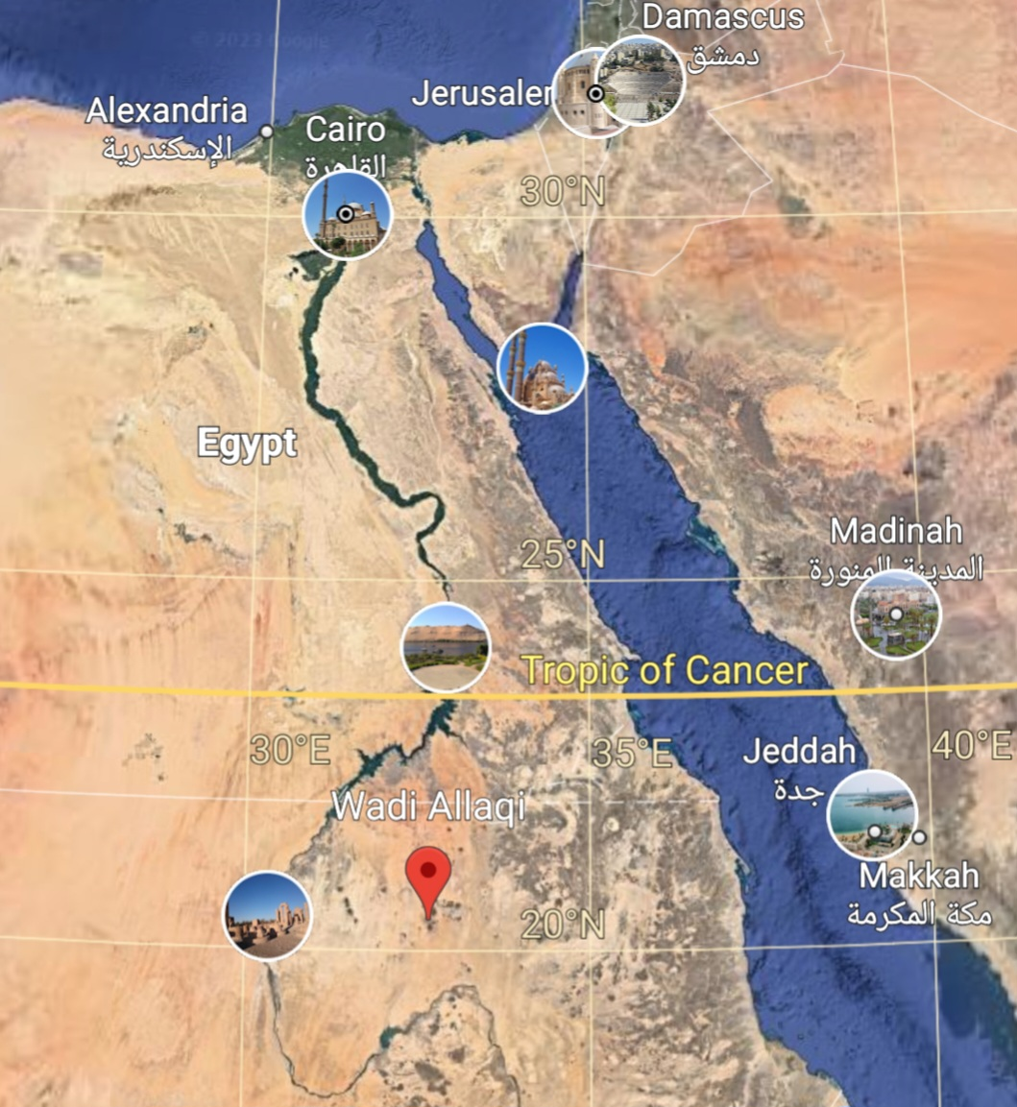

Fig.S1 Soil samples collected from Wadi-Allaqui Biosphere Reserve on the eastern side of Lake Nasser, Egypt.

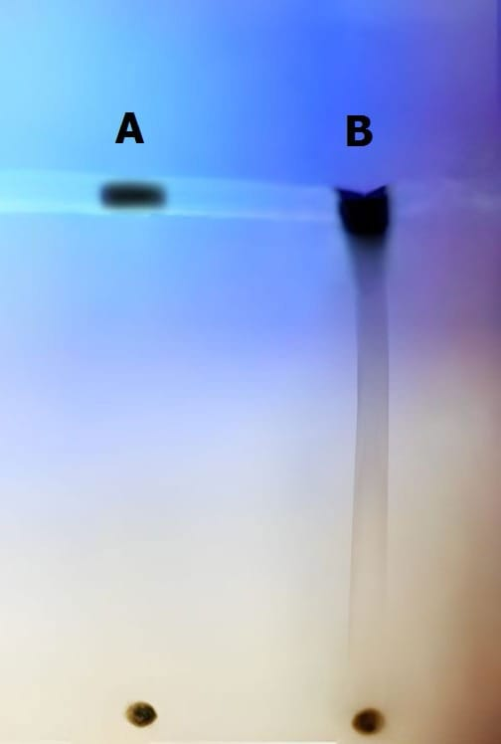

Fig.S2 TLC analysis of purified melanin pigment (A) compared with standard synthetic melanin (B).

