Evaluating oleaginous yeasts for enhanced microbial lipid production using sweetwater as a sustainable feedstock
Valériane Malika Keita^{1,2,†}, Yi Qing Lee^{3,†}, Meiyappan Lakshmanan^{2,4}, Dave Siak-Wei Ow², Paul Staniland⁵, Jessica Staniland⁵, Ian Savill⁵, Kang Lan Tee¹, Tuck Seng Wong^{1,6,7,8,*} and Dong-Yup Lee^{3,*}
¹Department of Chemical & Biological Engineering, University of Sheffield, Sir Robert Hadfield Building, Mappin Street, Sheffield S1 3JD, United Kingdom.
²Bioprocessing Technology Institute, Agency for Science, Technology and Research (A*STAR), 20 Biopolis Way, Centros, Singapore 138668, Singapore.
³School of Chemical Engineering, Sungkyunkwan University, 2066, Seobu-ro, Jangan-gu, Suwon-si, Gyeonggi-do 16419, Republic of Korea.
⁴Department of Biotechnology, Bhupat and Jyoti Mehta School of Biosciences, Indian Institute of Technology Madras, Chennai 600036, India.
⁵Croda Europe Ltd., Oak Road, Clough Road, Hull HU6 7PH, United Kingdom.
⁶Evolutor Ltd, The Innovation Centre, 217 Portobello, Sheffield S1 4DP, United Kingdom.
⁷National Center for Genetic Engineering and Biotechnology, 113 Thailand Science Park, Phahonyothin Road, Khlong Nueang, Khlong Luang, Pathum Thani 12120, Thailand.
⁸School of Pharmacy, Bandung Institute of Technology, 10 Coblong, Bandung, West Java 40132, Indonesia.
†Valériane Malika Keita and Yi Qing Lee contributed equally to this work.
*Correspondence: Tuck Seng Wong (t.wong@sheffield.ac.uk); Dong-Yup Lee (dongyuplee@skku.edu)
Supplementary Figures
Fig. S1 Aspect and properties of the three types of sweetwater used in this study. The asterisk indicates that SW₈₅ was diluted before pH measurement.
Fig. S2 Bar graphs of data shown in Table 2. Error bars indicate standard deviations.
Fig. S3 Evaluating the glycerol tolerance of oleaginous yeasts Cells were grown in 96-well microplates containing either refined glycerol diluted with synthetic complete nutrient mix for a final glycerol concentration of 2% (w/v) [black line: Gly₂SC], 8% (w/v) [blue line: Gly₈SC] or 16% (w/v) [red line: Gly₁₆SC]. Cells were grown in quadruplicates and the averages OD₆₀₀ and associated standard deviations were plotted against time.
Fig. S4 Bar graphs of data comparing growth in SW_{35>1.5S}C and SW₃₅SC shown in Table 3. Error bars indicate standard deviations.
Fig. S5 Bar graphs of data comparing pH 6.09 and pH 3.95 in SW₁₅ shown in Table 3. Error bars indicate standard deviations.
Fig. S6 Evaluating growth in different type of sweetwater diluted with the synthetic complete nutrient mic. Cells were grown in 96-well microplates containing either in SW₁₅ [black line: SW_{15>1.5}SC], SW₃₅ [teal line: SW_{35>1.5}SC] or SW₈₅ [purple line: SW_{85>1.5}SC] diluted in synthetic complete nutrient mix for a final glycerol concentration of 1.5% (w/v). Cells were grown in quadruplicates and the averages OD₆₀₀ and associated standard deviations were plotted against time.
Fig. S7 Evaluating effect of sweetwater pH on growth. Cells were grown in 96-well microplates containing either sweetwater with a 15% (w/v) glycerol content at native pH [black line: SW₁₅ pH 3.95] or sweetwater with a 15% (w/v) glycerol content with a pH adjusted to 6 [teal line: SW₁₅ pH 6.09]. Cells were grown in quadruplicates and the averages OD₆₀₀ and associated standard deviations were plotted against time.
Fig. S8 Clustergram of sample-to-sample Euclidean distances based on expression counts normalized by variance stabilizing transformation.
Fig. S9 Growth curves of R. toruloides NRRL Y-6987 in the 4 media used for the transcriptomic analysis.

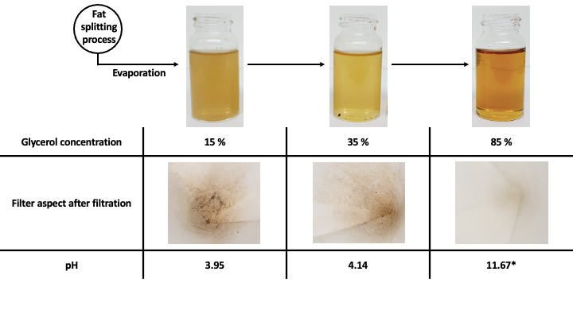
Fig. S1

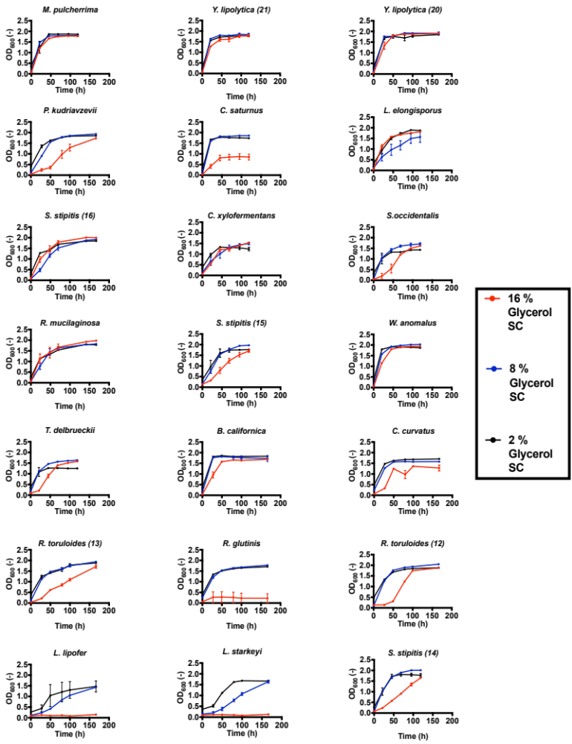
Fig. S2
Fig. S3

Fig. S4

Fig. S5
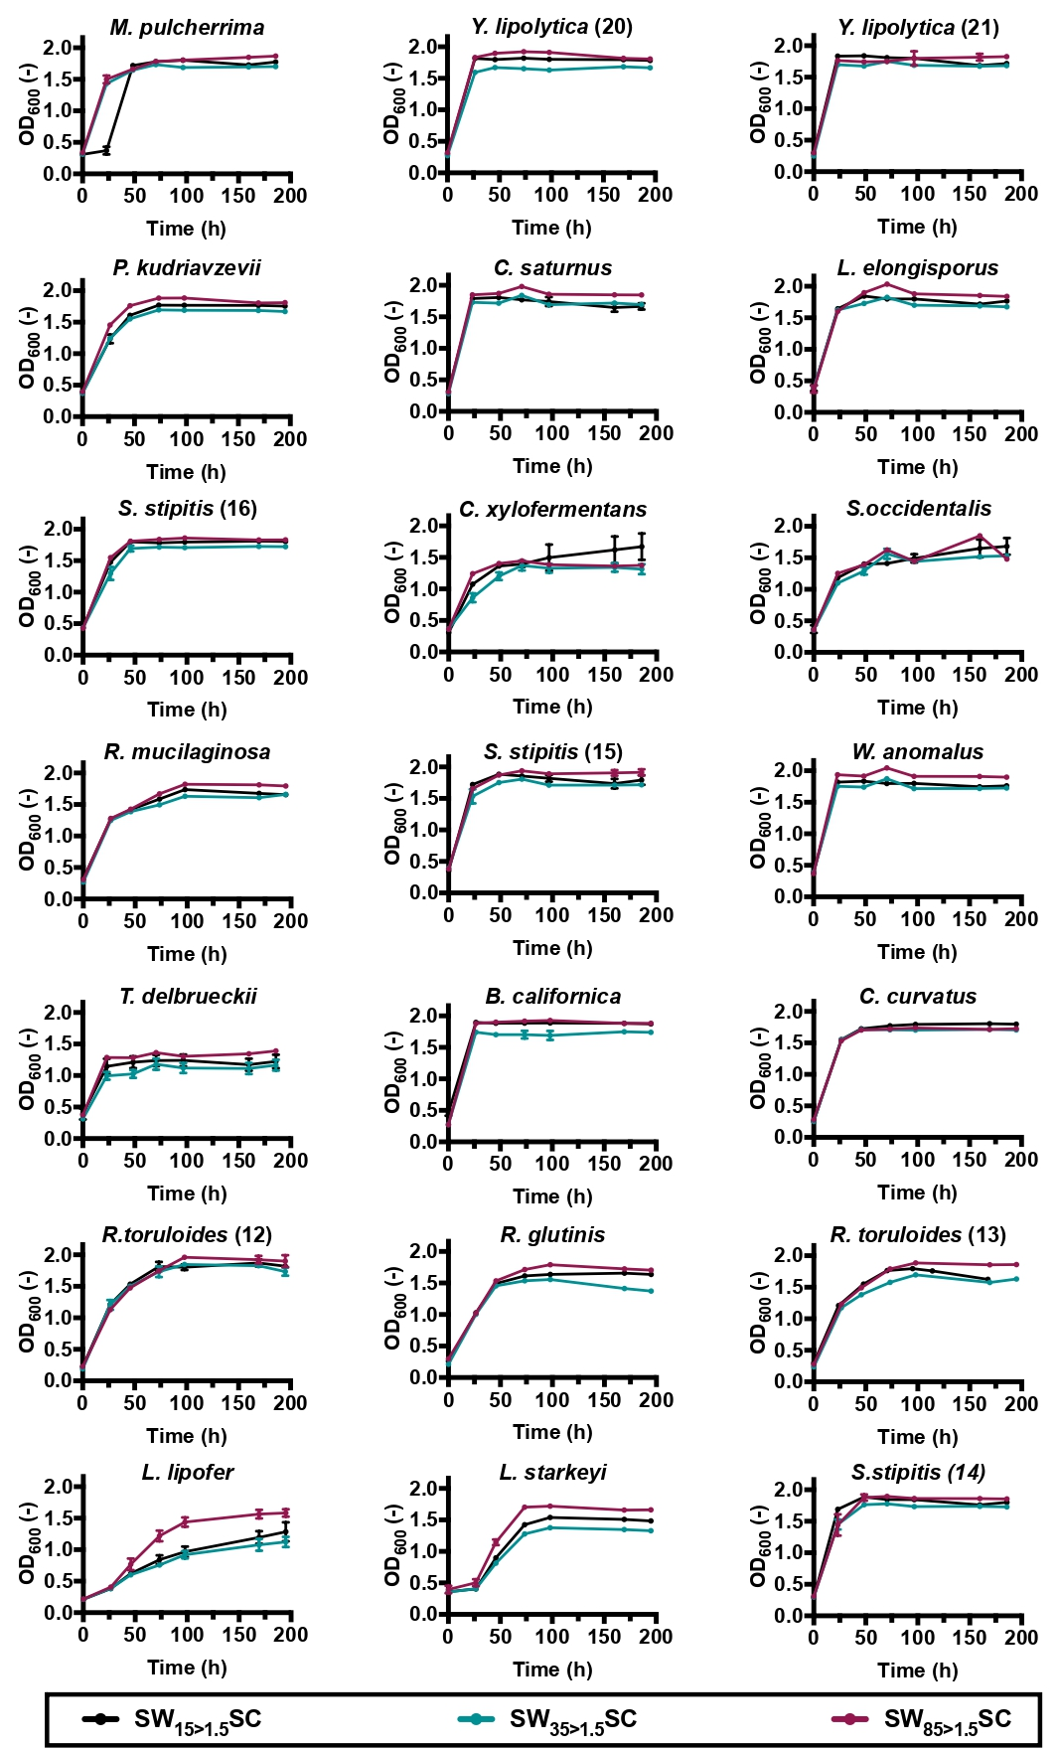
Fig. S6
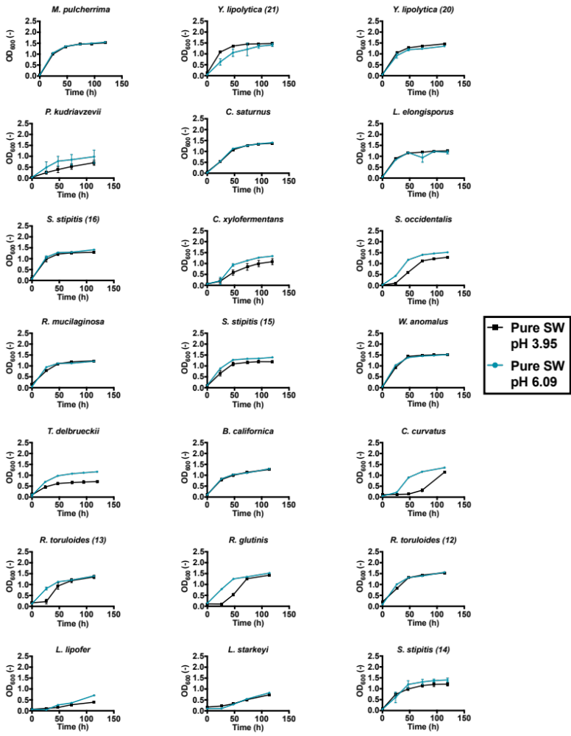
Fig. S7
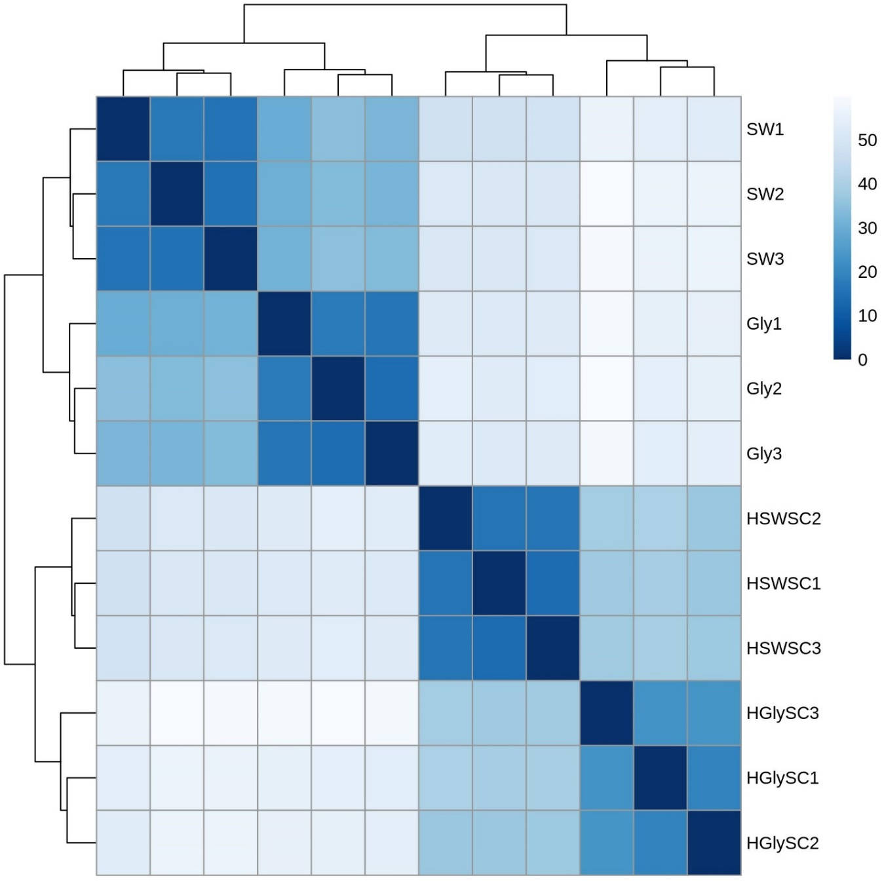
Fig. S8
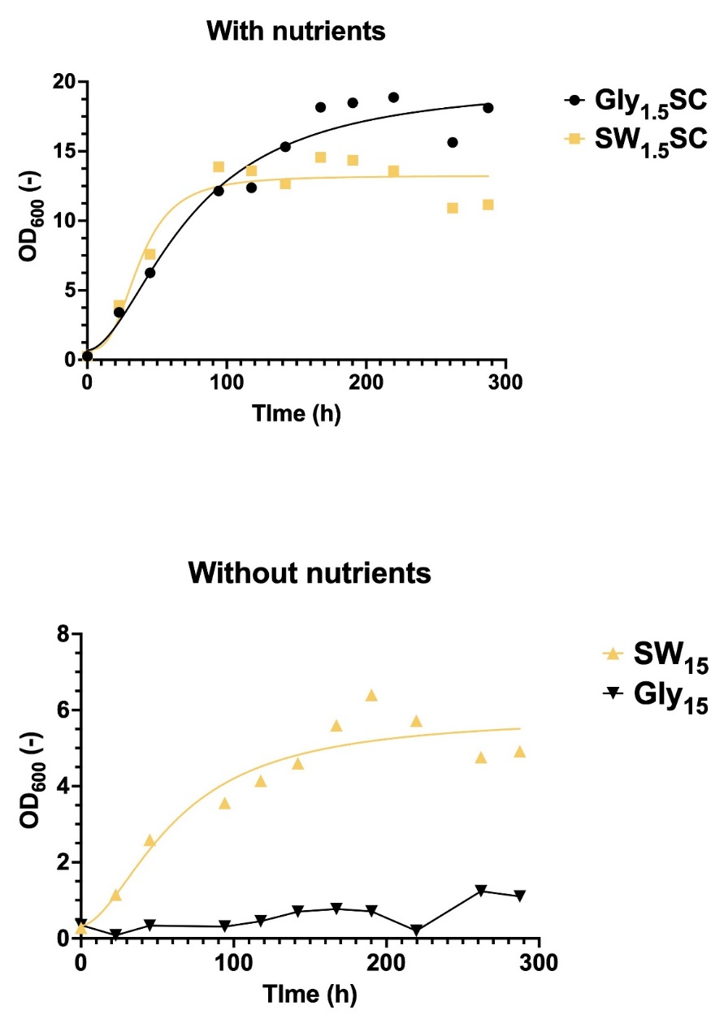

Fig. S9

Supplementary Tables
Table S1 Annotation of genes represented in the figure 3.
Table S2 Top 50 of annotated genes contributing the most to PC1 in the differential expression analysis of SW₁₅ vs Gly₁₅. Gene ranks in terms of contribution to PC1 were given in column Rank #, and genes were sorted by descending contribution in each category. The smallest rank corresponds to the highest contribution. LFC (Log2 fold change) gives the estimated change between gene expression level of in SW₁₅ compared to Gly₁₅ (Ctrl). This change is associated with a FDR adjusted p-value either non-significant (ns), non-computed (na), lower than 0.01 (<0.01), between 0.01 and 0.05 (<0.05) or between 0.05 and 0.1 (<0.1). Only padj <0.01 were considered significant in the manuscript.
Table S3 Differential expression results of SW₁₅ vs Gly₁₅ of relevant genes associated to lipid metabolism. Gene ranks in terms of contribution to PC1 were given in column Rank #, and genes were sorted by descending contribution in each category. LFC (Log2 fold change) gives the estimated change between gene expression level of in SW₁₅ compared to Gly₁₅ (Ctrl). This change is associated with a FDR adjusted p-value either non-significant (ns), non-computed (na), lower than 0.01 (<0.01), between 0.01 and 0.05 (<0.05) or between 0.05 and 0.1 (<0.1). Only padj <0.01 were considered significant in the manuscript.

Table S1
ID | KO | COG | Definition | Interclass
rtg2117 | K01580 | E | glutamate decarboxylase [EC:4.1.1.15] | Amino acids transport and metabolism
rtg4590 | K08192 | G | MFS transporter, ACS family, allantoate permease | Carbohydrates transport and metabolism
rtg428 | K05349 | G | beta-glucosidase [EC:3.2.1.21] | Carbohydrates transport and metabolism
rtg1145 | - | G | Major Facilitator Superfamily | Carbohydrates transport and metabolism
rtg1762 | K08139 | G | MFS transporter, SP family, sugar:H+ symporter | Carbohydrates transport and metabolism
rtg3791 | K01183 | G | chitinase [EC:3.2.1.14] | Carbohydrates transport and metabolism
rtg4244 | K08141 | G | MFS transporter, SP family, general alpha glucoside:H+ symporter | Carbohydrates transport and metabolism
rtg4245 | K01182 | G | oligo-1,6-glucosidase [EC:3.2.1.10] | Carbohydrates transport and metabolism
rtg4615 | K02429 | G | MFS transporter, FHS family, L-fucose permease | Carbohydrates transport and metabolism
rtg4722 | K08178 | G | MFS transporter, SHS family, lactate transporter | Carbohydrates transport and metabolism
rtg5254 | K08139 | G | MFS transporter, SP family, sugar:H+ symporter | Carbohydrates transport and metabolism
rtg1110 | K02365 | D | separase [EC:3.4.22.49] | Cell cycle control, cell division, chromosome partitioning
rtg5072 | K11547 | D | kinetochore protein NDC80 | Cell cycle control, cell division, chromosome partitioning
rtg3275 | K03843 | M | alpha-1,3/alpha-1,6-mannosyltransferase [EC:2.4.1.132 2.4.1.257] | Cell wall/membrane/envelope biogenesis
rtg239 | K11253 | B | histone H3 | Chromatin structure and dynamics
rtg698 | K11251 | B | histone H2A | Chromatin structure and dynamics
rtg3504 | K11253 | - | histone H3 | Chromatin structure and dynamics|Intracellular trafficking, secretion, and vesicular transport
rtg610 | K20520 | Z | drebrin-like protein | Cytoskeleton
rtg3437 | - | V | Male sterility protein | Defense mechanisms
rtg2031 | K00467 | C | lactate 2-monooxygenase [EC:1.13.12.4] | Energy production and conversion
rtg4853 | K00326;K17877 | C | cytochrome-b5 reductase [EC:1.6.2.2]|nitrite reductase (NAD(P)H) [EC:1.7.1.4] | Energy production and conversion
rtg5031 | K00354 | C | NADPH2 dehydrogenase [EC:1.6.99.1] | Energy production and conversion
rtg1482 | K19792 | P | low-affinity ferrous iron transport protein | Inorganic ion transport and metabolism
rtg2366 | K03549;K17871 | P | KUP system potassium uptake protein|NADH:ubiquinone reductase (non-electrogenic) [EC:1.6.5.9] | Inorganic ion transport and metabolism
rtg4153 | K20989 | P | urea-proton symporter | Inorganic ion transport and metabolism
rtg4852 | K02575 | P | MFS transporter, NNP family, nitrate/nitrite transporter | Inorganic ion transport and metabolism
rtg6000 | K03320 | P | ammonium transporter, Amt family | Inorganic ion transport and metabolism
rtg3429 | K18278 | - | Thiamine precursor biosynthesis enzyme | Metabolism of cofactors and vitamins
rtg6058 | K14709 | P | solute carrier family 39 (zinc transporter), member 1/2/3 | Inorganic ion transport and metabolism
rtg4154 | K20989 |  | urea-proton symporter | Intracellular trafficking, secretion, and vesicular transport
rtg3592 | K23516 | I | xanthine dioxygenase [EC:1.14.11.48] | Lipid transport and metabolism
rtg2138 | - | I | MaoC like domain (peroxisomal dehydratase - ncbiconfrimed) | Lipid transport and metabolism
rtg5959 | - | I | Acyl-CoA dehydrogenase, N-terminal domain | Lipid transport and metabolism
rtg4308 | K01487 | F | guanine deaminase [EC:3.5.4.3] | Nucleotide transport and metabolism
rtg4975 | K06910 |  | phosphatidylethanolamine-binding protein | Peptidases and inhibitors
rtg4874 | K03564 | O | peroxiredoxin Q/BCP [EC:1.11.1.15] | Post-translational modification and protein turnover
rtg5216 | K08770 | L | ubiquitin C | Replication, recombination and repair
rtg729 | - | A | RNA recognition motif. (a.k.a. RRM, RBD, or RNP domain) | RNA processing and modification
rtg206 | K13237 | Q | peroxisomal 2,4-dienoyl-CoA reductase [EC:1.3.1.34] | Secondary metabolites metabolism and transport
rtg2788 | K00002 | Q | alcohol dehydrogenase (NADP+) [EC:1.1.1.2] | Secondary metabolites metabolism and transport
rtg4053 | - | Q | Retinal pigment epithelial membrane protein | Secondary metabolites metabolism and transport
rtg4426 | K16216 | Q | benzil reductase ((S)-benzoin forming) [EC:1.1.1.320] | Secondary metabolites metabolism and transport
rtg6024 | - | Q | 2OG-Fe(II) oxygenase superfamily | Secondary metabolites metabolism and transport
rtg6040 | - | Q | short chain dehydrogenase reductase family protein | Secondary metabolites metabolism and transport
rtg6041 | - | Q | short chain dehydrogenase reductase family protein | Secondary metabolites metabolism and transport
rtg3996 | K00121 | Q | S-(hydroxymethyl)glutathione dehydrogenase / alcohol dehydrogenase [EC:1.1.1.284 1.1.1.1] | Secondary metabolites metabolism and transport
rtg3009 | K13953 | Q | alcohol dehydrogenase, propanol-preferring [EC:1.1.1.1] | Secondary metabolites metabolism and transport
rtg2375 | - | Q | Animal haem peroxidase | Secondary metabolites metabolism and transport
rtg814 | K06686;K08282 | T | cell cycle protein kinase DBF20 [EC:2.7.11.-]|non-specific serine/threonine protein kinase [EC:2.7.11.1] | Signal transduction mechanisms
rtg5735 | K11593 | J | eukaryotic translation initiation factor 2C | Translation, ribosomal structure and biogenesis

Table S2
ID | Rank # | LogFC | p_{adj} | KO | COG | Definition
Nitrogen scavenging/Nitrogen recycling
rtg4852 | 10 | -2.19279 | <0.01 | K02575 | P | MFS transporter, NNP family, nitrate/nitrite transporter
rtg3792 | 33 | 2.216161 | <0.01 | K01426 | E | Amidase [EC:3.5.1.4]
rtg3315 | 38 | 1.47717 | <0.01 |  | T | OPT oligopeptide transporter protein
rtg4853 | 44 | -1.43723 | <0.01 | K00326;K17877 | C | Cytochrome-b5 reductase [EC:1.6.2.2]|nitrite reductase (NAD(P)H) [EC:1.7.1.4]
rtg5673 | 45 | 1.560374 | <0.01 | K03305 | E | Proton-dependent oligopeptide transporter, POT family
Signaling
rtg3506 | 7 | 4.04169 | <0.01 | K17605 | D;T | Serine/threonine-protein phosphatase 2A activator
rtg4017 | 24 | 1.723819 | <0.01 | K23785 | T | Serine/threonine-protein kinase RCK2 [EC:2.7.11.1]
rtg4275 | 39 | 1.50702 | <0.01 |  | S | Stress response protein Rds1
rtg4659 | 59 | 1.451221 | <0.01 | K09419 | K | Heat shock transcription factor, other eukaryote
rtg4708 | 26 | 1.621092 | <0.01 |  | T | Cytoplasm protein (RGC2)
Membrane remodeling
rtg3898 | 8 | -5.3022 | <0.01 |  |  | Rare lipoprotein A (rlpa)-like double-psi beta-barrel/expansin
rtg6092 | 9 | 3.854252 | <0.01 |  | O | Fasciclin domain (involved in cell adhesion)/Beta-ig-h3 fasciclin
rtg2052 | 43 | 1.484737 | <0.01 | K12472 | T;U | Epidermal growth factor receptor substrate 15
rtg1123 | 60 | 1.359099 | <0.01 | K20046 | Z | Actin cytoskeleton-regulatory complex protein SLA1
Protein modification and turnover
rtg5563 | 15 | 2.083641 | <0.01 | K01875 | J | Seryl-trna synthetase [EC:6.1.1.11]
rtg3923 | 42 | 1.524287 | <0.01 | K03695 | O | ATP-dependent Clp protease ATP-binding subunit clpb
rtg2372 | 63 | 1.347649 | <0.01 |  | O | ATP-dependent protease La (LON) domain
Energy and redox balance
rtg5547 | 6 | 3.209785 | <0.01 | K00228 | H | Coproporphyrinogen III oxidase [EC:1.3.3.3]
rtg5031 | 32 | 1.59539 | <0.01 | K00354 | C | NADPH2 dehydrogenase [EC:1.6.99.1]
rtg2788 | 37 | 1.509143 | <0.01 | K00002 | Q | Alcohol dehydrogenase (NADP+) [EC:1.1.1.2]
Carbon catabolite repression
rtg4245 | 1 | 3.477264 | <0.01 | K01182 | G | Oligo-1,6-glucosidase [EC:3.2.1.10]
rtg5013 | 13 | 1.949483 | <0.01 | K01621 | G | Xylulose-5-phosphate/fructose-6-phosphate phosphoketolase [EC:4.1.2.9 4.1.2.22]
rtg769 | 14 | 1.93709 | <0.01 | K01193 | G | Beta-fructofuranosidase [EC:3.2.1.26]
rtg5302 | 19 | 1.801282 | <0.01 | K08139 | G | MFS transporter, SP family, sugar:H+ symporter (HXT family)
rtg428 | 25 | 2.701482 | <0.01 | K05349 | G | Beta-glucosidase [EC:3.2.1.21]
rtg2468 | 27 | 1.702245 | <0.01 |  |  | Pbh1 domain (= tertiary structures of pectate lyases and rhamnogalacturonase A)
rtg1823 | 29 | 1.788605 | <0.01 |  | E;G | Triose-phosphate Transporter family
rtg1162 | 34 | 1.699774 | <0.01 |  | G | Major facilitator superfamily
rtg3298 | 56 | 1.396897 | <0.01 |  | S | Glycosyl hydrolase family 88
Fatty acid uptake
rtg2252 | 31 | 2.678024 | <0.01 |  |  | Lipase B precursor
rtg2309 | 46 | 1.418252 | <0.01 | K00507 | I | Stearoyl-coa desaturase (Delta-9 desaturase) [EC:1.14.19.1]
Beta-oxidation and Glyoxylate cycle related
rtg2130 | 3 | -5.98348 | n.a. | K01638 | C | Malate synthase [EC:2.3.3.9]
rtg5452 | 41 | -1.53047 | <0.01 |  | I | Acyl-coa dehydrogenase, C-terminal domain
rtg4139 | 64 | -1.74603 | <0.01 | K00624 | I | Carnitine O-acetyltransferase [EC:2.3.1.7]
Fatty synthesis
rtg2312 | 17 | 1.797549 | <0.01 | K01648 | C | ATP citrate (pro-S)-lyase [EC:2.3.3.8]
rtg127 | 50 | 1.355341 | <0.01 | K00667 | I | Fatty acid synthase subunit alpha, fungi type [EC:2.3.1.86]
rtg226 | 57 | 1.329832 | <0.01 | K11262 | I | Acetyl-coa carboxylase / biotin carboxylase 1 [EC:6.4.1.2 6.3.4.14 2.1.3.15]
rtg204 | 58 | 1.376327 | <0.01 | K00667;K00668 | I | Fatty acid synthase subunit beta, fungi type [EC:2.3.1.86]
Unclassified
rtg5628 | 2 | 2.609292 | <0.01 |  |  | Stigma-specific protein, Stig1
rtg3278 | 4 | 3.410903 | <0.01 |  | Q | ABC-2 type transporter
rtg4452 | 5 | 4.020687 | <0.01 |  | S | Inherit from basnog: delayed-type hypersensitivity antigen
rtg3026 | 21 | -2.24292 | <0.01 |  | S | Protein similar to cwfj C-terminus 2
rtg2410 | 28 | 2.059587 | <0.01 |  | G | Fungal trichothecene (sesquiterpenoids) efflux pump (MFS familly)
rtg2948 | 30 | 2.616607 | <0.01 |  | S | Inherit from funog: CCCH zinc finger DNA binding protein
rtg2495 | 35 | 1.401479 | ns |  | S | Predicted membrane protein (DUF2231)
rtg617 | 40 | -2.3205 | <0.01 | K00622 | Q | Arylamine N-acetyltransferase [EC:2.3.1.5]
rtg5922 | 48 | -2.1786 | <0.01 |  | S | SCP (Cystein-rich secretory protein)
rtg3821 | 53 | 1.752634 | <0.01 |  | S | FAD dependent oxidoreductase
rtg3945 | 54 | 1.42675 | <0.01 |  | S | Zinc-binding dehydrogenase
rtg5476 | 61 | 1.64211 | <0.01 |  | Q | ABC transporter transmembrane region

Table S3
ID | Rank # | LogFC | p_{adj} | KO | COG | Definition
Acetyl-CoA metabolism
Acetyl-CoA synthetase
rtg931 | 1711 | 0.463515 | <0.05 | K01895 | H | Acetyl-coa synthetase [EC:6.2.1.1]
ATP:Citrate lyase
rtg2312 | 17 | 1.797549 | <0.01 | K01648 | C | ATP citrate (pro-S)-lyase [EC:2.3.3.8]
Acetyl-CoA C-acetyltransferase (ACAT)
rtg1529 | 3125 | -0.22239 | ns | K07513 | I | Acetyl-coa acyltransferase 1 [EC:2.3.1.16]
rtg3157 | 4703 | -0.11376 | ns | K07513 | I | Acetyl-coa acyltransferase 1 [EC:2.3.1.16]
rtg4298 | 1766 | -0.36792 | <0.01 | K07513 | I | Acetyl-coa acyltransferase 1 [EC:2.3.1.16]
Citrate synthase
rtg1700 | 1590 | 0.529734 | <0.05 | K01647 | C | Citrate synthase [EC:2.3.3.1]
rtg2745 | 3093 | 0.528872 | ns | K01647 | C | Citrate synthase [EC:2.3.3.1]
rtg2747 | 251 | 0.908961 | <0.01 | K01647 | C | Citrate synthase [EC:2.3.3.1]
Malate dehydrogenases
rtg1361 | 1394 | 0.429893 | <0.01 | K00026 | C | Malate dehydrogenase [EC:1.1.1.37]
rtg1596 | 2036 | 0.43835 | ns | K00027 | C | Malate dehydrogenase (oxaloacetate-decarboxylating) [EC:1.1.1.38]
rtg3452 | 359 | 0.777535 | <0.01 | K00026 | C | Malate dehydrogenase [EC:1.1.1.37]
rtg6104 | 649 | -1.02196 | <0.01 | K00027;K00029 | C | Malate dehydrogenase (oxaloacetate-decarboxylating) [EC:1.1.1.38]|malate dehydrogenase (oxaloacetate-decarboxylating)(NADP+) [EC:1.1.1.40]
Fumarase
rtg5411 | 1021 | 0.559453 | <0.01 | K01679 | C | Fumarate hydratase, class II [EC:4.2.1.2]
Succinate dH
rtg1051 | 663 | 0.683249 | <0.01 | K18168 | S | Succinate dehydrogenase assembly factor 2
rtg1256 | 286 | 0.828923 | <0.01 | K00234 | C | Succinate dehydrogenase (ubiquinone) flavoprotein subunit [EC:1.3.5.1]
rtg1876 | 2552 | -0.45795 | ns | K18167 | O | Succinate dehydrogenase assembly factor 1
rtg4479 | 1105 | 0.505001 | <0.01 | K00236 | C | Succinate dehydrogenase (ubiquinone) cytochrome b560 subunit
rtg5261 | 1913 | 0.340104 | <0.05 | K00235 | C | Succinate dehydrogenase (ubiquinone) iron-sulfur subunit [EC:1.3.5.1]
rtg603 | 987 | 0.600242 | <0.01 | K00237 | C | Succinate dehydrogenase (ubiquinone) membrane anchor subunit
Succinyl-CoA synthase
rtg5615 | 1600 | 0.385984 | <0.01 | K01900 | C | Succinyl-coa synthetase beta subunit [EC:6.2.1.4 6.2.1.5]
rtg5749 | 2564 | 0.255147 | <0.05 | K01899 | C | Succinyl-coa synthetase alpha subunit [EC:6.2.1.4 6.2.1.5]
alpha-ketoglutarate dH
rtg1066 | 324 | 0.83069 | <0.01 | K00658 | C | 2-oxoglutarate dehydrogenase E2 component (dihydrolipoamide succinyltransferase) [EC:2.3.1.61]
rtg2808 | 180 | 0.972097 | <0.01 | K00164 | G | 2-oxoglutarate dehydrogenase E1 component [EC:1.2.4.2]
rtg3479 | 4498 | 0.145618 | ns | K00164;K15791 | G | 2-oxoglutarate dehydrogenase E1 component [EC:1.2.4.2]|probable 2-oxoglutarate dehydrogenase E1 component DHKTD1 [EC:1.2.4.2]
Isocitrate dH
rtg3415 | 3893 | 0.145291 | ns | K00031 | C | Isocitrate dehydrogenase [EC:1.1.1.42]
rtg5809 | 1036 | 0.495925 | <0.01 | K00030 | E | Isocitrate dehydrogenase (NAD+) [EC:1.1.1.41]
rtg5810 | 418 | 0.772541 | <0.01 | K00030 | E | Isocitrate dehydrogenase (NAD+) [EC:1.1.1.41]
Aconitase
rtg4484 | 252 | 0.846646 | <0.01 | K01681 | C | Aconitate hydratase [EC:4.2.1.3]
Isocitrate lyase
rtg5517 | 3932 | 0.126558 | ns | K01637 | C | Isocitrate lyase [EC:4.1.3.1]
Malate synthase
rtg2130 | 3 | -5.98348 | n.a | K01638 | C | Malate synthase [EC:2.3.3.9]
rtg3633 | 136 | 1.127702 | <0.01 | K01638 | C | Malate synthase [EC:2.3.3.9]
De novo lipid synthesis
Acetyl-CoA carboxylase (ACC)
rtg226 | 57 | 1.329832 | <0.01 | K11262 | I | Acetyl-coa carboxylase / biotin carboxylase 1 [EC:6.4.1.2 6.3.4.14 2.1.3.15]
Fatty acid synthase (FAS)
rtg127 | 50 | 1.355341 | <0.01 | K00667 | I | Fatty acid synthase subunit alpha, fungi type [EC:2.3.1.86]
rtg204 | 58 | 1.376327 | <0.01 | K00667;K00668 | I | Fatty acid synthase subunit beta, fungi type [EC:2.3.1.86]
1-acylglycerol-3-phosphate O-acyltransferase (AGPAT)
rtg5664 | 2596 | 0.266996 | <0.1 | K13519 | I | Lysophospholipid acyltransferase [EC:2.3.1.51 2.3.1.23 2.3.1.-]
rtg2173 | 5298 | -0.02788 | ns |  | I | Acyltransferase (lysophospholipid acyltransferase)
rtg5355 | 5810 | -0.00527 | ns |  | I | Acyltransferase (lysophosphatidic acid acyltransferase / lysophosphatidylinositol acyltransferase)
Glycerol-3-phosphate acyltransferase (GPAT)
rtg1283 | 3535 | -0.25377 | ns | K13507 | I | Glycerol-3-phosphate O-acyltransferase / dihydroxyacetone phosphate acyltransferase [EC:2.3.1.15 2.3.1.42]
rtg3012 | 801 | 0.567038 | <0.01 | K13507 | I | Glycerol-3-phosphate O-acyltransferase / dihydroxyacetone phosphate acyltransferase [EC:2.3.1.15 2.3.1.42]
rtg3414 | 4623 | -0.1619 | ns | K13507 | I | Glycerol-3-phosphate O-acyltransferase / dihydroxyacetone phosphate acyltransferase [EC:2.3.1.15 2.3.1.42]
Phosphatidic acid phosphatase (PPAP)
rtg1218 | 3731 | 0.174715 | ns | K18693 | I | Diacylglycerol diphosphate phosphatase / phosphatidate phosphatase [EC:3.1.3.81 3.1.3.4]
rtg3174 | 2980 | 0.923743 | ns |  |  | (refseq) bifunctional diacylglycerol diphosphate phosphatase/phosphatidate phosphatase<|acidppc
rtg3837 | 4851 | 0.398036 | ns
Diacylglycerol O-acyltransferase (DGAT) and associated
rtg257 | 4851 | 0.530466 | <0.1 | K15728 | I | Phosphatidate phosphatase LPIN [EC:3.1.3.4]
rtg267 | 1385 | 0.478952 | <0.05 | K00679 | I | Phospholipid:diacylglycerol acyltransferase [EC:2.3.1.158]
alpha, omega-oxidation
Aldehyde dehydrogenase
rtg1234 | 3133 | 0.237564 | ns | K00128;K00129 | C | Aldehyde dehydrogenase (NAD(P)+) [EC:1.2.1.5]|aldehyde dehydrogenase (NAD+) [EC:1.2.1.3]
rtg1331 | 1672 | -0.61742 | <0.05 |  | C | Aldehyde dehydrogenase family
rtg1455 | 1741 | 0.41167 | <0.05 |  | V | D-lactaldehyde dehydrogenase
rtg3413 | 4758 | 0.105004 | ns | K00128 | C | Aldehyde dehydrogenase (NAD+) [EC:1.2.1.3]
rtg4159 | 1901 | 0.360954 | <0.01 | K00128;K14085 | C | Aldehyde dehydrogenase (NAD+) [EC:1.2.1.3]|aldehyde dehydrogenase family 7 member A1 [EC:1.2.1.31 1.2.1.8 1.2.1.3]
rtg4562 | 976 | -0.64903 | <0.01 | K00128 | C | Aldehyde dehydrogenase (NAD+) [EC:1.2.1.3]
rtg4984 | 668 | -0.64935 | <0.01 | K00128 | C | Aldehyde dehydrogenase (NAD+) [EC:1.2.1.3]
rtg513 | 4741 | 0.101235 | ns | K00128 | C | Aldehyde dehydrogenase (NAD+) [EC:1.2.1.3]
rtg5244 | 2097 | -0.84413 | <0.05 | K00128 | C | Aldehyde dehydrogenase (NAD+) [EC:1.2.1.3]
rtg738 | 1018 | -0.50214 | <0.01 | K00128 | C | Aldehyde dehydrogenase (NAD+) [EC:1.2.1.3]
Alcohol dehydrogenase
rtg1625 | 1196 | 0.602372 | <0.01 | K00002 | Q | Alcohol dehydrogenase (NADP+) [EC:1.1.1.2]
rtg2078 | 144 | 1.105919 | <0.01 | K00002 | Q | Alcohol dehydrogenase (NADP+) [EC:1.1.1.2]
rtg2788 | 37 | 1.509143 | <0.01 | K00002 | Q | Alcohol dehydrogenase (NADP+) [EC:1.1.1.2]
rtg289 |  | 0.795027 | <0.01 | K13953 | Q | Alcohol dehydrogenase, propanol-preferring [EC:1.1.1.1]
rtg2985 | 4952 | -0.17527 | ns | K13953 | Q | Alcohol dehydrogenase, propanol-preferring [EC:1.1.1.1]
rtg2999 | 114 | 1.40059 | <0.01 |  | C | Aryl-alcohol dehydrogenase
rtg3009 | 844 | 1.106993 | <0.01 | K13953 | Q | Alcohol dehydrogenase, propanol-preferring [EC:1.1.1.1]
rtg3974 | 2441 | -0.45701 | <0.05 | K13954 | C | Alcohol dehydrogenase [EC:1.1.1.1]
rtg3996 | 776 | 0.554074 | <0.01 | K00121 | Q | S-(hydroxymethyl)glutathione dehydrogenase / alcohol dehydrogenase [EC:1.1.1.284 1.1.1.1]
rtg4272 | 4812 | -0.14568 | ns | K13954 | C | Alcohol dehydrogenase [EC:1.1.1.1]
rtg4461 | 5004 | -0.12369 | ns | K13953 | Q | Alcohol dehydrogenase, propanol-preferring [EC:1.1.1.1]
rtg4464 | 4973 | 0.163424 | ns | K13953 | Q | Alcohol dehydrogenase, propanol-preferring [EC:1.1.1.1]
rtg5549 | 2598 | 0.34862 | ns |  | C | Alcohol dehydrogenase groes-like domain
rtg6061 | 5183 | -0.07196 | ns | K13953;K13955 | C | Alcohol dehydrogenase, propanol-preferring [EC:1.1.1.1]|zinc-binding alcohol dehydrogenase/oxidoreductase
rtg6101 | 5370 | -0.2791 | ns |  | Q | Alcohol dehydrogenase groes-like domain
Cytochrome P450 alkane monooxygenase/cytochrome P450 reductase complex (CYP + CPR)
rtg3373 | 2175 | -0.77424 | <0.05 |  | Q | Cytochrome P450
rtg3536 | 1733 | -0.5131 | <0.1 |  | Q | Cytochrome p450
rtg4089 | 380 | 0.369566 | ns |  | Q | Cytochrome p450
rtg5028 | 2606 | 0.276924 | ns |  | Q | Cytochrome P450
Lipases
rtg2110 | 3745 | 0.321266 | ns | K17756 | O | Secretory lipase (family LIP)
rtg2248 | 4610 | -0.09527 | ns | K06130;K06999 |  | Lysophospholipase II [EC:3.1.1.5]|phospholipase/carboxylesterase
rtg2252 | 31 | 2.678024 | <0.01 |  |  | (refseq) putative Lipase B precursor<
rtg2257 | 4026 | 0.806034 | ns |  | I | Inherit from funog: GDSL-like Lipase/Acylhydrolase
rtg2311 | 399 | 1.074245 | <0.01 | K01054 | I | Acylglycerol lipase [EC:3.1.1.23]
rtg2505 | 1516 | 0.555816 | <0.05 | K01046 | I | Triacylglycerol lipase [EC:3.1.1.3]
rtg2599 | 1517 | 0.555816 | <0.05 | K01046 | I | Triacylglycerol lipase [EC:3.1.1.3]
rtg3022 | 2988 | 0.242132 | ns | K14018 | I | Phospholipase A-2-activating protein
rtg3516 | 4122 | 0.146469 | ns |  | I;O;T | Lipase (class 3)
rtg3673 | 538 | 1.268124 | <0.01 |  | O | Secretory lipase
rtg3917 | 101 | 1.41606 | <0.01 | K13333 | I | Lysophospholipase [EC:3.1.1.5]
rtg409 | 3139 | 0.459692 | ns |  | T | Extracellular triacylglycerol lipase precursor (EC 3.1.1.3)
rtg434 | 2261 | -0.49125 | <0.1 | K13985 | S | N-acyl-phosphatidylethanolamine-hydrolysing phospholipase D [EC:3.1.4.54]
rtg4451 | 84 | 1.900333 | <0.01 | K13278 | E | 60kda lysophospholipase [EC:3.1.1.5 3.1.1.47 3.5.1.1]
rtg4582 | 2328 | 0.254256 | ns | K01046;K15979 | K | Staphylococcal nuclease domain-containing protein 1|triacylglycerol lipase [EC:3.1.1.3]
rtg4806 | 1948 | 0.372918 | <0.1 |  |  | (refseq) triglyceride lipase<
rtg4919 | 4041 | 0.187818 | ns |  | I | GDSL-like Lipase/Acylhydrolase
rtg498 | 2099 | -0.50138 | <0.1 | K01115;K15429 |  | Phospholipase D1/2 [EC:3.1.4.4]|trna (guanine37-N1)-methyltransferase [EC:2.1.1.228]
rtg511 | 5730 | 0.109941 | ns | K06130;K06999 | I | Lysophospholipase II [EC:3.1.1.5]|phospholipase/carboxylesterase
rtg5423 | 2591 | 0.237573 | ns | K01115 | I | Phospholipase D1/2 [EC:3.1.4.4]
rtg5514 | 2729 | -0.37738 | ns | K01054 | I | Acylglycerol lipase [EC:3.1.1.23]
rtg5578 | 831 | 0.670736 | <0.01 | K01052 | I | Lysosomal acid lipase/cholesteryl ester hydrolase [EC:3.1.1.13]
rtg6015 | 5646 | -0.0113 | ns |  | I | Phospholipase/carboxylesterase
rtg6067 | 5302 | 0.022295 | ns | K00997;K13333;K16342 | I | Cytosolic phospholipase A2 [EC:3.1.1.4]|holo-[acyl-carrier protein] synthase [EC:2.7.8.7]|lysophospholipase [EC:3.1.1.5]
rtg913 | 3449 | -0.18737 | ns |  | I | Partial alpha/beta-hydrolase lipase region
β-oxidation
Acyl-Coa dehydrogenase
rtg2045 | 1273 | -1.29835 | <0.01 |  |  | (refseq) bifunctional hydroxyacyl-coa dehydrogenase/enoyl-coa hydratase FOX2<|short chain dehydrogenase
rtg23 | 2267 | -0.86759 | <0.05 |  | I | Acyl-coa dehydrogenase
rtg2805 | 4708 | -0.12365 | ns | K00253 | I | Isovaleryl-coa dehydrogenase [EC:1.3.8.4]
rtg4074 | 5070 | -0.08105 | ns |  | I | Acyl-coa dehydrogenase, C-terminal domain
rtg4571 | 2264 | 0.513542 | <0.05 | K00249 | I | Acyl-coa dehydrogenase [EC:1.3.8.7]
rtg5452 | 41 | -1.53047 | <0.01 |  | I | Acyl-coa dehydrogenase, C-terminal domain
rtg5959 | 2923 | -0.23662 | ns |  | I | Acyl-coa dehydrogenase, N-terminal domain
rtg701 | 669 | -0.70349 | <0.01 |  | I | Acyl-coa dehydrogenase, C-terminal domain
enoyl-CoA hydratase
rtg2045 | 1273 | -1.29835 | <0.01 |  |  | (refseq) bifunctional hydroxyacyl-coa dehydrogenase/enoyl-coa hydratase FOX2<|short chain dehydrogenase
rtg3404 | 863 | -0.60749 | <0.01 |  | I | Enoyl-coa hydratase/isomerase family
rtg5742 | 2945 | -0.73283 | ns | K05605;K05607 | I | 3-hydroxyisobutyryl-coa hydrolase [EC:3.1.2.4]|methylglutaconyl-coa hydratase [EC:4.2.1.18]
rtg781 | 4023 | -0.15761 | ns | K05605;K07511 | I | 3-hydroxyisobutyryl-coa hydrolase [EC:3.1.2.4]|enoyl-coa hydratase [EC:4.2.1.17]
3L-hydroxyacyl-coa dehydrogenases
rtg3194 | 848 | -1.04956 | <0.01 | K00074 | I | 3-hydroxybutyryl-coa dehydrogenase [EC:1.1.1.157]
rtg1254 | 5159 | 0.077437 | ns | K08683 |  | 3-hydroxyacyl-coa dehydrogenase / 3-hydroxy-2-methylbutyryl-coa dehydrogenase [EC:1.1.1.35 1.1.1.178]
β-ketothiolase
rtg1529 | 3125 | -0.22239 | ns | K07513 | I | Acetyl-coa acyltransferase 1 [EC:2.3.1.16]
rtg3157 | 4703 | -0.11376 | ns | K07513 | I | Acetyl-coa acyltransferase 1 [EC:2.3.1.16]
rtg4298 | 1766 | -0.36792 | <0.01 | K07513 | I | Acetyl-coa acyltransferase 1 [EC:2.3.1.16]
Carotenoids synthesis
rtg281 | 1189 | 0.55891 | <0.01 | K00804 | H | Geranylgeranyl diphosphate synthase, type III [EC:2.5.1.1 2.5.1.10 2.5.1.29]
rtg4052 | 1768 | 0.356349 | <0.1 | K17841 | I | 15-cis-phytoene synthase / lycopene beta-cyclase [EC:2.5.1.32 5.5.1.19]
rtg4054 | 337 | 0.801796 | <0.01 | K15745 | H | Phytoene desaturase (3,4-didehydrolycopene-forming) [EC:1.3.99.30]
rtg1071 | 2788 | 0.252253 | ns | K01641 | I | Hydroxymethylglutaryl-coa synthase [EC:2.3.3.10]
rtg2210 | 1378 | 0.499395 | <0.1 | K00021 | I | Hydroxymethylglutaryl-coa reductase (NADPH) [EC:1.1.1.34]
rtg64 | 2091 | -0.42366 | <0.05 | K01823 | P | Isopentenyl-diphosphate Delta-isomerase [EC:5.3.3.2]
rtg55 | 6078 | 0.072335 | ns | K01823 | Q | Isopentenyl-diphosphate Delta-isomerase [EC:5.3.3.2]
rtg5984 | 2166 | -0.35186 | ns | K00787 | H | Farnesyl diphosphate synthase [EC:2.5.1.1 2.5.1.10]
Pentose phosphate pathway
Oxidative branch
rtg5491 | 2656 | 0.297504692 | <0.1 | K07404 | G | 6-phosphogluconolactonase [EC:3.1.1.31]
rtg994 | 695 | 0.586741311 | <0.01 | K01057 | G | 6-phosphogluconolactonase [EC:3.1.1.31]
rtg3203 | 190 | 0.93934475 | <0.01 | K00033 | G | 6-phosphogluconate dehydrogenase [EC:1.1.1.44 1.1.1.343]
Non-oxidative branch
rtg2879 | 3444 | 0.363202447 | ns | K00615 | G | Transketolase [EC:2.2.1.1]
rtg2881 | 307 | 0.806224211 | <0.01 | K00615 | G | Transketolase [EC:2.2.1.1]
rtg5013 | 13 | 1.94948339 | <0.01 | K01621 | G | Xylulose-5-phosphate/fructose-6-phosphate phosphoketolase [EC:4.1.2.9 4.1.2.22]
rtg5082 | 2674 | 0.27808639 | <0.1 | K01807 | G | Ribose 5-phosphate isomerase A [EC:5.3.1.6]
rtg11 | 5616 | 0.011283002 | ns | K01783 | G | Ribulose-phosphate 3-epimerase [EC:5.1.3.1]
rtg4731 | 1157 | 0.451830958 | <0.01 | K00616 | G | Transaldolase [EC:2.2.1.2]
rtg3728 | 564 | -0.769286911 | <0.01 | K15634;K22315 | G | Sedoheptulose-bisphosphatase [EC:3.1.3.37]
rtg1810 | 1269 | -0.554187819 | <0.1 | K00852 | G | Ribokinase [EC:2.7.1.15]
rtg1972 | 1920 | -0.458514409 | <0.05 | K01835 | G | Phosphoglucomutase [EC:5.4.2.2]
rtg2834 | 2125 | 0.426807962 | <0.01 | K01835 | G | Phosphoglucomutase [EC:5.4.2.2]
rtg3427 | 3269 | -0.381710813 | ns | K00948 | F | Ribose-phosphate pyrophosphokinase [EC:2.7.6.1]

