Additional information to the article “Utilizing of Chitooligosaccharides from Shrimp Waste Biodegradation via Recombinant Chitinase A: A Promising Approach for Emulsifying Hydrocarbon and Bioremediation” (Nour et al.)

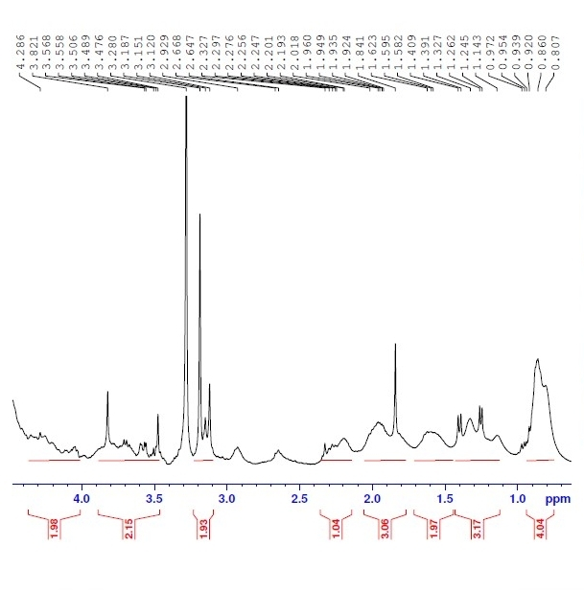
(A)

(B)
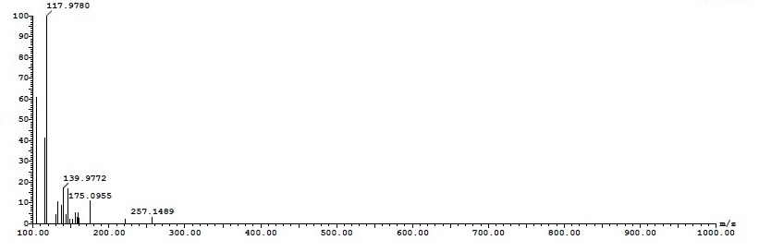
(C)
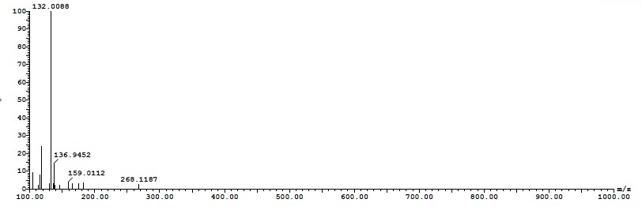
(D)
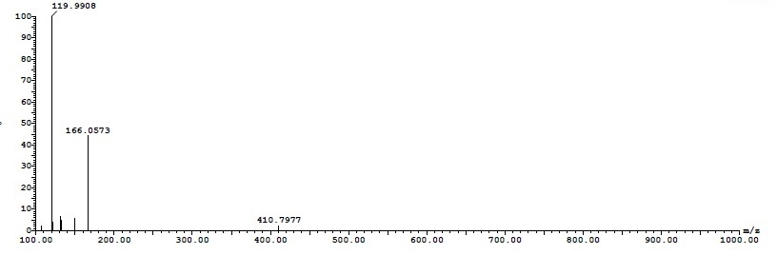
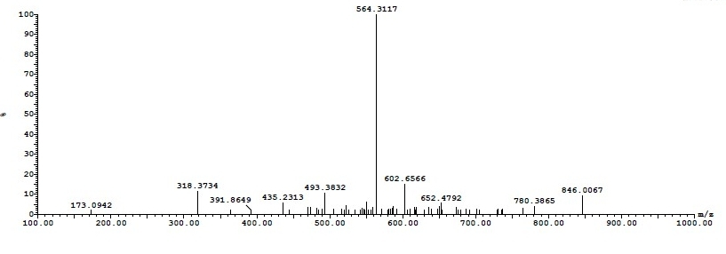
(E)
(F)
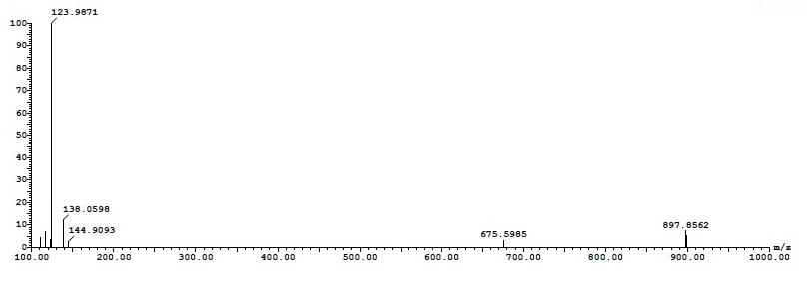
(G)
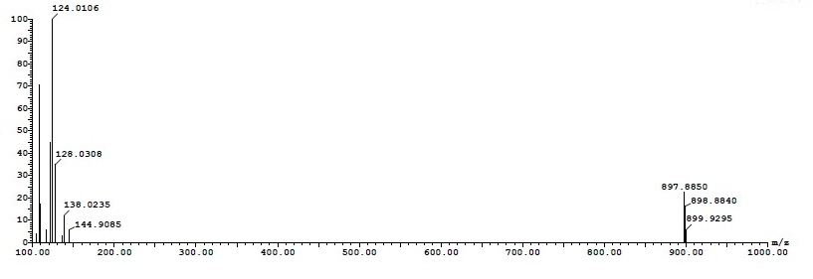
Fig. S1
NMR (A) and MS analysis of chito-oligosaccharides obtained from enzymatic hydrolysis and illustrations of its m/z values (B– G).

