Additional File

A new Zymomonas mobilis platform strain for the efficient production of chemicals
Jonas Frohwitter^{1,a}, Gerrich Behrendt^{1,a}, Steffen Klamt¹, Katja Bettenbrock^{1, *}

¹⁾ Analysis and Redesign of Biological Networks, Max Planck Institute for Dynamics of Complex Technical Systems, Sandtorstr. 1, 39106, Magdeburg, Germany
^{a)} These authors contributed equally.

*Corresponding author: bettenbrock@mpi-magdeburg.mpg.de

Table S1: Plasmids used in this study.
Plasmid | Description | Assembly
pZP014 | lvl1-pos2-accceptor | [1]
pZP016 | lvl1-pos4-accceptor | [1]
pZP017 | lvl1-pos5-accceptor | [1]
pZP027 | lvl1-pos1-dummy | [1]
pZP038 | lvl2-end-linker-5 | [1]
pZP131 | lvl1-pos3rev-SpecR_cassette | [1]
pZP137 | lvl2-pos1-acceptor-suicide | [1]
pZP159 | rbs-10k | [1]
pZP286 | lacI-PlacT7A1-in-001 | [1]
pZP289 | terminator-of-soxR-in-004 | [1]
pZP436 | Pstrong100k*-in-001 | [1]
pZP536 | lvl1-pos4-Pstrong100k*-ldhA-TrrnB1 | [1]
pZP941 | lvl1-pos4-lacI-PlacT7A1-for-GE | Pr 890 + Pr 891 (Templ. pZP286 , Atemp. 60 °C, 1700 bp) BsaI Cut-Ligation into pZP016
pZP948 | lvl1-pos2-usHA-pdc-promoter-switch | Pr 900 + Pr 901 (Templ. gDNA ZM4 , Atemp. 60 °C, 650 bp) BsaI Cut-Ligation into pZP014
pZP949 | lvl1-pos5-dsHA-pdc-promoter-switch | Pr 902 + Pr 903 (Templ. gDNA ZM4 , AT 60 °C, 100 bp),  Pri 904 + Pr 905 (Templ. gDNA ZM4 , AT 60 °C, 700 bp) BsaI Cut-Ligation into pZP017
pZP950 | lvl2-pos1-GE-pdc-promoter-switch-SpecR-lacI-PlacT7A1-suicide | pZP137 + pZP027 + pZP948 + pZP131 + pZP941 + pZP949 + pZP038 BbsI Cut-Ligation
pZP1254 | alaD-Geobacillus_stearothermophilus-pos003v2 | Synthesized by TWIST Biosciences, codon optimisation performed based on KAZUSA
pZP1257 | lvl1-pos4-Pstrong100k*-alaD-G_stearothermophilus-TsoxR | pZP016 + pZP436 + pZP159 + pZP1254 + pZP289 BsaI Cut-Ligation
Pr: Primer, [1] Behrendt et al., 2022 ACS Synthetic Biology 11(11), 3855-3864 DOI: 10.1021/acssynbio.2c00428

Tab. S2: Strains used in this study.
Strain | Base | Genotype | Plasmid /Enzyme expressed
ZM4
sGB027 | ZM4 wt | ZM4 ΔPpdc :: SpecR-lacI-PlacT7A1 | pZP950 (suicide)
sGB029 | sGB027 | ZM4 ΔPpdc :: SpecR-lacI-PlacT7A1/ pZP536 | pZP536 / LdhA
sGB038 | sGB027 | ZM4 ΔPpdc :: SpecR-lacI-PlacT7A1 /pZP1257 | pZP1257 / AlaDH

Tab. S:3 Primer used in this study.
Primer | Sequence (5´...3´)
Primer 890 | ggaGGTCTCaAGTGggtctgcgttgtcg
Primer 891 | ggaGGTCTCaGGTTaattgttatccgctcacaattgaatctaagtatca
Primer 900 | ggaGGTCTCaAGTGCACAATAATGGCAAAGCTGCTGACA
Primer 901 | ggaGGTCTCaGGTTGCCTGTTTTAAAATTTTTCCGGCTGTT
Primer 902 | ggaGGTCTCaAGTGGGGTCATCCTGATTCAGACATAGTG
Primer 903 | ggaGGTCTCaGGCCAATCTGGACAAGCCGCTCCG
Primer 904 | ggaGGTCTCaGGCCTCAAGCATCACTTCGCAGTCGC
Primer 905 | ggaGGTCTCaGGTTTGGGAAGAAGCTTTTTGCAGC
gap-for-real | ACCCCGGATGTCAGCCTTGTTG
gap-rev-real | GGAGCTGTGCGGATCGGAGTAGAA
zwf-for-real | AAGTTGCCGGTTACATTGACGA
zwf-rev-real | TGCGGATATAGAACGGAACACC
pdc-for-real | AGCTTCTTCCGGGGTGTAAATC
pdc-rev-real | GTGGCGCCTATGCAGAAAACCT

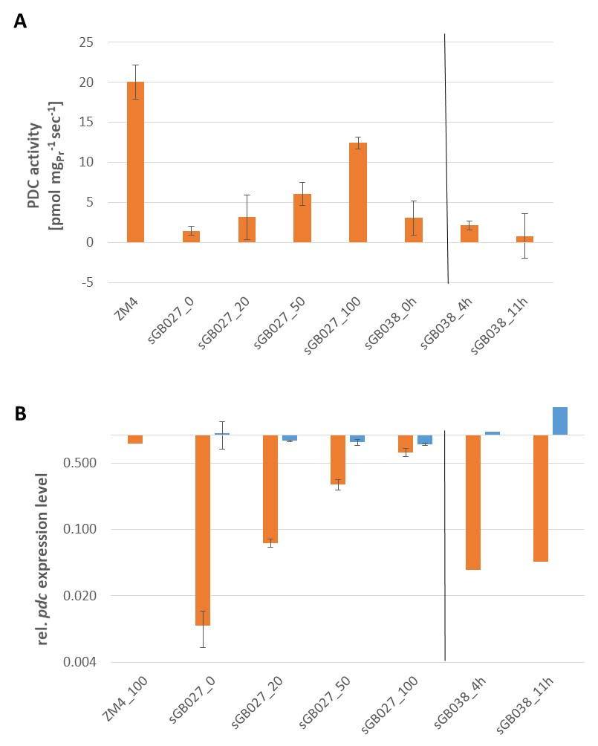

Fig. S1: PDC activity and pdc expression levels in sGB027 in dependence of IPTG and in sGB038 fermentations at two different time points. Data for sGB027 were derived from two independent growth experiments after approximately 6-7 hours of growth in ZMM when cultures showed a constant exponential growth rate. Numbers after the strain name sGB027 indicate the amount of IPTG added in µM. PDC activity for sGB038 were derived from two independent growth experiments after 4h and 8h, respectively, with no IPTG added. Data for pdc expression from sGB038 are determined from one experiment only. A) PDC activity in pmol µg_{Protein}⁻¹ sec⁻¹. B) Gene expression analysis by Real Time RT-PCR evaluated by the ΔΔCT method using the genes gap and zwf as housekeeping genes and ZM4_0 as reference sample. Data are plotted on a logarithmic scale to better visualize the changes. ZM4_100 is included to show that IPTG has no effect in pdc expression in the WT (data from one run only). We also show data for glk (in blue) to demonstrate the variation of a gene that is not controlled by IPTG.

Fig. S2: Growth of ZM4 WT in ZMM (2% glucose) with different nitrogen sources. Data were derived from two biological replicates. Control: ZMM with 1g/L (7.6 mM) Ammonium sulfate. Nitrogen sources were added at the start of the cultivation.

