Supplementary Fig. 1 The map of plasmid Pex5 with pHP13(spe) [14, 26] as the backbone. The arrangement of the promoters and genes is as follows: Pr ribA, ndk, PvegI, guaB, guaA, gmk. The synthetic operon is ligated to backbone plasmid pHP13(spe) by Gibson assembly to generate pEX5.

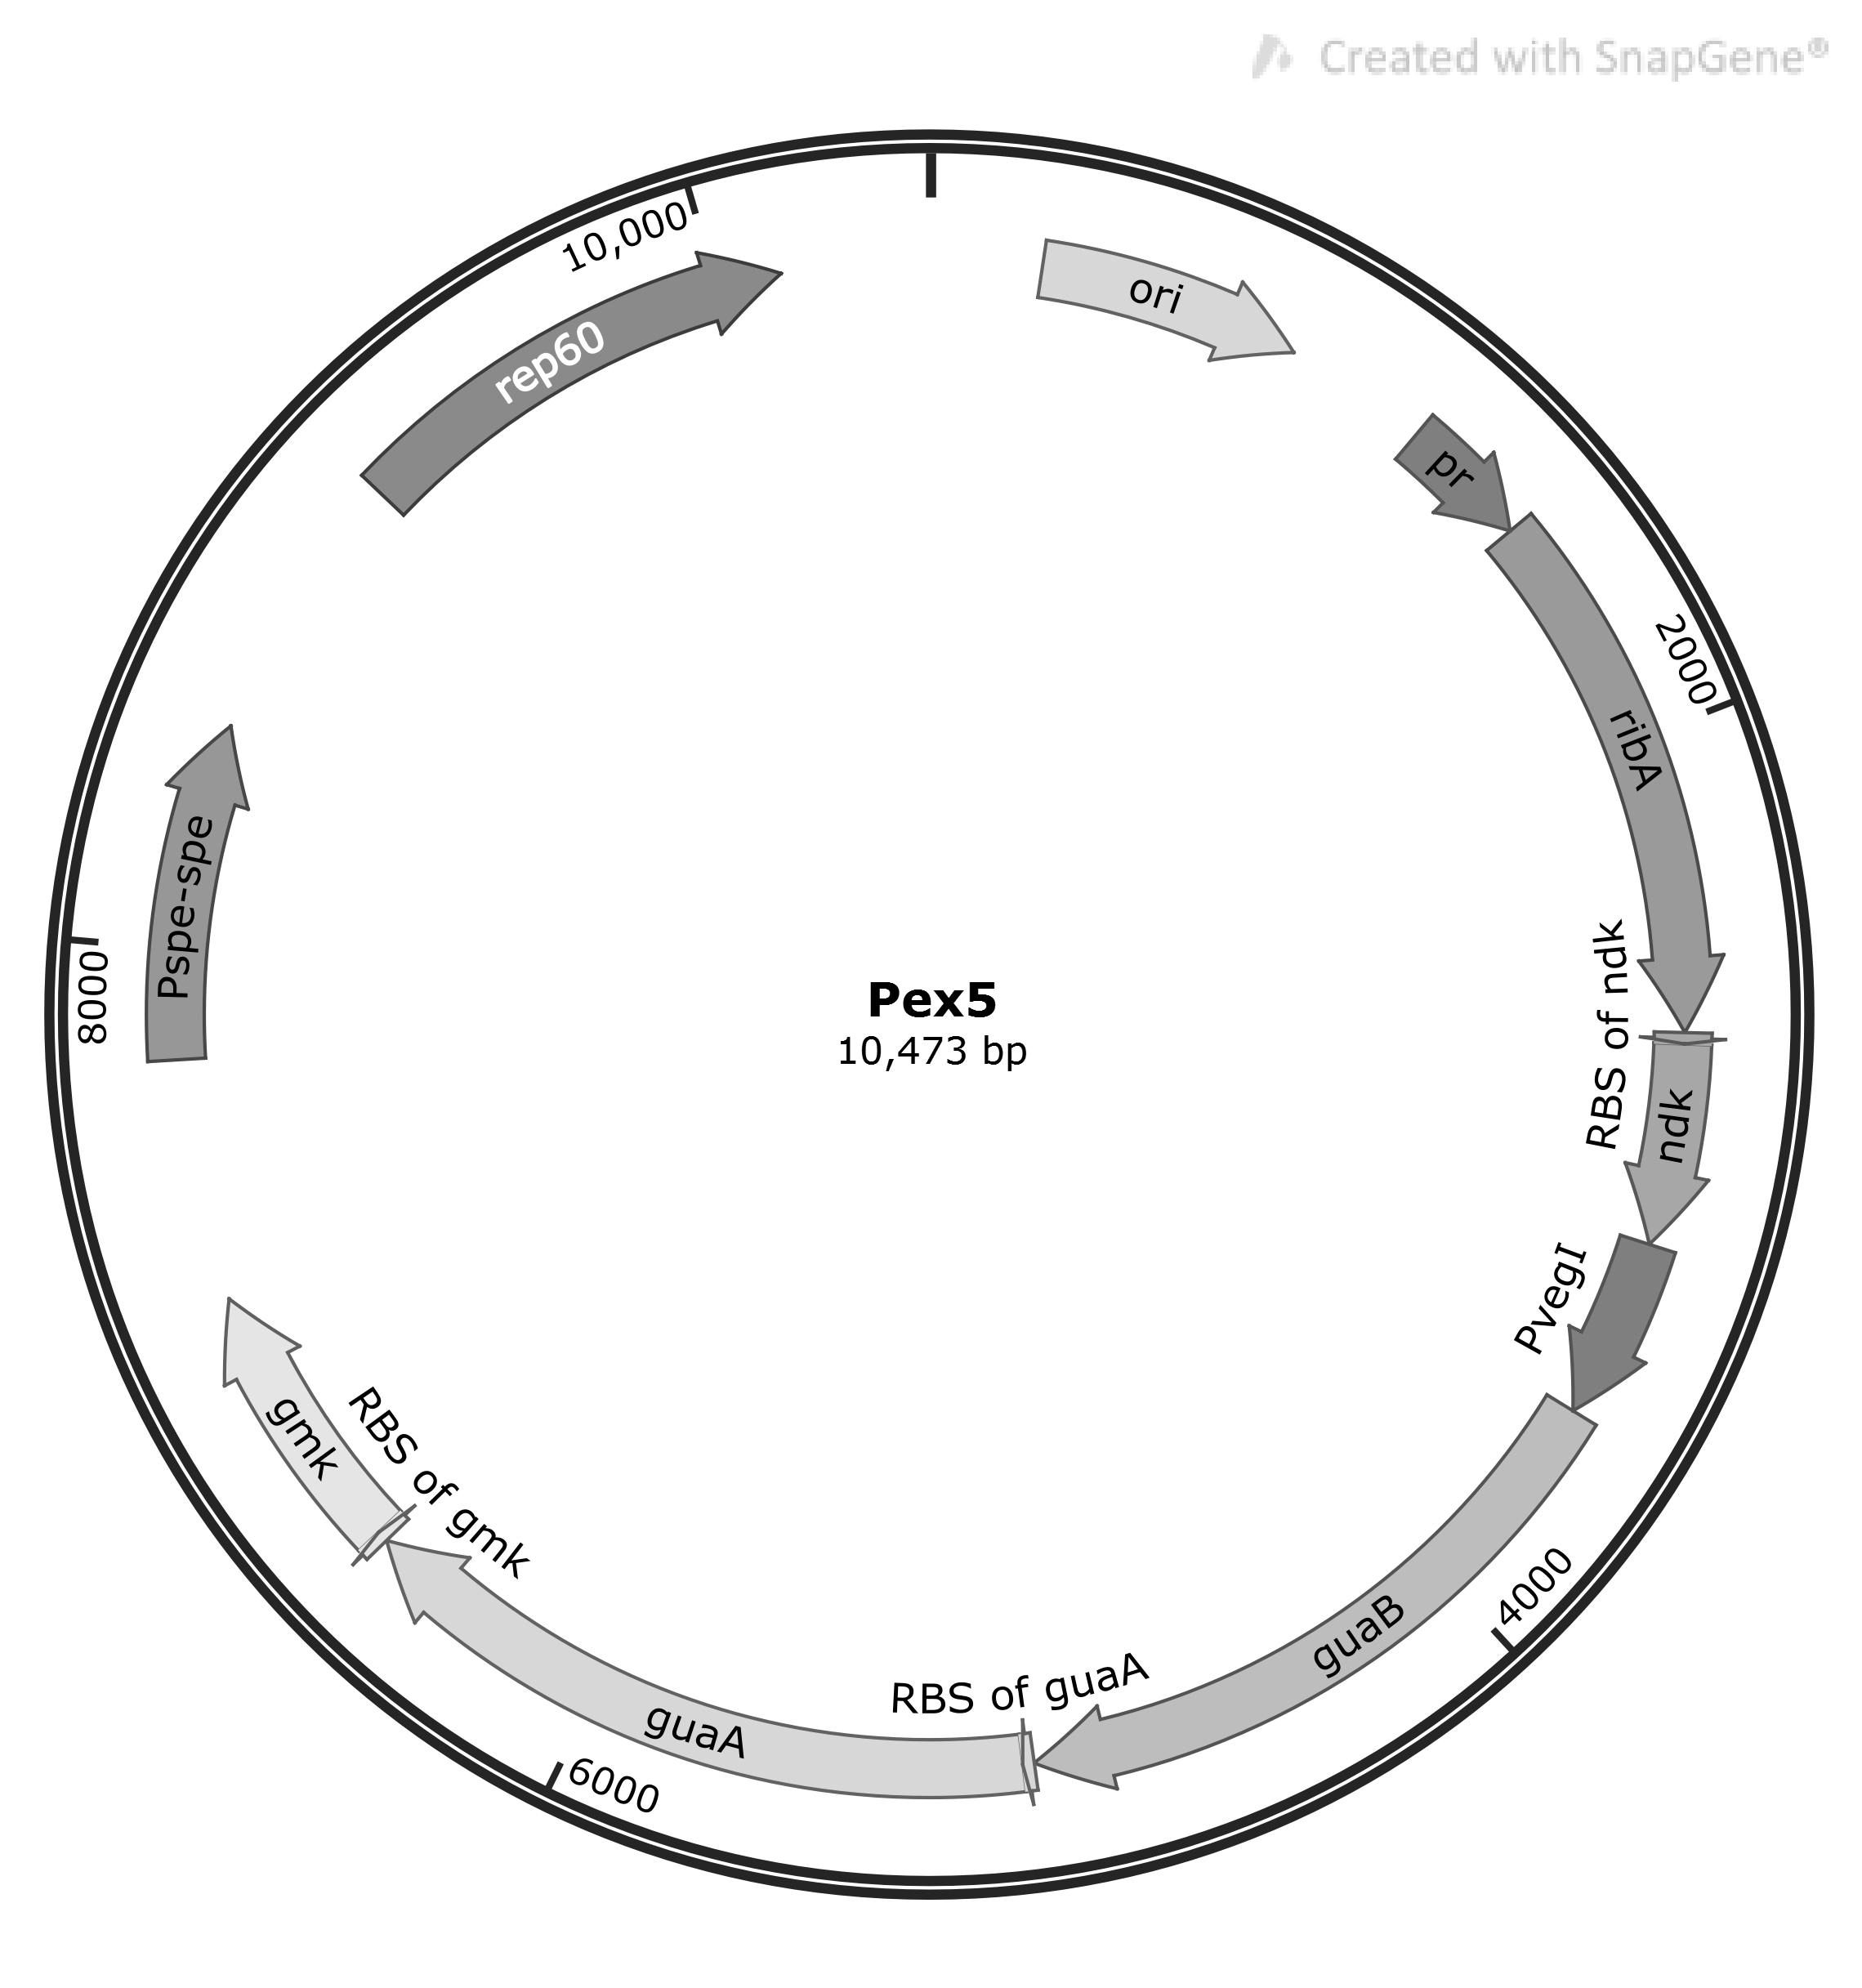

Supplementary Fig. 2 The biomass of strains individually overexpressing guaB, guaA, gmk, ndk, and ribA in the context of the BSR background.
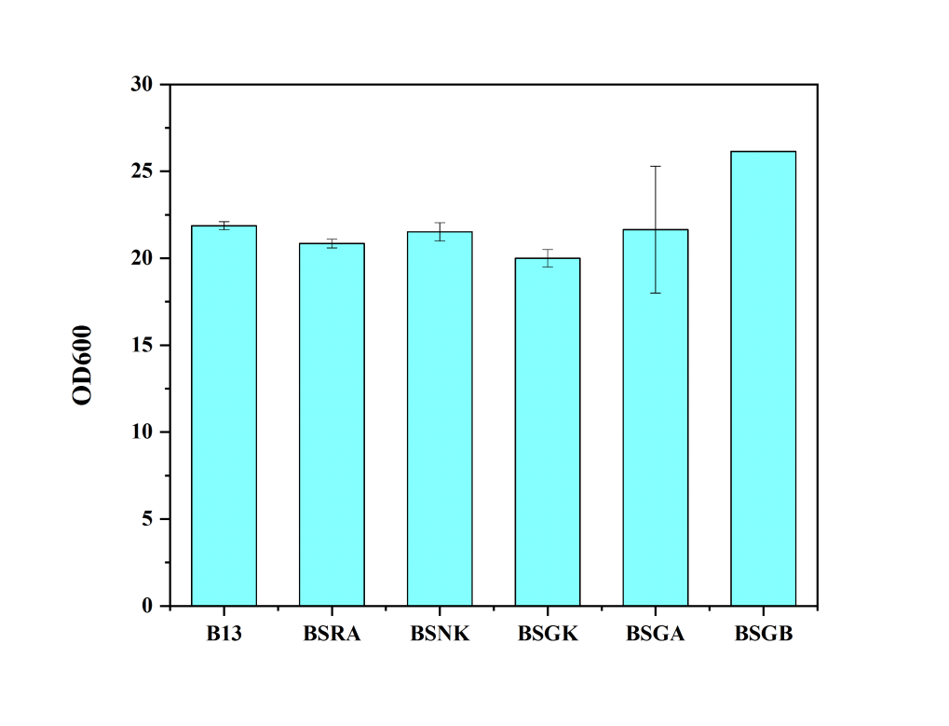

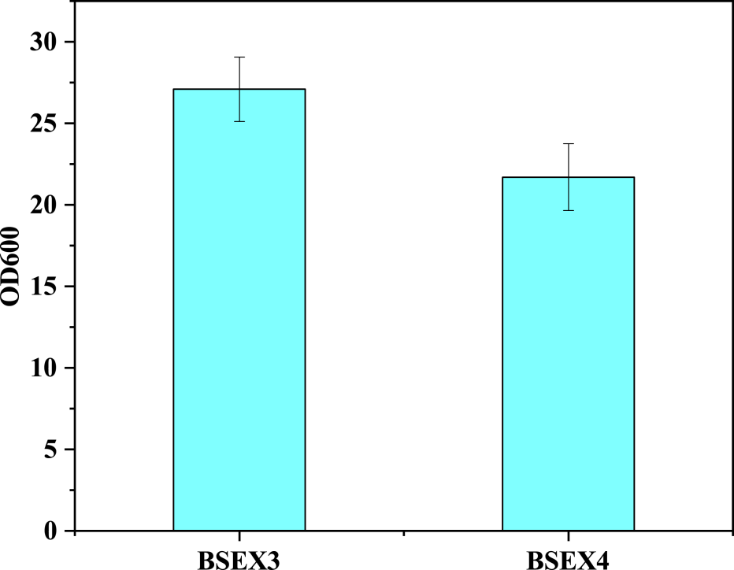

Supplementary Fig. 3 The biomass of BSEX3 and BSEX4. Transketolase was knocked out on the background of parent strain (BSRE3), which contain the ribulose-5-phosphate 3-epimerase mutation.

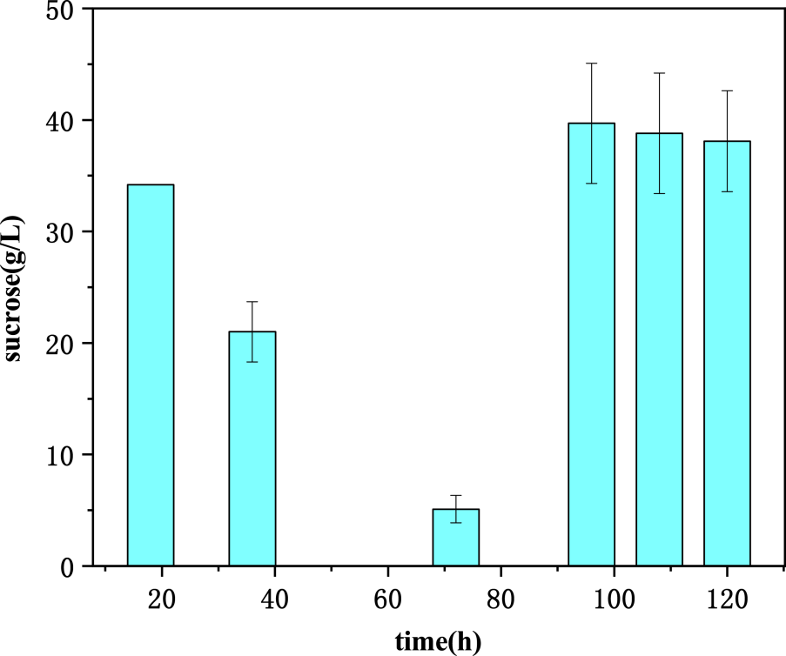

Supplementary Fig. 4 The sucrose concentration of BSEX4/pMX45 in the flask fermentation. Feeding process was conduct after measurement of the sucrose concentration in the medium at 72 h.

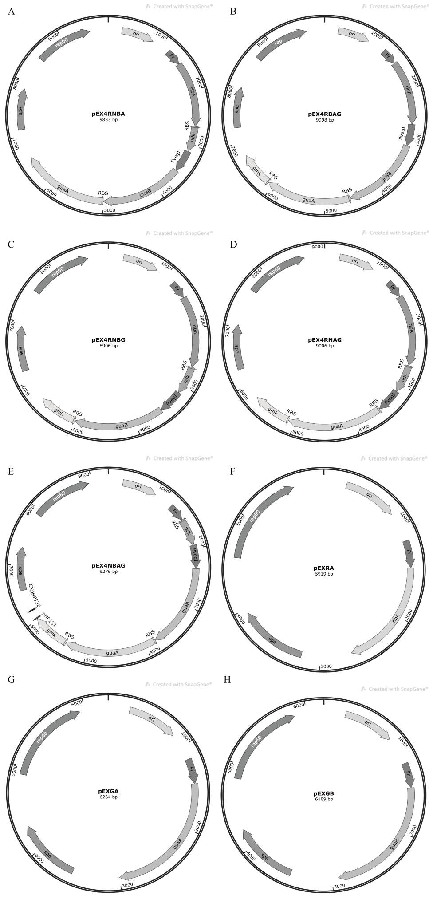

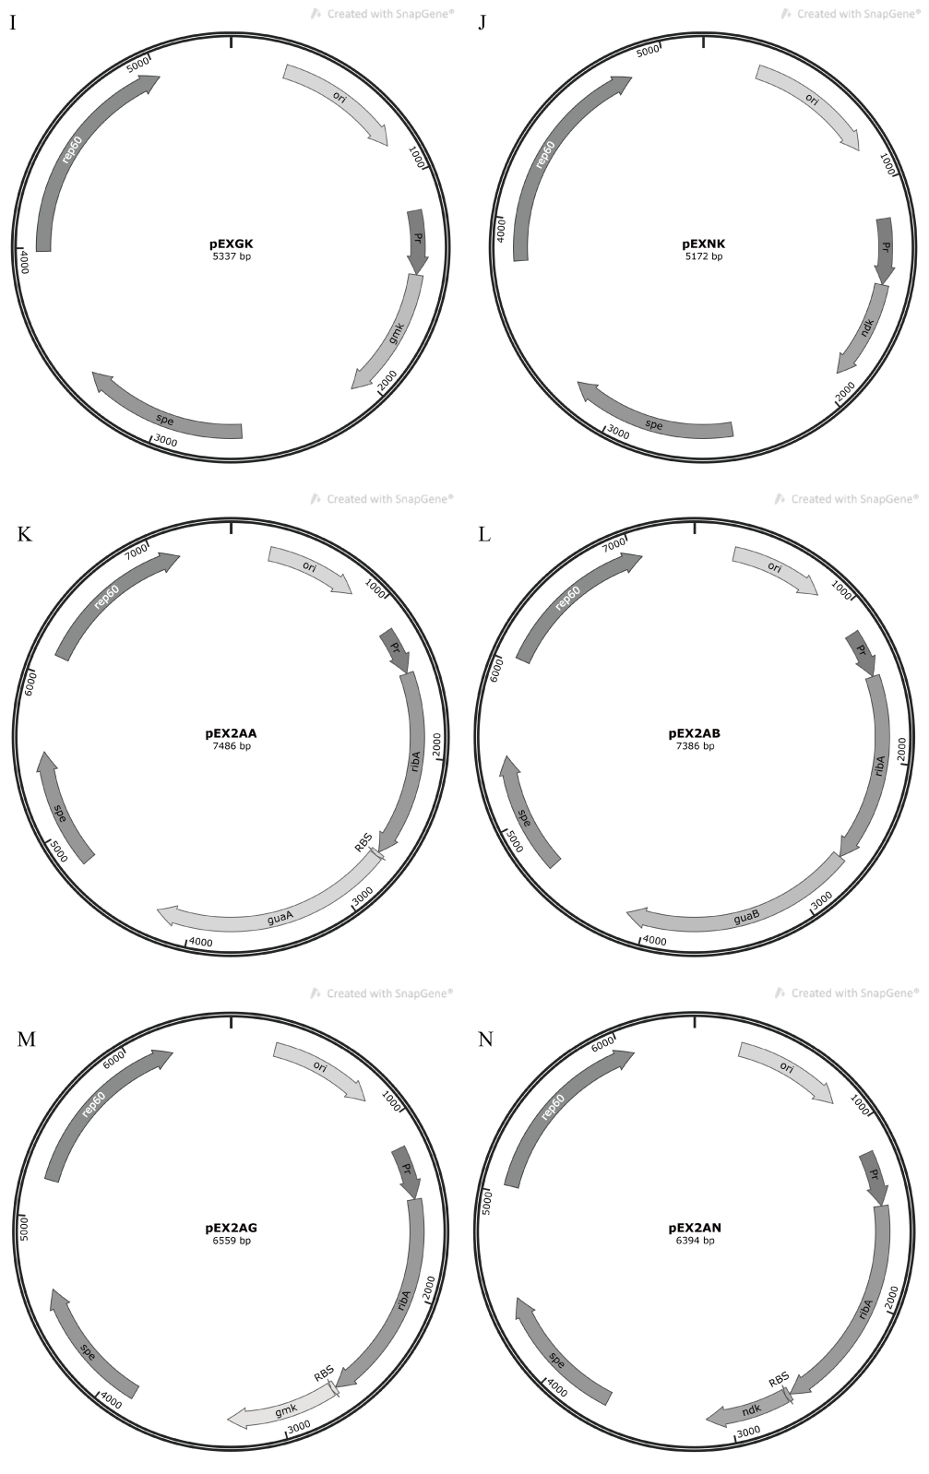

Supplementary Fig. 5 Organization of Recombinant Plasmids. A-N correspond to the organization of recombinant plasmids, including pEX4RNBA, pEX4RBAG, pEX4RNBG, pEX4RNAG, pEX4NBAG, pEXRA, pEXGA, pEXGB, pEXGK, pEXNK, pEX2AA, pEX2AB, pEX2AN and pEX2AG as detailed in Table 3.
