Supplementary Figure
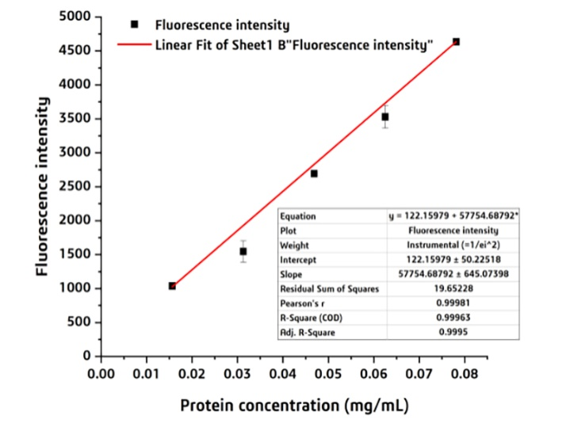

Supplementary Fig. 1 the standard curve of calculation the protein concentration through measuring the fluorescence intensity at 488 nm.
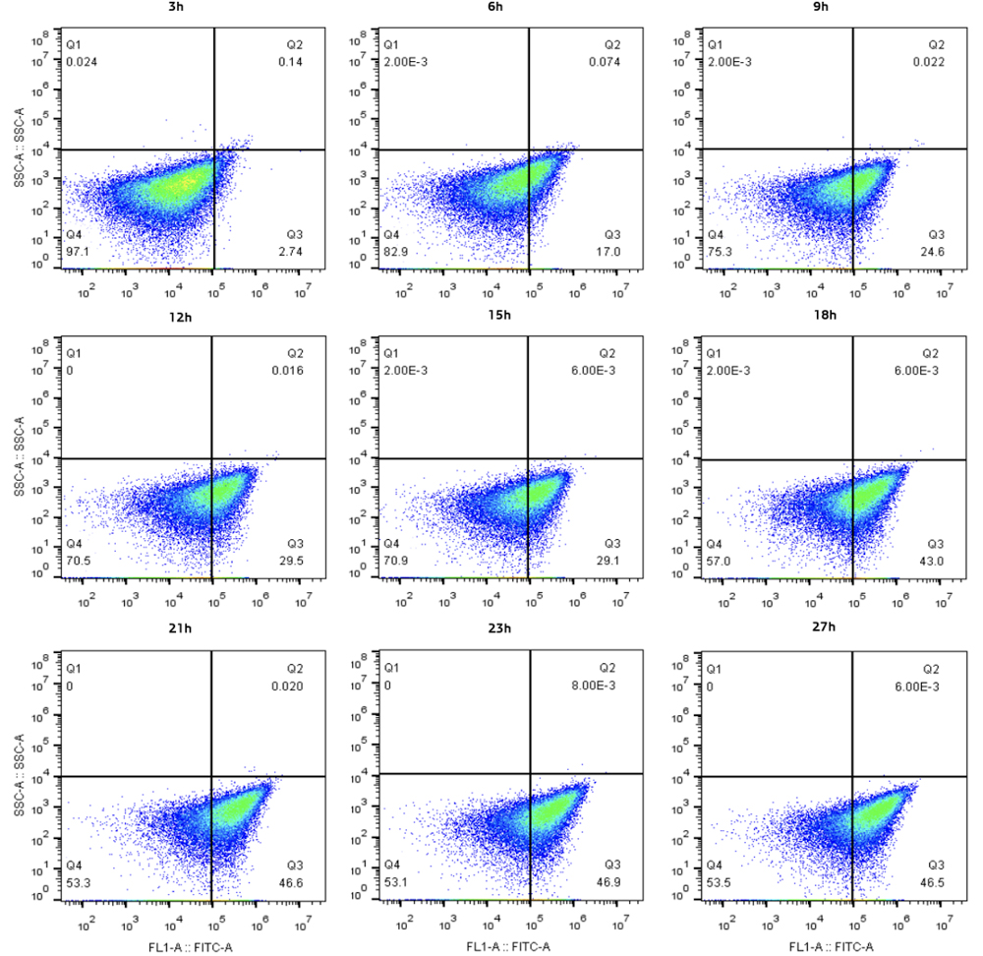
Supplementary Fig. 2 FACS to analyze the fluorescent intensity of the cells during the fermentation.
Supplementary Table
Supplementary Table 1 The activity of RM lipase and RM-sfGFP₍₋₁₅₎ to different esters.
Substrate | Activity of RM-sfGFP₍₋₁₅₎ against to RM（%）
DBP | 71.3±6.3
DEHP | 50.1±3.7
DCHP | 69.4±7.8
CHCM | 102.4±2.9
CHCI | 105.8±1.8

The results are presented as the means±SDs of three independent experiments.

