Full uncropped Gels images

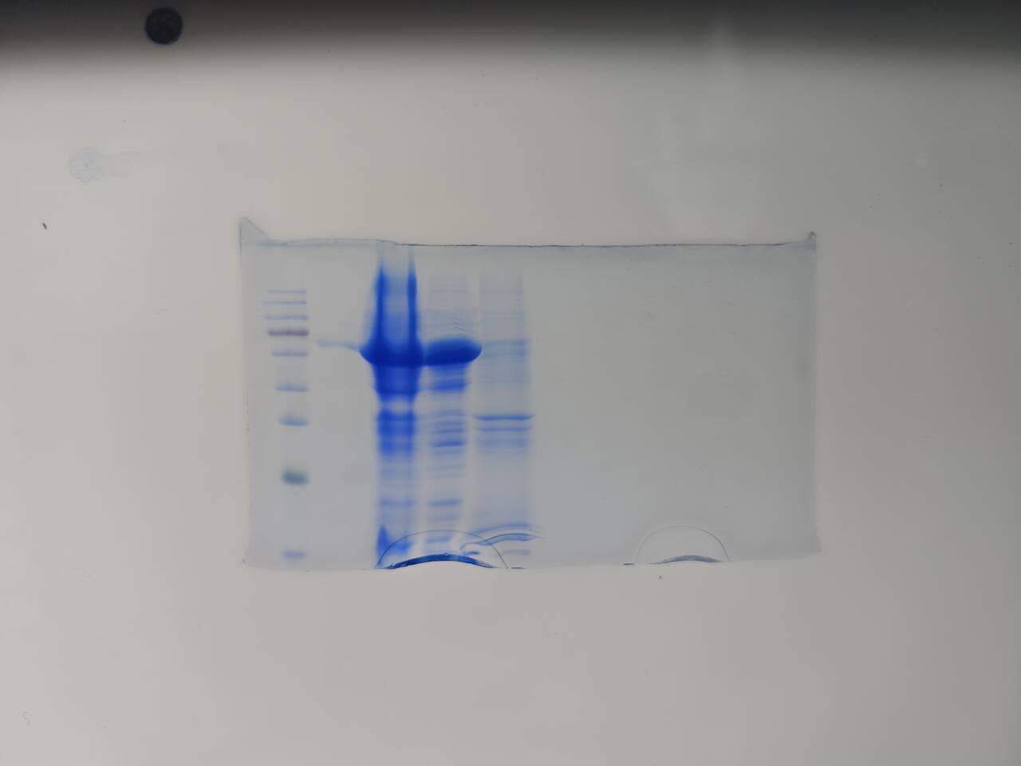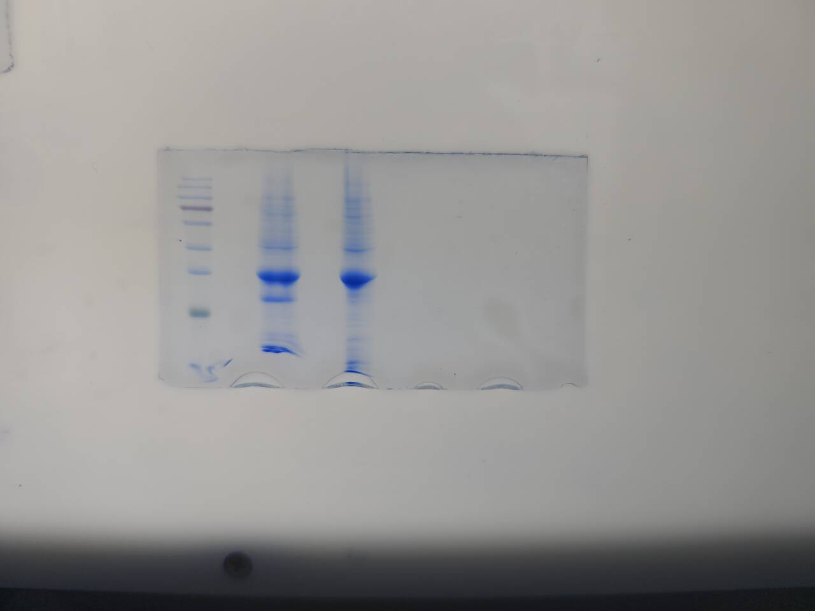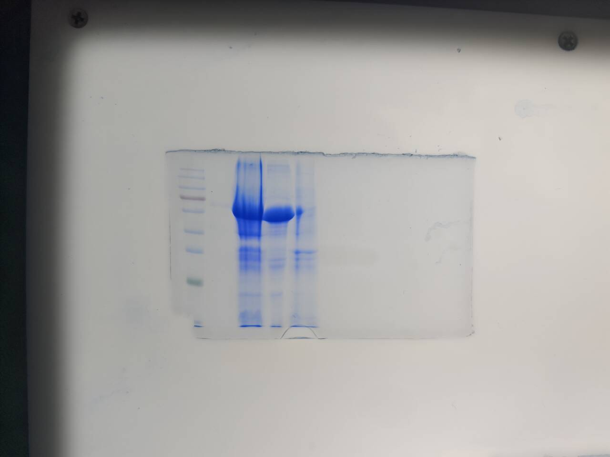

Full uncropped Gels images-Figure 3(manuscript)

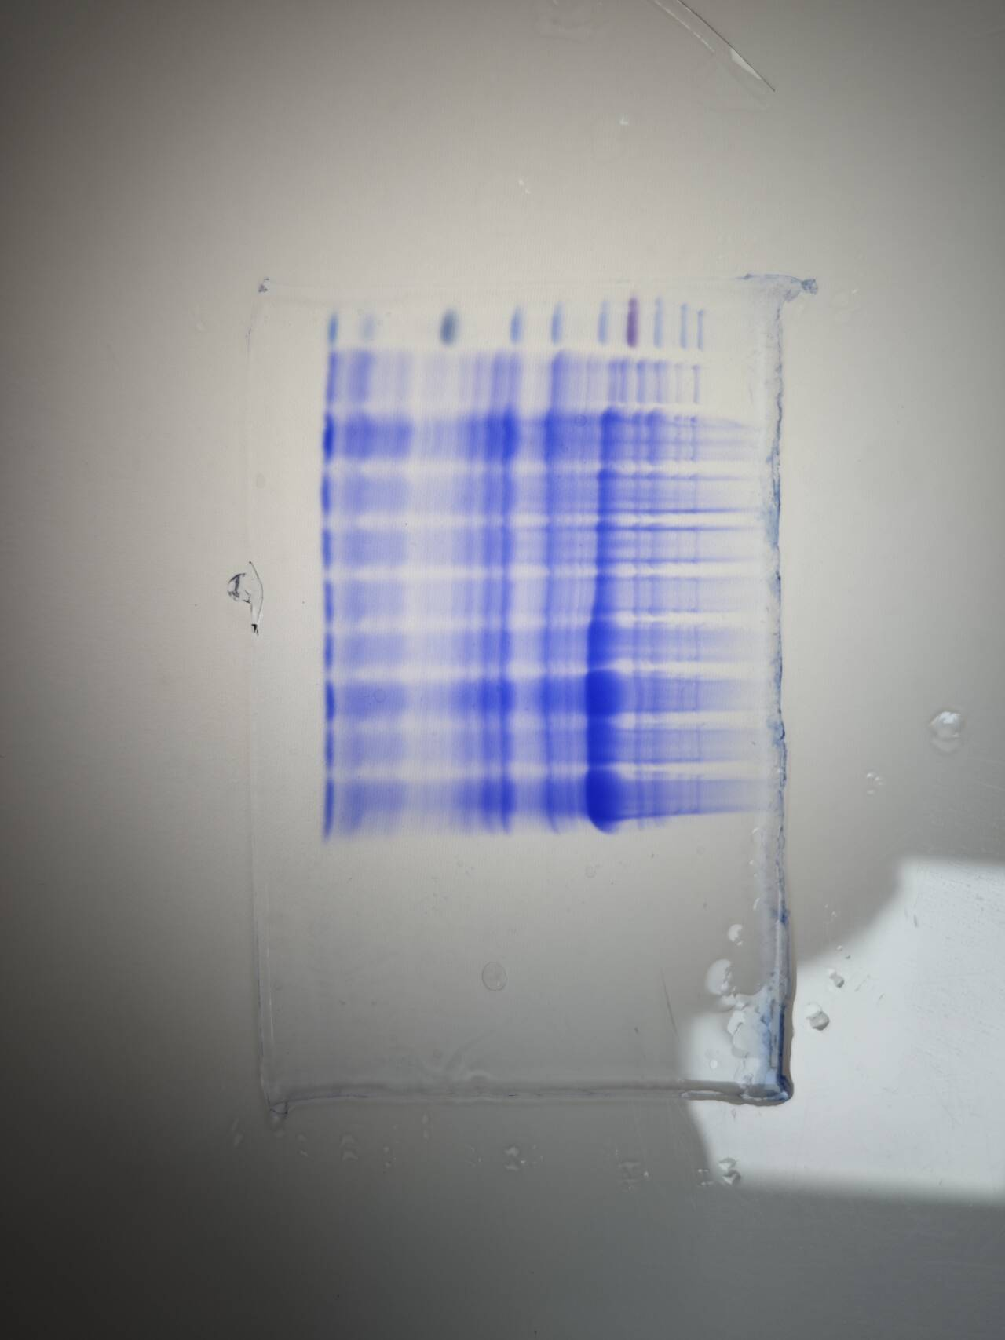
Full uncropped Gel image-Figure 5(manuscript)

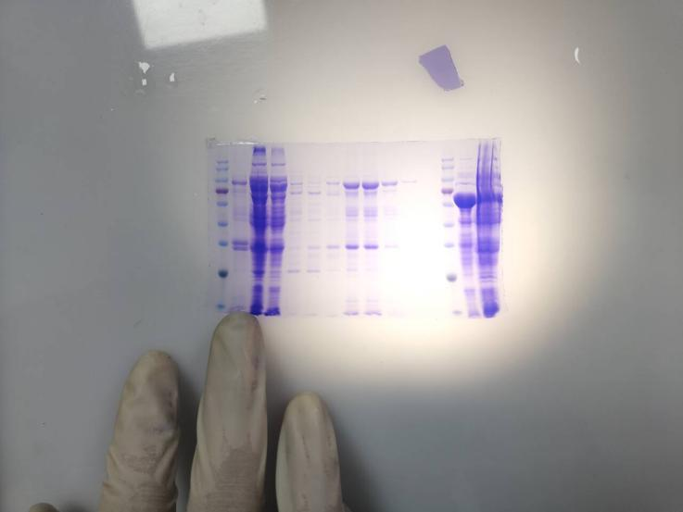
Full uncropped Gel image-Figure 6(manuscript)

