Supplementary materials for

Engineering cascade biocatalysis in whole cells for syringic acid bioproduction

Xin Liu, Yi An, Haijun Gao*

School of Life Science, Beijing Institute of Technology, Beijing 100081, China

* Corresponding author at: School of Life Science, Beijing Institute of Technology, Beijing 100081, China
E-mail address: hj_gao@bit.edu.cn (H. Gao)

TABLE OF CONTENTS

Supplementary methods
Method S1. Analytical methods for assessing other phenolic compounds and corresponding O-methyl compounds
Method S2. Molecular docking

Supplementary Tables
Table S1. The plasmids used in this work
Table S2. The strains used in this work
Table S3. The primers used in this work
Table S4. Library of O-Methyltransferase tested in this study

Supplementary Figures
Figure S1. Effect of Mg²⁺(a), syringic acid(b), glucose(c), CTAB(d), and lysozyme(e) on the whole-cell catalytic synthesis of syringic acid
Figure S2. The interaction between DesAOMT and the substrate GA

Supplementary Discussion

Supplementary methods

Method S1. Analytic methods for assessing other phenolic compounds and corresponding O-methyl compounds
In addition to SA and the intermediates produced in cascade biocatalysis, the other phenolic compounds and corresponding O-methyl compounds involved in this study were also analyzed using high-performance liquid chromatography (HPLC). The samples were centrifuged at 12,000 RPM for 2 min, after which the supernatant was collected, filtered through 0.22 μm filters, and subsequently injected into an HPLC system (Agilent 1260 Infinity II, USA) equipped with a GL Science InertSustain C-18 column (4.6×250 mm). Unless otherwise stated, the mobile phase was used at a flow rate of 0.8 mL/min. The temperature of the column was maintained at 32°C throughout the analysis. A 10 μL portion of each sample was injected for analysis using an automated injector. An ultraviolet detector was used to measure the samples. The other parameters for the specific chemicals used were as follows:
Gallic acid (GA) and its O-methyl derivatives: The mobile phase was a mixture of water containing 0.1% acetic acid and methanol (80:20, V/V), and the ultraviolet detection wavelength was set at 275 nm.
Protocatechuic acid (3,4-DHBA) and its O-methyl derivatives: A binary gradient elution of water containing 0.1% acetic acid (A) and methanol (B) was used to separate the chemicals in the samples: 0 to 25 min 70% solvent A and 30% solvent B; 25 to 30 min solvent A from 70% to 50%, solvent B from 30% to 50%, then a 10 minutes hold; 40 to 41 min solvent A from 50% to 70%, solvent B from 50% to 30%, then a hold to 50 min. The ultraviolet detection wavelength was set at 275 nm.
Caffeic acid and its O-methyl derivatives: The mobile phase was a mixture of water containing 0.1% acetic acid and methanol (55:45, V/V), and the ultraviolet detection wavelength was set at 310 nm.
3,5-Dihydroxybenzoic acid (3,5-DHBA), 2-hydroxybenzoic acid (2-HBA), 3-hydroxybenzoic acid (3-HBA), 4-hydroxybenzoic acid (4-HBA), and their O-methyl derivatives: The mobile phase was a mixture of water containing 0.1% acetic acid and methanol (55:45, V/V), and the ultraviolet detection wavelength was set at 275 nm.
2,5-Dihydroxybenzoic acid (2,5-DHBA), 2,6-dihydroxybenzoic acid (2,6-DHBA), and its O-methyl derivatives: The mobile phase was a mixture of water containing 0.1% acetic acid and methanol (65:35, V/V), and the ultraviolet detection wavelength was set at 240 nm.
2,4-Dihydroxybenzoic acid (2,4-DHBA) and its O-methyl derivatives: The mobile phase was a mixture of water containing 0.1% acetic acid and methanol (65:35, V/V), and the ultraviolet detection wavelength was set at 275 nm.

Method S2. Molecular docking
The DesAOMT protein structure (PDB: 8C9V) was downloaded from the RCSB PDB database (https://www.rcsb.org/), and the 3D structure of the substrate GA (ligand, PubChem CID: 370) was downloaded from the NCBI database (https://pubchem.ncbi.nlm.nih.gov/). Discovery Studio 4.1 was used to preprocess proteins and ligands, and perform molecular docking. The Prepare Protein module was used to optimize the structure of the protein molecule, the Prepare Ligands module was used to process the small molecule, and the Define and Edit Binding Site module was used to define the possible binding sites in the receptor by finding the cavity. The CDOCKER module was used for molecular docking, and the Ligand Interactions module was used for protein and substrate docking analysis.

Supplementary Tables
Table S1. The strains used in this work
Strains | Characteristics | Sources or references
E. coli BL21(DE3) | F–ompT hsdS_{B} (r_{B}– m_{B}–) gal dcm (DE3) | Lab stock
E. coli MG1655 | F– λ– ilvG– rfb–50 rph–1 | Lab stock
E. coli DH5α | F– φ80lacZΔM15 Δ(lacZYA-argF)U169 recA1 relA1 endA1 hsdR17(r_{K}– m_{K}⁺) phoA supE44 λ–thi-1 gyrA96 | Lab stock
LX1 | E. coli BL21(DE3) containing pET-28a | This work
LX2 | E. coli BL21(DE3) containing p-StiAOMT | This work
LX3 | E. coli BL21(DE3) containing p-StyLOMT | This work
LX4 | E. coli BL21(DE3) containing p-KibPOMT | This work
LX5 | E. coli BL21(DE3) containing p-SynOMT | This work
LX6 | E. coli BL21(DE3) containing p-RetFOMT | This work
LX7 | E. coli BL21(DE3) containing p-OmnBOMT | This work
LX8 | E. coli BL21(DE3) containing p-MyxXOMT | This work
LX9 | E. coli BL21(DE3) containing p-MycTOMT | This work
LX10 | E. coli BL21(DE3) containing p-StrAOMT | This work
LX11 | E. coli BL21(DE3) containing p-PhoAOMT | This work
LX12 | E. coli BL21(DE3) containing p-DesAOMT | This work
LX13 | E. coli DH5α containing pTrc99a | This work
LX14 | E. coli DH5α containing pT-DesAOMT | This work
LX15 | E. coli DH5α containing pT-AUPD | This work
LX16 | E. coli MG1655 containing pT-AUPD | This work
LX17 | E. coli MG1655 ΔaroE containing pT-AUPD | This work
LX18 | E. coli MG1655 ΔydiB containing pT-AUPD | This work
LX19 | E. coli MG1655 ΔtrpED containing pT-AUPD | This work
LX20 | E. coli MG1655 ΔpheA-tyrA containing pT-AUPD | This work
LX21 | E. coli MG1655 ΔaroEΔydiB containing pT-AUPD | This work
LX22 | E. coli MG1655 ΔaroEΔydiBΔtrpED containing pT-AUPD | This work
LX23 | E. coli MG1655 ΔaroEΔydiBΔtrpEDΔpheA-tyrA containing pT-AUPD | This work
LX24 | E. coli MG1655 ΔtrpEDΔpheA-tyrA containing pT-AUPD | This work

Table S2. The plasmids used in this work*
Plasmids | Characteristics | Sources or references
pCas | repA101(Ts) P_{cas}-cas9 P_{araB}-Red lacI^{q} P_{trc}-sgRNA-pMB1 kan | [1]
pET-28a | pBR322 origin, lacI, T7lac, kan | Lab stock
pTargetF | pMB1, aadA, sgRNA, spe | [1]
pTrc99a | pBR322 ori, trc promoter, Amp resistant | [2]
pE-DesAOMT | pET-28a harboring DesAOMT gene | This work
pE-KibPOMT | pET-28a harboring KibPOMT gene | This work
pE-MyxXOMT | pET-28a harboring MyxXOMT gene | This work
pE-MycTOMT | pET-28a harboring MycTOMT gene | This work
pE-OmnBOMT | pET-28a harboring OmnBOMT gene | This work
pE-PhoAOMT | pET-28a harboring PhoAOMT gene | This work
pE-RetFOMT | pET-28a harboring RetFOMT gene | This work
pE-StiAOMT | pET-28a harboring StiAOMT gene | This work
pE-StyLOMT | pET-28a harboring StyLOMT gene | This work
pE-SynOMT | pET-28a harboring SynOMT gene | This work
pE-StrAOMT | pET-28a harboring StrAOMT gene | This work
pT-AUPD | pTrc99a harboring aroL, ubiC, pobA**, and DesAOMT gene | This work
pTargetF-aroE | pMB1, aadA, sgRNA-aroE | This work
pTargetF-trpED | pMB1, aadA, sgRNA-trpED | This work
pTargetF-pheA-tyrA | pMB1, aadA sgRNA-pheA-tyrA | This work
pTargetF-ydiB | pMB1, aadA, sgRNA-ydiB | This work
* kan, kanamycin resistance gene; spe, spectinomycin resistance gene; aadA, spectinomycin resistance gene; cat, chloramphenicol resistance gene; P_{cas}-cas9, the cas9 gene with its native promoter; P_{araB}-Red, the Red recombination genes with an arabinose inducible promoter; P_{trc}-sgRNA-pMB1, sgRNA with an N20 sequence for targeting the pMB1 region with a trc promoter; the information for various O-methyltransferase (OMT) was provided in Table S4; aroL, shikimate kinase; ubiC, chorismate lyase; pobA**, p-hydroxybenzoate hydroxylase mutant gene from Pseudomonas fluorescens; sgRNA-aroE, sgRNA-ydiB, sgRNA-trpED, and sgRNA-pheA-tyrA sgRNA with an N20 sequence for targeting the aroE, ydiB, trpED, pheA-tyrA locus, respectively.

Table S3. The primers used in this work
Primers | Sequences (5’-3’) | Description
PTRC99C-F | Ttgcgccgacatcataac | Verification
PTRC99C-R | ctgcgttctgatttaatctg | Verification
T7 | taatacgactcactatagg | Verification
T7-TER | gctagttattgctcagcgg | Verification
StiAOMT-F | aagaaggagatataccatgaatgaaaaagtcatggcggtg | Construction of pET-StiAOMT
StiAOMT-R | cggagctcgaattcgtcaggtgggctcgaaccg | Construction of pET-StiAOMT
StyLOMT-F | aagaaggagatataccatggaagatctaaataaagataaat | Construction of pET-StyLOMT
StyLOMT-R | cggagctcgaattcgtcatttcttctttactattgtcaacccat | Construction of pET-StyLOMT
KibPOMT-F | aagaaggagatataccgtgacacccgaatggccg | Construction of pET-KibPOMT
KibPOMT-R | cggagctcgaattcgtcaggctgtcttcgccgc | Construction of pET-KibPOMT
slr0095-F | ttgtttaactttaagaaggagatataccatgggtaagggcatcaccg | Construction of pET-SynOMT
slr0095-R | gtcgacggagctcgaattcgctattttttgagtgccaaagtcatg | Construction of pET-SynOMT
RetFOMT-F | aagaaggagatataccatgaatagggcgacgtttataagg | Construction of pET-RetFOMT
RetFOMT-R | cggagctcgaattcgttacaattttcgaacaaacgtaac | Construction of pET-RetFOMT
OmnBOMT-F | aagaaggagatataccatgaatccaattcatcatgaactca | Construction of pET-OmnBOMT
OmnBOMT-R | cggagctcgaattcgtcatttttttcgcgccagtgtaa | Construction of pET-OmnBOMT
SafC-F | ttgtttaactttaagaaggagatataccatgatccaccacgtcgaattg | Construction of pET-MyxXOMT
SafC-R | gtcgacggagctcgaattcgctagcgcttgcgagcgag | Construction of pET-MyxXOMT
Rv0187-F | ttgtttaactttaagaaggagatataccatggaccagcaacccaacc | Construction of pET-MycTOMT
Rv0187-R | gtcgacggagctcgaattcgctaccgcaccaaagcgagg | Construction of pET-MycTOMT
StrAOMT-F | aagaaggagatataccatgagcgagtcgcaacagct | Construction of pET-StrAOMT
StrAOMT-R | cggagctcgaattcgctacggcagcacgcgg | Construction of pET-StrAOMT
PhoAOMT-F | aagaaggagatataccatgacaaaaaagacactgggattgga | Construction of pET-PhoAOMT-F
PhoAOMT-R | cggagctcgaattcgtcaacgtttccgtgccaaagttaaa | Construction of pET-PhoAOMT-F
DesAOMT-F | aagaaggagatataccatgaataaagaattgcaccagcttct | Construction of pET-DesAOMT
DesAOMT-R | cggagctcgaattcgtcatgcagagcgggtggc | Construction of pET-DesAOMT
pTD-F | caggaaacagaccatggaattcatgaataaagaattgcaccagc | Construction of pT-DesAOMT
pTD-R | aggtcgactctagaggatcctcatgcagagcgggtg | Construction of pT-DesAOMT
aroL-F | acacaggaaacagaccatggaattcatgacacaacctctttttctgat | Construction of pT-AUPD
aroL-R | tatttctcctctttctctagatcaacaattgatcgtctgtgc | Construction of pT-AUPD
Ubic-F | tctagagaaagaggagaaatactagatgtcacaccccgcg | Construction of pT-AUPD
Ubic-R | gtcgactctagaggatccttagtacaacggtgacgcc | Construction of pT-AUPD
pobA**-F | taaggatcctctagagtcgactctagagttcacacaggaaacc | Construction of pT-AUPD
pobA**-R | ctcctctttaatctctagactactcgatttcctcgtagg | Construction of pT-AUPD
RBSDes-F | tctagagattaaagaggagaaatactagatgaataaagaattgcacc | Construction of pT-AUPD
RBSDes-R | gccaaaacagccaagctttcatgcagagcgggt | Construction of pT-AUPD
aroE-1 | ccgagtcggtgctttttttgaattcAACGGAAGCCGTTTTCG | Construction of donor DNA for aroE disruption
aroE-2 | GATGGCCTGATTATGTTACCCCTGTCGAAAC | Construction of donor DNA for aroE disruption
aroE-3 | GGGGTAACATAATCAGGCCATCCAGTTTC | Construction of donor DNA for aroE disruption
aroE-4 | agggataacagggtaatagatctaagcttCCACGGCTGCACCATTG | Construction of donor DNA for aroE disruption
ydiB-1 | ccgagtcggtgctttttttgaattcATGGGCTCGTTGGTCTGT | Construction of donor DNA for ydiB disruption
ydiB-2 | CGGTCAGCCTGAATTAACTCCTTTAACCTCTATGCT | Construction of donor DNA for ydiB disruption
ydiB-3 | GGAGTTAATTCAGGCTGACCGCGTGC | Construction of donor DNA for ydiB disruption
ydiB-4 | ggataacagggtaatagatctaagcttCGGGCAATGATTTCTTCG | Construction of donor DNA for ydiB disruption
trpED-1 | gagtcggtgctttttttgaattcAGGAACTCACACATTAGCG | Construction of donor DNA for trpED disruption
trpED-2 | CGGTTTGCATCATTGTTATTCTCTAATTTTGTTCAA | Construction of donor DNA for trpED disruption
trpED-3 | TAGAGAATAACAATGATGCAAACCGTTTTAGCGA | Construction of donor DNA for trpED disruption
trpED-4 | agggataacagggtaatagatctaagcttTTACTGACTTCGGTCAGCAC | Construction of donor DNA for trpED disruption
pheA-tyrA-1 | gagtcggtgctttttttgaattcAAACACATCTGATTAATCCACA | Construction of donor DNA for pheA-tyrA disruption
pheA-tyrA-2 | AAGAGGTTTATTAGTGTTGCCTTTTTGTTATCAATA | Construction of donor DNA for pheA-tyrA disruption
pheA-tyrA-3 | AAAGGCAACACTAATAAACCTCTTAAGCCACGC | Construction of donor DNA for pheA-tyrA disruption
pheA-tyrA-4 | ataacagggtaatagatctaagcttGGCAACAGCAATTAACGCTA | Construction of donor DNA for pheA-tyrA disruption
pTargetF.fk-R | ACTAGTATTATACCTAGGACTGAGCTAGCTGTCAAG | Construction of pTargetF-sgRNA
aroEN20-1-F | TCCTAGGTATAATACTAGTGCAGAATACGTAAACCAGGGGTTTTAGAGCTAGAAATAGC | Construction of pTargetF-aroE
ydiBN20-1-F | TCCTAGGTATAATACTAGTCTGCGTGGCTATAACACCGAGTTTTAGAGCTAGAAATAGC | Construction of pTargetF-ydiB
trpEDN20-2-F | TCCTAGGTATAATACTAGTATTGCCGGAACACGCCCACGGTTTTAGAGCTAGAAATAGC | Construction of pTargetF-trpED
pheAtyrAN20-1-F | TCCTAGGTATAATACTAGTTGTACCGCCAGATCTGATTGGTTTTAGAGCTAGAAATAGC | Construction of pTargetF-pheA-tyrA
aorE.700-F | CCATAGCTGGAGAATGCCCT | Verification of the deletion to aroE
aorE.700-R | GGTGACGTTCGTCTGGCTGA | Verification of the deletion to aroE
ydiB.700-F | GCCAGCGTAACTAATGAATT | Verification of the deletion to ydiB
ydiB.700-R | AGCCAAATACTTCACCAGCC | Verification of the deletion to ydiB
trpED.700-F | TTCGGCAATCAGCTGCGC | Verification of the deletion to trpED
trpED.700-R | AACCGTTAGCGAAGTGGC | Verification of the deletion to trpED
pheAtyrA.700-F | ACGGTATGCTGAATTCACCA | Verification of the deletion to pheA-tyrA
pheAtyrA.700-R | CGTAAATTGCTGCTTGAGCT | Verification of the deletion to pheA-tyrA

Table S4. Library of O-Methyltransferase tested in this study
Protein names | Uniprot entry name | Sources
StiAOMT | E3FEM3_STIAD | Stigmatella aurantiaca (DW4/3-1)
StyLOMT | A0A078AUZ0_STYLE | Stylonychia lemnae
KibPOMT | A0A0N9HPV5_9PSEU | Kibdelosporangium phytohabitans
SynOMT | Q55813_SYNY3 | Synechocystis sp. (PCC 6803/Kazusa)
RetFOMT | X6M5Z7_RETFI | Reticulomyxa filosa
OmnBOMT | A0A1G1JPP6_9BACT | Omnitrophica bacterium GWA2_52_8
MycTOMT | CAMT_MYCTU | Mycobacterium tuberculosis (ATCC 25618/H37Rv)
MyxXOMT | Q50859_MYXXA | Myxococcus xanthus
StrAOMT | Q82B68_STRAW | Streptomyces avermitilis (ATCC 31267/DSM 46492)
PhoAOMT | A0A1U7IJN5_9CYAN | Phormidium ambiguum IAM M-71
DesAOMT | Q1JXV1_DESA6 | Desulfuromonas acetoxidans (DSM 684/11070)

Supplementary Figures
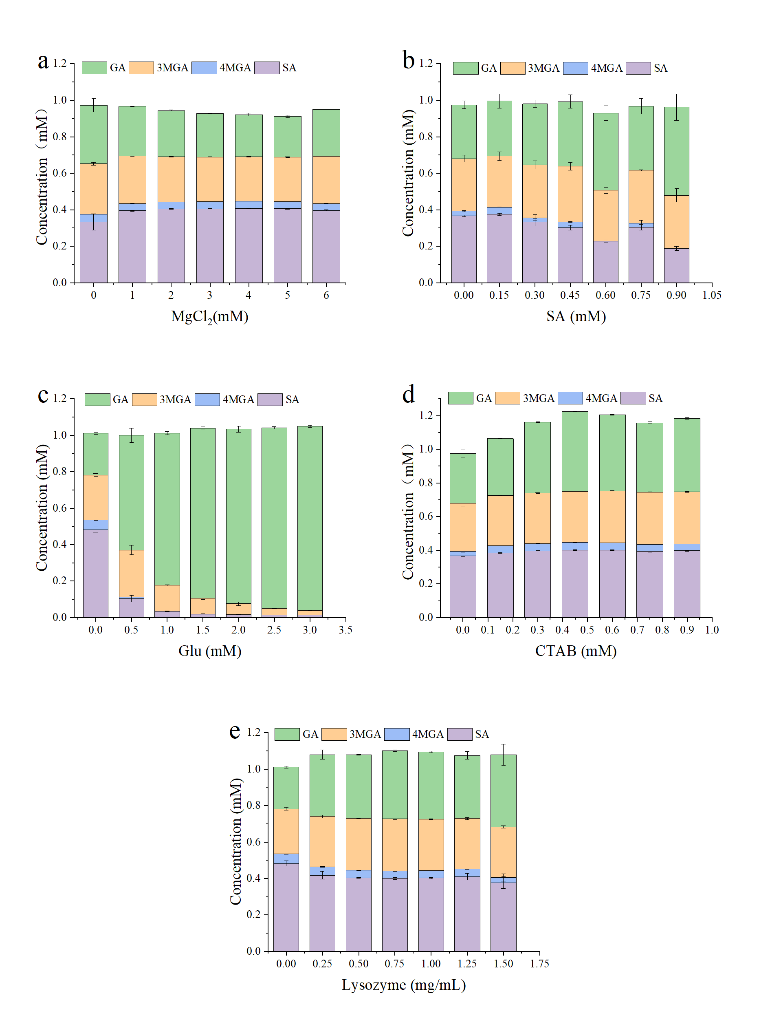
Figure S1 Effect of Mg²⁺(a), syringic acid(b), glucose(c), CTAB(d), and lysozyme(e) on the yields of syringic acid catalyzed by using resting whole cells. The E. coli LX12 was cultivated in shake flasks at 190 rpm and 37°C for 5 h, 0.5 mM IPTG was added to induce gene expression, and subsequent cultivation was conducted at 30°C for 18 hours. Then the cells were collected (OD_{600nm} of 9) and subjected to catalysis with 1.0 mM gallic acid for 8 hours. The error bars represent the standard deviations of the means of three independent measurements. Abbreviations: GA, gallic acid, 3MGA, 3-O-methyl gallic acid, 4MGA, 4-O-methyl gallic acid, SA, syringic acid.

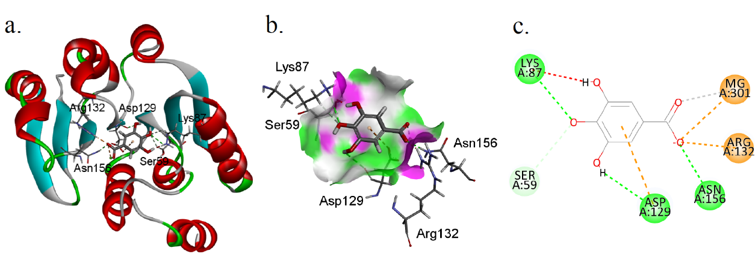
Figure S2. A diagram of the predicted interactions between the protein (DesAOMT) and ligand (GA). (a) Ribbon diagram of the DesAOMT-GA complex. The active amino acid residues and GA are shown in a ball-and-stick molecular structure. (b) H-Bonds surfaces on the active site of DesAOMT. The active amino acid residues and GA are shown in a stick molecular structure. (c) 2D diagram of the interaction between GA and DesAOMT. The colored circular shapes represent amino acid residues or metal ions. The green, yellow, and red dashed lines represent hydrogen bonds, electrostatic interaction, and donor–donor clashes, respectively.

Supplementary Discussion
The overall structure of DesAOMT (PDB: 8C9V) is a dimer formed by two subunits composed of 195 amino acids. The core structure of DesAOMT is a Rossmann fold containing 7 β-sheets and 7 α-helixes. Unlike other reported COMTs, DesAOMT is devoid of the N-terminal α-helix that is implicated in dimerization[3-5]. The interaction between DesAOMT and Gallic acid (GA) was studied using Discovery Studio. Our docking results showed that the carboxyl group of GA interacted with two amino acid residues of DesAOMT, Arg132, which formed electrostatic interactions, and Asn156, which formed conventional hydrogen bonds with a length of 2.12 Å. These two interactions may immobilize the substrate molecule. The para hydroxyl group of GA interacted with two amino acid residues, Lys87 formed a strong hydrogen bond with a length of 2.83 Å, and Ser59 formed a weak intermolecular hydrogen bond with a length of 2.96 Å. The ortho hydroxyl group of GA and the amino acid residue Asp129 formed a strong hydrogen bond with a length of 2.90 Å. In addition, Asp129 had a weak interaction force with the aromatic ring and may contribute to the fixation of substrate molecules. These docking results suggested that Lys87, Asp129, and Asn156 may contribute more to the catalytic activity of the enzyme. The surrounding hydrophobic amino acids further stabilized the DesAOMT-GA complex and improved its catalytic activity and thermostability.

References
1. Jiang Y, Chen B, Duan C, Sun B, Yang J, Yang S. Multigene editing in the Escherichia coli genome via the CRISPR-Cas9 system. Appl Environ Microbiol. 2015;81:2506-14.
2. Amann E, Ochs B, Abel KJ. Tightly regulated tac promoter vectors useful for the expression of unfused and fused proteins in Escherichia coli. Gene. 1988;69:301-15.
3. Lee SH, Kim B, Kim K-J. Crystal structure and regiospecificity of catechol O-methyltransferase from Niastella koreensis. J Agric Food Chem. 2021;69:2531-8.
4. Kopycki JG, Stubbs MT, Brandt W, Hagemann M, Porzel A, Schmidt J, et al. Functional and structural characterization of a cation-dependent O-methyltransferase from the cyanobacterium Synechocystis sp strain PCC 6803. J Biol Chem. 2008;283:20888-96.
5. Lee S, Kang J, Kim J. Structural and biochemical characterization of Rv0187, an O-methyltransferase from Mycobacterium tuberculosis. Sci Rep. 2019;9:8059.

