SUPPLEMENTARY INFORMATION
Enhanced 1´, 4´-trans-diol ABA production by metabolically engineered B.cinerea ZX2
Yifan Wang^{1, 2}, Dan Shu^{1*}, Zhemin Li¹, Di Luo¹, Jie Yang¹, Dongbo Chen¹, Tianfu Li¹, Xiaonan Hou^{1, 2}, Qi Yang^{1, 2} and Hong Tan^{1*}
1. CAS Key Laboratory of Environmental and Applied Microbiology, Environmental Microbiology Key Laboratory of Sichuan Province, Chengdu Institute of Biology, Chinese Academy of Sciences, Chengdu, China
2. University of Chinese Academy of Sciences, Beijing, China

SUPPLEMENTARY TABLES
Table S1. Primers used in PCR
Primer | Sequence | Description
bcaba4-5′F(P1) | TGTGATAGCCCCATTTGTTT | Amplification of the upstream fragment of bcaba4
bcaba4-5′R(P2) | CCCGAATCGGAATGCGGCTCCACACTCCAAACTTCCTTACATCG | Amplification of the upstream fragment of bcaba4
bcaba4-3′F(P3) | CAATAGTAACCATGCATGGTTGCCTAGCTAAAGACTGCCGAAAACT | Amplification of the downstream fragment of bcaba4
bcaba4-3′R(P4) | CCAGCCAGATTCGTCTCAAA | Amplification of the downstream fragment of bcaba4
hph-F(P5) | TGTGGAGCCGCATTCCGAT | Amplification of the resistance gene hph to construct a knockout cassette
hph-R(P6) | TAGGCAACCATGCATGGTTAC
bcaba4-7(P7) | TTTTCCCATTTGGTTTGAGC | Identification of upstream insertion location
bcaba4-8(P8) | TCGTGAATCCGTGACGCTGAAT | Identification of upstream insertion location
bcaba4-9(P9) | CGGCGAAGCAGAAGAATAG | Identification of downstream insertion location
bcaba4-10(P10) | TACGCTCCCACATTATCTTG | Identification of downstream insertion location
bcaba4-11(P11) | ACTTCCTTTGCTGCCGTTCT | Identification of knockout genes
bcba4-F(P12) | GAATTAAAGTAAGATATTCCTGAAAGC | Amplification of the ORF for bcaba4
bcaba4-R(P13) | GGCAGCAATCCACGAGA | Amplification of the ORF for bcaba4
neo-F | TTCTACCCAAGCATCGATATGATTGAACAAGATGGATTGCACG | Amplification of the resistance gene neo to construct pCBg418
neo-R | ACATTATTATGGAGAAATCAGAAGAACTCGTCAAGAAGGCGA
CaMV35S-F | TGACGAGTTCTTCTGATTTCTCCATAATAATGTGTGAGTAGTTCCCAG | Amplification of the terminator to construct pCBg418
CaMV35S-R | CTGAATTAACGCCGAATTGATCTGGATTTTAGTACTGGATTTTGGTTTTAG | Amplification of the terminator to construct pCBg418
pCBh1-AnoliC | GTCAAACACTGATAGTTTAAACTGAAGGCGGGAAACG | Amplification of MCS cassette and promoter of resistance gene neo to construct pCBg418
pCBh1-AntrpC | TCCATCTTGTTCAATCATATCGATGCTTGGGTAGAATAGGT
HMGR-F | AATCGATCCGAATTCGAGCTCATGATTGGAAATACGCTCCTGC | Amplification of bchmgr to construct pCBHR
HMGR-R | TGCCTGCAGGTCGACTCTAGACTATTTCTTTCCCCCTGCAGC | Amplification of bchmgr to construct pCBHR
MK-F | AATCGATCCGAATTCGAGCTCATGCCTGTGCGTGACAGCA | Amplification of bcerg12 to construct pCBMK
MK-R | TGCCTGCAGGTCGACTCTAGACTAATCATCTTCAACCCTCCAAAAC | Amplification of bcerg12 to construct pCBMK
FPPS-F | AATCGATCCGAATTCGAGCTCATGGCGAAGGCTACCACTCTC | Amplification of bcerg20 to construct pCBFS
FPPS-R | TGCCTGCAGGTCGACTCTAGATTACTTGCTTCTCTTGTAAATCTTGCT | Amplification of bcerg20 to construct pCBFS
ABA1-F | AATCGATCCGAATTCGAGCTCATGTCTAATTCTATATTGAACCTAGGCTCC | Amplification of bcaba1 to construct pCBA1
ABA1-R | TGCCTGCAGGTCGACTCTAGACTATTTGTATTCTGTTCCCTCACTTTCA | Amplification of bcaba1 to construct pCBA1
ABA2-F | AATCGATCCGAATTCGAGCTCATGCTGCTTAGCATTAAAGACCTG | Amplification of bcaba2 to construct pCBA2
ABA2-R | TGCCTGCAGGTCGACTCTAGACTATCTAGGAACCTCTTTTAACATGACC | Amplification of bcaba2 to construct pCBA2
ABA3-F | AATCGATCCGAATTCGAGCTCATGCAGCAAGTTATTACTCAAACG | Amplification of bcaba3 to construct pCBA3
ABA3-R | TGCCTGCAGGTCGACTCTAGATCAAACTGGAACCTCAAAATGTG | Amplification of bcaba3 to construct pCBA3
test-F | CCCATTTTTCTTCGGTTCC | Identify clones and sequence plasmids
test-R | TGTATCTGGAAGAGGTAAACCC | Identify clones and sequence plasmids
The underlined sequences indicated the homologous oligonucleotides that facilitate In-Fusion Assembly reactions.

Table S2. List of primers used for the quantitative PCR analysis.
Gene | GenBank  accession number | Primer | Sequence | size(bp) | Slope | Amplification efficiency (%) | (R²)
Actin | XM_024697950.1 | actin-F | GCCCCAATCAACCCAAAGT | 242 | 3.320 | 100.1 | 0.999
 |  | actin-R | TAATCAGTCAAATCACGACCAGC
bcacoaat1 | XM_024693202.1 | acoaat1-F | GCCTACAACAAGAAGGAGCACAT | 174 | 3.289 | 101.4 | 0.998
 |  | acoaat1-R | GCCACCGCTAACTTCCACTG
bcacoaat2 | XM_001559061.2 | acoaat2-F | AGCAGTCTTCCCCCATTCG | 156 | 3.444 | 95.1 | 0.999
 |  | acoaat2-R | GATAGCGTATTCGTCTTGTTGTTCT
bchmgs1 | XM_001552372.2 | hmgs1-F | CCAACCCAACCGCATCAG | 212 | 3.355 | 98.6 | 0.997
 |  | hmgs1-R | CAACAAACCAACCAATCCACC
bchmgs2 | XM_001557521.2 | hmgs2-F | CAAAGATAAGACGCTGGAGAAGAC | 212 | 3.413 | 96.3 | 0.993
 |  | hmgs2-R | TAGCAATGCCACTTCCAAAACT
bchmgr | XM_001559909.2 | hmgr-F | GGTCAAGGGTAGCAGCATCC | 115 | 3.301 | 100.8 | 0.996
 |  | hmgr-R | TTGAATACTGCTGTTGCCGC
bcerg12 | XM_024692977.1 | erg12-F | GCATACACGGAAACCCATCTG | 185 | 3.472 | 94.1 | 0.991
 |  | erg12-R | CAAATCCACTTTAGCAACCTCG
bcerg8 | XM_001553881.2 | erg8-F | GGTCTTCTTAGCAGGAGGGTATCT | 209 | 3.24 | 103.5 | 0.997
 |  | erg8-R | CTTCAATACCCCCATCATCCTTA
bcmvd1 | XM_001546637.2 | mvd1-F | TCGCTTCTCCTCAATGGCTC | 189 | 3.275 | 102 | 0.996
 |  | mvd1-R | AGCGGATGAAGCGAGACCT
bcidi | XM_024696269.1 | idi1-F | AATGACGGAAAATGGGGAGAG | 122 | 3.37 | 98 | 0.993
 |  | idi1-R | TTGAGTCCGTCGGCAGAAA
bcerg20 | XM_001558226.2 | erg20-F | TGTTCCCGACTCAGTATCTCTCC | 211 | 3.263 | 102.5 | 0.998
 |  | erg20-R | GAGGAAAGCGTCGTTGATAGC
bcaba1 | XM_024694601.1 | aba1-F | GTTCCTCTTTTCTCCCCCCTT | 193 | 3.269 | 102.3 | 0.997
 |  | aba1-R | GCCTTCAACTTCGCACTCCT
bcaba2 | XM_024694600.1 | aba2-F | GGCAAAGAACTCGTTGTCGG | 219 | 3.277 | 101.9 | 0.996
 |  | aba2-R | GCGTGGAGGTAAGGCAAATC
bcaba3 | XM_024694602.1 | aba3-F | GCCAGATTCACGATTGCCTC | 204 | 3.273 | 102.1 | 0.999
 |  | aba3-R | ACACTCGCTGTAGGCTTTGATG
bcaba4 | XM_001553919.2 | aba4-F | AGGAAGTTTGGAGAGGTGGAAG | 222 | 3.151 | 107.4 | 0.997
 |  | aba4-R | CGAGCCGTTGTTAGCCATTAC

Table S3. Concentration of antibiotic application
Antibiotic | Working concentration (μg/mL)
G418, Geneticin | 20 | 40 | 80 | 160 | 320
Bleomycin | 20 | 40 | 80 | 160 | 320
Nourseothricin | 20 | 40 | 80 | 160 | 320
Benomyl | 0.05 | 0.1 | 0.2 | 0.4
The above antibiotics were prepared in sterile water.

Table S4. Endogenous overexpression of genes
Gene symbol | Annotation | Length (bp)
HMGR | 3-hydroxy-3-methylglutaryl-coenzyme A reductase(hypothetical protein) | 3642
MK | mevalonate kinases | 1497
FPPS | farnesyl pyrophosphate synthetase | 1044
ABA1 | Cytochrome P450 | 1530
ABA2 | Cytochrome P450 | 1584
ABA3 | Cyclization (PROVISIONAL) | 1323

SUPPLEMENTARY FIGURES
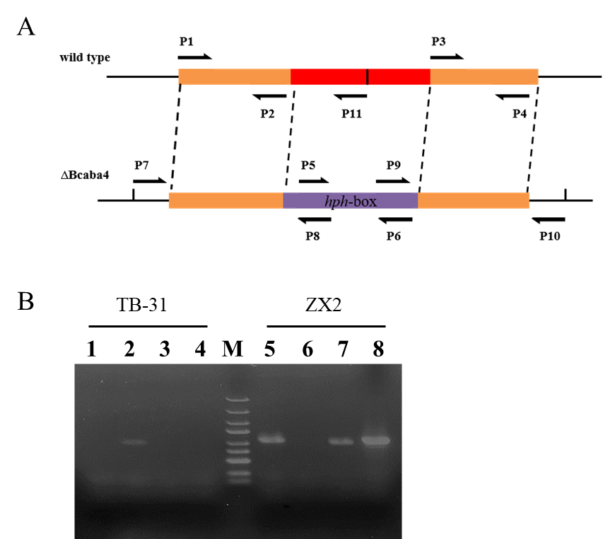
Figure S1. Identification of the mutant ZX2. (A) Schematic representation of the bcaba4 deletion strategy. bcaba4 and Hygromycin phosphotransferase fragment (hph) resistance box are denoted by red and purple. Black arrows indicate the gene-specific primers. (B) Identification of bcaba4 gene knockout in ZX2 strain. M: 5000 bp DNA Marker, Lane1/5: p7/p8 amplified the upstream of bcaba4 and promoter of replacement cassette, Lane2/6: p12/p13 amplified bcaba4 ORF, Lane3/7: p9/p10 amplified the downstream of bcaba4 and terminator of replacement cassette, Lane4/8: p5/p6 amplified hph.
Figure S2. OPLS-DA score chart and permutation test (200 times).
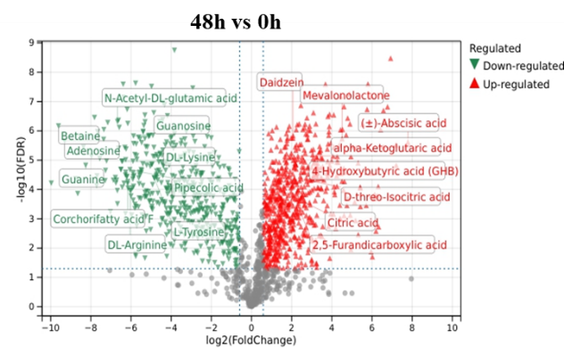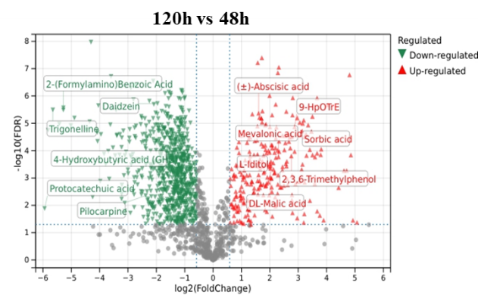
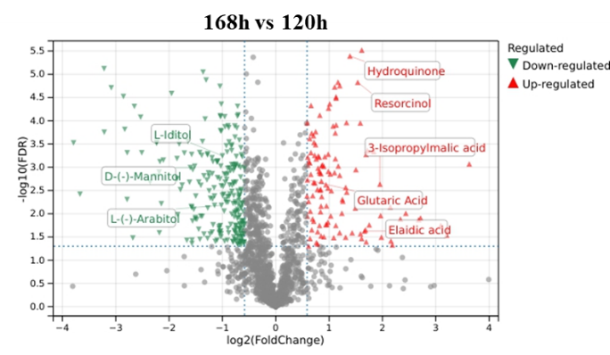
Figure S3. Volcano plot of differential metabolites between different fermentation stages
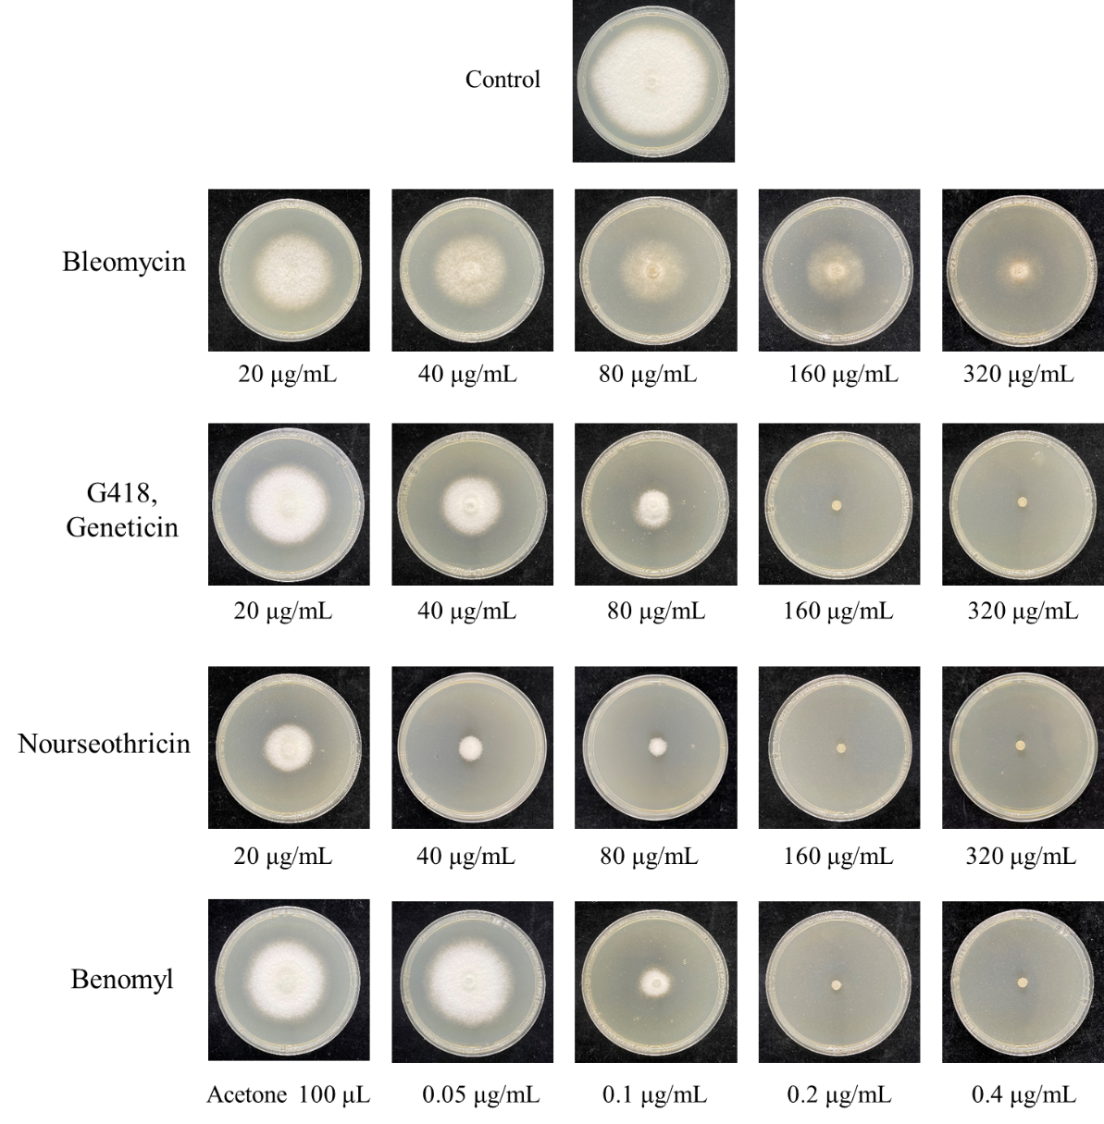
Figure S3. B.cinerea ZX2 antibiotic sensitivity test. All strain were inoculated on potato dextrose agar (PDA) plates in the presence of antibiotic and cultured at 25 ℃ for 5 days.
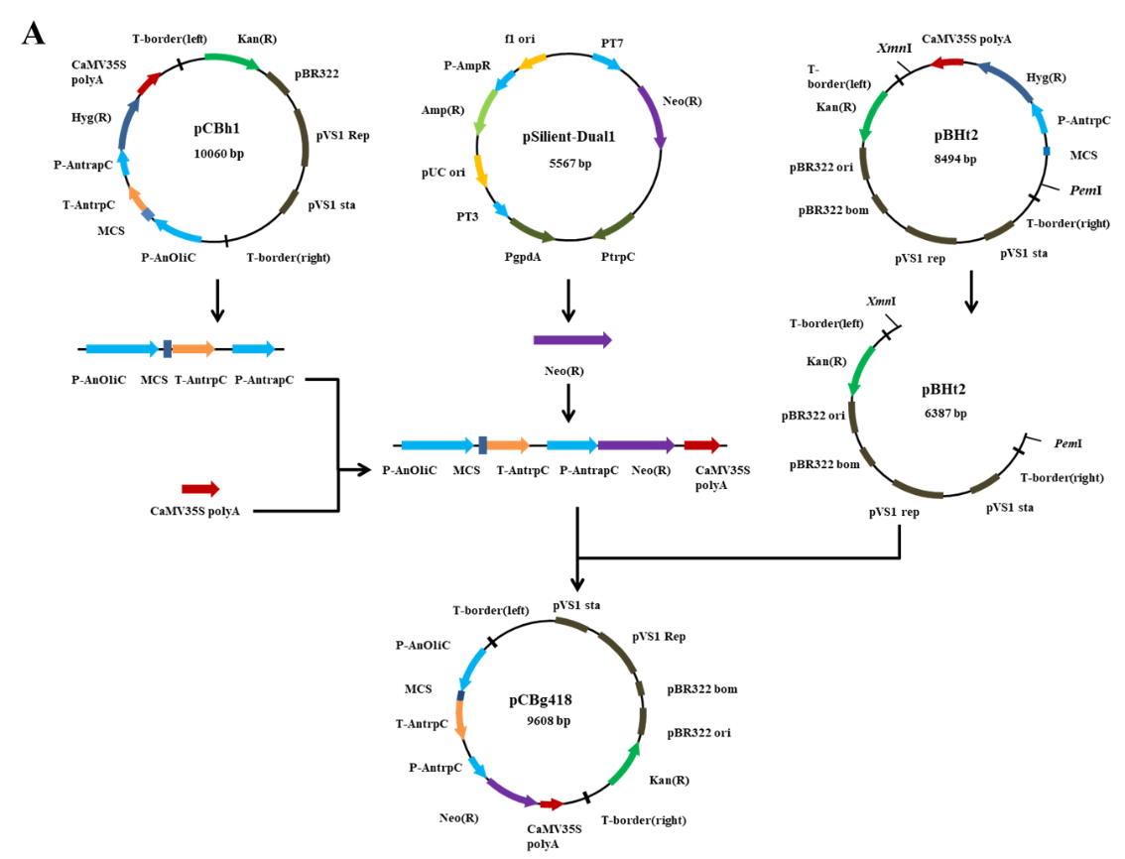
Figure S4. Construction of overexpression vector pCBg418 and overexpression vector with target genes. (A) Schematic build process of the over-expression vector pCBG418. (B) Overexpression vector components. M: 5000 bp DNA Marker, Lane 1-4: MCS expression cassette+AnTrpC promoter (2250 bp), G418 resistance gene (795 bp), CaMV35S polyA signal (211bp), G418 resistance gene+CaMV35S polyA (1006 bp).(C) Overexpression vector backbone. M: 15000 bp DNA Marker, Lane 1-2: pBht2; pBht2 (PmeI and XmnI digests). (D) Overexpressed gene fragment amplified by cDNA. M: 5000 bp DNA Marker, Lane 1-6: bchmgr, bcerg12, bcrrg20, bcaba1, bcaba2 and bcaba3.
The template used for amplifying the cloning site (MCS) cassette and the Aspergillus nidulans trpC promoter was pCBh1, with primer pairs pCBh1-AnoliC and pCBh1-AntrpC. The reverse primer pCBh1-AntrpC used here contains an additional 18 bp oligonucleotide homologous to the resistance gene neo in pSilient-Dual1. The coding domain sequence (CDS) of the resistance gene neo was used as a template for pSilent-Dual, with the forward primer neo-F containing an additional 18 bp oligonucleotide identical to the 18 bp DNA sequence at the 3' end of AntrpC in pBCh1. The reverse primer neo-R also contains an 18 bp oligonucleotide corresponding to the DNA sequence at the 5' end of CaMV35S-polyA in plasmid pCBh1. CaMV35S-polyA was amplified from pCBh1 using primer pair CaMV35S-F/CaMV35S-R. The reverse primer CaMV35S-R contains the same 18bp DNA sequence as that following the XmnI site of pBHt2 (excluding XmnI). The three PCR products described above were ligated by bridging PCR to produce a PCR product that included two expression cassettes: the G418 resistance cassette and the MCS cassette (Fig. S4).

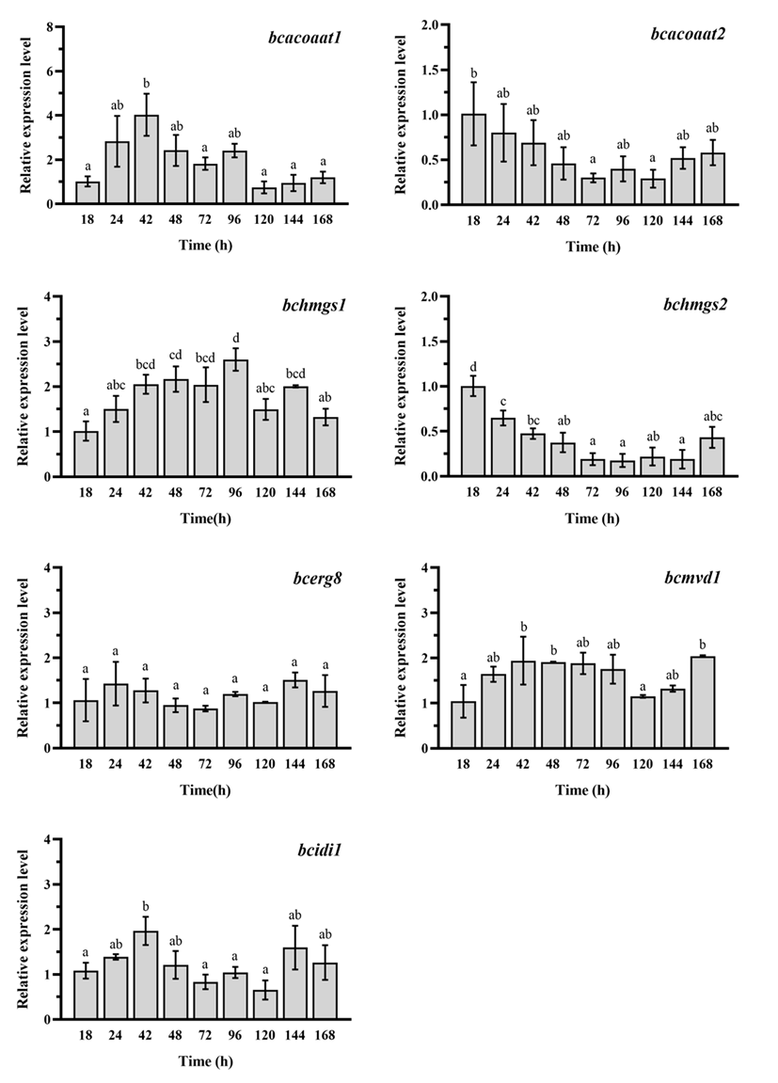
Figure S5. Expression of genes related to 1´,4´-trans-ABA-diol synthesis during 50 L fed-batch fermentation. acoaat1:acetyl-CoA acetyltransferase 1; ACOAAT2: acetyl-CoA acetyltransferase 2; HMGS, hydroxymethylglutaryl-CoA synthase; HMGR: geranylgeranyl pyrophosphate synthase; MK: mevalonate kinase; PMK: phosphomevalonate kinase; PMVADO: diphosphomevalonate decarboxylase; IDI: isopentenyl-diphosphate delta-isomerase; FPPS: farnesyl diphosphate synthase. BcABA1: B. cinerea cytochrome P450; BcABA2, B. cinerea cytochrome P450; BcABA3: B. cinerea α-ionylideneethane synthases.
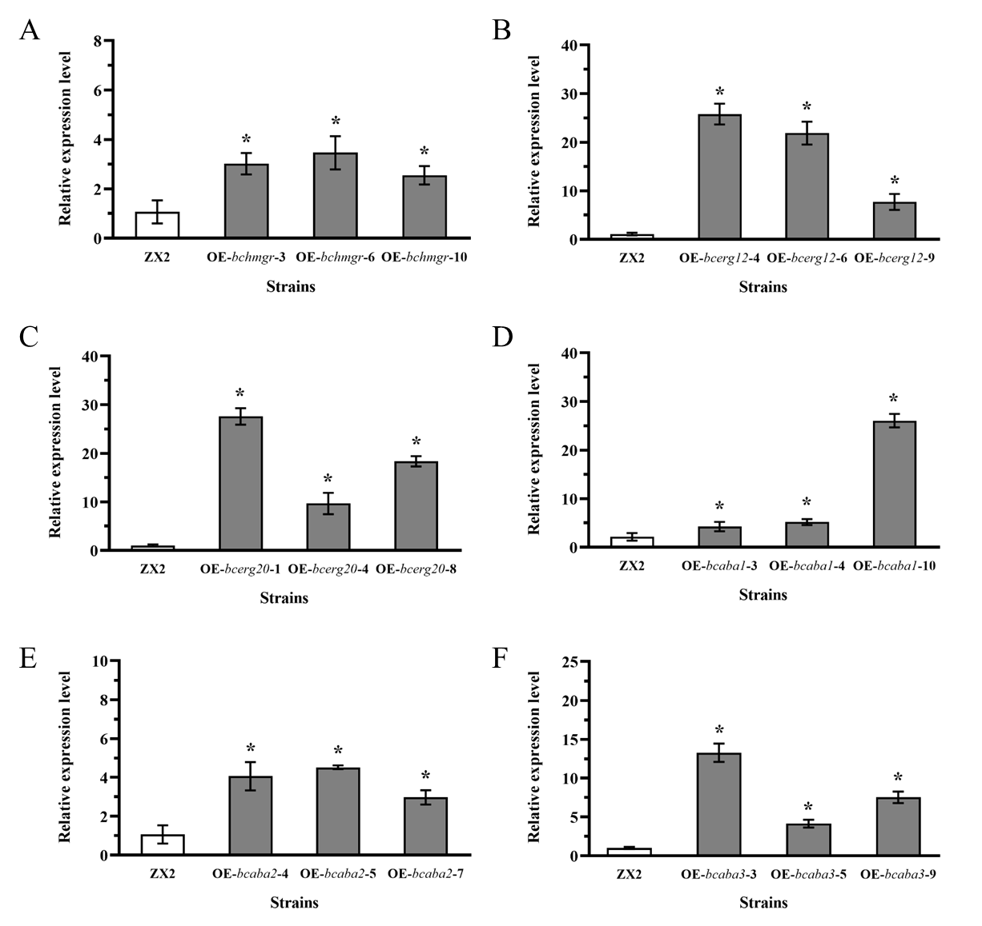
Figure S6. RT-qPCR validation of the relative gene expression of single gene over-expression strains. (A) ZX2 HR strain; (B) ZX2 MK strain; (C) ZX2 FS strain; (D) ZX2 A1 strain; (E) ZX2 A2 strain; (F) ZX2 A3 strain. Three single-gene overexpression mutants were randomly selected from each group and cultured on PDA media at 25°C for 7 days, and RNA was extracted for qRT-PCR analysis.

