Supplementary material
Metabolic engineering of Corynebacterium crenatum for enhanced L-Tyrosine production from mannitol and glucose
Gang Yangª, Sicheng Xiongª, Mingzhu Huangª, Bin Liuª, Yanna Shao^{b}, Xuelan Chen^{a,b*},
ª School of Life Sciences, Jiangxi Normal University, Nanchang 330022, China;
^{b} School of Health, Jiangxi Normal University, Nanchang 330022, China;

*Correspondence to:
Dr. Xuelan Chen
School of Life Science, School of Health, Jiangxi Normal University, Nanchang 330022, China
E-mail: 003793@jxnu.edu.cn; xuelanchen162@163.com

The primer sequences used in this study.
Primers | Sequence (5’-3’)
aroG_{Ec} ^{fbr} upF | gattacgaattcgagctcggtttccttaaaggggttctaaa
aroG_{Ec} ^{fbr} upR | gtaaatcgtcgttctgataattcatacatcgcctttctagtttcagcctg
aroG_{Ec} ^{fbr} midF | caggctgaaactagaaaggcgatgtatgaattatcagaacgacgatttac
aroG_{Ec} ^{fbr} midR | gagttcaaaacaagtgccaatgccattacccgcgacgcgcttttactgca
aroG_{Ec} ^{fbr} downF | tgcagtaaaagcgcgtcgcgggtaatggcattggcacttgttttgaactc
aroG_{Ec} ^{fbr} downR | ttttcccagtcacgacgttgttttattgatggcatacagtgcagct
trpE-TTG upF  trpE-TTG upR  trpE-TTG downF  trpE-TTG downR  trpE-TTG checkF  ΔpheA upF  ΔpheA upR  ΔpheA downF  ΔpheA downR  ΔqsuB upF  ΔqsuB upR  ΔqsuB downF  ΔqsuB downR  ΔqsuD upF  ΔqsuD upR  ΔqsuD downF  ΔqsuD downR  ::aroB upF  ::aroB upR  ::aroB midF  ::aroB midR  ::aroB downF  ::aroB downR  ::aroD upF  ::aroD upR  ::aroD midF  ::aroD midR  ::aroD downF  ::aroD downR  ::aroE upF  ::aroE upR  ::aroE midF  ::aroE midR  ::aroE downF  ::aroE downR  tyrA_{Ec} ^{fbr} upF  tyrA_{Ec} ^{fbr} upR  tyrA_{Ec} ^{fbr} midF  tyrA_{Ec} ^{fbr} midR  tyrA_{Ec} ^{fbr} downF  tyrA_{Ec} ^{fbr} downR  ::ppsA upF  ::ppsA upR  ::ppsA midF  ::ppsA midR  ::ppsA downF  ::ppsA downR  Δpyk upF  Δpyk upR  Δpyk dwonF  Δpyk dwonR  ΔtyrP upF  ΔtyrPupR  ΔtyrP dwonF  ΔtyrP dwonR  ΔaroP upF  ΔaroP upR  ΔaroP dwonF  ΔaroP dwonR  ΔmtlR upF  ΔmtlR upR  ΔmtlR dwonF  ΔmtlR dwonR  ::mtlD upF  ::mtlD upR  ::mtlD midF  ::mtlD midR  ::mtlD downF  ::mtlD downR  ::mtlTD upF  ::mtlTD upR  ::mtlTD midF  ::mtlTD midR  ::mtlTD downF  ::mtlTD downR  ::pfkB upF  ::pfkB downR  Ncgl0824::pfkB upR  Ncgl0824::pfkB midF  Ncgl0824::pfkB midR  Ncgl0824::pfkB downF  eftu::pfkB upR  eftu::pfkB midF  eftu::pfkBmidR  eftu::pfkBdownF  sod::pfkB upR  sod::pfkB midF  sod::pfkBmidR  sod::pfkBdownF | gattacgaattcgagctcggtgtatggctgcgcatactgttgcgat  aatacctcacaaggggcacctaccgaggaaatcattgtgg  ttgtgaggtattccccatgttttctccctagatgtccgct  ttttcccagtcacgacgttgtatttccgcgaggacgaactggtaat  ccacaatgatttcctcggtaggtgccccttgtgaggtatt  gattacgaattcgagctcggtcaccggacgaaccgccgggcgtgtg  agcaaaataatccggccggccatggggttacacagcttaacccgccgaac  gttcggcgggttaagctgtgtaaccccatggccggccggattattttgct  ttttcccagtcacgacgttgtccgccgggaagaccagcggcaggat  gattacgaattcgagctcggtccagtgttcatcatgggtgccattg  ttgttgggggggctagttcgggatggtggtcaaagagtccttttctttgg  ccaaagaaaaggactctttgaccaccatcccgaactagcccccccaacaa  ttttcccagtcacgacgttgtgctttctacttttggagatttgcca  gattacgaattcgagctcggtaacgttgccgtccaaaatag  tccaaaagtagaaagcccaaaaaataagagtcagtaaaacctcgacgctt  aagcgtcgaggttttactgactcttattttttgggctttctacttttgga  ttttcccagtcacgacgttgtagcatcccgaactagccccc  gattacgaattcgagctcggtaacactgaactcgtcgactccgacg  cacaaacccggaataatcggcagctggggcacgttgcctttcgcttgtaa  ttacaagcgaaaggcaacgtgccccagctgccgattattccgggtttgtg  tgttgaaaatctgcgctgcgctcatgggtaaaaatcctttcgtaggtttc  gaaacctacgaaaggatttttacccatgagcgcagcgcagattttcaaca  ttttcccagtcacgacgttgtactgcgtcaggctcgtggaacgcgc  gattacgaattcgagctcggttttggtgcgcaatcaggtgatgcgt  cacaaacccggaataatcggcagcttttaggttccttttctaattgttgt  acaacaattagaaaaggaacctaaaagctgccgattattccgggtttgtg  tgaggaggagaatttttccaagcatgggtaaaaatcctttcgtaggtttc  gaaacctacgaaaggatttttacccatgcttggaaaaattctcctcctca  ttttcccagtcacgacgttgttaggtcgaggccctggccgattagg  gattacgaattcgagctcggtcgatctgatcactcgttcag  ttttcaaactaccagctaccctgtgttttattcgttgatccttatcggtt  aaccgataaggatcaacgaataaaacacagggtagctggtagtttgaaaa  cccggtgagtgatgtgagaacccaatgtatgtcctcctggacttcgtggt  accacgaagtccaggaggacatacattgggttctcacatcactcaccggg  ttttcccagtcacgacgttgtagcgtttgcagttcggcggt  gattacgaattcgagctcggtctacaaaacccaaaaaagcg  gcggtcaattcagcaaccattccagccgggtgggtagtac  gtactacccacccggctggaatggttgctgaattgaccgc  tgtgaaagagtgtttaaagtagttttactggcgattgtcattcgcctgac  gtcaggcgaatgacaatcgccagtaaaactactttaaacactctttcaca  ttttcccagtcacgacgttgttggcaaggttgcttccgcagctgac  gattacgaattcgagctcggtggtcttgcggtactccggctcgatc  cacaaacccggaataatcggcagctggtgtctccttatttaataaagcgt  acgctttattaaataaggagacaccagctgccgattattccgggtttgtg  acgggatgttcaaactgttggtcatgggtaaaaatcctttcgtaggtttc  gaaacctacgaaaggatttttacccatgaccaacagtttgaacatcccgt  ttttcccagtcacgacgttgtcgggtaaatcttcggcagtggccga  gattacgaattcgagctcggttcaacaccatcgtctccgcagtagt  cgcattttttgaaagatttaagcgaaagcctagtacgtcattctccctca  tgagggagaatgacgtactaggctttcgcttaaatctttcaaaaaatgcg  ttttcccagtcacgacgttgtgacgaggatctaccgcaggaagatc  gattacgaattcgagctcggtgggccggtgatttctgcc  gcagccacaacatgaagtgagttttttccttcggattatt  aataatccgaaggaaaaaactcacttcatgttgtggctgc  ttttcccagtcacgacgttgttatccgcgccaccgcgagtc  gattacgaattcgagctcggtctccggcaccttgggtgccgcaaag  gtccagaataatttctatcggcctagtatcaaccgtaaacccacatggca  tgccatgtgggtttacggttgatactaggccgatagaaattattctggac  ttttcccagtcacgacgttgtaaccgtaacttggcctcggcgtgac  gattacgaattcgagctcggtaaagccttgcaggattgggtggaac  aacatttccgtggtaactttttcacgtcagcgcagttgaatgagctgtcg  cgacagctcattcaactgcgctgacgtgaaaaagttaccacggaaatgtt  ttttcccagtcacgacgttgtgttccagaatgttggtttcgacacc  gattacgaattcgagctcggttgggcacgaactgtgttctg  tccgtattagtggcacagttggtggaaaagatcctttcaa  ttgaaaggatcttttccaccaactgtgccactaatacgga  agctggagtggggtgttcatcaatttcgcctgcttccgat  atcggaagcaggcgaaattgatgaacaccccactccagct  ttttcccagtcacgacgttgtaaacaatgcggatggagtcc  gattacgaattcgagctcggttgatggcgttagattgttgt  atccgtattagtggcacagttgtgttcacctttgttttaa  ttaaaacaaaggtgaacacaactgtgccactaatacggat  ccgctttgctgtactgacatcaatttcgcctgcttccgat  atcggaagcaggcgaaattgatgtcagtacagcaaagcgg  ttttcccagtcacgacgttgtgtggcaaccagcgcacccaa  gattacgaattcgagctcggtctagcacgcagcattttcct  ttttcccagtcacgacgttgtgtatcgacagccacgcgaa  tccgtattagtggcacagttggggttaccacctgaaagtt  aactttcaggtggtaaccccaactgtgccactaatacgga  ggggtgaatgtgatgatcatcaatttcgcctgcttccgat  atcggaagcaggcgaaattgatgatcatcacattcacccc  aaactaccagctaccctgtgggggttaccacctgaaagtt  aactttcaggtggtaacccccacagggtagctggtagttt  ggggtgaatgtgatgatcattgtatgtcctcctggacttc  gaagtccaggaggacatacaatgatcatcacattcacccc  cacaaacccggaataatcggcagctggggttaccacctgaaagttgtggt  accacaactttcaggtggtaaccccagctgccgattattccgggtttgtg  ggtttggggtgaatgtgatgatcatgggtaaaaatcctttcgtaggtttc  gaaacctacgaaaggatttttacccatgatcatcacattcaccccaaacc

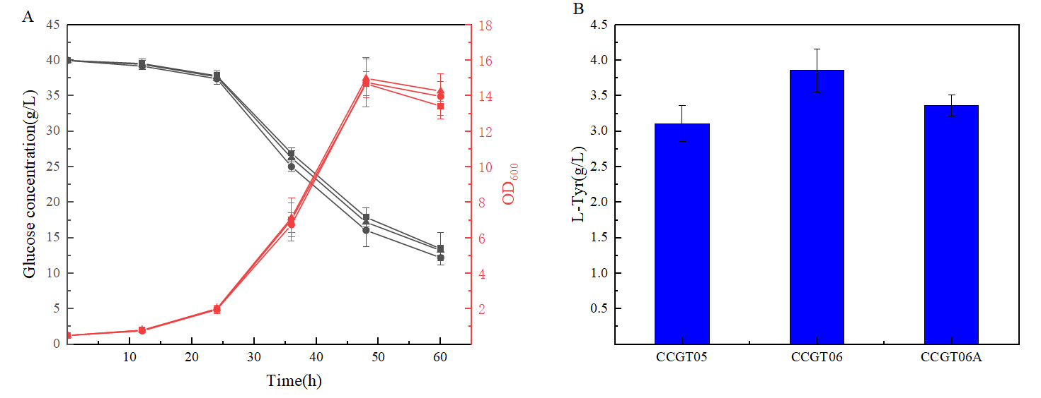
Fig. S2 Effect of wild-type tyrA and tyrA mutant on fermentation. A) Cell growth and glucose concentration curves of different strains. represents CCGT05, ○ represents CCGT06, and Δ represents CCGT6A. B) l-Tyr production of different strains.

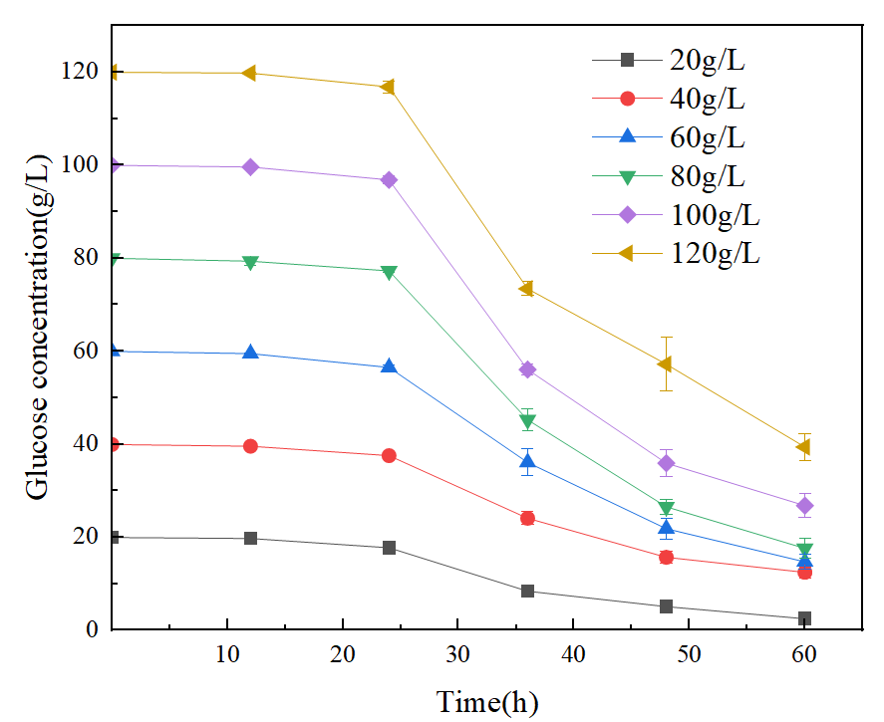
Fig.S2 Glucose consumption curves of CCGT10 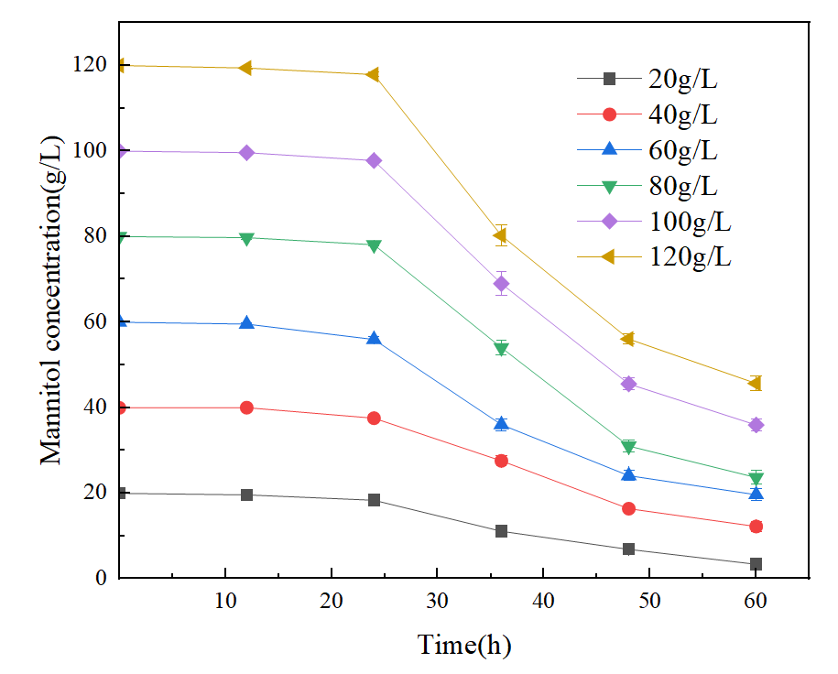
Fig.S3 Mannitol consumption curves of CCMT04 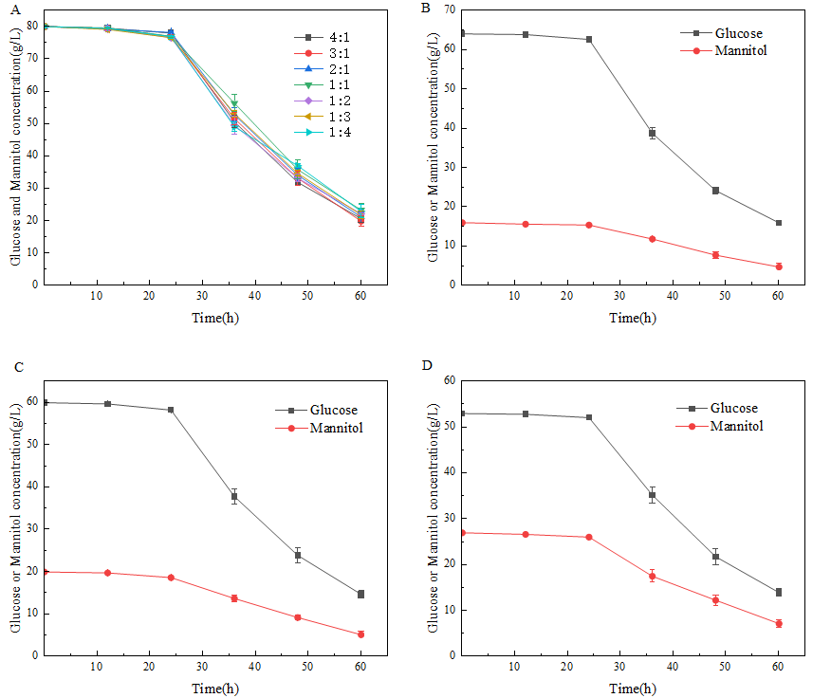
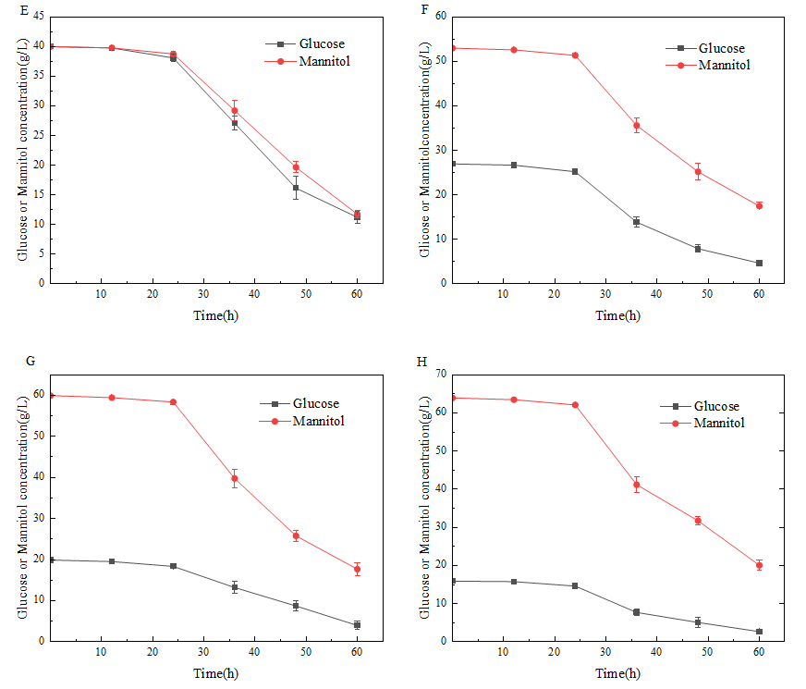
Fig. S4 Consumption curves of different ratio glucose to mannitol of CCMT04
A) Total carbon source consumption curves of different ratio glucose to mannitol of CCMT04;
B) Consumption curves of glucose to mannitol ratio of 4:1 of CCMT04;
C) Consumption curves of glucose to mannitol ratio of 3:1 of CCMT04;
D) Consumption curves of glucose to mannitol ratio of 2:1 of CCMT04;
E) Consumption curves of glucose to mannitol ratio of 1:1 of CCMT04;
F) Consumption curves of glucose to mannitol ratio of 1:2 of CCMT04;
G) Consumption curves of glucose to mannitol ratio of 1:3of CCMT04;
H) Consumption curves of glucose to mannitol ratio of 1:4 of CCMT04.

