2-O-α-D-glucosyl glycerol production by whole-cell biocatalyst of lactobacilli encapsulating sucrose phosphorylase with improved glycerol affinity and conversion rate
Yue Cui, Zhenxiang Xu, Yanying Yue, Wentao Kong, Jian Kong*, Tingting Guo*
State Key Laboratory of Microbial Technology, Shandong University, No. 72 Binhai Road, Qingdao 266237, P. R. China
Running title: 2-αGG production by whole-cell biocatalyst
*Corresponding author: Jian Kong, kongjian@sdu.edu.cn; Tingting Guo, guotingting@sdu.edu.cn.
Mailing address: No. 72 Binhai Road, Qingdao 266237, P. R. China
Tel: +86 532 58632433; +86 532 58632442

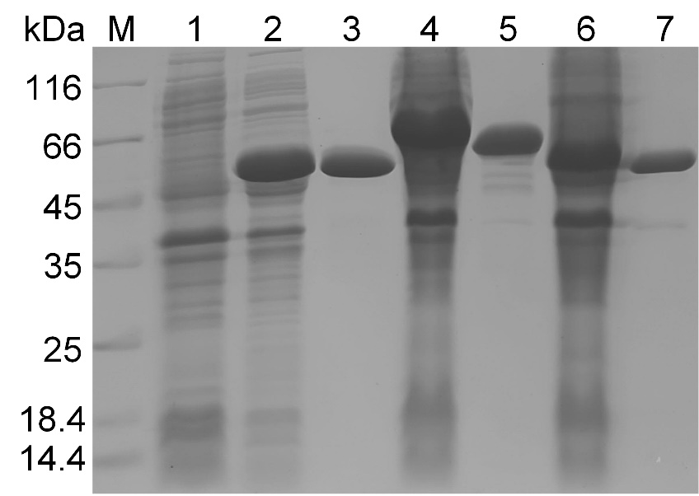
Fig. S1 SDS-PAGE analysis of the three SPases expressed in E. coli. Lane 1, 2, 4 and 6 are the intracellular proteins of E. coli BL21(DE3) (control), E. coli/pLrSP, E. coli/pBlSP and E. coli/pLaSP; lane 3, 5 and 7 are the purified LrSP, BlSP and LaSP protein. LrSP, BlSP and LaSP, SPases from Lb. reuteri SDMCC050455, B. longum SDMCC050402 and Lb. acidophilus SDMCC050288.

Fig. S2 Recombinant expression of the LrSP in Lb. paracasei BL-SP. (A) SDS-PAGE analysis of the intracellular proteins of Lb. paracasei BL23 and Lb. paracasei BL-SP after induction by nisin of different concentrations for 8 h. Lane 1, the intracellular proteins of Lb. paracasei BL23 (control); lane 2, 3, 4, 5, 6 and 7, the intracellular proteins of Lb. paracasei BL-SP induced by nisin of 2, 4, 6, 8, 10 and 12 ng/mL, respectively. (B) Relative transglucosylation activities of the whole-cells of Lb. paracasei BL-SP obtained after induction by nisin of 2, 4, 6, 8, 10 and 12 ng/mL, respectively.

Fig. S3 The relative phosphorylation activities between 5 μg of the LrSP in the reaction system and the whole-cells of Lb. paracasei BL-SP of different OD₆₀₀ in the reaction system.

