Trichoderma virens XZ11-1 producing siderophores inhibits the infection of Fusarium oxysporum and promotes plant growth in banana plants

HaiYang Cui^{1,2*}, Qifeng Cheng^{1,2*}, Tao Jing^{1,2}, Yufeng Chen^{1,2}, XiaoJuan Li^{1,2}, Miaoyi Zhang^{1,2}, Dengfeng Qi^{1,2}, Junting Feng^{1,2}, Farinaz Vafadar³, Yongzan Wei^{1,2}, Kai Li^{1,2}, Yankun Zhao^{1,2}, Dengbo Zhou^{1,2*}, Jianghui Xie^{1,2*}

¹School of Life and Health Sciences & College of Tropical Crops, Hainan University； Institute of Tropical Bioscience and Biotechnology, Chinese Academy of Tropical Agricultural Sciences, 571101, Haikou, China
²National Key Laboratory of Biological Breeding of Tropical Crops, Chinese Academy of Tropical Agricultural Sciences, 572024, Sanya, China
³Department of Agronomy and Plant Breeding, College of Agriculture, Isfahan University of Technology, Isfahan, 84156-83111, Iran

HaiYang Cui and Qifeng Cheng contribute equally to this work
*Correspondence Authors
Dr..Dengbo Zhou, E-mail: zhoudengbo@itbb.org.cn . Tel:(+86) 0898-66986419.
Dr. Jianghui Xie, E-mail: xiejianghui@itbb.org.cn . Tel:(+86) 0898-66986419.

Fig. S1 Isolation and morphological characterization of strain XZ11-1. (A) 40 fungal strains were isolated from the Pluteus pantherinus Uchida. (B) Growth status of strain XZ11-1 on PDA plates. (C) Hydroxamate-type siderophore. The change of the solution from colorless to red indicates the presence of Hydroxamate-type siderophore.

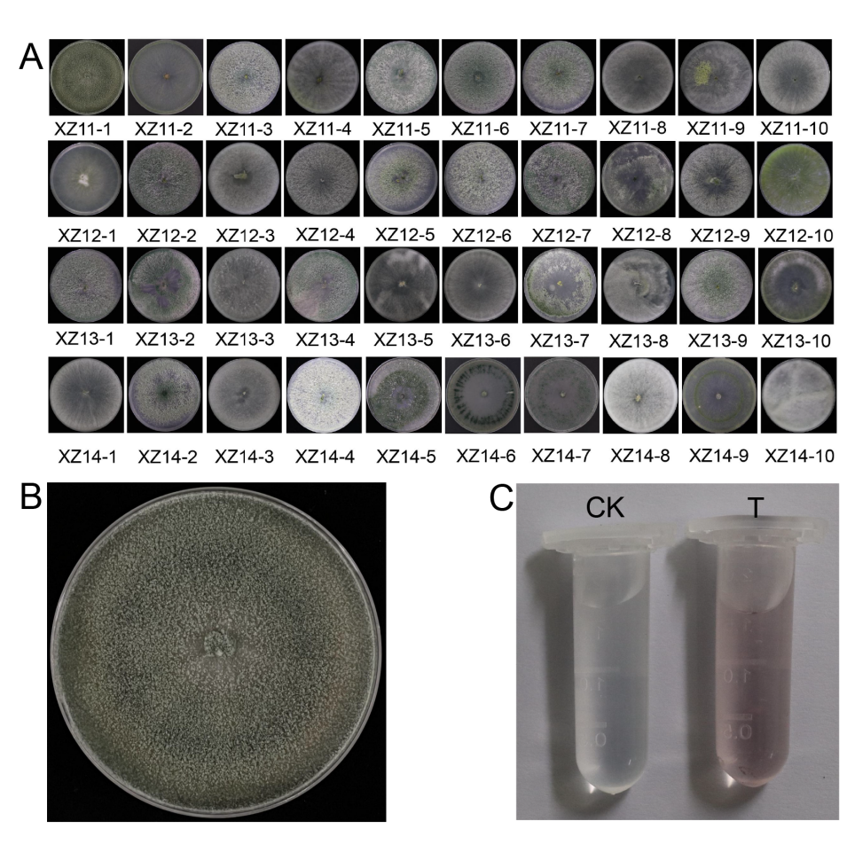

Fig. S2 Direct promoting properties of strain XZ11-1. (A) Nitrogen fixation, phosphorus solubilization, and potassium release status of strain XZ11-1. (B) Determination of the ability of strain XZ11-1 to produce IAA.

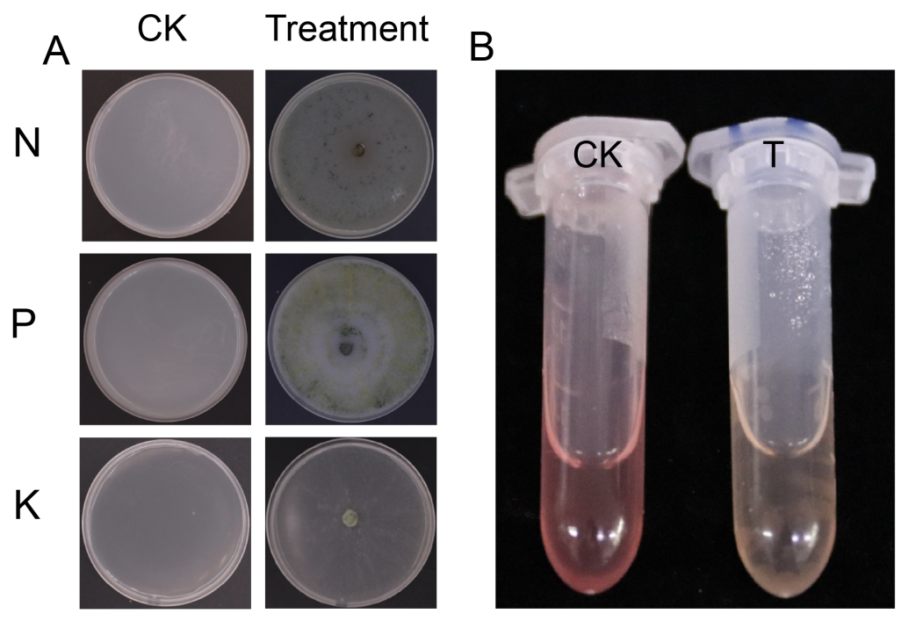

Fig. S3 Growth of Trichoderma viride XZ11-1 on the Columbia Blood Agar medium (CBA, Beijing Solarbio Biological Technology Co., Ltd.).
.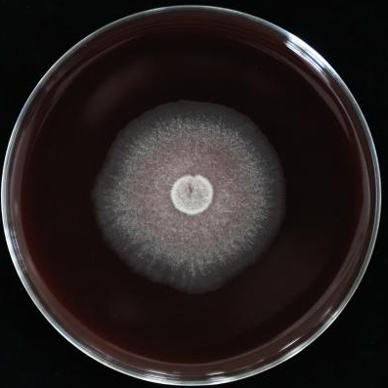

Supplementary Table 1. Determination of physiological and biochemical properties of Trichoderma viride XZ11-1
Carbon source utilization | Result | Nitrogen source utilization | Result
Sanitol | ++ | Glycine | ++
L-Arabinose | +++ | Methionine | -
Sorbitol | ++ | Ammonium sulfate | +
Yeast extract | ++ | Histidine | +
D-Mannose | +++ | Casein | ++
D-Trehalose | +++ | Cysteine | -
D-Galactose | ++ | L-Arginine | +
D-Fructose | +++ | L-Valine | -
Saccharose | +++ | Nitrate | ++
Dextrin | +++ | L-Asparagine | ++
Xylan | ++ | L-tyrosine | -
D-Melezitose | ++ | Glutamic acid | ++
D-Mannitol | ++ | Tyrosine | +
Glucose | +++ | L-Hydroxyproline | -
D-Ribose | + | DL-Methionine | -
Maltose | +++ | Carbamide | +++
Mannitol | ++ | Phenylalanine | +
L-Rhamnose | + | Anhydrous inositol | -
Raffinose | + | Tryptophan | ++

Supplementary Table 2. The strain XZ11-1's tolerance to pH and sodium chloride (NaCl).
pH | Result | NaCl | Result
4 | +++ | 1% | ++
5 | +++ | 3% | +
6 | ++ | 5% | -
7 | ++ | 7% | -
8 | + | 8% | -
9 | + | 9% | -
10 | - | 10% | -

Supplementary Table 3. Results of the genome sequencing and assembly of strain XZ11-1.

Scaffold Length （bp) | Scaffold Number | Scaffold N50 (bp) | Scaffold N90 (bp) | Contig Length (bp) | Contig Number | Contig N50 (bp) | Contig N90 (bp) | GC content (%) | Gaps Number
39,984,956 | 272 | 1,193,018 | 219,412 | 39,948,532 | 1,050 | 125,125 | 28,227 | 48,42 | 778

Supplementary Table 4. GO, KEGG and KOG annotated data.
Database | Number | 100<=length<300 | length>=300
GO_Annotation | 8,316 | 1,937 | 6,247
KEGG_Annotation | 3,326 | 813 | 2,455
KOG_Annotation | 5,903 | 1,180 | 4,666

