Supplementary files for

A single-plasmid-based, easily curable CRISPR/Cas9 system for rapid, iterative genome editing in Pseudomonas putida KT2440

Qifeng Wen ^{1, 2}, JinJin Chen ³, Jin Li ³, Ida Putu Wiweka Dharmasiddhi ³, Maohua Yang ^{1,} *, Jianmin Xing ^{1, 2,} *, and Yilan Liu ^{3,} *

¹ State Key Laboratory of Petroleum Molecular & Process Engineering, Institute of Process Engineering, Chinese Academy of Sciences, Beijing, China
² College of Chemical Engineering, University of Chinese Academy of Sciences, Beijing, China
³ Department of Chemical Engineering, University of Waterloo, Waterloo, Canada

* Corresponding authors:
Maohua Yang, Email: mhyang@ipe.ac.cn
Jianmin Xing, Email: jmxing@ipe.ac.cn
Yilan Liu, Email: yilan.liu@uwaterloo.ca

The file includes:
Supplementary Table S1-S2
Supplementary Figures S1-S6

Table S1 Primers used in this experiment.
Primers | Sequences
IR9s6 | aaccaatacgtgaacaagcagaa
IR9s7 | AAACGGAGGAATGGGAACG
tGyqhdF2 | TGGCGAATCTGCGTCTGC
tGyqhdR2 | GAGTGTCCGGGTCTGTTGTATG
tppyqhdF | TGCCTAGCAACAACCCTCG
tppyqhdR | AGCATCAGCGGACCGATTT
t2287F | GGTCTACACGACGCAGGTCG
t2287R2 | CACGCAACATGGCCAGCAGC
tGrbsfabHF | CCAAAAAATTTTTAAATAAGGAGGCTG
tGrbsfabHR2 | GGATGCAGAAGGCGTCGATATC
tGyqhdR3 | CGCCGCAACAGGCTTGCCGGCG
vdhsRNAF | ctagtAACCTTCGAGCGCTGTAACCgttttagagctagaaatagcaagttaaaataag
vdhgRNAR | GTTGATTTCCGACAGGCCGAAGGTCGgcttctgcagCATTATACG
vdhupF | CGACCTTCGGCCTGTCGGAAATCAACTGGGGCATCCCGCCTGGTAAC
vdhupR | GGCCTGCCGCGGCTACATGCTCATTCCTCTTGTTGTCGTTATAG
vdhdownF | CAAGAGGAATGAGCATGTAGCCGCGGCAGGCCCAGACCTCCGGC
vdhdownR | CCAGACTATACTAGACTGCAGACACCGGGCAATAGGCAATACCGGC
GvdhF | CTCGACGACAAGAGCATCAAG
GvdhR2 | GAACGGCTGGCTGTCGCTGA
pCas9vdhF | GTGTCTGCAGTCTAGTATAGTCTGGAACAGCGCACTTACGGGTTGCTGCG
pCas9vdhR | cGGTTACAGCGCTCGAAGGTTactagtattatacctaggactgagctagctg
vanABsRNAF | ctagtGTGAGTGATGAGTGGGCCTAgttttagagctagaaatagcaagttaaaataag
vanABsRNAR | GATCGACGACGTTCCGCTCGATGGACGTgcttctgcagCATTATAC
vanABupF | gaagcACGTCCATCGAGCGGAACGTCGTCGATCAGAATACGGCC
vanABupR | GTCGTAAGACGGGTCACATGGGAGGCTCTCCGGGTTTTG
vanABdownF | GAGCCTCCCATGTGACCCGTCTTACGACGAGGGCAGGATGAC
vanABdownR | CCAGACTATACTAGACTGCAGCGGGTGCGGTCGAGGTGCGCGGTGTGC
pCas9vanABF | GCTGCAGTCTAGTATAGTCTGGAACAGCGCACTTACGGGTTGCTG
pCas9vanABR | TAGGCCCACTCATCACTCACactagtattatacctaggactgagctagctgtcaaG
GvanABF | CATTGACCTACCACGCCGAC
tGrbsfabHF | CCAAAAAATTTTTAAATAAGGAGGCTG
DHA150F | ctctagagtcgacctgcagaagcTGCCTAGCAACAACCCTCGACATCG
DHA150R | CCAGACTATACTAGACTGCAGTACGCCGTTTGCGAGTTGGCGGGTAG
DHA300F | ctctagagtcgacctgcagaagcTGCATCAGTCGATGCGCTGCCAATG
DHA300R | CAGACTATACTAGACTGCAGGGCGCGGGTGCTGTAGTCCGCAGAC
yqhDup900F | tctagagtcgacctgcagaagcCATTCGAGGACAGCGAGGAGGATG
yqhD900downR | GTTCCAGACTATACTAGACTGCAGAGCTCTTCGAGCCAGAAACCGGTC
yqhD1200upF | tctagagtcgacctgcagaagcGCTTCGTGTTCCGCACCACGGGC
yqhD1200downR | GTTCCAGACTATACTAGACTGCAGTTGCCGGCGGCGATGGAGCGCTCA
speIevfgRNA2F | CTAGactagtCAGCGACTGACGATGGCCAAgttttagagctagaaatagc
evfSgRNAsalIR | ACGCgtcgactctagagaattc
evfupF | ctctagagtcgacctgcagaagcACCGCACGCGCACGGCCAGCGCGCG
evfupR | GCACAGCCCGGCCGCACTCACATGGTTCTGCACTCTTGTTGTTCGAGG
evfdownF | AGTGCAGAACCATGTGAGTGCGGCCGGGCTGTGCACCGTC
evfdownR | CAGACTATACTAGACTGCAGGATCATGTCCACGCCGGCAGCCGGGTCG
evf150upF | attctctagagtcgacctgcagaagcTCCTTATGCGATTCGGCTAGAGAG
evf150downR | GTTCCAGACTATACTAGACTGCAGCTGCACGTGCCAGCACCGCGCG
evf1200upF | ctctagagtcgacctgcagaagcCAGGCTGAAAGGGTTGCCAGTG
evf1200downR | CAGACTATACTAGACTGCAGCTTGGCCACCGCCGATGCATGCCG
evfup300F | ctctagagtcgacctgcagaagcGCGCGCGTCGCAAGGCGTAGCCGATC
evfdown300R | CCAGACTATACTAGACTGCAGCCGTGCCACAGATGCGCTGCACCGCC
evf900upF | ctctagagtcgacctgcagaagcATCAGGAAACTGATGGCGGCACG
evf900downR | CAGACTATACTAGACTGCAGGCACGCCAACAGCCGTGGCCATCAG
GevfF | GCAGCGCGCCTAACCCCAGG
GevFR3 | GAGGTCGACGTCGGCATATG
dCatBC-F | cactggctgacacgaatgct
dCatBC-R | caggcaaaatcacagtgacataac
endAupF | ctctagagtcgacctgcagaagcCGCAGCACGGGGGTTGAGCATTAC
endAupR | CCTTTGAAACGGTCACATGGGGAAAACATATTTCAGGTTG
endAdownF | TATGTTTTCCCCATGTGACCGTTTCAAAGGCTGCGCGGCCCCTG
endA downR | CAGACTATACTAGACTGCAGTGCGCGTGCTGTATCACAGCCAGCG
endASgRNASpeIF | CTAGactagtCGCATCGACGCTGCCTCGTGgttttagagctagaaatagc
GendAF | CATGCTCGACTCAGCCACATTC
GendAR | GGCAGTGATGTGCATGGCAAG
endXSgRNAspeIF | CTAGactagtCCTCGCCTTGAAGTCGACCTgttttagagctagaaatagc
endXupF | ctctagagtcgacctgcagaagcAAAGAGCTGCAGCGGATCTTCTG
endX upR | CTGGCCTGAGGATCACATGCGCAGTCAATCTTCCTTCGGT
endXdownF | GATTGACTGCGCATGTGATCCTCAGGCCAGCGTTTGTAAGTAGGC
endXdownR | CAGACTATACTAGACTGCAGTGTGTCAGGCGCCGTTCACACAAG
GendXF | GTACGCATCCAGAAGATCATC
GendXR2 | CCGATTCGGTGGTCATCCAG
phaGSgRNAspeIF | CTAGactagtTGGACTTGCCTGAATACGGCgttttagagctagaaatagc
phaGupF | ctctagagtcgacctgcagaagcCGATCGTCGAGGGGCGTTACCACCAG
phaGupR | CGCCGAGCCGCTCACATGTCATCGACTCCTGGCG
phaGdownF | GTCGATGACATGTGAGCGGCTCGGCGCCTTGTAG
phaGdownR | CAGACTATACTAGACTGCAGGATCGCGGCTACCGACAGGCCCGCTTG
GphaGF | CTGCATGTGACTACCAAGTC
GphaGR | GACCATCATCGGTAGCACAC
phaABCgRNAspeIF | CTAGactagtGTACAGCCCCATCACCGAGCgttttagagctagaaatagc
phaABCupF | ctctagagtcgacctgcagaagcCGAGCTGCAAGGCCGCCTGCCGATTCG
phaABCupR | CCAGTCAGCAGCTCACATCTACGACGCTCCGTTGTCCTGAGAC
phaABCdownF | GCGTCGTAGATGTGAGCTGCTGACTGGATGAAAACCCGCGATC
phaABCdownR | CCAGACTATACTAGACTGCAGAGCCGCAACGAGATCAAGGCACTGC
GphaABCF | CATCTGTTTGAATGACTTGC
GphaABCR | GCCAAGTCTTCGACCACTTC
ispAvsSgRNAspeIF | CTAGactagtTAGGTGAAGCTGTTTAGTTAgttttagagctagaaatagcaag
ispAvsup900F | ctctagagtcgacctgcagaagcCGCGGAGCCGGAAGCATGATTGGCA
ispAvsupR | CATCTCGGCCTTGGCTGCCGCTTCGTTACGGCGTTCGACAATATAAC
linkerVSF | GAAGCGGCAGCCAAGGCCGAGATGTTCAACGGCAACAG
linkerVSdeR | CAGGGATCGGtgaCGCGGTTCAGTGATGGTGATGGTGGTGCG
ispAvsdowndeF | CCATCACTGAACCGCGTCACCGATCCCTGTAGGATCGGGTTTACCCGCGAATGCGATC
ispAvsdown900R | GTTCCAGACTATACTAGACTGCAGCTTGGCGTATTCCTCGGTGCGACGGGC
GispAvsF | CCTATGCAATCGAACTGCGC
GispAvs900R2 | CAGGTCACGCATGTTGCGCAG
pBBRCnVS(rbsdxs)F | cgcggtggcggccgctctagaTAAGGAGGTCTTTTTATGCCCACGACGTTTCAAGAG
pBBRCnVS(rbsdxs)R | agcccgggggatccactagtCTAGAGCCCGAGCCTGGCCATG
DXSispAF | GGCTCGGGCTCTAGactagtTAAGGAGGACGGGTTATGATTGGCAC
DXSispAR | gcccgggggatccactagtTTAGTTACGGCGTTCGACAATATAAC

Table S2 Spacer sequences of targeted genes in this study.
Targeted genes | Spacer sequences | PAM
yqhD deletion | TCGGTAACCAAACCATTGCC | CGG
vdh deletion | AACCTTCGAGCGCTGTAACC | CGG
vanAB deletion | GTGAGTGATGAGTGGGCCTA | CGG
catBC deletion | AGCGCCTTGCTCGACGCCCA | GGG
endA deletion | CGCATCGACGCTGCCTCGTG | TGG
endX deletion | CCTCGCCTTGAAGTCGACCT | GGG
phaG deletion | TGGACTTGCCTGAATACGGC | TGG
phaC1ZC2 deletion | GTACAGCCCCATCACCGAGC | AGG
RBS FabH insertion | CATTGGGAAGCCAGAATGAT | TGG
yqhD::rfp substitution | TCGGTAACCAAACCATTGCC | CGG
yqhD::gfp substitution | TCGGTAACCAAACCATTGCC | CGG
PP_2827::MluI substitution | CAAGACCTGCTGCTGCAGAT | TGG
_{linker}VS insertion | TAGGTGAAGCTGTTTAGTTA | CGG

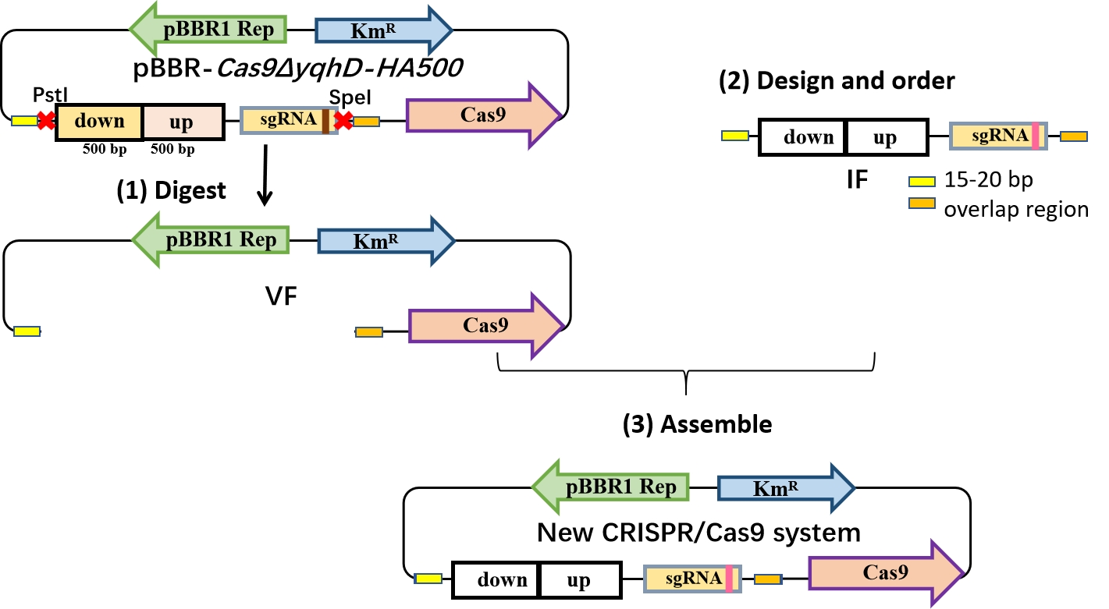
Fig. S1 Construction of the CRISPR/Cas9 for new target. (1) Digest pBBR-Cas9ΔyqhD-HA500 with PstI and SpeI to obtain the vector fragment (VF); (2) Design and order the insert fragment (IF) for the new target gene based on the sgRNA design described in Section 2.2; (3) Assemble the VF and IF into a new CRISPR/Cas9 system for genome editing.

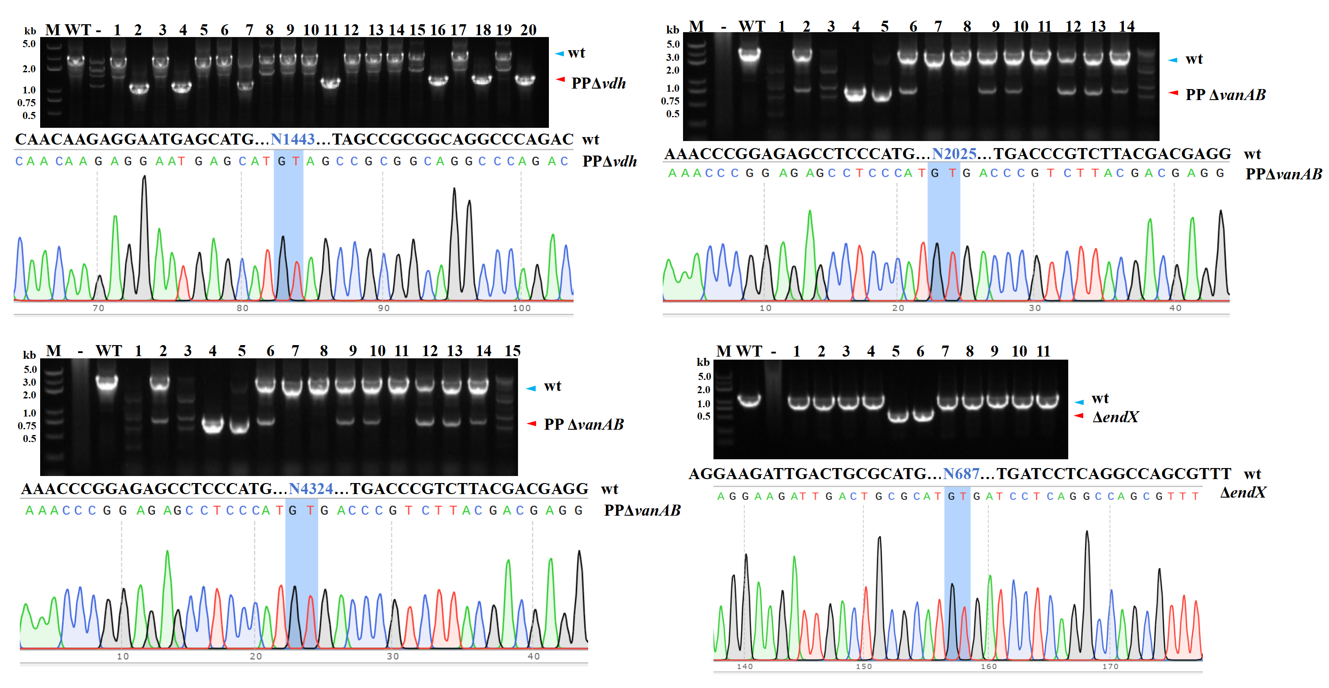
Fig. S2 PCR verification and sequencing of all genome editing in P. putida KT2440 in this study. To be continued on next page.

Continued Fig. S2 PCR verification and sequencing of all genome editing in P. putida KT2440 in this study.

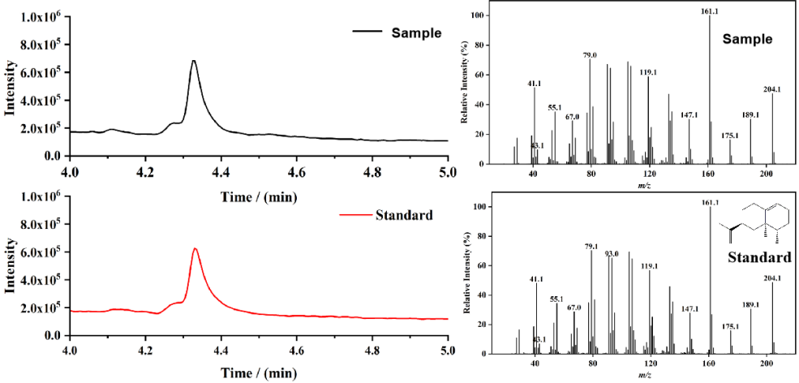
Fig. S3 GC-MS analysis of retention time and mass fragmentation for both a sample and a standard of valencene.

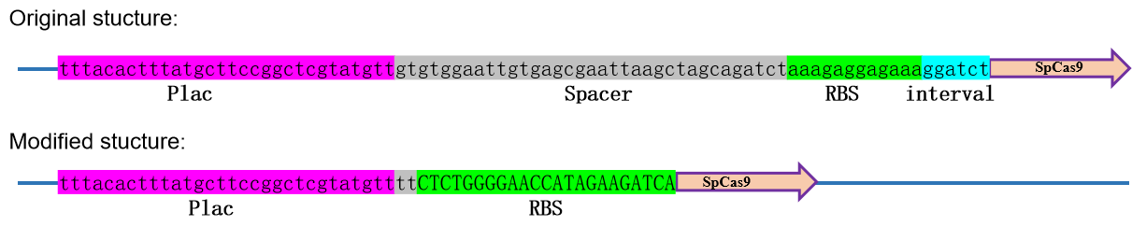
Fig. S4 Modified sequence before spCas9 to reduce its expression level. The spacer and interval were removed and the RBS was changed.

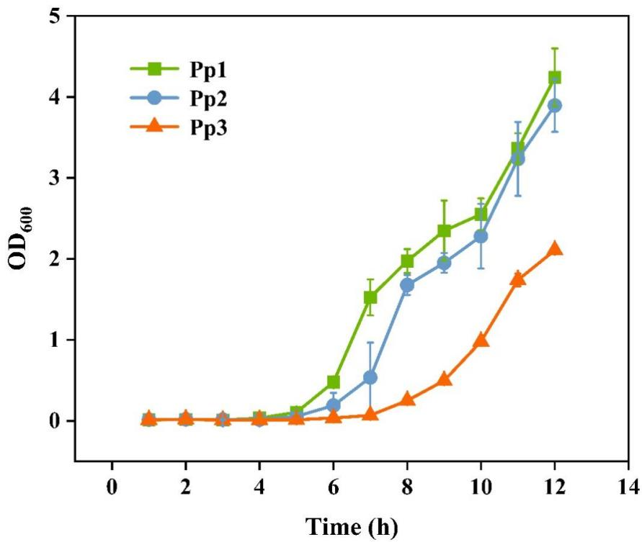
Fig. S5 Growth curves for the Figure 1 strains in the presence of the antibiotic kanamycin (Km). Pp1, green, Pp2,blue; Pp3,orange. Cells were grown in LB at 30 ºC, and three independent replicates were conducted for each strains.

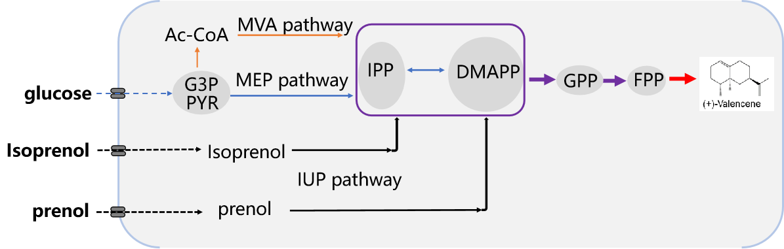
Fig. S6 Pathways for valencene synthesis. The valencene synthase (vs) was heterologously expressed to catalyze the formation of (+)-valencene from Farnesyl diphosphate (FPP) and geranyl diphosphate (GPP). These precursors typically originate from the condensation of dimethylallyl diphosphate (DMAPP) and isopentenyl diphosphate (IPP), which are synthesized via the methylerythritol 4-phosphate (MEP) pathway, the mevalonate (MVA) pathway, and the isopentenol (IUP) pathway.

