Additional file
Fig. S1
Fig. S1 Time course of UV inactivation (a) and thermal inactivation (b) on protoplast. The error bars represent the standard error of the mean.

Fig. S2
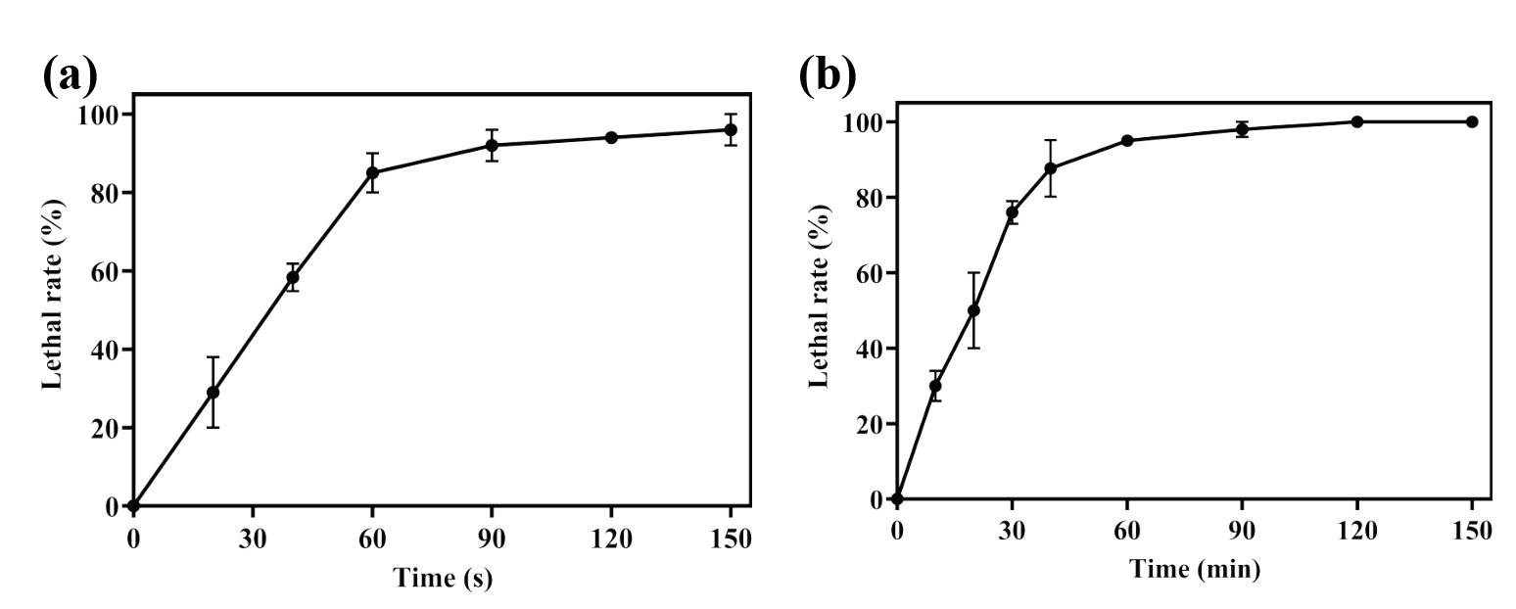
Fig. S2 The lethality rate curves of atmospheric and room temperature plasma (ARTP) mutagenesis (a) and diethyl sulfate mutagenesis (b) on S. gilvosporeus ATCC 13326. The error bars represent the standard error of the mean.

Fig. S3
Fig. S3 Effect of phosphate concentration on the growth of S. gilvosporeus ATCC 13326. The error bars represent the standard error of the mean.

Fig.S4
Fig.S4 Overview of transcriptome results. (a) GO enrichment analysis of upregulated differentially expressed genes. (b) GO enrichment analysis of downregulated differentially expressed genes. (c) KEGG enrichment analysis.

Fig. S5
Fig. S5 Differences in intracellular branched-chain amino acids concentrations between S. gilvosporeus ATCC 13326 and S. gilvosporeus GR2

Fig. S6
Fig. S6 Verification of differentially expressed genes by quantitative real-time PCR

Table S1 Strains and plasmids for overexpression and gene silencing
 | Characteristics
Strains
S. gilvosporeus ATCC13326 | Natamycin-producing strains
E.coli DH5α | cloning vector
E.coli ET12567 | E. coli and Streptomyces combination strains
NA-nasA | ATCC13326 harboring pIB139-nasA
NA-nasB | ATCC13326 harboring pIB139-nasB
NA-gdhA | ATCC13326 harboring pIB139-gdhA
NA-nirB | ATCC13326 harboring pIB139-nirB
NA-phoP | ATCC13326 harboring pIB139-phoP
NA-phoR | ATCC13326 harboring pIB139-phoR
pIB139 | Integrated carrier based on Φ C31 integrase
Plasmids
pIB139-nasA | nasA cloned in pIB139
pIB139-nasB | nasB cloned in pIB139
pIB139-gdhA | gdhA cloned in pIB139
pIB139-nirB | nirB cloned in pIB139
pIB139-phoP | phoP cloned in pIB139
pIB139-phoR | phoR cloned in pIB139
pIB139-hfp-micC | hfp and micC cloned in pIB139
pIB139-antiphop | antiphop cloned in pIB139-hfp-micC

Table S2 Primers used in this study
Primer | Sequence（5’→3’）
SgnR-R | CCGCTCCTACAACACCTTCA
nasA-F | GGTTGGTAGGATCCACATATGATGAACGCCGCGAACGC
nasA-R | CATGATTACGAATTCGATATCCTAGGCCCGTTCCACCTGC
nasB-F | GGTTGGTAGGATCCACATATGATGACCTCGAGTACGCGTGTG
nasB-R | CATGATTACGAATTCGATATCTCAGAAGCCTCCGTCGGTG
gdhA-F | GGTTGGTAGGATCCACATATGATGTCGAGTGTTCACACCGAGG
gdhA-R | CATGATTACGAATTCGATATCTCAGATCAGGCCCTGGTCC
nirB-F | GGTTGGTAGGATCCACATATGATGGCCGCAGCCGCCA
nirB-R | CATGATTACGAATTCGATATCTCATCGGGCGGAGGTCCC
phoR-F | GGTTGGTAGGATCCACATATGATGAACGTGGACGCGGC
phoR-R | CATGATTACGAATTCGATATCTCACGGAAGGACCTCCGG
phoP-F | GGTTGGTAGGATCCACATATGGTGACCCGAGTGCTCGTTGT
phoP-R | CATGATTACGAATTCGATATCCTACGGCTCGAACTTGTAGCC
GlnR-F | GGTTGGTAGGATCCACATATGGTGAGTTCGCTTCTGCTGCTG
GlnR-R | CATGATTACGAATTCGATATCCTACCGGGAGGCAGGTCG
Permp-F | GCCGCGCGCGATATCGAATTCGCATGCGAGTGTCCGTTCG
Permp-F | TTAGCCATTACCAACCGGCACGATTGTG
Phfq-F | TGCCGGTTGGTAATGGCTAAGGGGCAATCTTTACA
Phfq-R | CCGAGCGTTCTGAACAAATTATTCGGTTTCTTCGCTGTCC
Pmicc-F | GGTTGGTAGGATCCACATATGGTTATATGCCTTTATTGTCACAGATTTTA
Pmicc-R | CCGAGCGTTCTGAACAAAACTCGCATGCCGATATCGCGCGCGGCCG
Pmicc+Srna-F | GGTTGGTAGGATCCACATATGCTCGACAACGAGCACTCGGGTCACGTTATATGCCTTTATTGTCACAGATTTTA
Pmicc+Srna-R | CTAGAGGATCCCCAACATATGAAAAAAAAAGCCCGGACGA
SgnS0-F | ACACCTCGTCCGTCAACTC
SgnS0-R | TCGACGACACCACCTACAC
SgnS1-F | TCGTGATCGTCGGCATGAG
SgnS1-R | CAGGTCGTCTCCAGCAACA
SgnS2-F | CGCTACGCAGAGGTCTTCA
SgnS2-R | CGAAGCCGAGGTCACTGAA
SgnS3-F | GGTCGGTCAAGTCCAACCT
SgnS3-R | GCCTGCTCCACGATCACAT
SgnS4-F | CAAGTCCAACCTCGGTCACA
SgnS4-R | TGGCTGCTCAAGGATGATGT
SgnC-F | GTTGGCGAACAGCGAGTAG
SgnC-R | CTGCGGAGACGACCTCAATA
SgnG-F | TCGAAGGCGTTCTCGTCAT
SgnG-R | TGCTGATGCTCCTGCTCAT
SgnK-F | CGAAGGTCCGCAGCTTGAA
SgnK-R | GAAGTTCCGCCGTCTCCAA
SgnI-F | GGATCGTCGCCGAACTGAA
SgnI-R | GGAGCTGAGGAAGAAGTGACC
SgnJ-F | TGGTGTCCGAACTGTCCTT
SgnJ-R | CGACCTTGCCGAACATCTC
SgnE-F | AACAGGTGACGGCAGGAGA
SgnE-R | CGAGGTCATCTACGGCAACA
SgnF-F | TCGTCGTCCTGGTCGAAGAG
SgnF-R | ATGCGTATCACCGTTGACCC
SgnL-F | CAGATTGTTGGTGCGGTACAG
SgnL-R | CGTTCACCGTGTCCTGGAA
SgnD-F | GGTGAACAGCTTGGTGAACATC
SgnD-R | GCCAGCGAGGACATGGAATT
SgnA-F | TCACCATCACCACCGACAT
SgnA-R | GCCGCACCAATTCCGAAT
SgnB-F | CGTTGTGCTCGTCGAAGAC
SgnB-R | CGTTCTCCGTGCTGACCAT
SgnT-F | GGTGTCCACGGAGAGCATT
SgnT-R | CGCCGAGGTAGACGAGATAC
SgnH-F | TCCTCAATGCCGCCTCGTA
SgnH-R | GGAGTGGAAGACCGTGATCG
SgnM-F | GGCTCGTCCGAGGACATAT
SgnM-R | GAGGATCTTCTTGCGTTTGGT
SgnR-F | CCAGCATCGCCTTCCAGTA
SgnR-R | CCGCTCCTACAACACCTTCA

Table S3 Differentially expressed genes involved in the citric acid cycle
Gene | Gene ID | Description | Log₂ (FC)  (GR /WT)
DLAT | B1H19_RS03740 | 2-oxo acid dehydrogenase subunit E2 | -2.06
sdhC | B1H19_RS12140 | succinate dehydrogenase cytochrome b subunit | -3.04
sdhA | B1H19_RS12145 | fumarate reductase/succinate dehydrogenase flavoprotein subunit | -3.11
sdhB | B1H19_RS12150 | succinate dehydrogenase/fumarate reductase iron-sulfur subunit | -2.85
aceE | B1H19_RS12835 | pyruvate dehydrogenase (acetyl-transferring), homodimeric type | -1.13
IDH1 | B1H19_RS25215 | NADP-dependent isocitrate dehydrogenase | -1.21
mdh | B1H19_RS25220 | malate dehydrogenase | -1.11
pckA | B1H19_RS26025 | phosphoenolpyruvate carboxykinase (GTP) | -1.10
CS | B1H19_RS24860 | citrate synthase 2 | -1.05
fumC | B1H19_RS26240 | class II fumarate hydratase | -1.10

Table S4 Differentially expressed genes involved in the phosphate metabolism
Gene | Gene ID | Description | Log₂ (FC)  (GR /WT)
phoR | B1H19_RS24300 | ATP-binding protein | 0.63
phoP | B1H19_RS24305 | response regulator transcription factor | 0.74
phoU | B1H19_RS24295 | phosphate signaling complex protein PhoU | 0.94
phoA | B1H19_RS26655 | P-loop NTPase | -0.14
pstS | B1H19_RS23935 | phosphate ABC transporter substrate-binding protein PstS | -0.03
pstC | B1H19_RS23930 | phosphate ABC transporter permease subunit PstC | -0.082
pstA | B1H19_RS23925 | phosphate ABC transporter permease PstA | 0.073
pstB | B1H19_RS23920 | phosphate ABC transporter ATP-binding protein PstB | 0.10
regX3 | B1H19_RS15725 | response regulator transcription factor | 0.09
senX3 | B1H19_RS24300 | ATP-binding protein | 0.63

