dCas12a-mediated CRISPR interference for multiplex gene repression in cyanobacteria for enhanced isobutanol and 3-methyl-1-butanol production

Additional file 1

Fig. S1-11
Tables S1-2

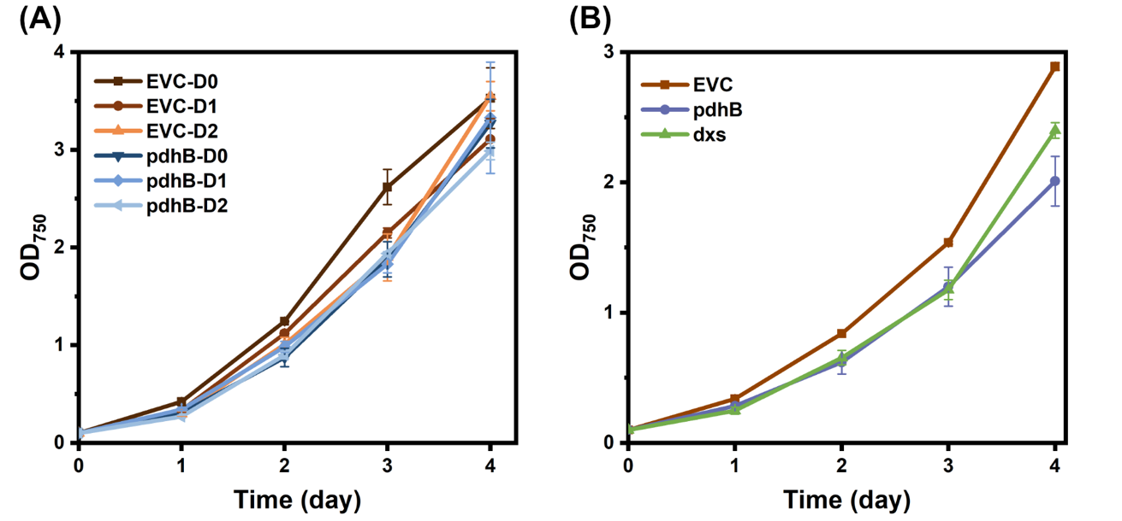
Fig. S1: Growth curves of cultures with CRISPRi tool induced with 3 mM rhamnose. EVC = empty vector control. Error bars represent standard deviation (three biology replicates).

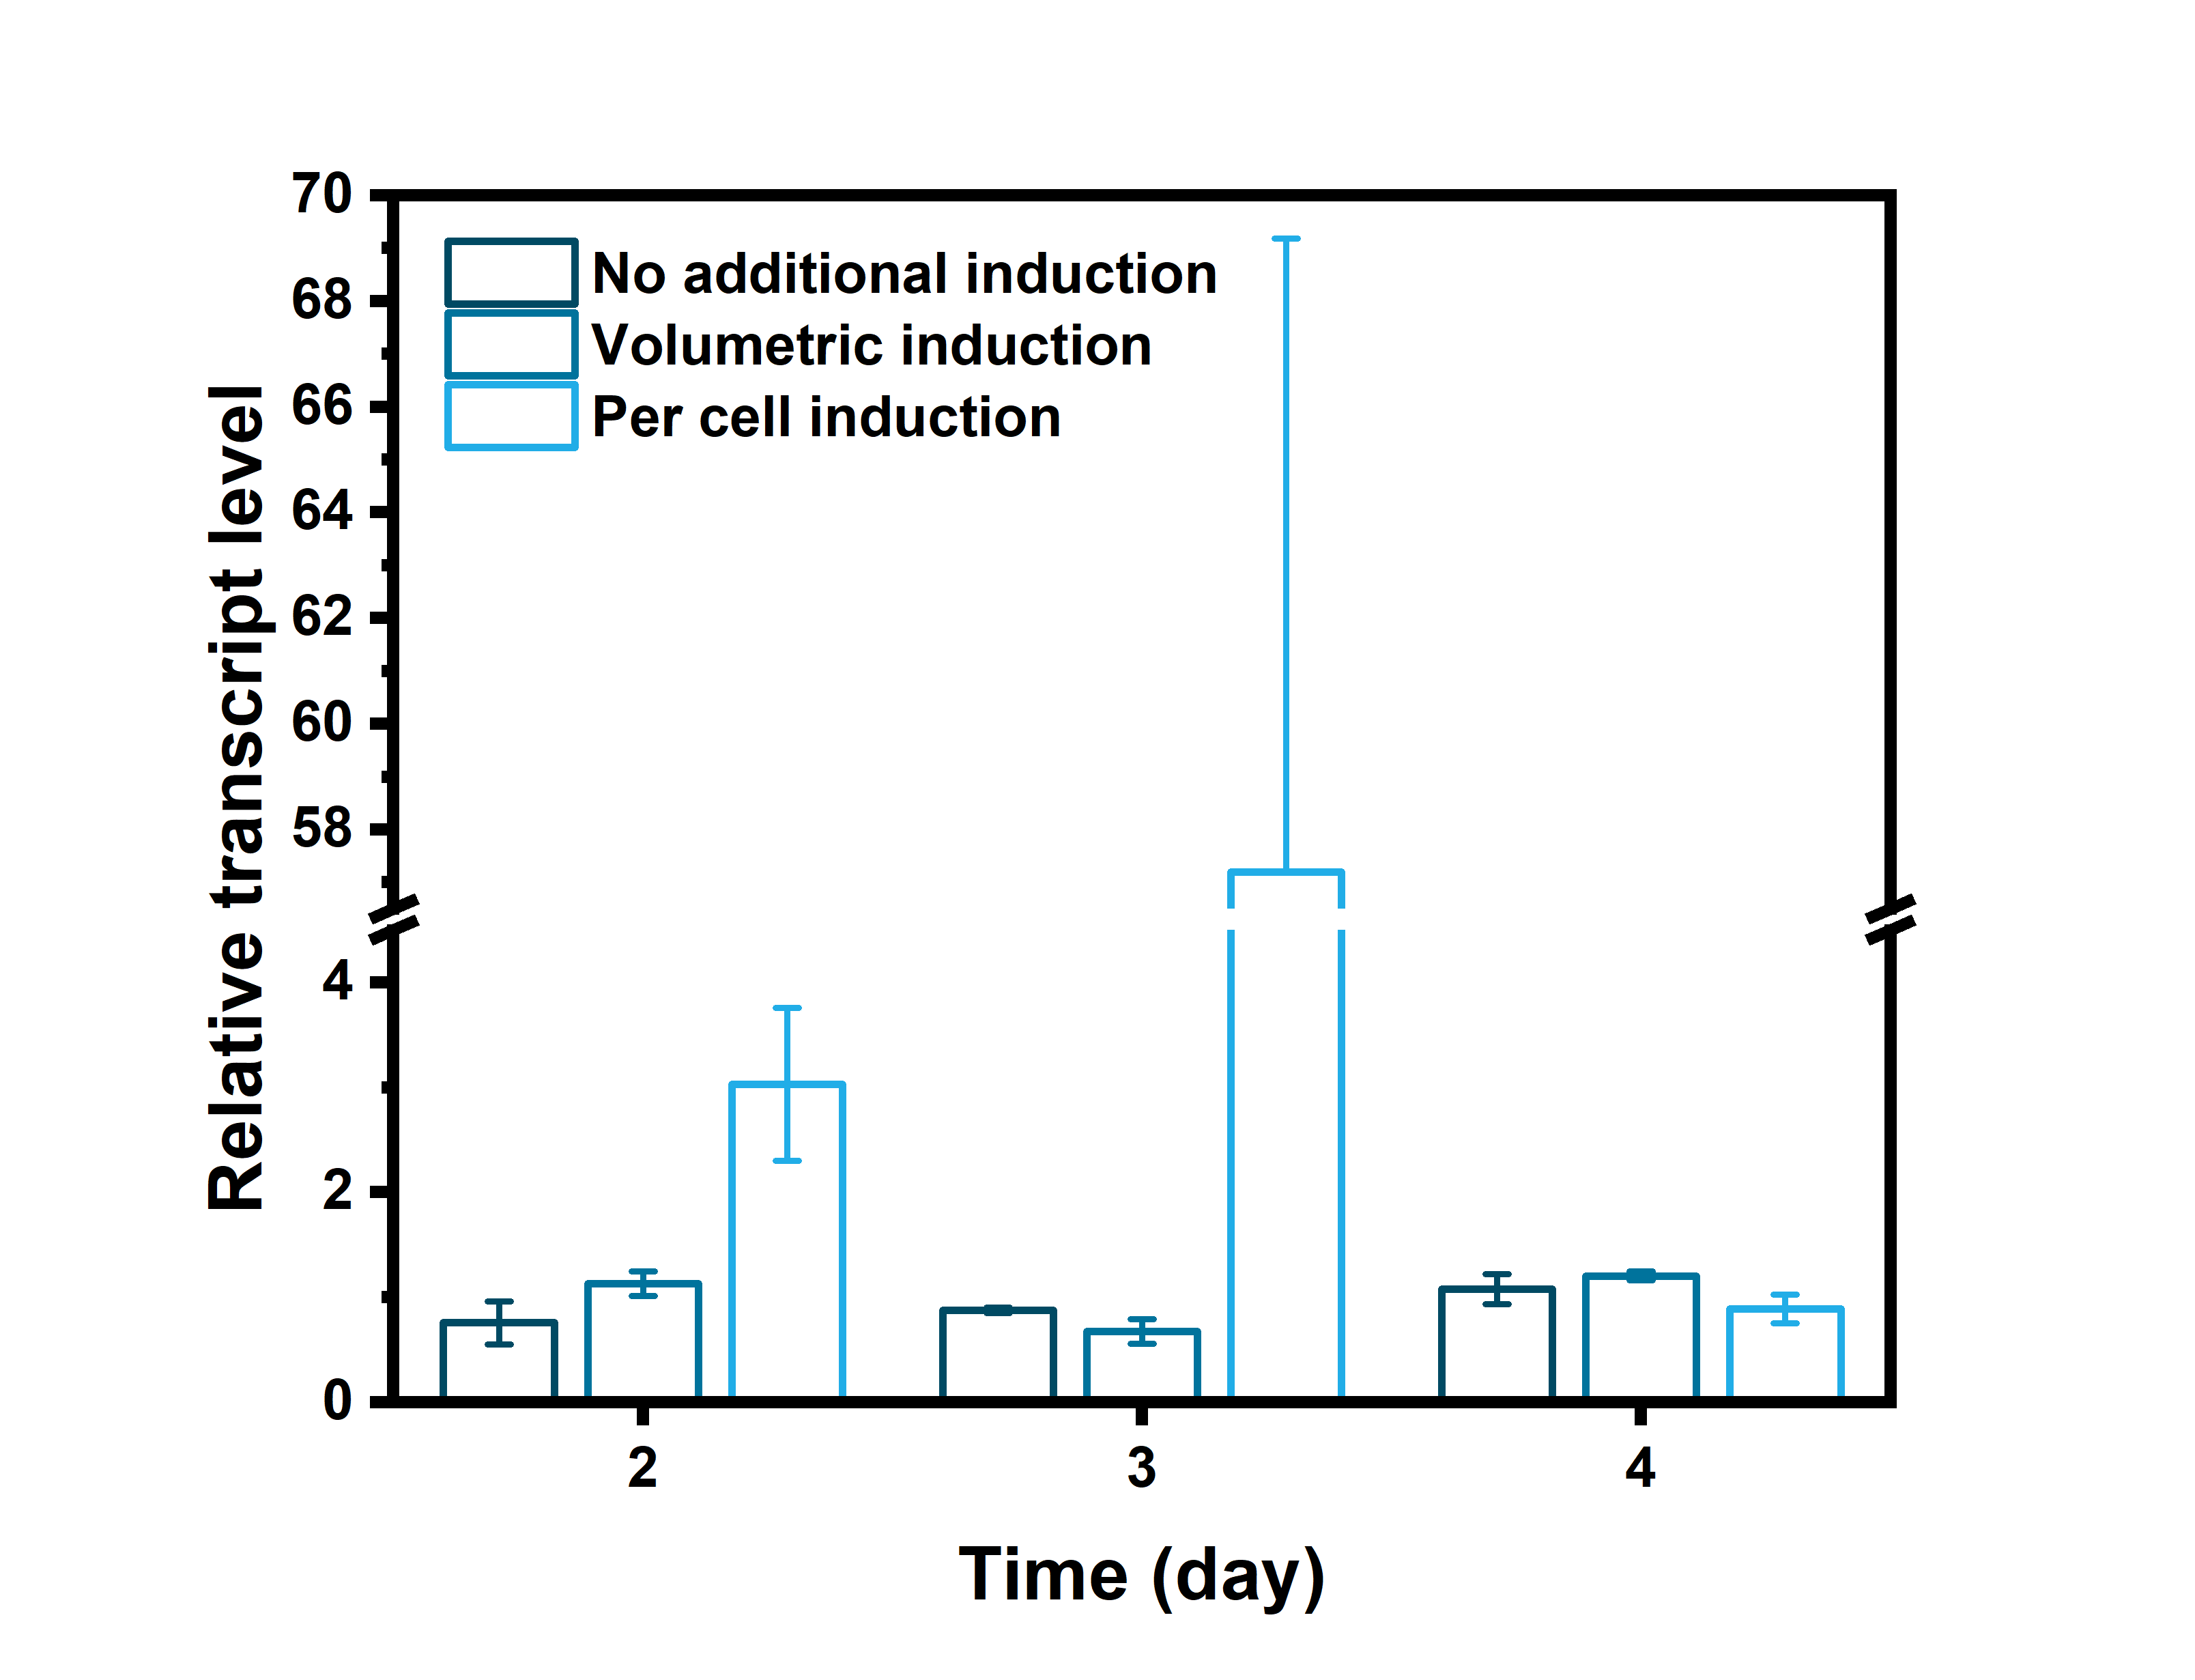
Fig. S2: pdhB downregulation induced with 3 mM rhamnose on day 0. No additional induction = rhamnose was added once at day 0. Volumetric induction = rhamnose was added a second time at day 2. 3 mM final concentration was added to the culture. Per cell induction = a second rhamnose induction was performed on day 2. Rhamnose concentration was normalised per cell. Error bars represent standard deviation (three biological replicates).

Fig. S3: Western-immunoblot analysis of strain HX11-EVC, schematic diagram of pEEK* plasmid, and growth profile of selected strains. (A) Western-immunoblot analysis expressed Kivd^{S286T} enzyme. Twenty micrograms of total soluble proteins were loaded to detect Flag-tagged and His-tagged proteins. Protein size: Kivd^{S286T}, 61 kDa. The numbers represent biological triplicates. (B) Schematic diagram of pEEK* plasmid. It was used to generate strain HX11-pEEK* strain. (C) Growth profile of strains HX11-EVC, HX11-ppc, HX11-cpcB, and HX11-ppsA. Error bars represent standard deviation (two biological replicates).

Fig. S4: Examination of the effects of dCas12a protein expression in isobutanol (IB) / 3-methyl-1-butanol (3M1B)-producing Synechocystis strain HX11. (A) Growth profile of strains HX11-EVC and HX11-pEEK*. (B) IB production per cell of strains HX11-EVC and HX11-pEEK* on days 2, 3, and 4. (C) 3M1B production per cell of strains HX11-EVC and HX11-pEEK* on days 2, 3, and 4. Results are the mean of three biological replicates, each with three technical replicates. Error bars represent standard deviation.

Fig. S5: Test of dCas12a-mediated CRISPRi system in isobutanol (IB) / 3-methyl-1-butanol (3M1B)-producing Synechocystis strain with varied rhamnose induction timepoints. Three millimolar rhamnose were added for induction in strains HX11-EVC and HX11-ppc before inoculation (BI), on days 0 (D0), 1 (D1), 2 (D2), 3 (D3), or without rhamnose addition (0). (A) Growth profile of strain HX11-EVC cultivated under varied induction timepoints. (B) IB production per cell of strain HX11-EVC with varied rhamnose induction timepoints on days 2, 3, 4, and 5. (C) 3M1B production per cell of strain HX11-EVC with varied rhamnose induction timepoints on days 2, 3, 4, and 5. (D) Growth profile of strain HX11-ppc cultivated under varied induction timepoints. (E) IB production per cell of strain HX11-ppc with varied rhamnose induction timepoints on days 2, 3, 4, and 5. (F) 3M1B production per cell of strain HX11-ppc with varied rhamnose induction timepoints on days 2, 3, 4, and 5. Results are the mean of three biological replicates. Error bars represent standard deviation.

Fig. S6: Test of dCas12a-mediated CRISPRi system in isobutanol (IB) / 3-methyl-1-butanol (3M1B)-producing Synechocystis strain with varied rhamnose concentrations for induction. Rhamnose (0 mM, 1 mM, 3 mM, 5 mM, or 10 mM) was added for induction in strains HX11-EVC and HX11-ppc on day 1. (A) Growth profile of strain HX11-EVC cultivated under varied rhamnose concentrations. (B) IB production per cell of strain HX11-EVC with varied rhamnose concentrations for induction on days 2, 3, 4, and 5. (C) 3M1B production per cell of strain HX11-EVC with varied rhamnose concentrations for induction on days 2, 3, 4, and 5. (D) Growth profile of strain HX11-ppc cultivated under varied rhamnose concentrations. (E) IB production per cell of strain HX11-ppc with varied rhamnose concentrations for induction on days 2, 3, 4, and 5. (F) 3M1B production per cell of strain HX11-ppc with varied rhamnose concentrations for induction on days 2, 3, 4, and 5. Results are the mean of three biological replicates. Error bars represent standard deviation.

Fig. S7: Test of the effects of HCl titration on dCas12a-mediated CRISPRi system in isobutanol (IB) / 3-methyl-1-butanol (3M1B)-producing Synechocystis strain. Three millimolar rhamnose were added for induction in strains HX11-EVC and HX11-ppc on day 1 (D1). The target pH range of the cultures with HCl titration was between 7 and 8. (A) Growth profile of strains HX11-EVC and HX11-ppc cultivated with or without HCl titration. (B) IB production per cell of strains HX11-EVC and HX11-ppc cultivated with or without HCl titration on days 2, 3, 4, and 5. (C) 3M1B production per cell of strains HX11-EVC and HX11-ppc cultivated with or without HCl titration on days 2, 3, 4, and 5. Results are the mean of three biological replicates. Error bars represent standard deviation.

Fig. S8: Isobutanol (IB) and 3-methyl-1-butanol (3M1B) titers of engineered strains. (A) IB titer of the engineered Synechocystis strains with selected gene(s) repressed on day 4 (first batch). (B) 3M1B titer of the engineered Synechocystis strains with selected gene(s) repressed on day 4 (first batch). (C) IB titer of the engineered Synechocystis strains with selected gene(s) repressed on day 4 (second batch). (D) 3M1B titer of the engineered Synechocystis strains with selected gene(s) repressed on day 4 (second batch). Results are the mean of three biological replicates. Error bars represent standard deviation.

Fig. S9: Further investigation of HX11-ilvE strains. HX11-ilvE1, 2 and 3 represent three independent cell lines isolated after transformation. (A) Growth profile of strains HX11-EVC and HX11-ilvE1, 2 and 3. (B) IB production per cell of strains HX11-EVC and HX11-ilvE1, 2, and 3 on day 2, 3 and 4. (C) 3M1B production per cell of strains HX11-EVC and HX11-ilvE1, 2, and 3 on day 2, 3 and 4. (D) IB production per cell of strains HX11-EVC and HX11-ilvE on day 2, 3 and 4. (E) 3M1B production per cell of strains HX11-EVC and HX11-ilvE on day 2, 3 and 4. Error bars represent standard deviation (three biological replicates). Asterisk represents significant difference between recombinant strains and control strain (t-Test, *p < 0.05, **p < 0.005).

Fig. S10: Isobutanol (IB) and 3-methyl-1-butanol (3M1B) production per cell of selected strains. (A) IB production per cell of strains HX11-EVC, HX11-gltA, and HX11-ppc. (B) 3M1B production per cell of strains HX11-EVC, HX11-gltA, and HX11-ppc. Error bars represent standard deviation (three biological replicates).

Fig. S11: Growth profiles of strains with combinatorial multiplex genes repression using dCas12a-mediated CRISPRi system for IB / 3M1B production. See Table 1 for the details of the strains. (A) Growth profile of strains HX11-EVC, HX11-gltA, HX11-ppc, and HX106. (B) Growth profile of strains HX106, HX11-acnB, and HX107. (C) Growth profile of strains HX106, HX11-ppsA, and HX108. (D) Growth profile of strains HX106, HX11-cpcB, and HX109. (E) Growth profile of strains HX106, HX11-accC, and HX110. (F) Growth profile of strains HX11-ppc, HX11-ppsA, HX11-ccmA, and HX111. (G) Growth profile of strains HX11-ppsA, HX11-accC, HX11-pdh, and HX112. Error bars represent standard deviation (three biological replicates).

Table S1. Plasmid used in this study. Expressed genes in bold.
Plasmid | Relevant characteristicsª | Reference
pSL3287 | P_{trc2O}_dCas12_T_J23119_crRNA(no target)_Km^{R} | (Knoot et al., 2020)
pSHDY_Prha:mVenus-PJ23119:rhaS | PrhaBAD_mVenus_T_J23119_rhaS_Km^{R} | (Behle et al., 2020)
pBB_dCas12a | PrhaBAD_dCas12a_T_PrhaBAD_crRNA(no target)_Km^{R} | This study
pBB1 | pBB_PrhaBAD_dCas12a_T_PrhaBAD_crRNA(pdhB)_Km^{R} | This study
pBB2 | pBB_PrhaBAD_dCas12a_T_PrhaBAD_crRNA(dxs)_Km^{R} | This study
pHX8 | pDdh_(PtrcBCD_kivd^{S286T}_T)_Cm^{R} | (Xie & Lindblad, 2022)
pHX15 | pSlr0168_(PtrcBCD_kivd^{S286T}_T)_Sp^{R} | (Xie & Lindblad, 2022)
pHX22 | pEEK* | Englund, E., not published
pHX23 | pBB_PrhaBAD_dCas12a_T_PrhaBAD_crRNA(accC)_Km^{R} | This study
pHX24 | pBB_PrhaBAD_dCas12a_T_PrhaBAD_crRNA(acnB)_Km^{R} | This study
pHX25 | pBB_PrhaBAD_dCas12a_T_PrhaBAD_crRNA(ccmA)_Km^{R} | This study
pHX26 | pBB_PrhaBAD_dCas12a_T_PrhaBAD_crRNA(cpcB)_Km^{R} | This study
pHX27 | pBB_PrhaBAD_dCas12a_T_PrhaBAD_crRNA(fbp, glpX)_Km^{R} | This study
pHX28 | pBB_PrhaBAD_dCas12a_T_PrhaBAD_crRNA(fumC)_Km^{R} | This study
pHX29 | pBB_PrhaBAD_dCas12a_T_PrhaBAD_crRNA(gltA)_Km^{R} | This study
pHX30 | pBB_PrhaBAD_dCas12a_T_PrhaBAD_crRNA(icd)_Km^{R} | This study
pHX31 | pBB_PrhaBAD_dCas12a_T_PrhaBAD_crRNA(ilvE)_Km^{R} | This study
pHX32 | pBB_PrhaBAD_dCas12a_T_PrhaBAD_crRNA(sll1721, slr1934)_Km^{R} | This study
pHX33 | pBB_PrhaBAD_dCas12a_T_PrhaBAD_crRNA(phaA)_Km^{R} | This study
pHX34 | pBB_PrhaBAD_dCas12a_T_PrhaBAD_crRNA(ppc)_Km^{R} | This study
pHX35 | pBB_PrhaBAD_dCas12a_T_PrhaBAD_crRNA(ppsA)_Km^{R} | This study
pHX36 | pBB_PrhaBAD_dCas12a_T_PrhaBAD_crRNA(pta, ach)_Km^{R} | This study
pHX37 | pBB_PrhaBAD_dCas12a_T_PrhaBAD_crRNA(sps)_Km^{R} | This study
pHX38 | pBB_PrhaBAD_dCas12a_T_PrhaBAD_crRNA(ppc, gltA)_Km^{R} | This study
pHX39 | pBB_PrhaBAD_dCas12a_T_PrhaBAD_crRNA(ppc, gltA, acnB)_Km^{R} | This study
pHX40 | pBB_PrhaBAD_dCas12a_T_PrhaBAD_crRNA(ppc, gltA, ppsA)_Km^{R} | This study
pHX41 | pBB_PrhaBAD_dCas12a_T_PrhaBAD_crRNA(ppc, gltA, cpcB)_Km^{R} | This study
pHX42 | pBB_PrhaBAD_dCas12a_T_PrhaBAD_crRNA(ppc, gltA, accC)_Km^{R} | This study
pHX43 | pBB_PrhaBAD_dCas12a_T_PrhaBAD_crRNA(ppc, ppsA, ccmA)_Km^{R} | This study
pHX44 | pBB_PrhaBAD_dCas12a_T_PrhaBAD_crRNA(ppsA, accC, sll1721, slr1934)_Km^{R} | This study
pHX45 | pBB_PrhaBAD_dCas12a_T_PrhaBAD_crRNA(pdhB)_Km^{R} | This study
pHX46 | pBB_PrhaBAD_dCas12a_T_PrhaBAD_crRNA(dxs)_Km^{R} | This study
a Km^{R}, Kanamycin resistance cassette; Sp^{R}, spectinomycin resistance cassette; Cm^{R}: chloramphenicol resistance cassette; T, Terminator.

Table S2. Oligonucleotides used in this study.
Primer name | Oligonucleotides sequence
A. Primers for fragment amplification
RhaS_F | ATATATGGTACCTTGACAGCTAGCTCAGTCCT
RhaS_R | TGTTCACAATTTGCTGAATTGTGGCTCAACTCGTATAAACGCAGAA
Prha_F | GCCTTTCTGCGTTTATACGAGTTGAGCCACAATTCAGCAAATTGT
Prha_R | ATATATGGTACCTTCATTACGACCAGTCTAAA
dCas12_F | ATATATACTAGTGTCCTAAATACTATCTTACAAAT
dCas12_R | CGCTTTTTAGACTGGTCGTAATGAAGCTGATTTAGGCAAAAACG
Prha_gRNA_F | ATATATGTCGACGCCACAATTCAGCAAATTGT
Prha_gRNA_R | TAGACCCGTTTTTGCCTAAATCAGCTTCATTACGACCAGTCTAAA
B. Primers for oligo annealing
g_pdhB_F(P) | Phos-AGATTTGTGCCCCGATCGCCCTTG
g_pdhB_R(P) | Phos- AGACCAAGGGCGATCGGGGCACAA
g_dxs_F(P) | Phos-AGATTCCAGACTGTGACTGGGGTT
g_dxs_R(P) | Phos-AGACAACCCCAGTCACAGTCTGGA
g_acnB_F(P) | Phos-AGATACCATGAACTAATATTGCCG
g_acnB_R(P) | Phos-AGACCGGCAATATTAGTTCATGGT
g_accC_F(P) | Phos-AGATTACTAAAAGACTAAACACAT
g_accC_R(P) | Phos-AGACATGTGTTTAGTCTTTTAGTA
g_ccmA_F(P) | Phos-AGATGCATCGGCTTTTCGAGTCCG
g_ccmA_R(P) | Phos-AGACCGGACTCGAAAAGCCGATGC
g_cpcB_F(P) | Phos-AGATAGAAAATCCCAACTCATAAA
g_cpcB_R(P) | Phos-AGACTTTATGAGTTGGGATTTTCT
g_fbp_glpX_F(P) | Phos-AGATAGCCTAGCAATCCAAGGAGAGTCTAAGAACTTTAAATAATTTCTACTGTTGTAGATA CACTTAATCACAAGCTAGG
g_fbp_glpX_R(P) | Phos-AGACCCTAGCTTGTGATTAAGTGTATCTACAACAGTAGAAATTATTTAAAGTTCTTAGACT  CTCCTTGGATTGCTAGGCT
g_fumC_F(P) | Phos-AGATCCACCGGAGTATTTGCAAAT
g_fumC_R(P) | Phos-AGACATTTGCAAATACTCCGGTGG
g_gltA_F(P) | Phos-AGATTCCGTTATAGGTGAATTATA
g_gltA_R(P) | Phos-AGACTATAATTCACCTATAACGGA
g_icd_F(P) | Phos-AGATTGATCTGCTCCGTGCCGTTT
g_icd_R(P) | Phos-AGACAAACGGCACGGAGCAGATCA
g_ilvE_F(P) | Phos-AGATGATGACCGGGGTTAAGTCCA
g_ilvE_R(P) | Phos-AGACTGGACTTAACCCCGGTCATC
g_pdh_F(P) | Phos-AGATTTGTGCCCCGATCGCCCTTGGTCTAAGAACTTTAAATAATTTCTACTGTTGTAGATC  CCTTTATCTACTGCAAATT
g_pdh_R(P) | Phos-AGACAATTTGCAGTAGATAAAGGGATCTACAACAGTAGAAATTATTTAAAGTTCTTAGACC  AAGGGCGATCGGGGCACAA
g_phaA_F(P) | Phos-AGATAGCTGGAGGCGGAGTTAATG
g_phaA_R(P) | Phos-AGACCATTAACTCCGCCTCCAGCT
g_ppc_F(P) | Phos-AGATTACAGTAGCAACGCATTCTG
g_ppc_R(P) | Phos-AGACCAGAATGCGTTGCTACTGTA
g_ppsA_F(P) | Phos-AGATGGGGTAAATAGATATGGTAA
g_ppsA_R(P) | Phos-AGACTTACCATATCTATTTACCCC
g_pta_ach_F(P) | Phos-AGATCTGGATACGTTGAGGTTATTGTCTAAGAACTTTAAATAATTTCTACTGTTGTAGATAT  GGGGGAAACAGCTTCACT
g_pta_ach_R(P) | Phos-AGACAGTGAAGCTGTTTCCCCCATATCTACAACAGTAGAAATTATTTAAAGTTCTTAGACA  ATAACCTCAACGTATCCAG
g_sps_F(P) | Phos-AGATTAGTAATTTGTAAAACTTAT
g_sps_R(P) | Phos-AGACATAAGTTTTACAAATTACTA
g_ppc_gltA_F(P) | Phos-AGATTACAGTAGCAACGCATTCTGGTCTAAGAACTTTAAATAATTTCTACTGTTGTAGATT  CCGTTATAGGTGAATTATA
g_PEPc_gltA_R(P) | Phos-AGACTATAATTCACCTATAACGGAATCTACAACAGTAGAAATTATTTAAAGTTCTTAGACC  AGAATGCGTTGCTACTGTA
g_PEPc_gltA_F1(P) | Phos-AGATTACAGTAGCAACGCATTCTGGTCTAAGAACTTTAAATAATTTCTACTGTTGTAGATT  CCGTTATAGGTGAATTATA
g_PEPc_gltA_R1(P) | Phos-ATCTACAACAGTAGAAATTATTTAAAGTTCTTAGACCAGAATGCGTTGCTACTGTA
g_acnB_F1(P) | Phos-GTCTAAGAACTTTAAATAATTTCTACTGTTGTAGATACCATGAACTAATATTGCCG
g_acnB_R1(P) | Phos-AGACCGGCAATATTAGTTCATGGTATCTACAACAGTAGAAATTATTTAAAGTTCTTAGACT  ATAATTCACCTATAACGGA
g_ppsA_F1(P) | Phos-GTCTAAGAACTTTAAATAATTTCTACTGTTGTAGATGGGGTAAATAGATATGGTAA
g_ppsA_R1(P) | Phos-AGACTTACCATATCTATTTACCCCATCTACAACAGTAGAAATTATTTAAAGTTCTTAGACTA  TAATTCACCTATAACGGA
g_cpcB_F1(P) | Phos-GTCTAAGAACTTTAAATAATTTCTACTGTTGTAGATAGAAAATCCCAACTCATAAA
g_cpcB_R1(P) | Phos-AGACTTTATGAGTTGGGATTTTCTATCTACAACAGTAGAAATTATTTAAAGTTCTTAGACTA  TAATTCACCTATAACGGA
g_accC_F1(P) | Phos-GTCTAAGAACTTTAAATAATTTCTACTGTTGTAGATTACTAAAAGACTAAACACAT
g_accC_R1(P) | Phos-AGACATGTGTTTAGTCTTTTAGTAATCTACAACAGTAGAAATTATTTAAAGTTCTTAGACTA  TAATTCACCTATAACGGA
g_ccmA_F1(P) | Phos-GTCTAAGAACTTTAAATAATTTCTACTGTTGTAGATGCATCGGCTTTTCGAGTCCG
g_ccmA_R1(P) | Phos-AGACCGGACTCGAAAAGCCGATGCATCTACAACAGTAGAAATTATTTAAAGTTCTTAGAC  TTACCATATCTATTTACCCC
g_ppsA_accC_F1(P) | Phos-AGATGGGGTAAATAGATATGGTAAGTCTAAGAACTTTAAATAATTTCTACTGTTGTAGATT  ACTAAAAGACTAAACACAT
g_ppsA_accC_R1(P) | Phos-ATCTACAACAGTAGAAATTATTTAAAGTTCTTAGACTTACCATATCTATTTACCCC
g_sll1721_F1(P) | Phos-GTCTAAGAACTTTAAATAATTTCTACTGTTGTAGATTTGTGCCCCGATCGCCCTTG
g_sll1721_R1(P) | Phos-ATCTACAACAGTAGAAATTATTTAAAGTTCTTAGACATGTGTTTAGTCTTTTAGTA
g_slr1934_F1(P) | Phos-GTCTAAGAACTTTAAATAATTTCTACTGTTGTAGATCCCTTTATCTACTGCAAATT
g_slr1934_R1(P) | Phos-AGACAATTTGCAGTAGATAAAGGGATCTACAACAGTAGAAATTATTTAAAGTTCTTAGACC  AAGGGCGATCGGGGCACAA
C. Primers for E. coli colony PCR and Synechocystis colony PCR
dCas12_Seq6 | AGCAGATGTAAATGGCAATTTCTTTG
g_accC_SR | TACTAAAAGACTAAACACATGTCTAAG
g_acnB_SR | GTTGTAGATACCATGAACTAATATTGCCG
g_ccmA_SR | GCATCGGCTTTTCGAGTCCG
g_cpcB_SR | GTTGTAGATAGAAAATCCCAACTCATAAAG
g_fbp_SR | AGCCTAGCAATCCAAGGAGA
g_fumC_SR | GATCCACCGGAGTATTTGCAAAT
g_gltA_SR | GTAGATTCCGTTATAGGTGAATTATAGTC
g_icd_SR | GATCTGCTCCGTGCCGTTTG
g_ilvE_SR | GATGACCGGGGTTAAGTCCA
g_slr1934_SR | CCCTTTATCTACTGCAAATTGTC
g_phaA_SR | AGCTGGAGGCGGAGTTAATG
g_ppc_SR | GATTACAGTAGCAACGCATTCTG
g_ppsA_SR | GTTGTAGATGGGGTAAATAGATATGGTAAG
g_pta_SR | GTAGATCTGGATACGTTGAGGTTATT
g_sps_SR | AGATTAGTAATTTGTAAAACTTATGTCTAAGAAC
VF2 | TGCCACCTGACGTCTAAGAA
VR | ATTACCGCCTTTGAGTGAGC
dCas12_fwd | GTCCTAAATACTATCTTACAAAT
KanR_fwd | CTGCCTCGGTGAGTTTTCTC
D. Primers for RT-qPCR
qrnpB_F | CGTTAGGATAGTGCCACAG
qrnpB_R | CGCTCTTACCGCACCTTTG
qpdhB_F | CTTCCCAAGATATTCCCACTCC
qpdhB_R | GCCGATGATCGCCTTAACT
qdxs_F | CCCATACCAGACTAATGGTGATT
qdxs_R | TGCTGAGGCGGACTTTATTT
qcpcB_F | GACGTATTCACTCGGGTTGTT
qcpcB_R | CAATCCGTTTGTTGCCTTCAG
qPEPc_F | CGAAGAACTTTCTCTCCGCTATC
qPEPc_R | CTGGGTTGGCTAGACGATTATT
qppsA_F | TATTCACTGACCGGGCTATTTC
qppsA_R | AGATCAGAACGCACCATCTTT

References

Behle, A., Saake, P., Germann, A. T., Dienst, D., & Axmann, I. M. (2020, Apr 17). Comparative Dose-Response Analysis of Inducible Promoters in Cyanobacteria. ACS Synth Biol, 9(4), 843-855. https://doi.org/10.1021/acssynbio.9b00505

Knoot, C. J., Biswas, S., & Pakrasi, H. B. (2020, Jan 17). Tunable Repression of Key Photosynthetic Processes Using Cas12a CRISPR Interference in the Fast-Growing Cyanobacterium Synechococcus sp. UTEX 2973. ACS Synth Biol, 9(1), 132-143. https://doi.org/10.1021/acssynbio.9b00417

Xie, H., & Lindblad, P. (2022, Feb 1). Expressing 2-keto acid pathway enzymes significantly increases photosynthetic isobutanol production. Microb Cell Fact, 21(1), 17. https://doi.org/10.1186/s12934-022-01738-z

