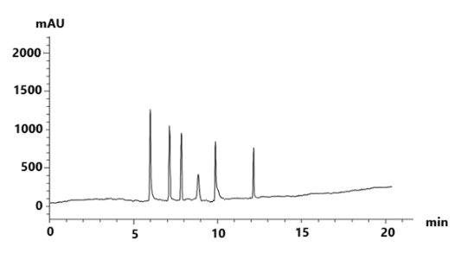
Rhamnose
Galactose
Glucose
Mannose
Arabinose
Raffinose
Supplemented Figure 1 Standard curve of monosaccharides using HPLC chromatograph.

