Table S1: Source Information of Endophytic Fungi
Glycine max (Linn.) Merr | Gleditsia japonica Miq. |  | Cannabis sativa L.
ZX-WD-S4 | ZZ1 | ZL18-3-2 | YZ9 | YH6 | XZ9 | XJ3
Z1R1 | ZS25 | ZL18-3 | YZ8-4 | YH5-1 | XZ8 | XJ2-2
Z1L5 | ZS23 | ZL18-1 | YZ8-3 | YH4 | XZ7 | XJ2-1
WDSⅡ | ZS22-1 | ZL14-2 | YZ8-2 | YH3 | XZ6 | XJ1-4
WDS6 | ZS2 | ZL14-1 | YZ8-1 | YH2 | XZ5-1 | XJ1-3
WDS5 | ZS16-2 | ZL13-3 | YZ7-2 | YH1-8 | XZ4 | XJ1-2
WDS2 | ZS16-1 | ZL13-1 | YZ7-1 | YH1-7 | XZ3 | XJ1-1
WDL2 | ZS13-2 | ZL1-2 | YZ6 | YH1-6 | XZ2-2 | XG9
W | ZS12-2 | ZL11-1 | YZ5 | YH1-5 | XZ2-1 | XG8
SY2S2-1 | ZS12-1 | ZJ29 | YZ4 | YH1-4 | XZ17 | XG7
S20-2 | ZS11 | ZJ22 | YZ3 | YH14 | XZ16 | XG6-2
Q1 | ZS010-1 | ZJ20 | YZ2 | YH1-3 | XZ14 | XG5
E1 | ZL9-2 | ZJ15-2 | YZ14-2 | YH13 | XZ13-2 | XG4-5
Y6S26 | ZL9-1 | ZJ11 | YZ14-1 | YH1-2 | XZ13-1 | XG4-4
Y6R15 | ZL8 | ZBS57 | YZ13-3 | YH12 | XZ1-3 | XG4-2
Y6r① | ZL5 | ZBS55 | YZ13-2 | YH1-17 | XZ1-2 | XG4-1
Y6L14 | ZL42-2 | ZBS53 | YZ13-1 | YH1-16 | XZ12 | XG3
Y5S11 | ZL42-1 | ZBS5 | YZ1-3 | YH1-15 | XZ1-1 | XG2-8
Y2S1 | ZL4 | ZBS49 | YZ13 | YH1-13 | XZ11 | XG2-7
Y2-2 | ZS13-2(2) | ZBS46 | YZ1-2 | YH1-12 | XZ10 | XG2-6
 | ZL32-2 | ZBS4 | YZ12 | YH1-11 | XYB1 | XG2-5
 | ZL30 | ZBS20-1 | YZ11 | YH1-10 | XY1 | XG2-4
 | ZL23 | ZB6L | YZ10 | YH1-1 | XJ6 | XG1-2
 | ZL2-2 | ZB17 | YH9 | YH11 | XJ5 | XG1-1
 | ZB14-1 | ZB15-1 | YH8 | YH10 | XJ4 | XG11
 |  |  | YH7

Table S2: Types and components of optimized fermentation media
 | Culture medium | Ingredients
T1 | Potato powder medium | Potato powder 5 g/L, peptone 10 g/L, sucrose 15 g/L, sodium chloride 0.5 g/L, pH 6.5
T2 | Soybean meal medium | Soybean meal extract 20 g/L, sucrose 15 g/L, peptone 2 g/L, yeast extract 2 g/L, dipotassium hydrogen phosphate 0.3 g/L, calcium carbonate 0.1 g/L, pH 7
T3 | Modified Martin's medium | Peptone 5 g/L, glucose 20 g/L, yeast extract 2 g/L, potassium dihydrogen phosphate 1 g/L, magnesium sulfate 0.5 g/L, pH 6.5
T4 | Potato medium (PDA) | Potato 200 g/L, Sucrose 20 g/L
T5 | Medicinal Fungus Medium | Maltose 15 g/L, dextrose 15 g/L, raw soybean meal 0.6 g/L, yeast extract 2 g/L, potassium dihydrogen phosphate 3 g/L, magnesium sulfate 1.5 g/L, pH 7.5
T6 | High-salt Chartreuse medium | Sucrose 30 g/L, sodium nitrate 3 g/L, dipotassium hydrogen phosphate 1 g/L, magnesium sulfate 0.5 g/L, ferrous sulfate 0.01 g/L, pH 6.5

Table S3 Clonostachys sp. Relatively closely related species of fungi in the order Sarcosporidiomycetes
species | Genomic resources
Claviceps arundinis | Claviceps arundinis genome assembly CSU_CCC1102_v1 - NCBI - NLM (nih.gov)
Clonostachys byssicola | Clonostachys byssicola genome assembly C_byssicola_245-78 - NCBI - NLM (nih.gov)
Clonostachys rhizophaga | Clonostachys rhizophaga genome assembly C_rhizophaga_906-72A - NCBI - NLM (nih.gov)
Clonostachys rosea f rosea | Clonostachys rosea f. rosea IK726 genome assembly C_rosea_IK726 - NCBI - NLM (nih.gov)
Clonostachys solani | Clonostachys solani genome assembly C_solani_1703 - NCBI - NLM (nih.gov)
Cordyceps javanica | Cordyceps javanica genome assembly ASM698197v1 - NCBI - NLM (nih.gov)
Fusarium acutatum | Fusarium acutatum genome assembly ASM1293201v1 - NCBI - NLM (nih.gov)

Table S4 Identification results of strain ZBS49 LC-MS
PK | Mass | RT (min) | Library Hit | Formula Finder Result
1 | 118.0864892 | 2.314694589 | Betaine | C5H11NO2
2 | 166.0861379 | 4.776090546 | Benzocaine | C9H11NO2
3 | 205.0688507 | 2.269455396 | Levamisole | C4H8N6O4
4 | 246.243155 | 10.96411939 | Pyrovalerone | C14H31NO2
5 | 250.177895 | 13.69515736 | O-Desmethyl-cis-tramadol | C13H24NNaO2
6 | 256.2631336 | 21.81570491 | Aminoflubendazol | C16H33NO
7 | 262.1292367 | 2.492333333 | Oxolinic acid | C11H19NO6
8 | 263.2370485 | 20.78183389 | Methohexital | C18H30O
9 | 274.2753279 | 12.4962869 | Fenpropidin | C16H35NO2
10 | 279.2310545 | 19.45209251 | Acecarbromal | C18H30O2
11 | 279.2320428 | 17.42864843 | Dibutyl phthalate | C18H30O2
12 | 290.0864707 | 3.441270863 | Imazethapyr | C10H12N5NaO4
13 | 296.2563089 | 12.49491125 | Pizotifen | C18H33NO2
14 | 301.1412446 | 19.04053233 | Phenmedipham | C6H17N10NaO3
15 | 302.3055859 | 13.92289758 | Fenhexamid | C18H39NO2
16 | 315.2315175 | 22.47207885 | Malaoxon | C21H30O2
17 | 325.2118021 | 21.68675477 | Quinine | C17H28N2O4
18 | 327.2270126 | 22.86320146 | Triphenylphosphate | C18H32Na2O2
19 | 329.2426749 | 24.51214602 | Stanozolol | C18H34Na2O2
20 | 333.2041904 | 14.78589747 | Sulochrin | C19H25N4Na
21 | 340.282754 | 13.92315811 | Mepenzolate | C20H37NO3
22 | 341.2065835 | 17.42604716 | Esculin | C20H29NaO3
23 | 358.3677341 | 16.6587676 | Oxybutynin | C22H47NO2
24 | 371.277657 | 19.31248344 | Thioridazine | C20H35N4NaO
25 | 373.2711102 | 23.54061717 | Aminoquinuride | No formula found
26 | 382.3073347 | 24.02600985 | Azelastine | C24H40NNaO
27 | 386.3422756 | 24.24742407 | Buspirone | C26H43NO
28 | 389.2666132 | 21.66544861 | Trimethobenzamide | C24H36O4
29 | 398.2266066 | 17.47088101 | Cefetamet | C19H31N3O6
30 | 406.3085194 | 22.88392984 | JWH-398 N-pentanoic acid metabolite | C23H44NNaOS
31 | 413.2668302 | 24.51998638 | Ziprasidone | C26H36O4
32 | 415.3030718 | 19.28213148 | Diltiazem | C25H40N2Na2
33 | 461.3241913 | 22.94552626 | Desmethyl Sildenafil | C27H41N4NaO
34 | 463.2819618 | 22.47167619 | Desoxycortone-21-3-phenylpropionate | C20H40N4Na2O5
35 | 467.2980817 | 18.42381964 | lambda-Cyhalothrin | C26H42O7
36 | 469.1104382 | 12.4801086 | Flucythrinate | C15H17N10Na5O
37 | 477.3186501 | 21.22704382 | Loperamide | C27H41N4NaO2
38 | 485.1120712 | 20.6035358 | Gallopamil | C26H25N2NaS3
39 | 501.3759085 | 21.90444453 | Tritoqualine | C28H52O7
40 | 505.3496657 | 22.76461722 | Dipyridamole | C29H45N4NaO2
41 | 577.4074581 | 24.29268662 | Tulathromycin Marker | C31H59N2Na3OS
42 | 646.4896585 | 23.09941407 | Aconitine | C36H63N5O5

Table S Clonostachys sp. Genomic characteristics
characteristic | numerical value
Gene Total Len （bp） | 56975717
Total Scaf No. | 2135
Scaf N50 （bp） | 455082
Scaf N90 （bp） | 66079
G+C （%） | 49.84
repeat In Genome （%） | 0.073
protien coding gene | 18425
Genes assigned to COGs | 14999

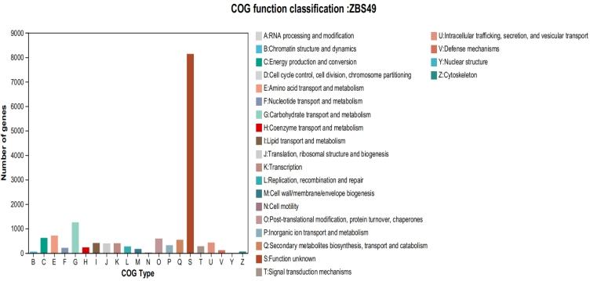
Fig. S1COG annotation classification statistical chart

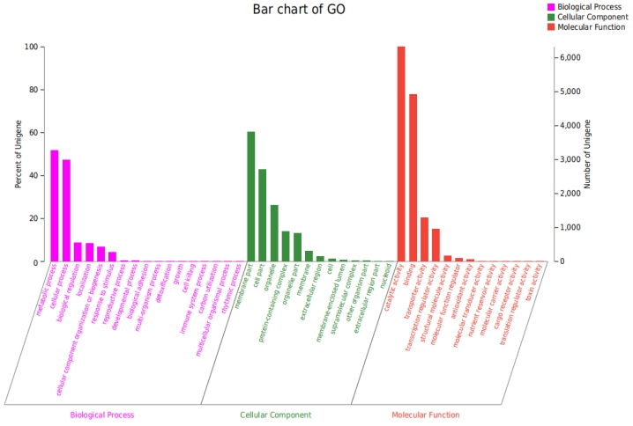
Fig. S2 GO annotation classification statistical chart
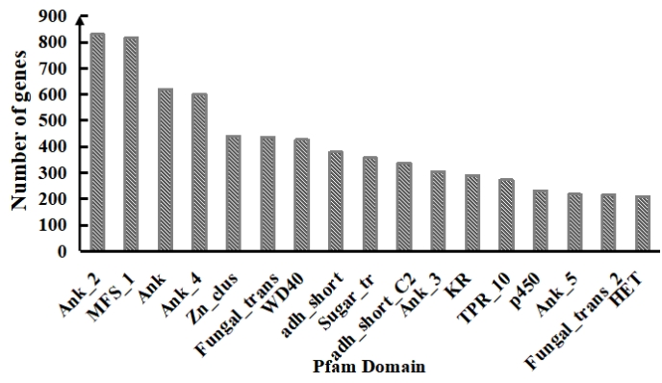
Fig. S3 ZBS49 genome sequence pfam domain

