Supplementary information for:
Region-based segmental swapping of homologous enzymes for higher cadaverine production
Seungjin Kim^{1,2,}†, Dae-yeol Ye¹†, Hyun Gyu Lim², Myung Hyun Noh^{3*}, Jae-Seong Yang^{4*}, and Gyoo Yeol Jung^{1,5*}

¹Department of Chemical Engineering, Pohang University of Science and Technology, 77 Cheongam-Ro, Nam-Gu, Pohang, Gyeongbuk 37673, Korea.
²Department of Biological Sciences and Bioengineering, Inha University, 100 Inha-Ro, Michuhol-Gu, Incheon 22212, Korea
³Research Center for Bio-based Chemistry, Korea Research Institute of Chemical Technology (KRICT), 406-30, Jongga-ro, Jung-gu, Ulsan, 44429, Korea.
⁴Centre for Research in Agricultural Genomics (CRAG), CSIC-IRTA-UAB-UB, Campus UAB, Bellaterra, Barcelona 08193, Spain.
⁵School of Interdisciplinary Bioscience and Bioengineering, Pohang University of Science and Technology, 77 Cheongam-Ro, Nam-Gu, Pohang, Gyeongbuk 37673, Korea.
*Correspondence: mhnoh@krict.re.kr (M.H.N.); jaeseong.yang@cragenomica.es (J-S.Y); gyjung@postech.ac.kr (G.Y.J.);
Tel.: +82-54-279-2391 (G.Y.J.)
† These authors contributed equally to this work.

Contents
Table S1– S2
Fig. S1 – S2

Supplementary Table

Table S1. Strains and plasmids used in this study.
Name | Description | Antibiotic resistance | Source
Strains
E. coli BL21(DE3) | E. coli F − ompT gal dcm lon hsdSB (rB− mB−) λ(DE3) | None | Invitrogen
E. coli Mach1-T1R | A cloning host | None | Invitrogen
BLL | E. coli BL21(DE3) / pUC_ldcC | Kan | This study
BLC | E. coli BL21(DE3) / pUC_cadA | Kan | This study
BLCL1 | E. coli BL21(DE3) / pUC_CL1 | Kan | This study
BLCL2 | E. coli BL21(DE3) / pUC_CL2 | Kan | This study
BLCL3 | E. coli BL21(DE3) / pUC_CL3 | Kan | This study
BLCL4 | E. coli BL21(DE3) / pUC_CL4 | Kan | This study
BLCL5 | E. coli BL21(DE3) / pUC_CL5 | Kan | This study
BLCL6 | E. coli BL21(DE3) / pUC_CL6 | Kan | This study
Plasmids
pUC_kan | pMB1-derived ori, kanR gene | Kan | [1]
pUC_ldcC | pMB1-derived ori, kanR gene, P_{HCE}-ldcC | Kan | This study
pUC_cadA | pMB1-derived ori, kanR gene, P_{HCE}-cadA | Kan | This study
pUC_CL1 | pMB1-derived ori, kanR gene, P_{HCE}-ldcC region1-cadA region2,3,4,5,6 | Kan | This study
pUC_CL2 | pMB1-derived ori, kanR gene, P_{HCE}-cadA region1-ldcC region2-cadA region3,4,5,6 | Kan | This study
pUC_CL3 | pMB1-derived ori, kanR gene, P_{HCE}-cadA region1,2-ldcC region3-cadA region4,5,6 | Kan | This study
pUC_CL4 | pMB1-derived ori, kanR gene, P_{HCE}-cadA region1,2,3-ldcC region4-cadA region5,6 | Kan | This study
pUC_CL5 | pMB1-derived ori, kanR gene, P_{HCE}-cadA region1,2,3,4-ldcC region5-cadA region6 | Kan | This study
pUC_CL6 | pMB1-derived ori, kanR gene, P_{HCE}-cadA region1,2,3,4,5-ldcC region6 | Kan | This study
ªAbbreviations: Km, kanamycin.

Table S2. Oligonucleotide sequences used in this study.
Name | Sequence (5′−3′)ª
VEC_F (CL6_vec_F) | ggatgagagaagattttcagcctg
VEC_B | gctagcttggcgtaatcatgg
HCE_F | tatgaccatgattacgccaagctagcttgatctctccttcacagattccc
HCE_B (CL1_vec_B) | atggatatctcctttttccagaagtgtg
ldcC_genome_F | cacacttctggaaaaaggagatatccatatgaacatcattgccattatgggac
ldcC_genome_B | caggctgaaaatcttctctcatccttatcccgccatttttaggactcg
cadA_genome_F | cacacttctggaaaaaggagatatccatatgaacgttattgcaatattgaatcacatg
cadA_genome_B | caggctgaaaatcttctctcatccttattttttgctttcttctttcaataccttaacgg
CL1_ins_F | cacacttctggaaaaaggagatatccatatgaacatcattgccattatgggac
CL1_ins_B | ggcagaatagtgttgatatattcgtcagtgtactgacgcatacgaatggc
CL1_vec_F | actgacgaatatatcaacactattctgc
CL2_ins_F | aagatattgctaataagatcaagcagaccaccgacgaatatcttgataacattacacc
CL2_vec_B | ggtctgcttgatcttattagcaatatctt
CL2_ins_B | gggtcagcgatttgtggcagttacggtcgatcaacagcgtactgccg
CL2_vec_F | gaccgtaactgccacaaatcg
CL3_ins_F | ctgctccagcaggcagcaccattctgattgaccgcaattgtcataaatcgctg
CL3_vec_B | aatcagaatggtgctgcctg
CL3_ins_B | cagcagtttgtgagtggactgggtttcgaagatcacttttcccgcaacac
CL3_vec_F | gaaacccagtccactcacaaac
CL4_ins_F | gccgtgtagaagggaaagtgatttacgaaacgcaatcgacccacaaa
CL4_vec_B | gtaaatcactttcccttctacacgg
CL4_ins_B | gatcgggtcaagatacatgtgctcgttatccgcatcgttaaagccg
CL4_vec_F | aacgagcacatgtatcttgaccc
CL5_ins_F | cacctggcacggcttcaaaaacatcgatgccgatcatatgtttctcgatcc
CL5_vec_B | atcgatgtttttgaagccgtgc
CL5_ins_B | tgcgcgatacatcagatccggcagattgtgtttacgaatcagcttatggatcc
CL5_vec_F | aatctgccggatctgatgtatcg
CL6_ins_F | aatatccacaaactgattgttcaccacgatcttcccggtttgatgttgc
CL6_vec_B | gtggtgaacaatcagtttgtggat
CL6_ins_B | caggctgaaaatcttctctcatcc
The bold sequences represent the priming sites.
The non-bold sequences were added as overhangs to provide homology for Gibson assembly.

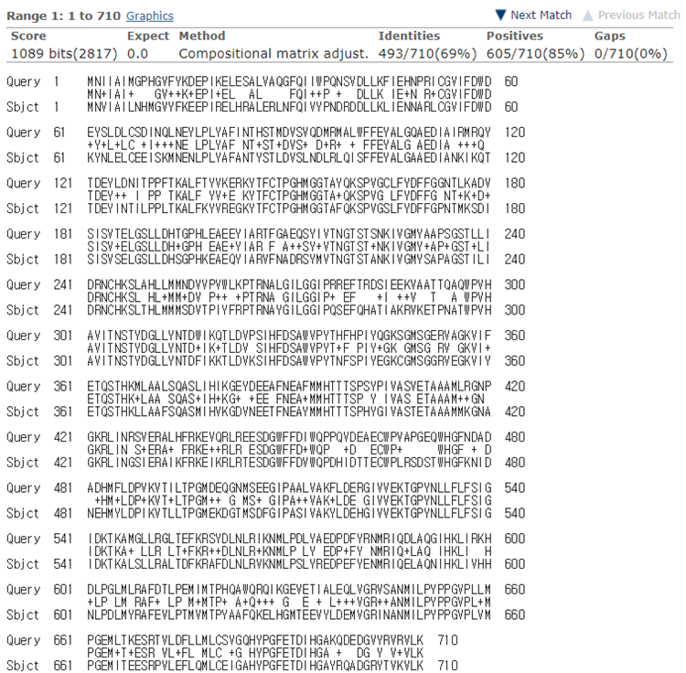
Supplementary figures

Fig. S1. Sequence comparison between CadA and LdcC
Query sequence is the amino acid sequence of CadA (715 amino acid, NCBI accession number: QNG34951.1). Subject sequence is LdcC (713 amino acid, NCBI accession number: GCI02210.1) BLASTP was used for the sequence alignment (https://blast.ncbi.nlm.nih.gov/Blast.cgi).

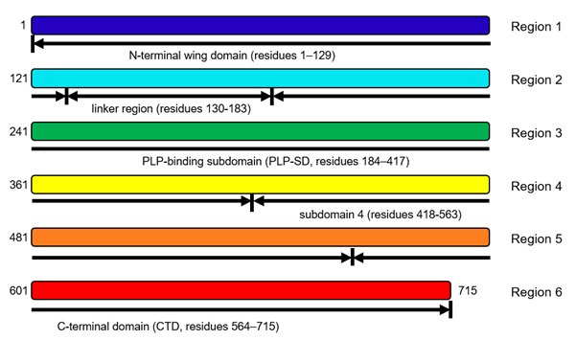

Fig. S2. Detailed domain view of LdcC and replaced regions.

Different colors indicate different regions. The number is based on LdcC structure (PDB ID: 3N75).

Reference
1. Kim S, Jin SH, Lim HG, Lee B, Kim J, Yang J, et al. Synthetic cellular communication-based screening for strains with improved 3-hydroxypropionic acid secretion. Lab Chip. 2021;21:4455–63.

