Sortase-Mediated Surface Display of a Chimeric Immunogen on Bacillus subtilis: A Chicken Necrotic Enteritis Vaccine Candidate

Bassima Al-Aneed¹, Hoang Duc Nguyen², Ali Akbar Masoudi¹*, Saghi Nooraei³, Abbas Hajizade4, Hossein Tarrahimofrad3, Gholamreza Ahmadian3*, Jamshid Razmyar5, Moeen Khatami3

- Department of Animal Science, Faculty of Agriculture, Tarbiat Modares University, P.O. Box 14115–336, Pajoohesh Blvd, 149771311 Tehran, Iran
- Vietnam National University, Ho Chi Minh City, Vietnam
- Department of System Biotechnology, National Institute of Genetic Engineering and Biotechnology (NIGEB), P. O. BOX: 14155-6343, Tehran 1497716316, Iran
- Applied Microbiology Research Center, Systems Biology and Poisonings Institute, Baqiyatallah University of Medical Sciences, Tehran, IRAN
- University of Tehran, Faculty of Veterinary Medicine, Tehran, IRAN
*Corresponding authors:
Ali Akbar Masoudi: masoudia@modares.ac.ir,
Gholamreza Ahmadian: ahmadian@nigeb.ac.ir

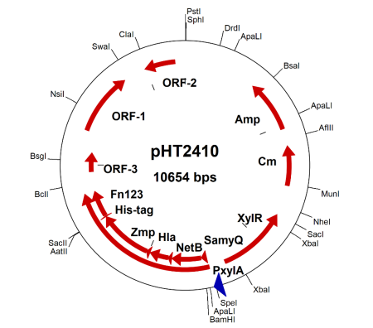
Figure S1. The schematic of the pHT2410 vector

