Supplementary Table
Table S1. Target panel strains and culture conditions
Strain Name | Strain Origin | Growth Medium | Culture Temp (℃)
Fungi
Debaryomyces hansenii | In lab | PDA | 28
Alternaria alterata | In lab | PDA | 28
Alternaria solani | In lab | PDA | 28
Botrytis cinerea | In lab | PDA | 25
Colletotrichum gloeosporioides | In lab | PDA | 28
Fusarium | In lab | PDA | 28
Fusarium solani | In lab | PDA | 28
Geotrichum | In lab | PDA | 28
Penicillium | In lab | PDA | 28
Penicillium citreo-virde | In lab | PDA | 28
Pestalotipsis funerea sp. | In lab | PDA | 28
Rhizopus nigricans | In lab | PDA | 28
Rhizopus oryzae | In lab | PDA | 28
Sclerotinia sclerotiorum | In lab | PDA | 28
Streptomyces lavendulae | In lab | PDA | 28
Trichoderma viride | In lab | PDA | 28
Aspergillus flavus | In lab | PDA | 28
Gram-positive
Staphyloccocus aureus | In lab | LB | 37
Micrococcus luteus | In lab | LB | 37
Streptococcus agalactiae | In lab | LB | 37
Bacillus beleister J22-1 | In lab | LB | 37
Bacillus subtillis 1560 | In lab | LB | 37
Bacillus licheniformis XS-4 | In lab | LB | 37
Gram-negative
Shigella Castellani | In lab | LB | 37
Escherichia coli | In lab | LB | 37
salmonella enteritidis | In lab | LB | 37
Bacillus amyloliquefaciens 1841 | CGMCC No. 19463 | LB/landy/BOM | 37/30
Bacillus amyloliquefaciens M86 | ARTP in study | LB/landy/BOM | 37/30
Bacillus amyloliquefaciens M18 | ARTP in study | LB/landy | 37/30
Bacillus amyloliquefaciens M19 | ARTP in study | LB/landy | 37/30
Bacillus amyloliquefaciens M29 | ARTP in study | LB/landy | 37/30
Bacillus amyloliquefaciens M45 | ARTP in study | LB/landy | 37/30
Bacillus amyloliquefaciens M54 | ARTP in study | LB/landy | 37/30
Bacillus amyloliquefaciens M79 | ARTP in study | LB/landy | 37/30
Bacillus amyloliquefaciens M80 | ARTP in study | LB/landy | 37/30

Table S2. RT-qPCR primers and primer sequences used in this study
Primer | Sequence（5’-3’） | Primer | Sequence（5’-3’）
16s-F | TCCACGATTACTAGCGATTC | locD-F | CATGCGTTAAAGGCAGCCAA
16s-R | AGCAAGCGGACCTCATAA | locD-R | GGTTCAACTGGTGACCCCAA
FenA-F | CTGTGCGGATGATTGAAGCG | bacD-F | CTCGAAAACTGCGCAACACA
FenA-R | AGGCGTTTTCTTGTTTCCGC | bacD-R | CATCCAATAACAGCTGCGCC
FenB-F | TCGTGACCGAAAAGGACCTG | epsC-F | TGATATCGGCGGACTTCGTG
FenB-R | GACATACGCCCAATTTCCGC | epsC-R | GTCAGACAGGACAGCGGAAA
FenC-F | TCGCCGCGTACAATACGTTA | DfnA-F | GGCGTTTTTGCCTCTTCGTT
FenC-R | TGTTGACGAACATGCCGAGA | DfnA-R | ATCAGACGGCGTATCGTGTC
FenD-F | TGCAATGTTTGAACGGCAGG | DfnD-F | GATCGCGACCAATGTGCTTC
FenD-R | GGGCCAGCTTATTAGCCGAT | DfnD-R | TGGTTGAATATGGTGCGGCT
FenE-F | AGGCGTTCAGCTATCATCCG | DfnE-F | GGTATACAGTGCCGAGTCCG
FenE-R | GCATCCGATTCCTTTTCCGC | DfnE-R | TCTCCGAGTTCAGTACCCGT
BmyD-F | CGATGCCGGTTAGATGGACA | DfnF-F | TATTGCGATCGTCGGGATGG
BmyD-R | GAAAGCGGGGGAACATCAGA | DfnF-R | GGAACGAGGCACTTCCGTTA
bmyA-F | ACAACCGCAATTTGTCCAGC | DfnG-F | CTATCCGTTCAGAGCCGACC
bmyA-R | CCCGAAAAGGTTAACCCCGA | DfnG-R | TTGTTGAACGGCTCGGATGA
BmyB-F | GTACGTTGCGGCAAGTGTTT | DfnH-F | CGAAAAACAGCCGCACTGAA
BmyB-R | CATACGCTTGGTTCGCTTCG | DfnH-R | GTTCCCTGCCCTGTCGTAAA
bmyC-F | AGCAAGCGGCGATTGTTTTT | DfnI-F | ACCGGTCTCTGAAACGCAAT
bmyC-R | CTGCCATAATGCCGACAAGC | DfnI-R | ATATCTTTCAGCTCGGCGGG
BaeR-F | GATCGCCGTCTTCAATTGCC | DfnJ-F | GCGTATGACGGATACACGGT
BaeR-R | TTTAAGCAAAAACGGCCGGG | DfnJ-R | AGGCGTTTATGGGCATTCCA
BaeN-F | AAGGCCCTTCACTTTCGGAG | yplP-F | GAAGGCGCATTAAACAGGGC
BaeN-R | CGCAATATACGCAAACGGCA | yplP-R | GTATCACCAAGATCCGCCGT
BaeM-F | GATGGCGGGCAAATAAGCAG | ykvP-F | TTATACGGAAGGGTATTCGC
BaeM-R | CACCGAACCAACCGGACTAA | ykvP-R | TTTTGCAAACCGATAACGAC
BaeL-F | TGAACGGCGTACTCGGAAAA | xkdE-F | TGTCAGAAGCATCGTACAAA
BaeL-R | GAAGCATAAGCAGCTCGCAC | xkdE-R | CAATCAGCAGAAACTTGTGG
BaeJ-F | CATCGTCGCTGCAAGAATGG | cotJA-F | TGACGCTTTATCTGGATACG
BaeJ-R | ACAGATCAAGACTTGGCGGG | cotJA-R | TGTCTTGAGTACCGGGAATA
BaeG-F | CGGACTCCGAGCAGGTAATC | gutR-F | CATTGCATACATGTCAGACG
BaeG-R | TGAAAGAAAAAGCGGTGGCG | gutR-R | TCCAATAATGAGTAGCCTGC
BaeE-F | GAAATTCCGCGGTACATGCC | ydzE-F | TCGTCACAACGTATTCCATT
BaeE-R | GCGGAGCCGATAACAGATGA | ydzE-R | ATAAAAGTCCGCCCCATATC
BaeD-F | AAAAAGCGCTTGTACGGCTG | GE01829-F | AACAATACATGAATGCGCTG
BaeD-R | CGGGAGAGCGGGAACATATC | GE01829-R | TTTTATGGCGCACAAACATT
baeC-F | CTGCTGCAAACAGCGCATTA | xdhA-F | GACAAATATCGCAAACCTGG
baeC-R | TCCAACCTTCACAAGACGCA | xdhA-R | ATTCTGCTGTCACATCACTT
MlnG-F | CCGCTGTCGCTTTAATCAGC | ywdK-F | AGGAAGCCTGTACGTATTGA
MlnG-R | AAGCCGCTTCTTTGCAAGTG | ywdK-R | CCAAGAGATGATAAACGCCA
MlnF-F | AGTTCCGGCAACGATGACTT | ywfA-F | TTCCGATCGGCTCTTTTATC
MlnF-R | CGCTTTTCCTTTATCCGGCG | ywfA-R | TTCTGTTTTATCCCCATCCG
MlnE-F | TCAAAGTCTGGACGCTGACC | GE03075-F | CTGGGTAAAGAATTGAGGCT
MlnE-R | AGTCTTTCGATCCCGCGTTT | GE03075-R | CTTTCACGAAAGAGTCATGC
MlnD-F | AATTGATTCCAGGCCGCTGA | GE03080-F | GTTTGGAAAAGGCGTATCTG
MlnD-R | GCGGCAGACCGATCAAAATC | GE03080-R | GATCCCGCTTAACTCATCAT
MlnC-F | TCCGAACCGTAACCTCTCCT | yqeW-F | ATGATTCTCGACACGAATGT
MlnC-R | TATGGGGCGGAAAAACGGAA | yqeW-R | GATCTGCCTGAACGGATATT
MlnB-F | CACTTTCAGCACTCCGGCTA | yqgH-F | TTTTAAATCAAGCGGAACGG
MlnB-R | CAGAAATGCTGCGGAATCGG | yqgH-R | ATCAGCGGAAATCGATGTAA
MlnA-F | CTCATCCAGTCCGATCACGG | ytrB-F | ATGTCAAGTCTGTCGTTGAA
MlnA-R | TATACTGCGCTTTTTGCGGC | ytrB-R | AAGCTCCATATTGGCTTTGA
srfAC-F | GGGAACGCAAACAGTGTGTC | ytrC-F | GAAAGAGAGATTAACGGGCT
srfAC-R | ACATTCCGGTGCAGCTGTTA | ytrC-R | CAATGATCACCAAATCAGGC
srfAB-F | GCAGCTTCTTAATCTGCGCC | ytrC2-F | TGTTCCGCTATCGTAAAGAG
srfAB-R | TGTTGGATCTGCCGCTTGAT | ytrC2-R | TTTTGACCTCGTGAATCCAT
srfAA-F | TCATCTATCAGCACGCCGAC | ytrD-F | GCTGAATAAACAAGAGGTGC
srfAA-R | CTGGCTGAACATGACCACCT | ytrD-R | GATAACGGCAGGAGTATGTT
locC-F | TTAACATCGGGATGGCGGAG | ytrE-F | ACTGACTCATTTACCGCTTT
locC-R | CGTTTGAAAAAGGCCAGCGA | ytrE-R | TTTTCATGTCGCCGTTTATG
mycB-F | CGGAAGCTGAGCGTGATTTG | ytrF-F | TATGGCTGCTTTGTCATCAT
mycB-R | AAAGCCGACGTCTTACGGAG | ytrF-R | GGAAAGAATACGCCCCTAAA
locB-F | CCCTTGTTTGGGATACGCCT | DegU-F | CAACGAATTCCGCCGTCTTG
locB-R | GGTTTACCGCTCAGTTCCCA | DegU-R | CTGCAAGCATTTGCAGCACT
locA-F | AAAACGCCAATTGACCAGCC
locA-R | ATTTAGGGCGCTGCTGGTAG

Table S3. Information of in M86 mutation site after ARTP mutation
Position | Reference base | Mutant base | Gene ID | Gene name | Mutant  region | CDS mutation location | Protein mutati | Mutation type
 |  |  |  |  |  |  | location | Mutation type
312941 | T | TC | GE00285, GE00286, | GEO00285, yoaW, yndM, GEO00288 | upstream | —— | —— | Indel
312941 | T | TC | GE00287; GE00288
814535 | T | TC | GE00682, GE00683, GE00684 | ykvZ, GE00683, ykvY | upstream | —— | —— | Indel
1862323 | A | AC | GE01757, GE01758 | ycgO, ycgN | upstream | —— | —— | Indel
2434315 | C | CT | GE02256, GE02257 | yxjB, ycgN | downstream | —— | —— | Indel
824120 | A | AC | GE00696 | ykvP | exonic | 666dupG | F223fs | Indel
1434230 | T | TC | GE01329 | cotJA | exonic | 223dupG | E75fs | Indel
2334423 | T | TG | GE02167 | xdhA | exonic | 2007dupG | M669fs | Indel
2544952 | C | CG | GE02367 | ywfA | exonic | 759dupG | P253fs | Indel
3226061 | A | AG | GE03075 | GE03075 | exonic | 810dupG | Q270fs | Indel
973123 | G | T | GE00859 | GE00859 | exonic | G36T | G12G | SNP
1478636 | A | G | GE01366 | GE01366 | exonic | A552G | Q184Q | SNP
3230327 | A | G | GE03080 | GE03080 | exonic | A846G | V282V | SNP
43129 | C | T | GE00065 | yplP | exonic | C331T | R111C | SNP
935417 | C | T | GE00815 | xkdE | exonic | C808T | P270S | SNP
1523048 | A | G | GE01407 | gutR | exonic | A1204G | N402D | SNP
1608279 | G | T | GE01515 | ydzE | exonic | G325T | V109F | SNP
1937127 | T | A | GE01829 | GE01829 | exonic | T104A | L35Q | SNP
2524508 | C | G | GE02348 | GE02348 | exonic | C277G | Q93E | SNP
3230388 | C | A | GE03080 | GE03080 | exonic | C907A | P303T | SNP
3689973 | A | G | GE03535 | yqeW | exonic | A272G | D91G | SNP
3729485 | G | A | GE03578 | yqgH | exonic | G365A | G122E | SNP

Table S4. One-way analysis of variance for the Plackett-Burman test
Source | Sum of Squares | Degrees of freedom | Mean Square | F-value | P-value
Model | 10872.99 | 4 | 2718.25 | 10.53 | 0.0070
A-K₂HPO₄ | 6717.11 | 1 | 6717.11 | 26.03 | 0.0022
B-Gly | 4753.69 | 1 | 4753.69 | 18.42 | 0.0051
C-Yeast powder | 739.02 | 1 | 739.02 | 2.86 | 0.1416
D-Ser | 1655.09 | 1 | 1655.09 | 6.41 | 0.0445
Residual | 1548.48 | 6 | 258.08
Lack of Fit | 1279.24 | 5 | 255.85 | 0.9503 | 0.6480
Pure Error | 269.24 | 1 | 269.24
Cor Total | 12421.46 | 10
R²=0.8753; Pred R² = 0.58; Adeq Precision =10.1487; Adj R² = 0.7922

Table S5. Box Behnken test combinations and results
Clusters | K₂HPO₄  (g/L) | Gly  (g/L) | Ser  (g/L) | Yeid(mg/L)
1 | 1.5 | 2.9 | 0 | 451.50
2 | 2.5 | 2.9 | 0 | 546.33
3 | 1.5 | 3.7 | 0 | 482.33
4 | 2.5 | 3.7 | 0 | 651.33
5 | 1.5 | 0 | 0.6 | 579.83
6 | 2.5 | 0 | 0.6 | 626.00
7 | 1.5 | 0 | 1.0 | 498.83
8 | 2.5 | 0 | 1.0 | 618.83
9 | 0 | 2.9 | 0.6 | 634.50
10 | 0 | 3.7 | 0.6 | 563.83
11 | 0 | 2.9 | 1.0 | 668.83
12 | 0 | 3.7 | 1.0 | 653.50
13 | 0 | 0 | 0 | 646.83
14 | 0 | 0 | 0 | 649.17
15 | 0 | 0 | 0 | 635.83
16 | 0 | 0 | 0 | 621.67
17 | 0 | 0 | 0 | 645.50
Ignore. We constructed the model because the value of 10 clusters was off.
Supplementary Figures
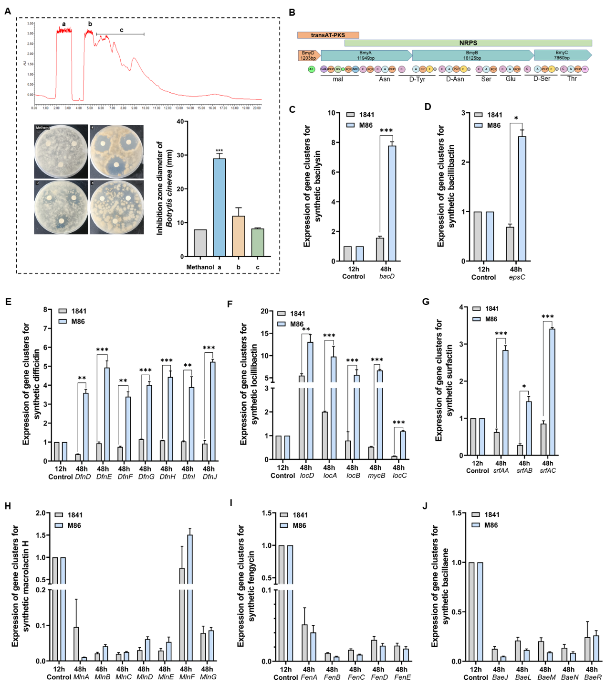
Figure S1. Mass spectrometry information of bacillomycin L homologues and mRNA expression differences in other lipopeptide synthesis gene clusters
A. First fractionation preparation of lipopeptides by HPLC. B. Prediction of structural domains within the bacillomycin L synthetic cluster using antiASMHS. C. Gene expression of Bacilysin synthesis gene cluster. D. Gene expression of Bacilllibactin synthesis gene cluster. E. Gene expression of difficidin synthesis gene cluster. F. Gene expression of locillibactin synthesis gene cluster. G. Gene expression of surfactin synthetic gene cluster. H. Gene expression of Macrolactin H synthesis gene cluster. I. Gene expression of Fengycin synthesis gene cluster. J. Gene expression of Bacillaene synthesis gene cluster. All data are presented as mean ± standard deviation (error bar; n = 3).

