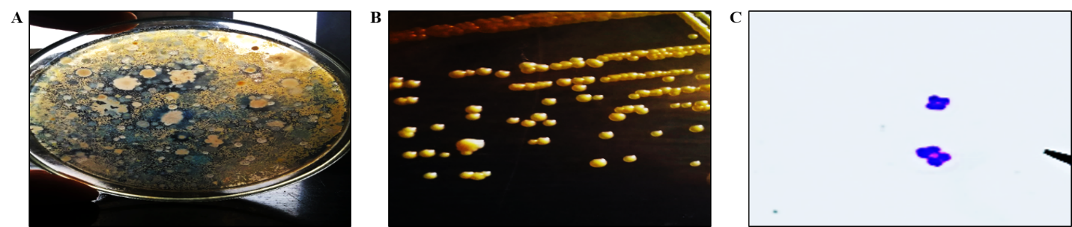
Fig. S1 The yellow-pigmented colonies of M. luteus from the soil sample (A). The characteristic yellow colonies of M. luteus on nutrient agar (B). Tetrad arrangement of M. luteus under 100-X magnification using a light microscope (C).

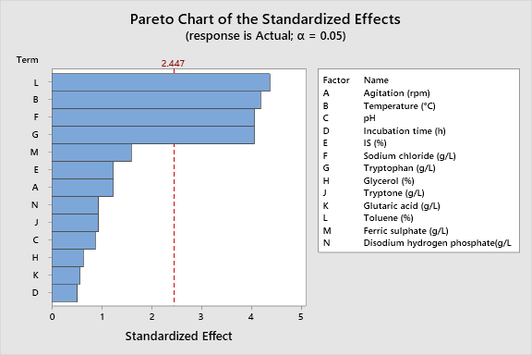

Fig. S2 Pareto chart of PBD.


Fig. S3 The TLC plate showed a retardation factor of 0.89 (characteristic of β-carotene).

Table S1 The examined physicochemical parameters in OFAT experiments.
Parameters | Values
Medium | Peptone broth (PB) | NB |  |  | Luria Bertani broth (LBB) |  | Tryptic soya broth (TSB) |  |  | Brain heart infusion broth (BHIB)
Agitation (rpm) | 0 | 30 |  |  | 60 |  | 120
Temperature (℃) | 25 | 30 |  |  | 37 |  | 40
pH | 5 | 6 |  |  | 7 |  | 8 |  |  | 9
Incubation time (h) | 24 | 48 |  |  | 72 |  | 96 |  |  | 120
Inoculum size (%) | 1 | 2 |  |  | 3 |  | 4
Inorganic salt (5 g/l) | Magnesium bromide |  | Potassium bromide |  |  | Calcium bromide |  |  | Sodium chloride
Amino acid (5 g/l) | Tryptophan |  |  | Serine |  |  | Arginine
Carbon source (5 g/l) | Mannitol | Glycerol |  |  | Sucrose |  |  | Glucose
Nitrogen source (5 g/l) | Peptone | Tryptone |  |  | Ammonium sulphate |  |  | Sodium nitrate
Organic acid (5 g/l) | Glutaric acid |  |  | Salicylic acid |  |  | Ascorbic acid
Organic solvent (0.5%) | Benzene |  |  | Toluene |  |  | Petroleum ether
Ferric (5 g/l) | Ferric chloride |  |  | Ferric hydroxide |  |  | Ferric sulphate
Phosphate (5 g/l) | Dipotassium hydrogen phosphate |  |  | Disodium hydrogen phosphate |  |  | Diammonium hydrogen phosphate

Table S2 Sequences of primers used in qRT-PCR.
Genes | Primer sequences | References
gelE | F: 5'- TATGACAATGCTTTTTGGGAT -3'  R: 5'- AGATGCACCCGAAATAATATA -3 | [41]
16s rRNA (internal control) | F: 5'-GTCGAACGCTTCTTTCCTCC -3'  R: 5'- AGCGCCTTTCACTCTTATGC -3' | [42]

Table S3 Result of PBD experiment.
Run | Agitation (rpm) | Temperature (°C) | pH | Incubation time (h) | IS (%) | Sodium chloride (g/l) | Tryptophan (g/l) | Glycerol (%) | Tryptone (g/l) | Glutaric acid (g/l) | Toluene (%) | Ferric sulphate (g/l) | Disodium hydrogen phosphate (g/l) | Actual | Predicted
1 | 120 | 37 | 5 | 24 | 1 | 0 | 5 | 0 | 5 | 0 | 5 | 5 | 5 | 0.85 | 0.869
2 | 0 | 25 | 5 | 24 | 1 | 0 | 0 | 0 | 0 | 0 | 0 | 0 | 0 | 0.2 | 0.294
3 | 120 | 37 | 7 | 96 | 2 | 5 | 5 | 0 | 0 | 5 | 5 | 0 | 5 | 0.9 | 0.956
4 | 0 | 25 | 5 | 96 | 1 | 5 | 0 | 5 | 5 | 5 | 5 | 0 | 0 | 0.69 | 0.662
5 | 120 | 37 | 7 | 24 | 1 | 5 | 5 | 0 | 5 | 5 | 0 | 0 | 0 | 0.83 | 0.823
6 | 120 | 37 | 7 | 96 | 1 | 0 | 5 | 5 | 0 | 5 | 5 | 0 | 0 | 0.82 | 0.84
7 | 120 | 37 | 5 | 24 | 2 | 5 | 0 | 5 | 5 | 0 | 0 | 0 | 0 | 0.72 | 0.702
8 | 120 | 25 | 7 | 96 | 2 | 5 | 0 | 0 | 5 | 5 | 0 | 5 | 5 | 0.63 | 0.691
9 | 120 | 25 | 7 | 24 | 2 | 5 | 5 | 5 | 0 | 0 | 5 | 5 | 0 | 0.86 | 0.894
10 | 0 | 37 | 7 | 96 | 2 | 0 | 0 | 5 | 5 | 0 | 5 | 5 | 0 | 0.73 | 0.77
11 | 0 | 25 | 5 | 24 | 2 | 0 | 5 | 0 | 5 | 5 | 5 | 5 | 0 | 0.77 | 0.718
12 | 0 | 25 | 7 | 24 | 2 | 0 | 5 | 5 | 5 | 5 | 0 | 0 | 5 | 0.59 | 0.601
13 | 120 | 25 | 5 | 24 | 1 | 5 | 0 | 5 | 0 | 5 | 5 | 5 | 5 | 0.74 | 0.739
14 | 120 | 25 | 7 | 96 | 1 | 0 | 0 | 0 | 5 | 0 | 5 | 0 | 5 | 0.62 | 0.588
15 | 0 | 25 | 7 | 96 | 1 | 5 | 5 | 0 | 0 | 0 | 0 | 5 | 0 | 0.71 | 0.663
16 | 0 | 37 | 5 | 96 | 1 | 5 | 5 | 5 | 5 | 0 | 0 | 5 | 5 | 0.85 | 0.856
17 | 120 | 37 | 5 | 96 | 2 | 0 | 0 | 0 | 0 | 5 | 0 | 5 | 0 | 0.64 | 0.604
18 | 120 | 25 | 5 | 96 | 2 | 0 | 5 | 5 | 0 | 0 | 0 | 0 | 5 | 0.62 | 0.58
19 | 0 | 37 | 7 | 24 | 2 | 5 | 0 | 0 | 0 | 0 | 5 | 0 | 5 | 0.87 | 0.814
20 | 0 | 37 | 7 | 24 | 1 | 0 | 0 | 5 | 0 | 5 | 0 | 5 | 5 | 0.61 | 0.586

Table S4 Response surface model analysis by ANOVA.
Source | DF | Adj SS | Adj MS | F-Value | P-Value
Model | 14 | 4.92267 | 0.35162 | 216.66 | 0.000 | Significant
Linear | 4 | 0.24165 | 0.06041 | 37.22 | 0.000
Temperature (°C) | 1 | 0.01392 | 0.01392 | 8.58 | 0.010
Sodium chloride (g/l) | 1 | 0.03043 | 0.03043 | 18.75 | 0.001
Tryptophan (g/l) | 1 | 0.14897 | 0.14897 | 91.79 | 0.000
Toluene (%) | 1 | 0.04368 | 0.04368 | 26.91 | 0.000
Square | 4 | 4.77499 | 1.19375 | 735.57 | 0.000
Temperature (°C)*Temperature (°C) | 1 | 3.11669 | 3.11669 | 1920.46 | 0.000
Sodium chloride (g/l)*Sodium chloride (g/l) | 1 | 0.79833 | 0.79833 | 491.92 | 0.000
Tryptophan (g/l)*Tryptophan (g/l) | 1 | 0.28158 | 0.28158 | 173.50 | 0.000
Toluene (%)*Toluene (%) | 1 | 0.65682 | 0.65682 | 404.72 | 0.000
2-Way Interaction | 6 | 0.01325 | 0.00221 | 1.36 | 0.289
Temperature (°C)*Sodium chloride (g/l) | 1 | 0.01000 | 0.01000 | 6.16 | 0.025
Temperature (°C)*Tryptophan (g/l) | 1 | 0.00000 | 0.00000 | 0.00 | 1.000
Temperature (°C)*Toluene (%) | 1 | 0.00202 | 0.00202 | 1.25 | 0.280
Sodium chloride (g/l)*Tryptophan (g/l) | 1 | 0.00022 | 0.00022 | 0.14 | 0.715
Sodium chloride (g/l)*Toluene (%) | 1 | 0.00090 | 0.00090 | 0.55 | 0.467
Tryptophan (g/l)*Toluene (%) | 1 | 0.00010 | 0.00010 | 0.06 | 0.807
Error | 16 | 0.02597 | 0.00162
Lack-of-Fit | 10 | 0.02548 | 0.00255
Pure Error | 6 | 0.00049 | 0.00008
Total | 30 | 4.94864

Table S5 VITEK 2 compact system biochemical profile of E. faecalis.

Well number | Test | E. faecails | Well number | Test | E. faecails
2 | AMY | + | 32 | POLYB | +
4 | PIPLC | - | 37 | dGAL | +
5 | Dxyl | - | 38 | dRIB | +
8 | ADHI | + | 39 | ILATk | -
9 | BGAL | - | 42 | LAC | +
11 | AGLU | + | 44 | NAG | +
13 | APPA | - | 45 | dMAL | +
14 | CDEX | + | 46 | BACI | +
15 | AspA | + | 47 | NOVO | +
16 | BGAR | - | 50 | NC6.S | +
17 | AMAN | - | 52 | dMAN | +
19 | PHOS | - | 53 | dMNE | +
20 | LeuA | - | 54 | MBdG | +
23 | ProA | - | 56 | PUL | -
24 | BGURr | - | 57 | dRAF | -
25 | AGAL | - | 58 | 0129R | -
26 | PyrA | + | 59 | SAL | +
27 | BGUR | - | 60 | SAC | +
28 | AlaA | + | 62 | dTRE | +
29 | TyrA | + | 63 | ADH2s | +
30 | Dsor | + | 64 | OPTO | +
31 | URE | -

Table S6 Resistance pattern of E. faecalis (n = 20)
Resistotypes | Resistance pattern | Isolates | Percentage
I | AP, CIP, E, TE | 1, 10, 15, 19 | 20%
II | CIP, E, TE | 2, 3, 5, 6, 7, 8, 9, 11, 12, 13, 14, 15, 16, 17, 18, 19, 20. | 75%
III | AP, E, TE | 4 | 5%
AP: ampicillin, CIP: ciprofloxacin, E: erythromycin, TE: tetracycline, VAN: vancomycin.

Table S7 Average ODs of E. faecalis (n = 20) at 595 nm.
Isolate | Average OD at 595 nm | Biofilm | Isolate | Average OD at 595 nm | Biofilm
1 | 0.982 | Strong | 11 | 0.351 | Moderate
2 | 0.834 | Strong | 12 | 0.826 | Strong
3 | 0.798 | Strong | 13 | 1.32 | Strong
4 | 0.956 | Strong | 14 | 0.842 | Strong
5 | 0.32 | Moderate | 15 | 0.304 | Moderate
6 | 0.212 | Moderate | 16 | 0.311 | Moderate
7 | 0.367 | Moderate | 17 | 0.325 | Moderate
8 | 0.34 | Moderate | 18 | 0.274 | Moderate
9 | 0.283 | Moderate | 19 | 0.21 | Moderate
10 | 0.193 | Weak | 20 | 0.924 | Strong

