Supplementary
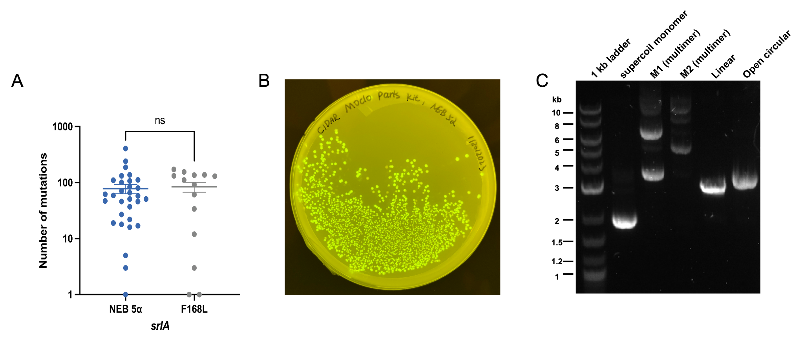
Figure S1: (A) The F168L mutation in srlA does not significantly affect the overall mutation rate induced by MP6. The number of mutations induced by MP6 was quantified in WT (without the srlA F168L mutation) and the srlA F168L mutant. Each dot represents an individual isolate randomly selected (n = 50) after induction, with isolates containing zero mutations excluded. Data are presented as mean ± standard error of the mean (SEM). Statistical analysis shows no significant difference between WT and srlA F168L (P > 0.05, ns). (B) Fluorescence intensity of colonies after transformation, showcasing varying brightness levels due to the distinct combinations of promoters and RBS. (C) Gel electrophoresis image of reporter plasmids. Line 1: 1 kb DNA ladder. Line 2: Plasmid extracted from NEB 5α, primarily producing supercoiled monomers. Line 3: Plasmid extracted from M1. Line 4: Plasmid extracted from M2. Line 5: Linearized plasmid. Line 6: Open circular plasmid.

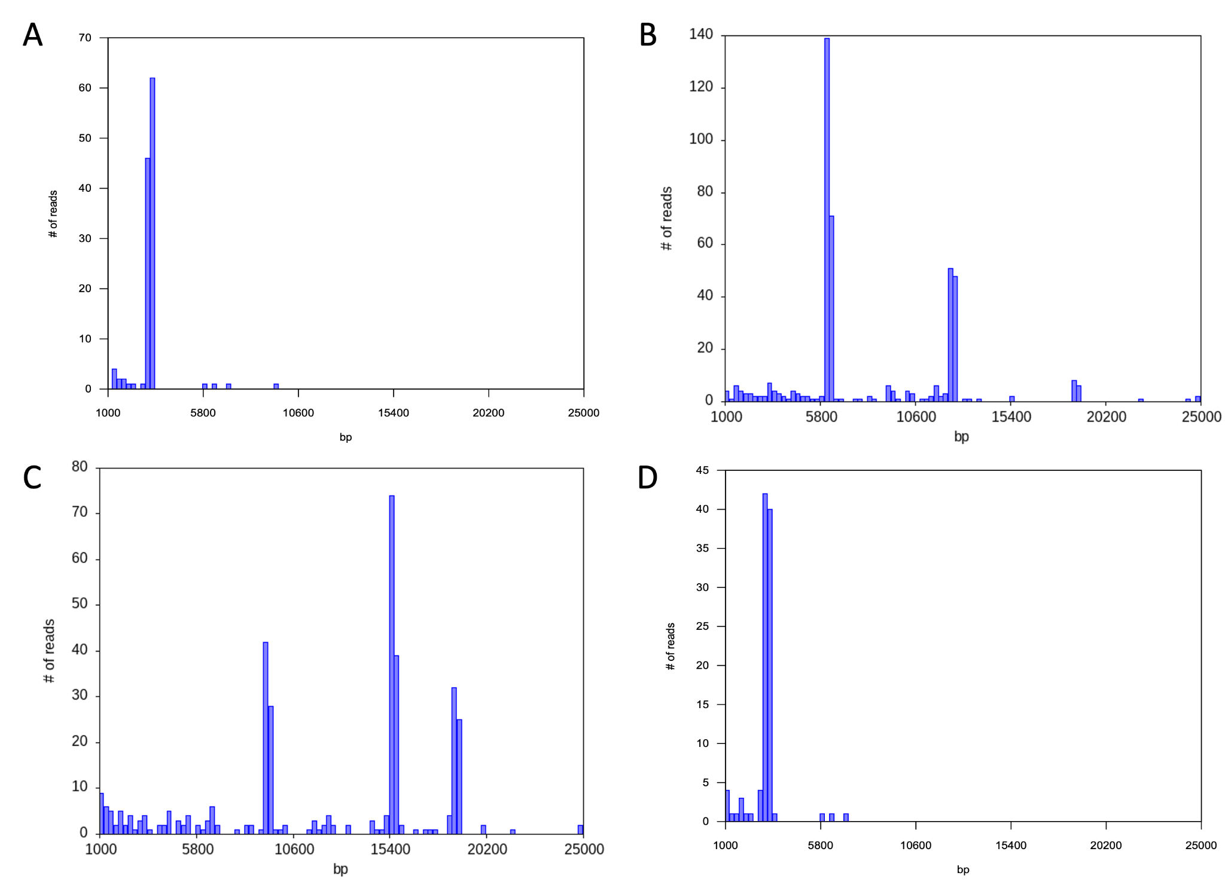
Figure S2: Read length histograms of the reporter plasmid extracted from NEB 5α, M1, and M2. (A) Plasmid extracted from NEB 5 alpha shows a dominant peak at 3.1 kb, corresponding to the plasmid monomer. (B) Plasmid extracted from M1 exhibits two peaks, indicating the presence of dimers and tetramers. (C) Plasmid extracted from M2 displays three peaks, corresponding to trimers, pentamers, and hexamers. (D) Plasmid extracted from M3.The single peak, similar to the parental NEB 5α strain, indicates the presence of the plasmid monomer.

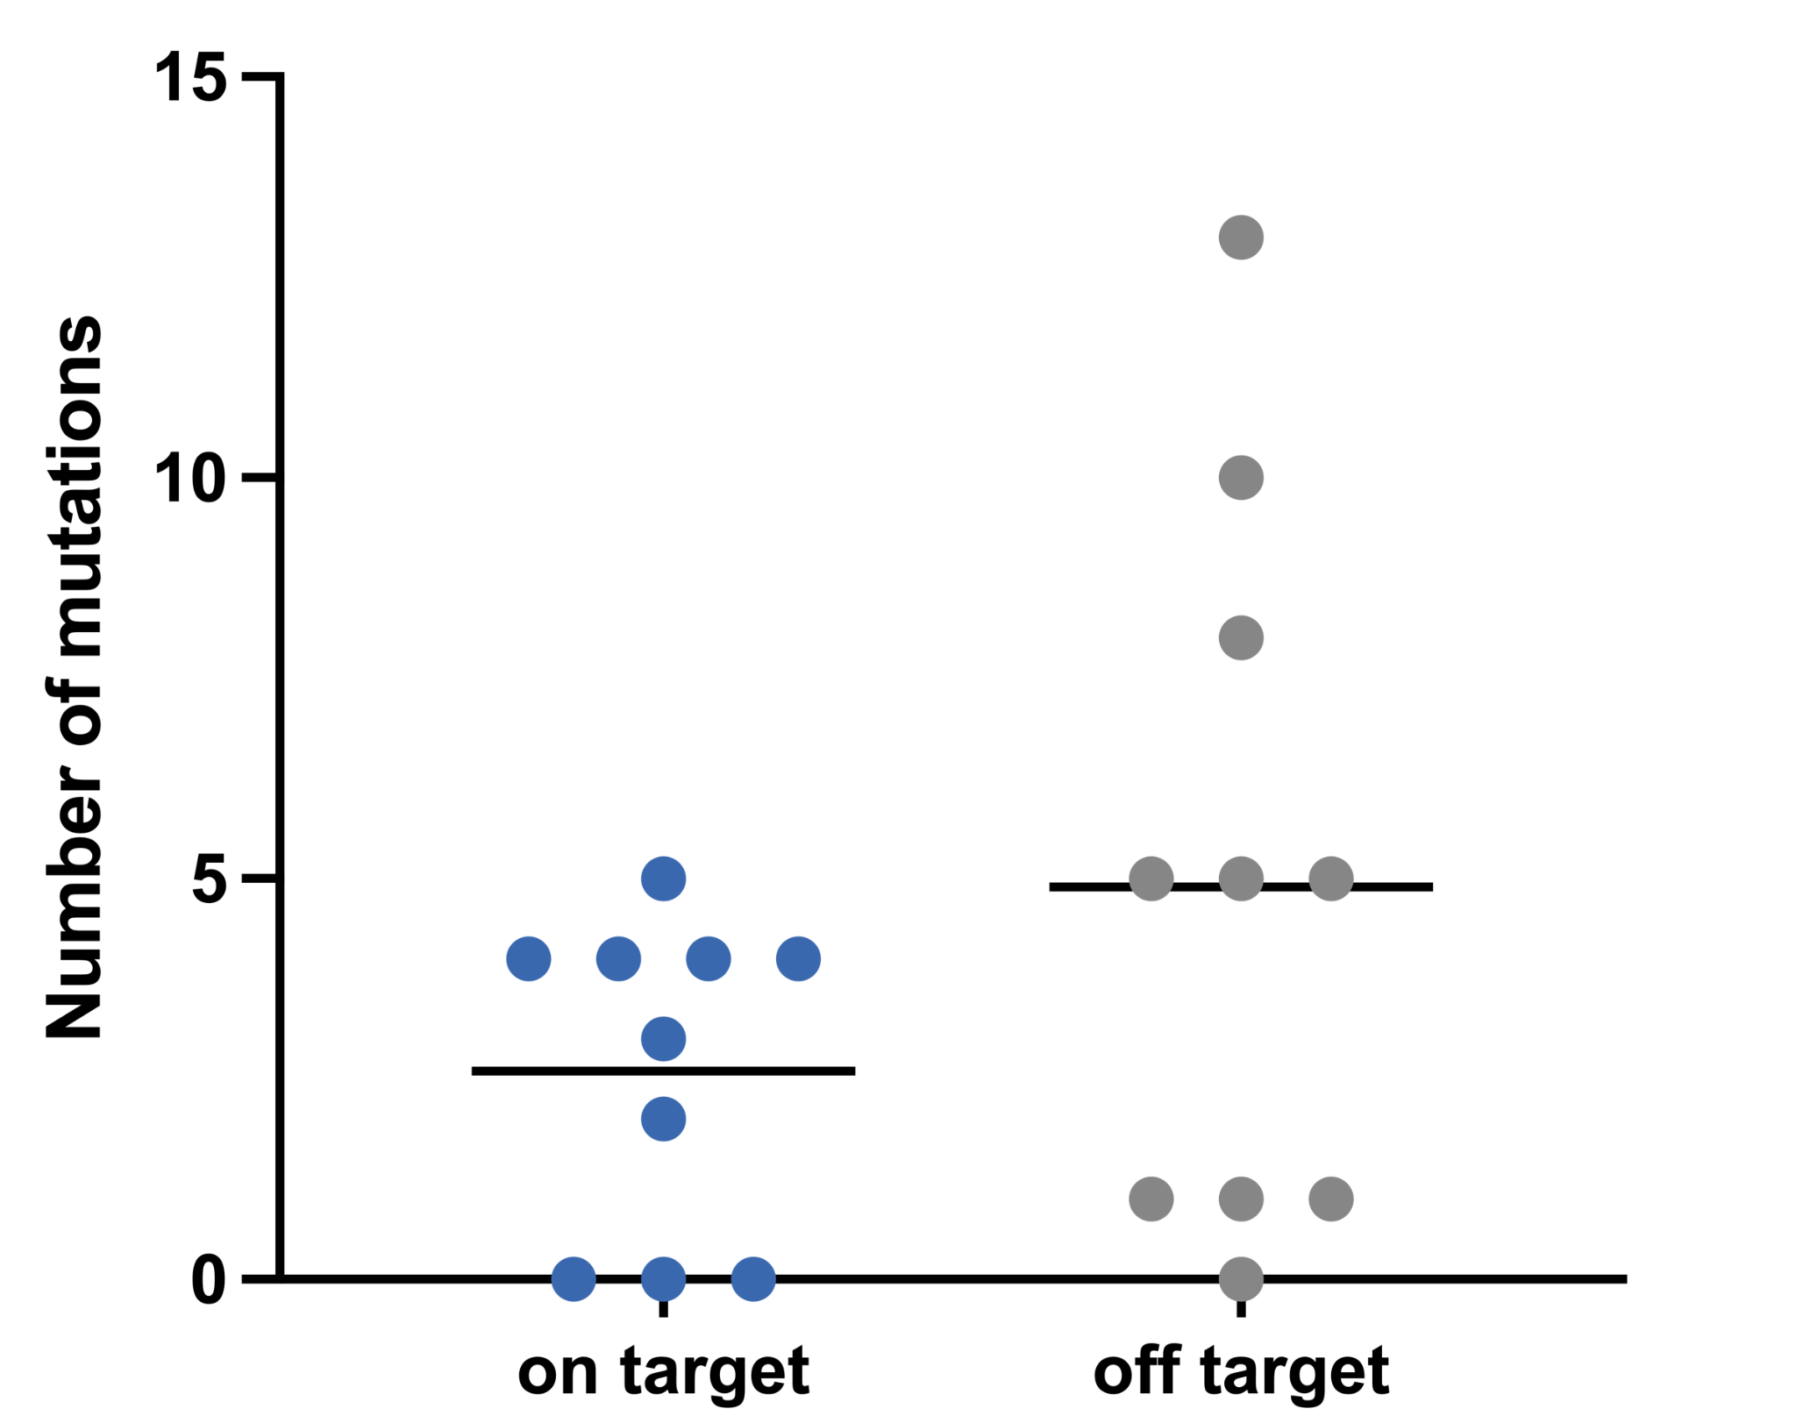
Figure S3: Analysis of on-target and off-target mutations after 10 cycles of MAGE. 10 random isolates were picked prior to reporter plasmid transformation to evaluate mutation outcomes. On average, each isolate carried 2.9 on-target mutations and 4.9 off-target mutations, indicating a higher frequency of off-target events after multiple MAGE cycles.

