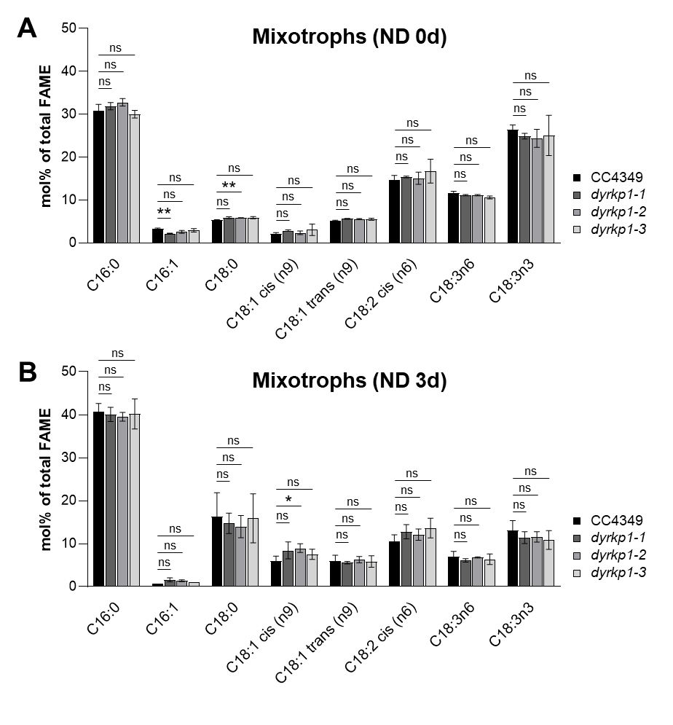
Figure S1. Fatty acid composition of DYRKP1 single knockout mutants under mixotrophic conditions with and without nitrogen. A, Mole percentage of fatty acid composition before nitrogen depletion (ND 0d; nitrogen-sufficient condition); B, Mole percentage of fatty acid composition after 3 days of nitrogen depletion (ND 3d). The experiments were performed in biological replicates (n = 6). Statistical analysis was performed using Student’s t-test (* p < 0.05 and ** p < 0.005). The ‘ns’ indicates no significant difference.

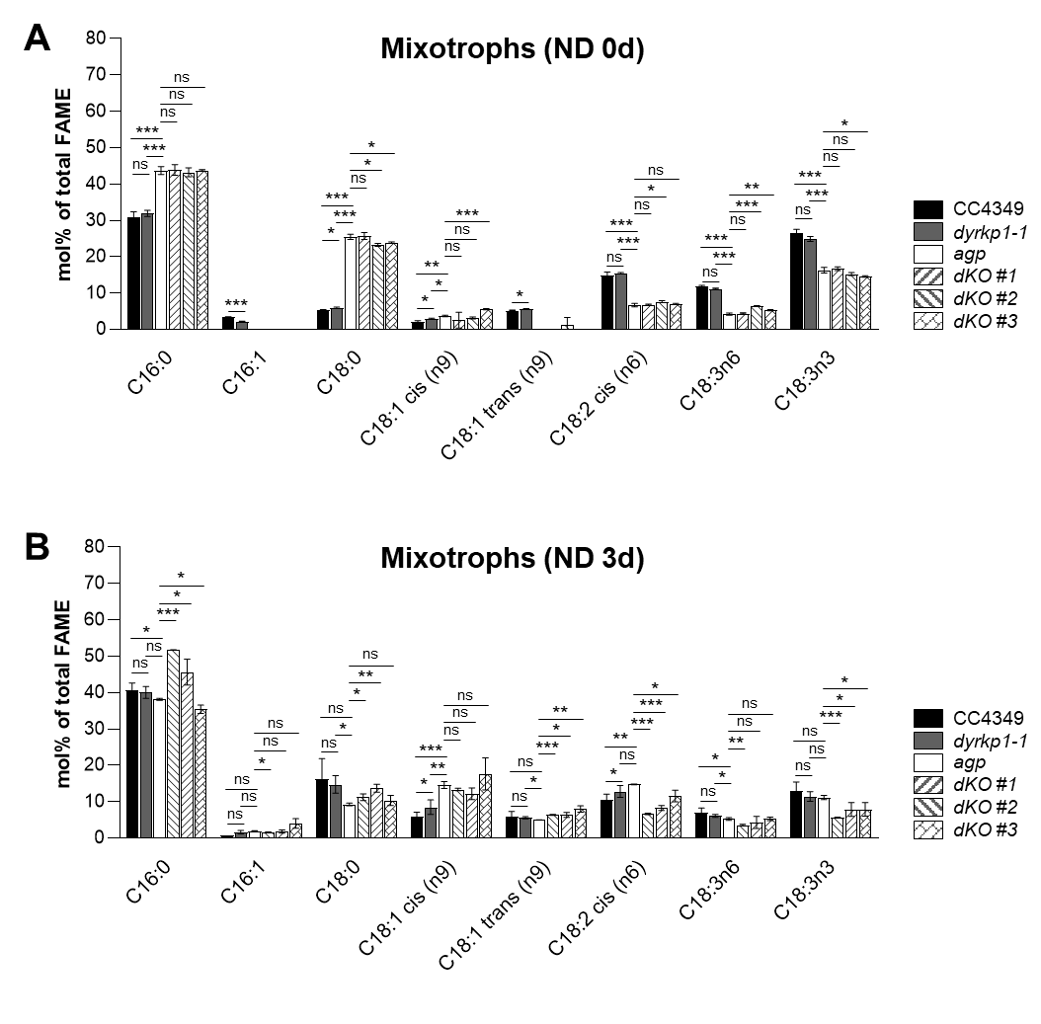
Figure S2. Fatty acid composition of DYRKP1 or AGP single knockout mutants, and DYRKP1-AGP double knockout mutants under mixotrophic conditions with and without nitrogen. A, Mole percentage of fatty acid composition before nitrogen depletion (ND 0d; nitrogen-sufficient condition); B, Mole percentage of fatty acid composition after 3 days of nitrogen depletion (ND 3d). The experiments were performed in biological replicates (n = 6). Statistical analysis was performed using Student’s t-test (* p < 0.05, ** p < 0.005, and *** p < 0.0005). The ‘ns’ indicates no significant difference.
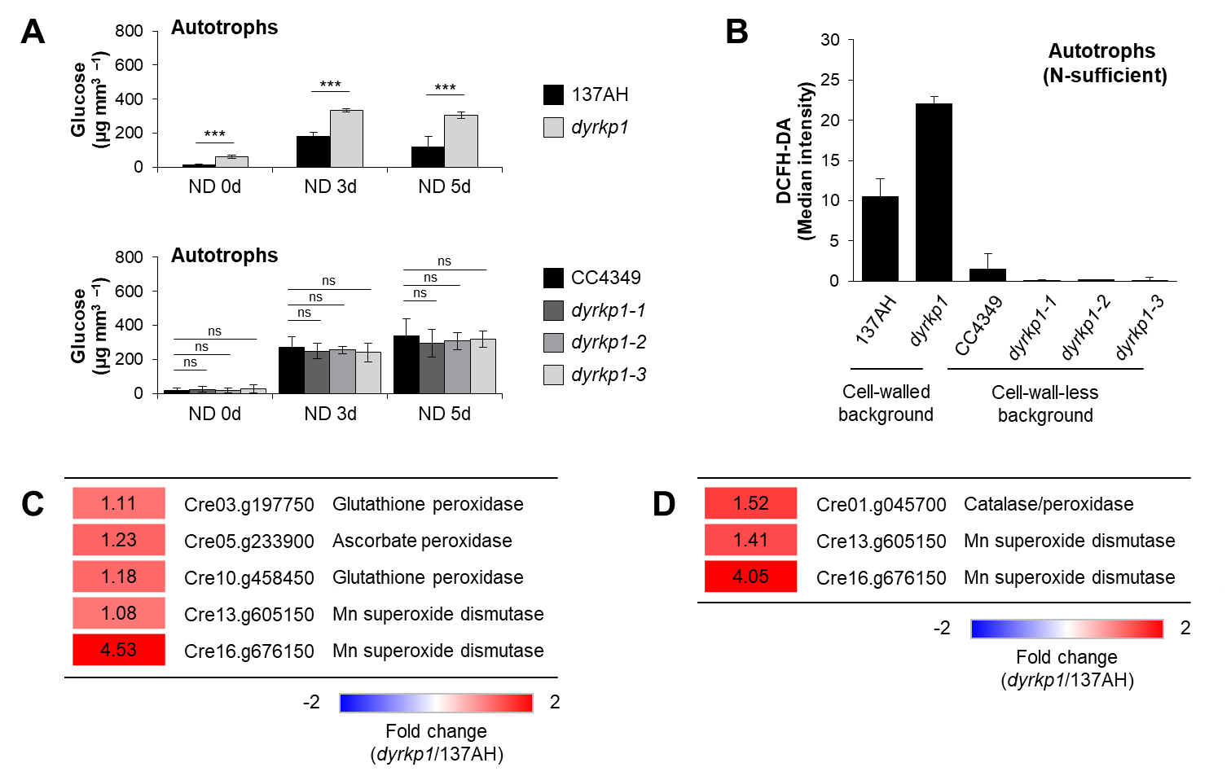
Figure S3. Comparison of dyrkp1 mutants generated from the cell-walled and cell-wall-less strains under autotrophic conditions. A, Starch content before nitrogen depletion (ND 0d; nitrogen-sufficient condition) and 3 and 5 days after nitrogen depletion (ND 3d and ND 5d). Starch content was normalized to particle volume; B, Intracellular ROS signals in nitrogen-sufficient conditions. Intracellular ROS signals were expressed by the median value of DCFH-DA intensity; C, The differentially expressed genes related to ROS-scavenging enzymes; D, The difference of protein abundance related to ROS-scavenging enzymes. The transcriptome and pellet proteome data were displayed by the fold change of dyrkp1 (137AH background) versus the 137AH strain. The experiments were performed in biological replicates (n = 3). Statistical analysis was performed using Student’s t-test (*** p < 0.0005). The ‘ns’ indicates no significant difference. The transcriptome and pellet proteome data were obtained from the previous study [18].

