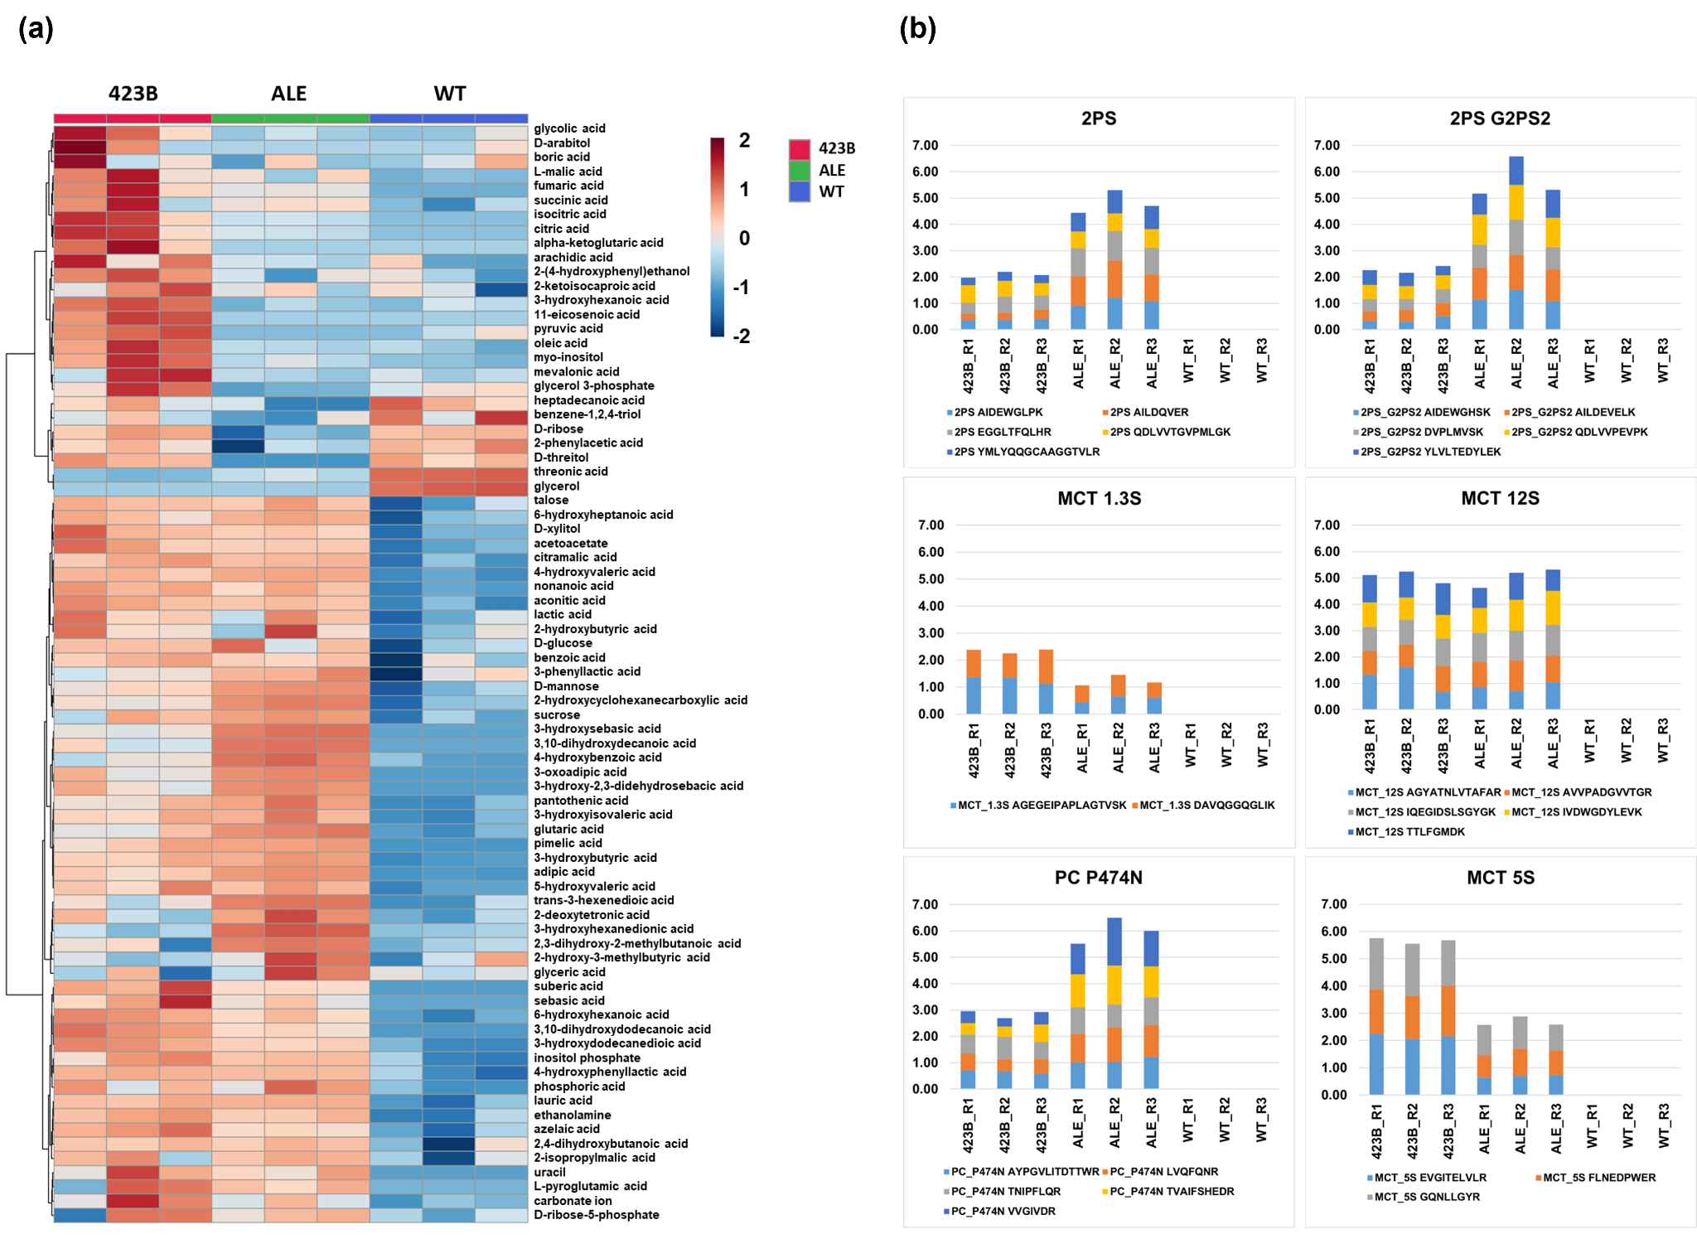

Supplementary File 7. Targeted proteomics data of expressed TAL pathway enzymes in the 423B and ALE strains. No TAL pathway proteins were detected in samples from the WT strain.

