Supplementary Material
Stress response regulation to extracellular polymeric substances biosynthesis in Bacillus licheniformis

Xiaoyu Wei¹, Ziwei Pan², Zhen Chen^{3*}, Ning He^{2*}
1 Technical Innovation Center for Utilization of Marine Biological Resources, Third Institute of Oceanography, Ministry of Natural Resources, Xiamen 361005, China
2 Department of Chemical and Biochemical Engineering, College of Chemistry and Chemical Engineering, Xiamen University, Xiamen, Fujian 361005, China
3 Henan Key Laboratory of Tea Plant Biology, College of Tea and Food Science, Xinyang Normal University, Xinyang, Henan 464000, China

*Corresponding Author:
Ning He: Department of Chemical and Biochemical Engineering, College of Chemistry and Chemical Engineering, Xiamen University, Xiamen, Fujian 361005, China
Email: hening@xmu.edu.cn
Zhen Chen: Henan Key Laboratory of Tea Plant Biology, College of Tea and Food Science, Xinyang Normal University, Xinyang, Henan 464000, China
E-mail: chenzhen@xynu.edu.cn

Table S1. Plasmids used in this study.
Plasmid | Description | Source
pHY300PLK-PamyL-TtamyL | E. coli and B. s shuttle vector; Amp^{r}, Tet^{r} | Lab collection
pHY-ccpA-2 | pHY300PLK derivative carrying ccpA-2 gene | This study
pHY-cggR | pHY300PLK derivative carrying cggR gene | This study
pHY-rbsRA | pHY300PLK derivative carrying rbsRA gene | This study
pHY-rapA | pHY300PLK derivative carrying rapA gene | This study
pHY-nadR | pHY300PLK derivative carrying nadR gene | This study
pHY-nrgB | pHY300PLK derivative carrying nrgB gene | This study
pHY-codY | pHY300PLK derivative carrying codY gene | This study
pHY-tnrA | pHY300PLK derivative carrying tnrA gene | This study

Table S2. Strains used in this study.
Strains | Description | Source
B. licheniformis CGMCC 2876 | EPS and PGA production strain, Wild-Type (CGMCC 2876) | Lab collection
DH5α/ pHY-ccpA-2 | DH5α contains plasmid pHY-ccpA-2 | This study
DH5α/ pHY-cggR | DH5α contains plasmid pHY-cggR | This study
DH5α/ pHY-rbsRA | DH5α contains plasmid pHY-rbsRA | This study
DH5α/ pHY-rapA | DH5α contains plasmid pHY-rapA | This study
DH5α/ pHY-nadR | DH5α contains plasmid pHY-nadR | This study
DH5α/ pHY-nrgB | DH5α contains plasmid pHY-nrgB | This study
DH5α/ pHY-codY | DH5α contains plasmid pHY-codY | This study
DH5α/ pHY-tnrA | DH5α contains plasmid pHY-tnrA | This study
OE-ccpA-2 | B. licheniformiscontains plasmid pHY-ccpA-2 | This study
OE-cggR | B. licheniformiscontains plasmid pHY-cggR | This study
OE-rbsRA | B. licheniformiscontains plasmid pHY-rbsRA | This study
OE-rapA | B. licheniformiscontains plasmid pHY-rapA | This study
OE-nadR | B. licheniformiscontains plasmid pHY-nadR | This study
OE-nrgB | B. licheniformiscontains plasmid pHY-nrgB | This study
OE-codY | B. licheniformiscontains plasmid pHY-codY | This study
OE-tnrA | B. licheniformiscontains plasmid pHY-tnrA | This study

Table S3. Primers used in this study.
Primer name | Sequence (5′ to 3′)
rsbRA-F | GCGCTCGAGATGTCGAATCAAGCAGT
rsbRA-R | CCGGTACCTTATTCCTCCAATGAAAC
rapA-F | CCGGTACCTTAGATTTCATACGACCA
rapA-R | AAACTCGAGGTGAGCGTAAAAATCCCA
nadR-F | CCGGTACCTTGACAGACGGATTAAAAC
nadR-R | GCGCTCGAGTTATTCGGGAATGAGGAT
cggR-F | CCGGTACCAATTTATATTGAGGGAAGAAGCT
cggR-R | CCGCTCGAGATGAATCAACTTATACAGGCTCA
ccpA-2-F | CCGGTACCATGAGTAATGTGACAATATATG
ccpA-2-R | CCGCTCGAGTCATTTTGTTGATTGTCTGAGT
codY-F | ATGGCTTTATTACAAAAAACAAGAAAGATTAA
codY-R | CTTTTAATGAGACTTTAGTTTTTCTAATTCCAT
tnrA-F | AAAATGACAGTCGAAGATCTTTCTTAT
tnrA-R | TTAGCGGTTTTTGTATTTAAAATG
nrgB-F | ATGAGCGGTCAAATGTATAAGGTGG
nrgB-R | TTATAAAGCGTCAGGACCTTCCTC

Table S4. qRT-PCR primers used in this study.
Primer name | Sequence (5′ to 3′)
q-16s-F | ACAGATTTGTGGGATTGGCTTAG
q-16s-R | CGTGTCGTGAGATGTTGGGTTA
q-crr-F | TCAAGCCGCATCCACC
q-crr-R | AAGTTCTCCAATAAAATCTCCC
q-pgi-F | GGATGGGTGGATCTTCCGAC
q-pgi-R | CATTTCGATCGCCGCTCTTG
q-pyk-F | CAGCCGCTTTTTCAAGGGAC
q-pyk-R | CAGCCGCTTTTTCAAGGGAC
q-pdhD-F | TGCAGCCAAATTCCCGTTTG
q-pdhD-R | GGCAATTTGTGCACCGATGA
q-gapB-F | ACGCTGGAGACGATTGC
q-gapB-R | CCACGGAAGAAGTTTAGGG
q-glmU-F | CGACAGGCTACGGACGCATTA
q-glmU-R | AGCGGCTACAGTTTCACCTTGATTTT
q-galE-F | GCACGGTGTCAAATGGG
q-galE-R | ACGAGGGGAATGAGATGG
q-epsG-F | TCCATAAGAGTGCGGTAAATC
q-epsG-R | ACAAGGTCGGAACGGATTA
q-epsO-F | CGATGATGGCGTCCTTTG
q-epsO-R | TTTACTTGGACTACCCGCTCTAC
q-gtaB-F | CACAGGAGCCCAAAAACAGC
q-gtaB-R | GCAGTCTGCTCCGGTATCTC
q-gltA-F | CCGAGCAGGTTGATGCTTTCTA
q-gltA-R | TCAGATAGCGGTTCGGATGTG
q-glnA-F | ATCGTCGATCTTCCTGCGAC
q-glnA-R | GAATAGATGGTCGCCGAGGG
q-capB-F | GAATTGTCTGCGACGATGACT
q-capB-R | GATGGGACCGACTTTGGAT
q-capC-F | AGCGTAATCGTTAATCCCTGTC
q-capC-R | CGGTGATGCCGTTTGAGA
q-capA-F | CCATTTGCGAAGGAGTTT
q-capA-R | GCTGACGAAGCAGGAGAA
q-gltB-F | AGCGTCGTCCAGTTCGG
q-gltB-R | CGCCTCTTCATAAGCATAGT
q-pgdS-F | AGCGTCGTCCAGTTCGG
q-pgdS-R | CGCCTCTTCATAAGCATAGT
q-rsbRA-F | TCAAACACCGGTCCGAAGTC
q-rsbRA-R | TTCGGAAGCCTGCATGATGT
q-rapA-F | GGCGCATGAAACTTACACGG
q-rapA-R | ATGAGCTGGCCTTTCTCCTG
q-nadR-F | CGCAACAAGCCAAGGATACG
q-nadR-R | CGCCGTAGACAGGATGTTCA
q-ccpA2-F | AACCGTTTCCAGGGTTGTGA
q-ccpA2-R | CGATAGCCAAGACGCTCGAT
q-nrgB-F | GGCCTGCAAAAAGGGCATAC
q-nrgB-R | TTCGACAGGCACTTTGCTGA
q-codY-F | GCTTGAAGAGCGCCAGTTTC
q-codY-R | TTTTCCACAGGGAAAGCCGTA
q-tnrA-F | TTTGTCGGTCAGGCAGATCC
q-tnrA-R | GCGATTTCCATCAGCCGTTC
q-cggR-F | TCGGCTACTATTTCGACCGC
q-cggR-R | GGATTGAATCAAGATCTTCGAGCTG
q-tuaD-F | TGCGAAGTCAGTCGGCTATC
q-tuaD-R | CGCCAAACACATCAAGGAGC
q-pgcA-F | TCGGCGTTGCTGTAAAGGAT
q-pgcA-R | CCGAAAGAAGCGGCAATGTC
q-sigB-F | TTGGGATGCTCGGATTGCTT
q-sigB-R | CGGAATCGCAAACGCTTCAA
q-wbpa-F | GCTGTTTCAGGCGATGTG
q-wbpa-R | CGTGCCGAAGGTAGTGG
q-glmM-F | ACACGATCAAAATGACAGGTAAGT
q-glmM-R | TCTCAACCTCTTCGATGACCG
q-fliG-F | ATCGAAAGGCTGACGCTTGA
q-fliG-R | CTGTTGATAATGCTGGCGGC
q-glmS-F | GCGCGCGAATATTTGACAGT
q-glmS-R | GTGCCGTCTTCGATCAATGC
q-epsH-F | GCCGACCTTGTCATCTGTGA
q-epsH-R | CGCCTGTAGAGCTTGTTCCA
q-spoIIAA-F | TTTATCGCTCAGCTCGACCC
q-spoIIAA-R | TCGTAAAGCCCATTCCCGAC
q-cinA-F | AAGCTCGGCTCGAAGGAAAA
q-cinA-R | CTTCGGATCCGCATGCTTTG
q-spo0F-F | CCAGTACGGGATTCGGGTTC
q-spo0F-R | GGGCGCTGGTTTTTCACAAT
q-tpiA-F | AATCTTCCATTCCCGCAGCA
q-tpiA-R | GGCTCATAAGCGATCACGGA
q-gapA-F | CAGCTCCTGCGAGTGAAGAA
q-gapA-R | GTGTTGGAACACGCATTGCT
q-pgk-F | TGAACGTCCGTTTACAGCG
q-pgk-R | TCACGCCTTTTTCTTTGGCG
q-eno-F | ATCGCACCTGAGCTTATCGG
q-eno-R | CGATGTCAGCGATTGTGCTG
q-rsbU-F | CTGAACAGGGTCGTCGAACA
q-rsbU-R | AGGTTCTGCAAGTCAGACCG
q-rsbS-F | TTTGGCGCCCATCAGTTTTG
q-rsbS-R | GGTTCGAACGGAGTGGTGAT
q-rsbT-F | CTCAGAGCTGGCGCGTAATA
q-rsbT-R | CGCCTGAGGTTGAAAAACCG

Table S5. The specific values of significant metabolites of B. licheniformis CGMCC 2876 in combined stress
Metabolites | Compound ID | KEGG | log₂FC | VIP | Pvalue
Pentadecanoic acid | HMDB0000826 | C16537 | 2.28 | 1.63 | 0.08
Flavin Mononucleotide | HMDB0001520 | C00061 | 2.24 | 2.01 | 0.0036
Citrulline | HMDB0000904 | C00327 | 2.17 | 1.99 | 0.0038
Xanthosine | HMDB0000299 | C01762 | -2.17 | 1.33
Phthalic acid | HMDB0002107 | C01606 | -2.16 | 1.09
D-RIBOSE 5-PHOSPHATE | HMDB0001548 | C00117 | -1.93 | 1.11
N-Acetyl mannosamine | HMDB0001129 | C00645 | -1.75 | 1.01 | 0.045
GLUTAMINE | HMDB0000641 | C00064 | 1.65 | 1.92 | 0.01
N-Alpha-acetyllysine | HMDB0000446 | C12989 | 1.63 | 1.73 | 0.05
N-Acetyl-L-lysine | HMDB0000446 | C12989 | 1.63 | 1.73 | 0.05
2-METHYLMALEATE |  |  | 1.60 | 1.10
PHOSPHOENOLPYRUVATE | HMDB0000263 | C00074 | 1.29 | 1.64 | 0.08
HEPTADECANOATE | HMDB0002259 |  | 1.24 | 1.34
Cytidine monophosphate | HMDB0000095 | C00055 | -1.18 | 1.45
3-Hydroxybenzaldehyde |  |  | -1.13 | 1.05 | 0.0088
3-PHOSPHOGLYCERATE | HMDB0000807 | C00597 | 1.10 | 1.23
N-ACETYLGALACTOSAMINE | HMDB0000304 | C00203 | -1.08 | 1.16 | 0.045
N-ACETYLGLUCOSAMINE | HMDB0000290 | C00043 | -1.08 | 1.16 | 0.045
GLYCEROL 3-PHOSPHATE | HMDB0000126 | C00093 | 2.48 | 1.16 | 0.014
L-Glutamine | HMDB0000641 | C00064 | 2.40 | 0.83 | 0.013
GLUTAMATE | HMDB0000148 | C00025 | 1.29 | 0.544 | 0.038
Coproporphyrin I | HMDB0000643 | C05769 | 5.14 | 1.58 | 0.011479
FAD | HMDB0001248 | C00016 | 3.35 | 1.50 | 0.03
CYCLIC GMP | HMDB0001314 | C00942 | 2.62 | 1.55 | 0.018397
Adenosine triphosphate | HMDB0000538 | C00002 | 2.57 | 1.10
Citrulline | HMDB0000904 | C00327 | 2.50 | 1.44 | 0.04
GLYCEROL 3-PHOSPHATE | HMDB0000126 | C00093 | 2.48 | 1.16
D-Glutamine | HMDB0003423 | C00819 | 2.40 | 0.83
L-Glutamine | HMDB0000641 | C00064 | 2.40 | 0.83
N-Acetyl Glutamate | HMDB0001138 | C00624 | 2.40 | 1.14
ADP | HMDB0001341 | C00008 | 2.07 | 1.24
Uridine Monophosphate | HMDB0000288 | C00105 | 1.74 | 1.19
2-Aminoisobutyrate | HMDB0001906 | C03665 | 1.64 | 1.46 | 0.03
D-Alpha-aminobutyric acid | HMDB0000650 | C02261 | 1.59 | 1.46 | 0.03
Dimethylglycine | HMDB0000092 | C01026 | -1.55 | 1.46
L-Alpha-aminobutyric acid | HMDB0000452 | C02356 | -1.55 | 1.46 | 0.03
DL-2-Aminobutyric acid | HMDB0000650 | C02261 | -1.55 | 1.46 | 0.03
ACETOIN | HMDB0003243 | C00466 | -1.49 | 1.08
Butanoate | HMDB0000039 | C00246 | -1.49 | 1.08
Isobutyrate | HMDB0001873 | C02632 | -1.49 | 1.08
Hypoxanthine | HMDB0000157 | C00262 | -1.45 | 1.37
L-Glutamic acid | HMDB0000148 | C00025 | 1.32 | 1.34
BETA-Nicotinamide Adenine Dinucleotide | HMDB0000902 | C00003 | 1.13 | 1.27
Pyrrolidonecarboxylic acid | HMDB0000805 | C02237 | 1.03 | 1.23

Table S6. The specific values of significant genes in OE-nrgB compared to the wild-type strain
Gene ID | Symbol | Description | log₂FC
PROKKA_00001 | spsC | polysaccharide biosynthesis protein | -2.03
PROKKA_00004 |  | glycosyltransferase | -2.38
PROKKA_00009 | wbpA | nucleotide sugar dehydrogenase family protein | -2.30
PROKKA_00058 |  | SAM-dependent methyltransferase | -1.85
PROKKA_00162 |  | metallopeptidase | 1.07
PROKKA_00319 |  | YnzH | -2.34
PROKKA_00371 | yhjO | MFS transporter | -2.64
PROKKA_00626 | dppE | cytochrome C | -1.33
PROKKA_00692 | motB | flagellar motor protein MotB | 1.26
PROKKA_00738 | ykyB | YkyB | -1.22
PROKKA_00985 | swrB | swarming motility protein swrB | -1.32
PROKKA_01059 | tetB | MFS transporter | 1.02
PROKKA_01207 | narI | nitrate reductase gamma subunit NarI | 1.28
PROKKA_01215 | ywiC | membrane protein | 1.21
PROKKA_01339 | aprX | serine protease | -2.78
PROKKA_01389 |  | peptidase | -2.61
PROKKA_01422 | yojO | von Willebrand factor A | -1.07
PROKKA_01976 | hxlB | 6-phospho 3-hexuloisomerase | 1.78
PROKKA_02026 | yybF | MFS transporter | 1.11
PROKKA_02094 |  | hypothetical protein | -2.03
PROKKA_02119 | RadC | DNA repair protein RadC | 1.10
PROKKA_02207 | lrgB | antiholin factor LrgB | 2.46
PROKKA_02208 | lrgA | antiholin factor LrgA | 2.74
PROKKA_02395 | glgP | MULTISPECIES: maltodextrin phosphorylase | -1.04
PROKKA_02396 | glgA | starch synthase | -1.44
PROKKA_02397 | glgD | glycogen biosynthesis protein glgD | -1.46
PROKKA_02398 | glgC | glucose-1-phosphate adenylyltransferase | -1.33
PROKKA_02399 | glgB | glycogen-branching enzyme | -1.27
PROKKA_02465 | mcpA | methyl-accepting chemotaxis protein | 1.88
PROKKA_02625 | fadA | acetyl-CoA C-acetyltransferase family protein | -1.76
PROKKA_02728 | yvmA | major facilitator family transporter | 1.66
PROKKA_02729 | yvmC | tRNA-dependent cyclodipeptide synthase | 3.11
PROKKA_02730 | cypX | cyclodipeptide synthase-associated | 3.07
PROKKA_02742 | yvrL | regulatory YrvL family protein | 2.33
PROKKA_02792 | yvfF | polysaccharide pyruvyl transferase YvfF | 1.24
PROKKA_02793 | pglE | polysaccharide biosynthesis protein YvfE | 1.41
PROKKA_02805 | ywqD | tyrosine protein kinase | 1.28
PROKKA_02872 | swrAA | motility-swarming | 1.25
PROKKA_02889 | hag | flagellin | 2.16
PROKKA_02938 | lytD | beta-N-acetylglucosaminidase | 1.46
PROKKA_02965 | ycgJ | SAM-dependent methyltransferase YafE | -8.49
PROKKA_03013 | nrgB | nitrogen-regulated PII-like protein | 1.64
PROKKA_03014 | clpP2 | clp protease family protein | 2.36
PROKKA_03015 | sigG | RNA polymerase subunit sigma-70 | 2.44
PROKKA_03040 | fdxG | molybdopterin oxidoreductase family protein | -1.22
PROKKA_03106 | rsfA | Prespore-specific transcriptional regulator RsfA | -1.62
PROKKA_03221 | yweA | YweA | 1.08
PROKKA_03237 | cydD | thiol reductant ABC exporter subunit CydC | 1.21
PROKKA_03241 | ywcJ | formate/nitrite transporter YwcJ | 2.14
PROKKA_03242 |  | O-methyltransferase | 1.43
PROKKA_03353 | egsA | glycerol dehydrogenase | 1.03
PROKKA_03910 | yclG | Pectin lyase-like protein | -2.70

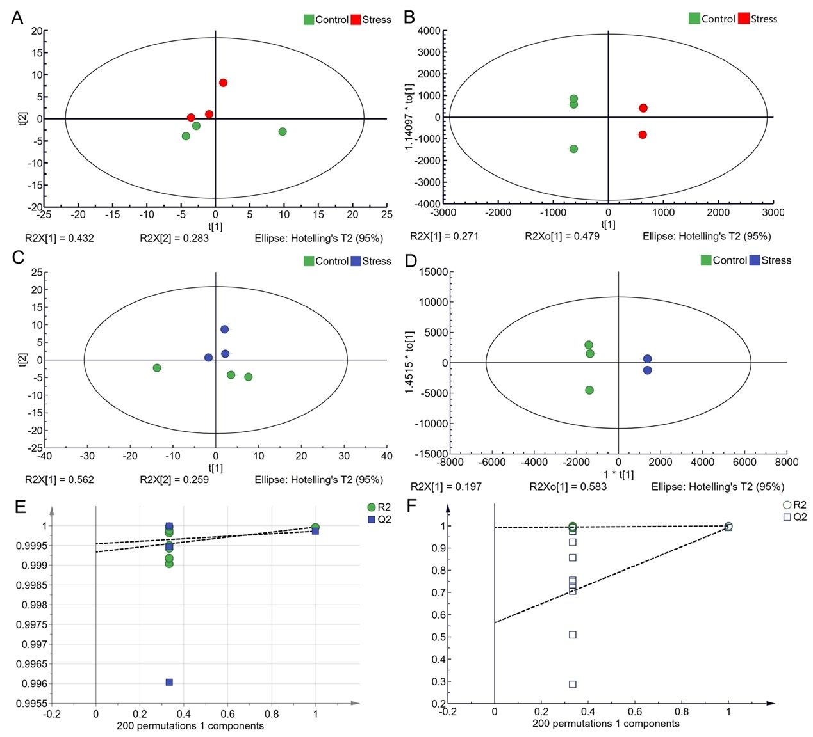
Figure S1. The cluster analysis of metabolites of combined stress group and control group. The cluster analysis of intracellular metabolites with PCA in positive (A) and negative (C) ion mode; the cluster analysis of with OPLS-DA in positive (B) and negative (D) ion mode; permutation test for the OPLS-DA model in positive (E) and negative (F) ion mode
Figure S2. VIP maps of metabolites in positive (A) and negative (B) ion mode.

Figure S3. Volcanic plots of metabolites in positive (A) and negative (B) ion mode.

Figure S4. Analysis of gene expression in the combined stresses of B. licheniformis based on qPCR analysis. All data are expressed as mean ± SD of three independent experiments. *p < 0.05 versus control group.

Figure S5. Relative expression of 8 global transcriptional regulators in the wild-type and overexpression strains by qPCR analysis. All data are expressed as mean ± SD of three independent experiments. *p < 0.05 versus control group.

Figure S6. The fermentation process curve of wild-type strain in 1.5 L fermenter. All data are expressed as mean ± SD of three independent experiments.

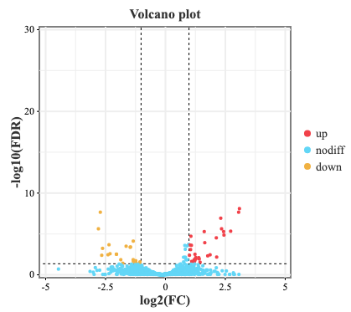
Figure S7. Visualized volcano plot of differentially expressed genes in transcriptome data intergroup.

Figure S8. Verification of the credibility of transcriptome data. (A) The qPCR analysis of samples (Relative expression was determined by 2^{-△△Ct}, *p < 0.05 versus control group. (B) Transcriptome data of samples. All data are expressed as mean ± SD of three independent experiments.

Figure S9. Effect of oxidative stress on extracellular polymeric substances in B. licheniformis. (A) The crude yield of extracellular polymeric substances and biomass of strain; (B) The yield of γ-PGA and EPS. All data are expressed as mean ± SD of three independent experiments.

