Supplementary data
Table S1. F/2 media recipe
F/2 Media (ASW) components | Concentration
Sea salt | 32 g/L
NaNO₃ | 880 µM
NaH₂PO₄·H₂O | 36 µM
Na2SiO3·9H2O | 106 µM
Trace Metal Solution (1 mL/L)
ZnSO₄·7H₂O | 0.08 µM
MnSO₄·H₂O | 0.9 µM
Na₂MoO₄·2H₂O | 0.03 µM
CoSO₄·7H₂O | 0.05 µM
CuCl₂·2H₂O | 0.04 µM
Fe(NH₄)₂(SO₄)₂·6H₂O | 11.7 µM
Na₂EDTA·2H₂O | 11.7 µM
Vitamin Solutions (1 mL/L)
Vitamin B₁₂ | 0.1 mM
Biotin Vitamin | 0.1 mM
Thiamine Vitamin | 1 mM

Table S2. Primers list
Primer name | Sequence
colPCR-FcpB-Fw | 5’- TCGTTGATCCGGAGAGATTC-3’
colPCR-TwOSC4-Rv | 5’- ACCAGAGCTTGAAAGCCAAA-3’
qPCR-TwOSC4-Fw | 5’-AGAGCACGCAAGTGGATTCT-3’
qPCR-TwOSC4-Rv | 5’-ATCCGGCAATAACACCACAT-3’
qPCR-TubA-Fw | 5’-CTGGGAGCTTTACTGCTTGGA-3’
qPCR-TubA-Rv | 5’-ATGGCTCGAGATCGACGTAAA-3’

Figure S1. Optimized sequence of the TwOSC4 gene
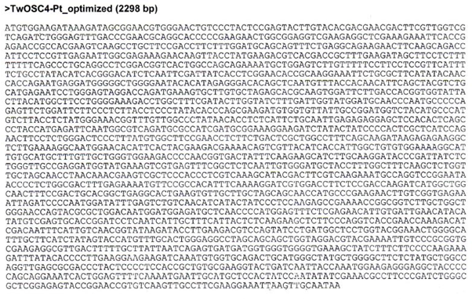
Figure S2. Expression vector of TwOSC4 gene for Phaeodactylum tricornutum
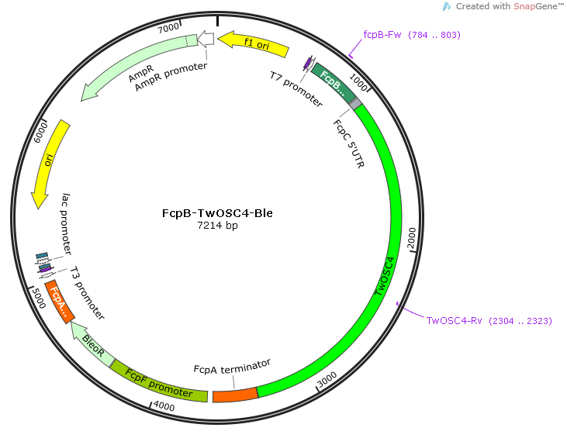
Figure S3. Biomass and total lipid production of the WT and transgenic strains under normal F/2 media and additional of Ro 48-8071. a) Dry cell weight (DCW) as biomass production at day 4 and day 6 of culturing period. b) Total lipid extracted from day 4 and day 6 of culturing period. The content was calculated based on harvested volume of culturing media. c) Lipid content was calculated based on cell numbers. Error bars represent mean values from three independent experiments. Statistically significant differences were determined by Student’s t test (**p < 0.01, *p < 0.05)
