Supplementary data

Biodegradation potential of used motor oil by mixed bacterial community: optimization, emulsification activity, bioelectrochemical and metagenomics analyses using single chamber microbial fuel cell
Ebtehag A E Sakr^{1*,} Nahla M Mansour², Hanaa M Sabaa³, Kamel M El-khatib⁴, and Dena Z Khater⁴

¹Botany Department, Faculty of Women for Arts, Science and Education, Ain Shams University, Cairo, Egypt.
²Gut Microbiome and Immunology Group, Chemistry of Natural and Microbial Products Department, Institute of Pharmaceutical and Drug Industries Research, National Research Centre, Dokki, Cairo, Egypt.
³Processes Development Department, Egyptian Petroleum Research Institute, Nasr City, Cairo, Egypt.
⁴Chemical engineering department, Engineering research and renewable energy institute, National Research Centre.

Table S1.
Calculated each R_{int} and R_{ct} (R_{S} and R_{ct} of anode and cathode EIS) to whole Rint at steady state OCV condition in SCMFC and Equivalent circuit.
EIS parameter | R_{ct} (Ω) | R_{int} (Ω) | Equivalent circuit
Anode | 38.45 ± 3.60 | 47.08 ±0.22 | 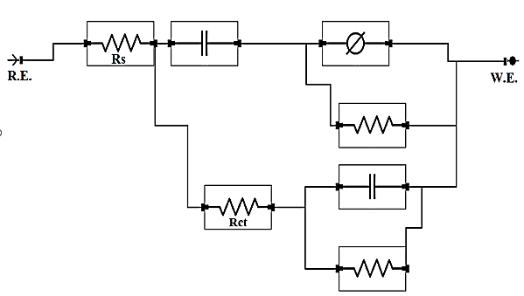
Cathode | 317.24± 12.81 | 323.71±21.97 | 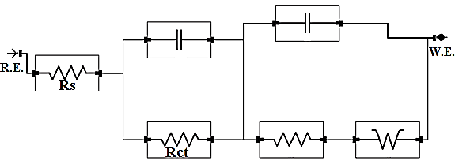
Whole SCMFC | 23.24±0.27 | 370. 79±0.24 | 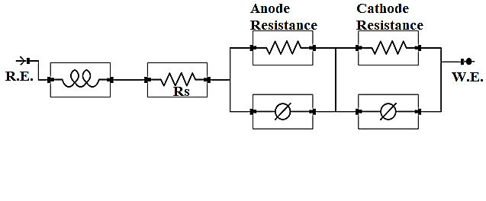
EIS; Electrochemical Impedance Spectroscopy
R_{ct}; electron transfer resistance
R_{int}; internal resistance.
SCMFC; single-chamber microbial fuel cell

Table S2.
GC-MS data for the UMO biodegradation.
Compound Name | RT | Control-Area % | B1-Area % | B2-Area % | Molecular Weight | Molecular Formula
Methyl-Cyclopentane | 3.08 | 11.37 | ― | 7.42 | 84 | C₆H₁₂
3-Methyl-Pentane | 3.09 | ― | 5.78 | ― | 86 | C₆H₁₄
2,6,11,15-Tetramethyl-Hexadecane | 9.25 | 1.8 | 0.8 | 0.95 | 282 | C₂₀H₄₂
Piperazine | 9.33 | 0.43 | ― | 0.39 | 86 | C₄H₁₀N₂
Pentanal | 9.34 | ― | 0.31 | ― | 86 | C₅H₁₀O
Dodecane | 9.96 | 1.68 | 0.87 | 1.15 | 170 | C₁₂H₂₆
1-Iodo-2-methylundecane | 12.61 | 0.88 | 0.45 | 0.67 | 296 | C₁₂H₂₅I
Bis(1,1-Dimethylethyl)-Phenol | 15.67 | 0.99 | ― | 0.53 | 206 | C₁₄H₂₂O
2-(1,1-Dimethylethyl)-5-(2-Propenyl)-1,4-Benzenediol | 15.68 | ― | 0.5 | ― | 206 | C₁₃H₁₈O₂
2,6,10-Trimethyl-Tetradecane | 16 | 0.56 | 0.27 | 0.37 | 240 | C₁₇H₃₆
Di(2-ethylhexyl) phthalate | 25.65 | 14.91 | 12 | ― | 390 | C₂₄H₃₈O₄
3,7,11-trimethyl-1-Dodecanol | 25.66 | ― | ― | 11.32 | 228 | C₁₅H₃₂O
RT; Retention time
Control-Area %; before treatment
B1-Area %; after 48 days treatment of SCMFC with 2% optimized UMO
B2-Area %; after 56 days treatment of SCMFC with 2% optimized UMO

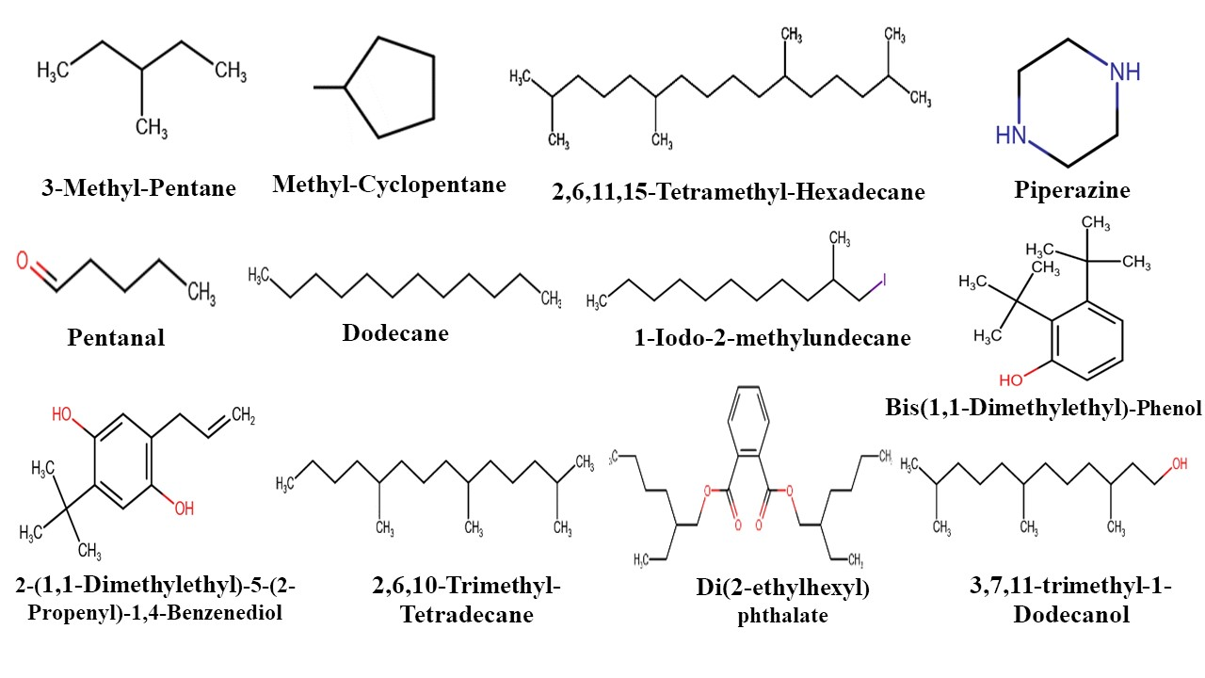
Fig. S1. Molecular Structure of hydrocarbons detected in UMO samples; control, B1, and B2, respectively.

(a)
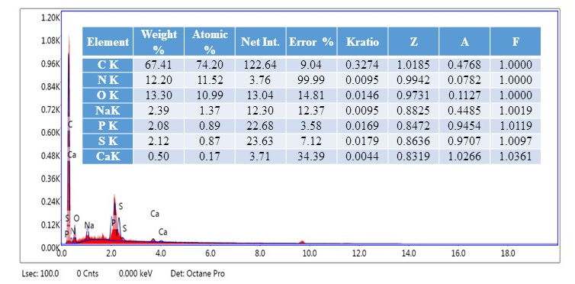
(b)
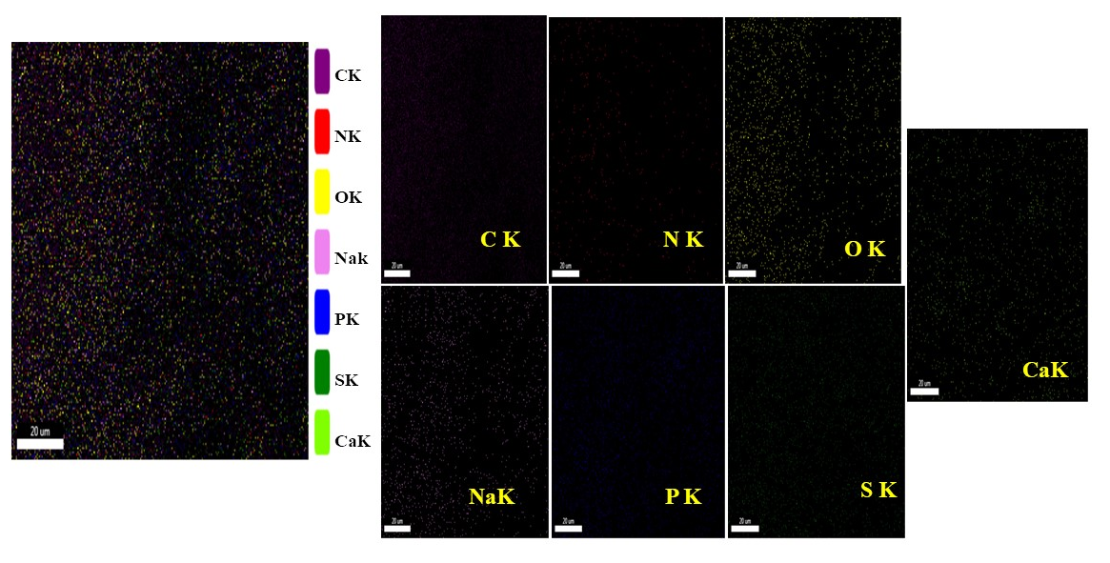

Fig. S2. EDX (a), and mapping (b) of anodic biofilm.

Material and methods
Fourier Transform Infrared Spectroscopy (FTIR) Analysis
UMO samples, before (control) and after biodegradation (B1, B2), were analyzed by ATR-FTIR spectroscopy to determine the functional groups and the nature of the chemical bonds by using a Bruker Vertex 80 instrument (Germany). A certain quantity of the UMO sample was mixed and ground with KBr in an agate mortar. The translucent discs were prepared by pressing the ground material with pressure from a bench press. The tablet was immediately analyzed with a spectrophotometer in the range of 4000-400 cm⁻¹ with a resolution of 4 cm⁻¹.

Gas Chromatography-Mass Spectroscopy (GC–MS) Analysis
The chemical composition of UMO samples was determined by GC–MS. The GC–MS analysis was performed for UMO before (control) and after biodegradation (B1, B2) on a Thermo Scientific Trace 1300 series gas chromatography coupled with an ISQ 7000 single quadrupole mass spectrometer with an electron capture detector (ECD). A 1 μL sample volume was injected by a CTC A200S autosampler with splitless mode into the DB 1 capillary separation column (60 m × 0.32 mm i.d. × 0.25 μm film thickness). For the chromatographic analysis, the initial temperature was 40 °C and held for 2 min, followed by an increase at a rate of 10 °C/min to the injection temperature of 290 °C and was held for 20 min. The carrier gas was helium, with a constant flow rate of 1 mL/min. Mass spectrometry conditions were as follows: electron bombardment ion source, electron beam energy 70 eV, ion source temperature 210 °C, transmission line temperature 280 °C, mass scan range was m/z 50-650, with a scan rate was 100 ms. Data were collected on a Windows-based personal computer. The relative abundance of the components was obtained by integrating the peak area of each component in the chromatogram, and the absolute content of each component was determined by the acquisition general method.

