Additional File 1

Transient Analysis and Engineering of Bacterial Metabolic Pathways Using Cell-penetrating Peptide-Peptide Nucleic Acid Conjugates

Yugo Kawabuchi¹, Shunichi Kobayashi¹, Jaeyoung Yu¹, Gota Kasai¹, Miku Kobe¹, Rei Suo², Shiro Itoi², Koji Sode³, Takahiro Muraoka⁴, Ryutaro Asano¹, Tetsushi Mori^{1*}
¹ Department of Biotechnology and Life Science, Tokyo University of Agriculture and Technology, Koganei, Tokyo, 184-8588, Japan.
² Department of Marine Science and Resources, Nihon University, Fujisawa, Kanagawa, 252-0880, Japan.
³ Lampe Joint Department of Biomedical Engineering, The University of North Carolina at Chapel Hill and North Carolina State University, Chapel Hill, NC, 27599, USA.
⁴ Department of Applied Chemistry, Tokyo University of Agriculture and Technology, Koganei, Tokyo, 184-8588, Japan.

* Corresponding Author:
(Phone) +81-42-388-7641
(E-mail) moritets@go.tuat.ac.jp
Supplementary Materials and Methods
Construction of Δddh and Δddh-ΔglyII knockout strains
Homologous recombination was employed to establish the knockout strains. First, the complete genome of Synechocystis sp. PCC6803 was downloaded from GenBank (BA000022.2), and the upstream and downstream sequences flanking the target genes ddh, encoding D-lactate dehydrogenase (Ddh) and glyII, encoding the glyoxalase II enzyme (GlyII) were identified. The upstream and downstream flanking regions of each gene were subsequently amplified by PCR from the genome of strain PCC6803, and an antibiotic resistance gene was integrated between these flanking regions using the In-Fusion cloning kit (Takara Bio Inc., Shiga, Japan) according to the manufacturer's protocol. The flanking regions of the ddh and glyII genes were integrated with kanamycin and chloramphenicol resistance genes, respectively. The resulting cassettes were subsequently cloned into a pUC18 plasmid using Escherichia coli DH5α (Toyobo Co. Ltd., Osaka, Japan) as the host, and the sequence of each cassette was confirmed.
Approximately 200 ng of each confirmed plasmid was electroporated into Synechocystis using a Gene Pulser Xcell™ (Bio-Rad Laboratories, Hercules, USA). The Δddh strain was first established by knocking out the wild-type ddh gene with the kanamycin cassette and the Δddh-ΔglyII was subsequently established by knocking out the wild-type glyII gene with the chloramphenicol cassette into the Δddh strain. Cells were recovered for 24 h in BG11 medium at 30°C under continuous red light (660 nm, 30 µmol m⁻² s⁻¹) with shaking at 100 rpm. Subsequently, transformants were selected for 1 week on BG11 agar at 30°C containing kanamycin (50 µg mL⁻¹) for the Δddh and kanamycin (50 µg mL⁻¹)/ chloramphenicol (20 µg mL⁻¹) for the Δddh-ΔglyII strains, respectively. Single resistant colonies were re-isolated on antibiotic-supplemented BG11 medium and screened by colony PCR to confirm complete deletion of the target genes.
Quantification and Normalization of Western Blot Signals
Total pixel intensity of all protein bands (TPV) in each SDS–PAGE lane was obtained individually (Figure S2(a)). Only bands migrating between the highest (180 kDa) and lowest (10 kDa) molecular-mass markers were included in the analysis. Band intensity values for the target protein in the corresponding Western blot (WBV) were then divided by the TPV from the matched SDS–PAGE lane (WBV/TPV) to yield a “standardized” WBV. Finally, these standardized WBV values were normalized to the WBV of the wild-type sample at 0 h to generate the “normalized” values presented in the supplemented bar graph (Figure S2(b)).

Supplementary Tables

CPP-PNA probe name | Target Gene | Sequence  (5’ to 3’) | Target Region  (+1 = start codon) | Off-target bind (³TIR)
¹(N) -²CPP-Syn6803acpP | acpP | TTCATTACAA | -5 to +5 | 4 (0)
(N)- CPP-Syn6803dnaB | dnaB | GCCATCAAGT | -5 to +5 | 6 (0)
(N)- CPP-Syn6803ftsZ | ftsZ | GTCATTGCAG | -5 to +5 | 0
(N)- CPP-Syn6803ddh | ddh | TTCATGACGA | -5 to +5 | 4 (0)
(N)- CPP-Syn6803glyⅡ | glyⅡ | TATCCATAAT | -7 to +3 | 9 (0)
(N)- CPP-Syn6803ncPNA | None (control) | CTCATAGATC | - | 1 (0)
(N)- CPP-Syn6803ddh_Asp130 | ddh (Asp130) | TTATCGTCCC | +383 to +392 | 4 (0)
Table S1. Sequence of PNA probes employed for metabolic pathway regulation.
¹ (N) indicates the PNA N terminus, corresponding to the 5’ end of a conventional oligonucleotide.
² The CPP sequence is KFFKFFKFFK.
³ TIR stands for Translational Initiation Region (start codon).

Table S2. RT-qPCR primers employed for gene expression analysis.
Primer name | Sequence (5’ to 3’)
glyII_Fw | atcgccagaggaatcaggcc
glyII_Rv | attcgctcccacatggtccc
rnpB_Fw | aaagggtaagggtgcaaagg
rnpB_Rv | aattcctcaagcggttccac

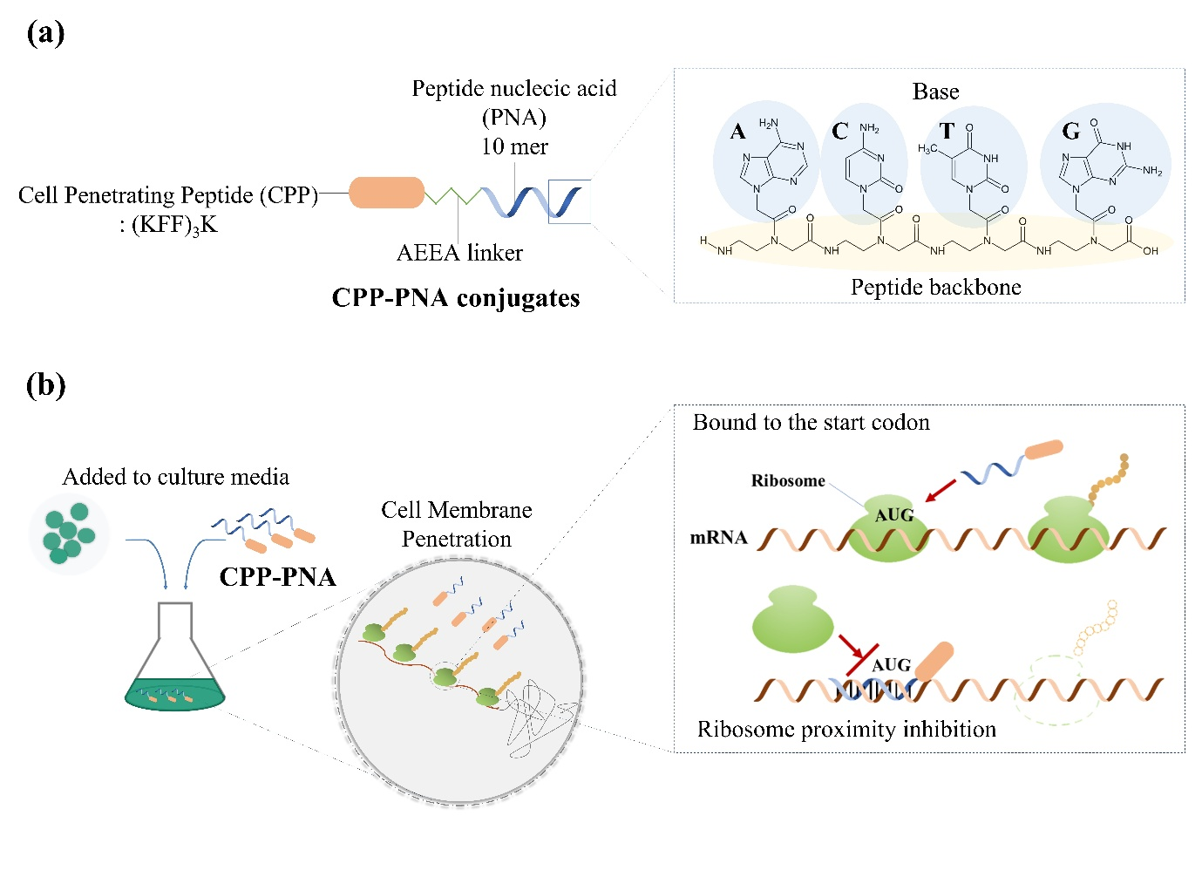
Supplementary Figures

Fig. S1. Schematic representation of CPP–PNAs and their mechanism in bacterial cells.
(a) Structural illustration of CPP–PNAs. The conjugate consists of a cell-penetrating peptide (CPP; (KFF)₃K) linked to a 10-mer peptide nucleic acid (PNA) via 2-aminoethoxy-2-ethoxy acetic acid (AEEA) linker. The PNA backbone is composed of a neutral peptide-like structure bearing nucleobases (A, T, G, C) that hybridize sequence-specifically with complementary nucleic acid strands. (b) Principle of CPP–PNAs against bacteria. Upon addition to the culture medium, CPP–PNA permeates bacterial cell membranes and hybridizes with the target mRNA at the translation initiation region near the start codon (AUG), sterically blocking ribosome binding and thereby inhibiting translation initiation.

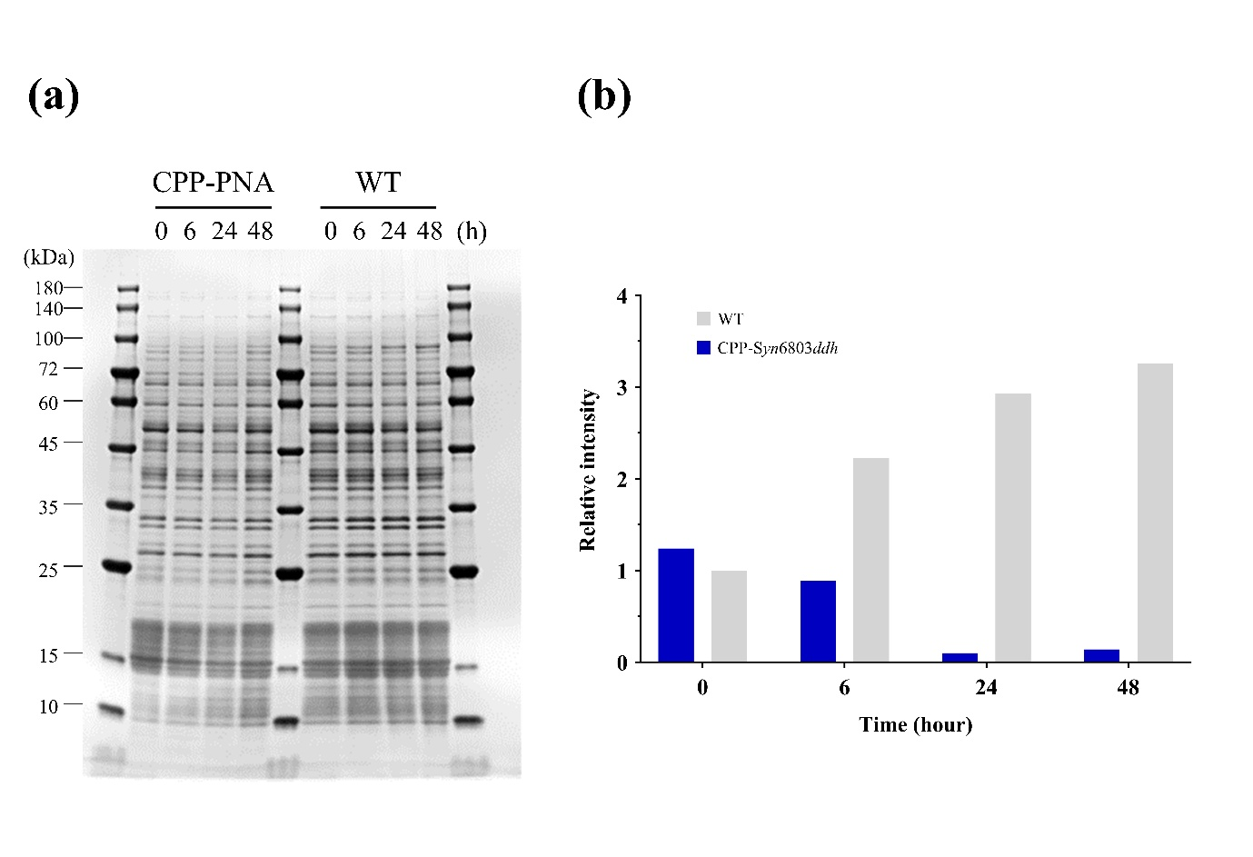
Fig. S2. SDS–PAGE profile and quantitative Western blot analysis of Ddh
(a) Total protein patterns (SDS–PAGE) for wild type (WT) and cells treated with 10 µM CPP-Syn6803ddh, sampled at 0, 6, 24, and 48 h. Only bands migrating between the 10 and 180 kDa markers were used for loading standardization. (b) Quantification of Ddh band intensity

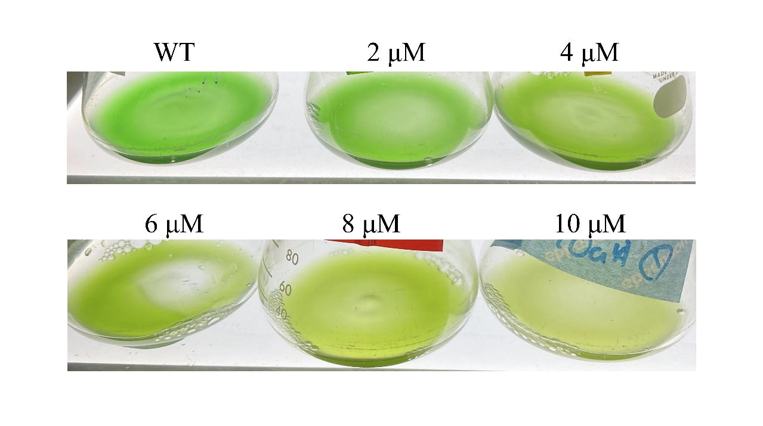
Fig. S3. Dose-dependent growth inhibition of Synechocystis sp. PCC 6803 upon CPP-PNA treatment.
Cultures were treated with CPP-Syn6803ddh_Asp130 at final concentrations of 2, 4, 6, 8, and 10 µM and photographed after 72 h. WT represents the untreated control. With increasing CPP-PNA concentrations, decolorization of the subcultures were observed.

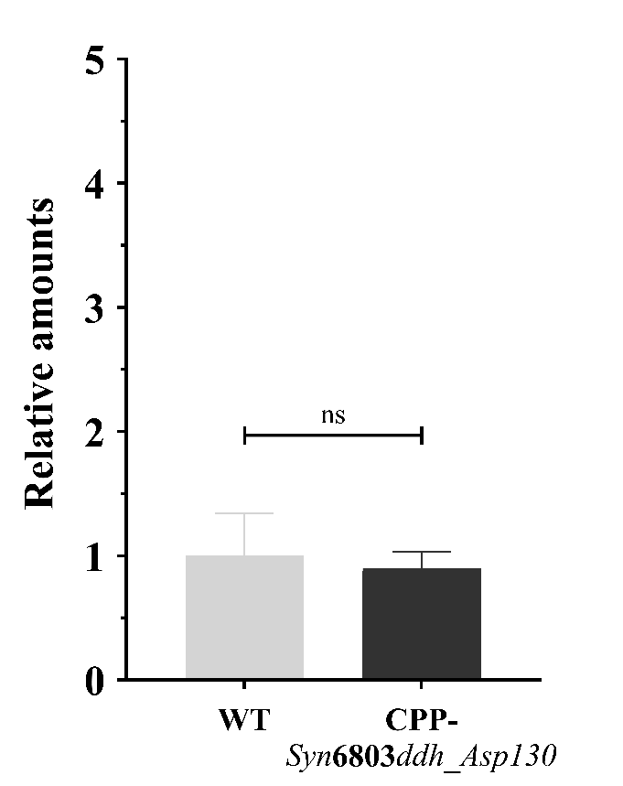
Fig. S4. Verification of potential off-target effects of CPP–PNA targeting an internal region of the ddh mRNA.
The bar graph shows the relative intracellular D-lactate levels in Synechocystis sp. PCC 6803 cells treated with 10 µM of CPP–Syn6803ddh_Asp130 compared with the untreated wild-type (WT) control at 48 hours after CPP–PNA treatment. Quantification was performed using LC–MS and normalized to WT levels. In this probe design, the internal target region corresponds to the codon for Asp130, a conserved aspartic acid residue critically involved in maintaining the tertiary structure of the Ddh enzyme [1]. No significant difference (ns) was observed, indicating that CPP–PNA binding to this internal mRNA region did not affect D-lactate accumulation. Data represent the mean + standard deviation (SD) from three independent experiments. Statistical analysis was performed using one-way ANOVA.
1. Furukawa N, Miyanaga A, Nakajima M, Taguchi H. Structural Basis of Sequential Allosteric Transitions in Tetrameric d-Lactate Dehydrogenases from Three Gram-Negative Bacteria. Biochemistry. 2018;57:5388–406.

