Supplementary Material

Supplementary Methods
PGAM/PirC antibody production in rabbits
The antibodies against PGAM and PirC were obtained from Davids Biotechnologie (Regensburg, Germany) according to the company's protocols. For each protein, three rabbits were immunized after a check of immunity to the cyanobacterial cell extract, performed by Western blot using pre-serum of the rabbits and a cell extract with a whole protein amount of 1 mg (as mentioned previously). Accordingly, rabbits with the lowest reaction against the cell extract were chosen. The immunogenic proteins were produced according to the protein expression protocol described by Orthwein et al. 2025, using the plasmids pET28a-PGAM (PGAM-His) and pJS22 (PirC-His) [1]. To prevent immunization against the His-tags, the tags were removed using the Thrombin CleanCleave™ Kit (Sigma-Aldrich, St. Louis, USA) according to the provided protocol. First, the optimal cleavage times (1 h, 2 h, 4 h, 6 h, and 24 h) were tested. According to the results, 4 h cleavage was used. The thrombin agarose resin was washed twice with 500 µL of 1x cleavage buffer (50 mM Tris-HCl, pH 8.0, 10 mM CaCl₂) by resuspension and centrifugation.100 µL of suspended resin was transferred to a 1.5 mL reaction tube and centrifuged. After the buffer was removed, 100 µL of 10x cleavage buffer (500 mM Tris-HCl, pH 8.0, 100 mM CaCl₂) was added again. Subsequently, 1 mg of fusion protein was added, and the slurry was diluted to 1 ml to obtain the cleavage slurry. The cleavage was done by gentle agitation within a reaction tube mixer for 4 h. The resin was removed by gentle centrifugation, and the supernatant was transferred to a new reaction tube. The buffer was exchanged to the transport buffer (50 mM Tris-HCl, 50 mM NaCl). This procedure was done with 5 vials. After cleavage, the proteins were pooled to a final concentration of 1 mg/mL in a transport buffer. Three vials of each protein were sent to David's Biotechnology in a cooling box (~4 °C) for immunization. The final serums were tested via Western blot according to the protocol (as mentioned previously).

Supplementary Tables

Table S1: List of plasmids used and generated in this study.
Name | Plasmid | Purpose | Source
 | pSEVA251, Km^{R} | Control plasmid | [2]
 | pSEVA451, Sm^{R} | Control plasmid | [2]
pNB204 | pSEVA251-P_{J23101}::pgam, Km^{R} | Overexpression of slr1945 with J23101 promoter | This study
pNB205 | pSEVA251-P_{J23119}::pgam, Km^{R} | Overexpression of slr1945 with J23119 promoter | This study
pFH01 | pSEVA451-P_{petE}::pirC, Spec^{R} | Overexpression of sll0944 with the promoter of the petE gene | This study
pFH10 | pEX-K248-P_{petJ}::pgam, Km^{R} | Downregulation of slr1945 with the promoter of the petJ gene | This study
pEERM3:2MEP-IspS | pJ344, Km^{R} | Knockout of slr0168 replacing it with Ptrc-driven overexpression of DXS, Idi, IspS and Kanamycin resistance casette | [3]
pEERM3-PirC:2MEP-IspS | pJ344, Km^{R} | Knockout of sll0944 replacing it with Ptrc-driven overexpression of DXS, Idi, IspS and Kanamycin resistance casette | This study
pJS22 | pET15b, Amp^{R} | Overexpression of His8-PirC with the T7 promoter | [4]
pET28a_PGAM | pET28a, Km^{R} | Overexpression of PGAM-His6 with the T7 promoter | [4]

Table S2: List of strains used and generated in this study.
Organism/ Strain |  | Genotype | Purpose/ Reference
E. coli | NEB10β | Δ(ara-leu) 7697 araD139 fhuA ΔlacX74 galK16 galE15 e14- Φ80dlacZΔM15 recA1 relA1 endA1 nupG rpsL (StrR) rph spoT1 Δ(mrr-hsdRMS-mcrBC) | Molecular Cloning, NEB
E. coli | Stellar | F- endA1 supE44 thi-1 recA1 relA1 gyrA96 phoA Φ80dlacZΔM15 Δ(lacZYA-argF) U169 Δ(mrr-hsdRMS-mcrBC), ΔmcrA, λ- | Molecular Cloning, TAKARA
E. coli | Top10 | F–mcrA Δ(mrr-hsdRMS-mcrBC) φ80lacZΔM15 ΔlacX74 recA1 araD139 Δ(ara-leu)7697 galU galK λ–rpsL(Str^{R}) endA1 nupG | Molecular cloning,
E. coli | DH5α | F– φ80lacZΔM15 Δ(lacZYA-argF)U169 recA1 endA1 hsdR17(r_{K}–, m_{K}⁺) phoA supE44 λ–thi-1 gyrA96 relA1 | Molecular cloning,
Synechocystis sp. PCC 6803 | wildtype glucose-tolerant | WT | Control strain
Synechocystis sp. PCC 6803 | ΔpirC | sll0944::Spec^{R} | [4]
Synechocystis sp. PCC 6803 | 101_pgam | WT + pSEVA251-P_{J23101}::pgam, Km^{R} | This study
Synechocystis sp. PCC 6803 | 119_pgam | WT + pSEVA251-P_{J23119}::pgam, Km^{R} | This study
Synechocystis sp. PCC 6803 | ΔpirC + 101_pgam | sll0944::Spec^{R} +  pSEVA251-P_{J23101}::pgam, Km^{R} | This study
Synechocystis sp. PCC 6803 | pirC_OEX | WT + pSEVA451-P_{petE}::pirC, Sm^{R} | This study
Synechocystis sp. PCC 6803 | pgam_KD | P_{petJ}::pgam, Km^{R} | This study
Synechocystis sp. PCC 6803 | NSI-IspS | slr0168:dxs-idi-ispS::Km^{R} | [3]
Synechocystis sp. PCC 6803 | ΔPirC-IspS | sll0944:dxs-idi-ispS::Km^{R} | This study

Table S3: List of oligonucleotides used in this study.
GA= Gibson Assembly, sdm= side-directed mutagenesis, AQ = AQUA cloning
name | sequence | Purpose, Reference
NB042 | aaaagcgcggatcctctagagtcgacctgca | GA, pSEVA-P_{J23101}::pgam  (This study)
NB045 | gtcgactctagaggatccgcgcttttc | GA, pSEVA-P_{J23101}::pgam  (This study)
NB046 | ctgtaaagaattcgcgcggcc | GA, pSEVA-P_{J23101}::pgam  (This study)
NB047 | ccgcggccgcgcgaattctttacagctagctcagtcc | GA, pSEVA-P_{J23101}::pgam  (This study)
NB062 | agggcggcggatttgtcc | Colony PCR  (https://seva-plasmids.com/backbone-modules-nomenclature/)
NB063 | gcggcaaccgagcgttc
NB075 | cctaggtataatgctagcATCTTTTGCAGACTTTATAACTGTAGTGAG | sdm, substitute P_{J23101} with P_{J23119} on pSEVA251-P_{J23101}::pgam plasmid (This study)
NB076 | actgagctagctgtcaaGAATTCGCGCGGCCG
FH013 | gaattcGAAGGGATAGCAAGCTAATTTTT | Ligation for pSEVA451-P_{petE}::pirC (This study)
FH017 | tttgggacatACTTCTTGGCGATTGTATCTAT | Ligation for pSEVA451-P_{petE}::pirC (This study)
FH018 | gccaagaagtATGTCCCAAATTCTTGATCCC | Ligation for pSEVA451-P_{petE}::pirC (This study)
FH019 | ggatccTTTTTCTTAGTGCTTTGTCCG | Ligation for pSEVA451-P_{petE}::pirC (This study)
FH020 | AGGGAGTCCCGGATTAAA | Colony PCR pgam_KD (This study)
FH027 | GCGCTTTTCCATCCCC | Colony PCR pgam_KD (This study)
FH112 | ATCTTTTGCAGACTTTATAACTGTAG | Colony PCR pgam_KD (This study)
2-MEP-PirCup_fw | aatcaccaacgccaaaAAAAAAAGGATCTCAAGAAGATCCTT | AQ, pEERM3-PirC:2MEP-IspS (This study)
2-MEP-PirCdwn_rev | ttcattaattcattgGGATCCCTCGAGTCCCG | AQ, pEERM3-PirC:2MEP-IspS (This study)
PirCup_fw | CCTATAGTGTCTTCGGGGattcgccgtaataggcactg | AQ, pEERM3-PirC:2MEP-IspS (This study)
PirCup_2MEP_rev | TTGAGATCCTTTTTTTtttggcgttggtgattactt | AQ, pEERM3-PirC:2MEP-IspS (This study)
PirCdwn-2MEP_fw | GGGACTCGAGGGATCCcaatgaattaatgaattggaatac | AQ, pEERM3-PirC:2MEP-IspS (This study)
PirCdwn-rev | GACGTATATGGTCTTCTTTTatctccgccatagatcctt | AQ, pEERM3-PirC:2MEP-IspS (This study)
pEERM-PirCdwn_fw | gaaggatctatggcggagatAAAAGAAGACCATATACGTC | AQ, pEERM3-PirC:2MEP-IspS (This study)
pEERM-PirCup_rev | cagtgcctattacggcgaatCCCCGAAGACACTATAGG | AQ, pEERM3-PirC:2MEP-IspS (This study)

Supplementary Figures

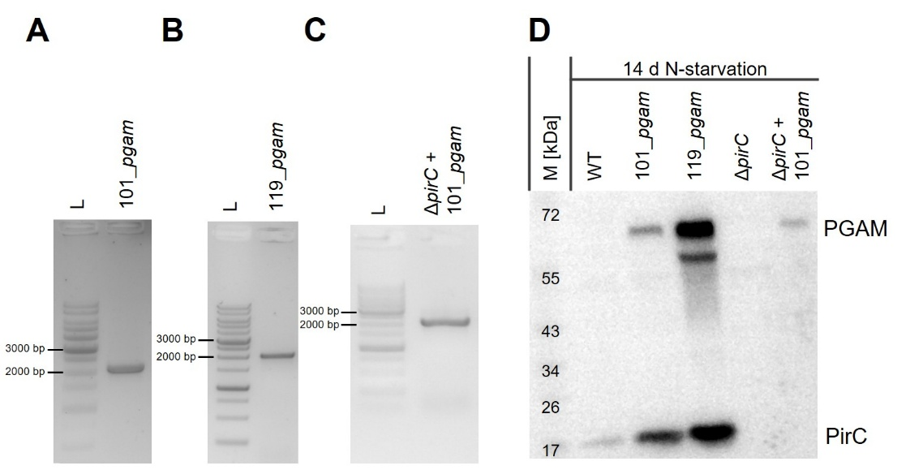
Suppl. Figure 1: Colony PCR of strains 101_pgam, 119_pgam and ΔpirC + 101_pgam and immunoblots against PGAM and PirC. A-C: Colony PCR of the Synechocystis strains 101_pgam (A), 119_pgam (B) and ΔpirC + 101_pgam (C) with the primers NB062/063. As ladder (L) the GenLadder 1kb ready-to-use DNA-Marker from Genaxxon was used. D: Immunoblots against PGAM and PirC 14 days into nitrogen starvation.

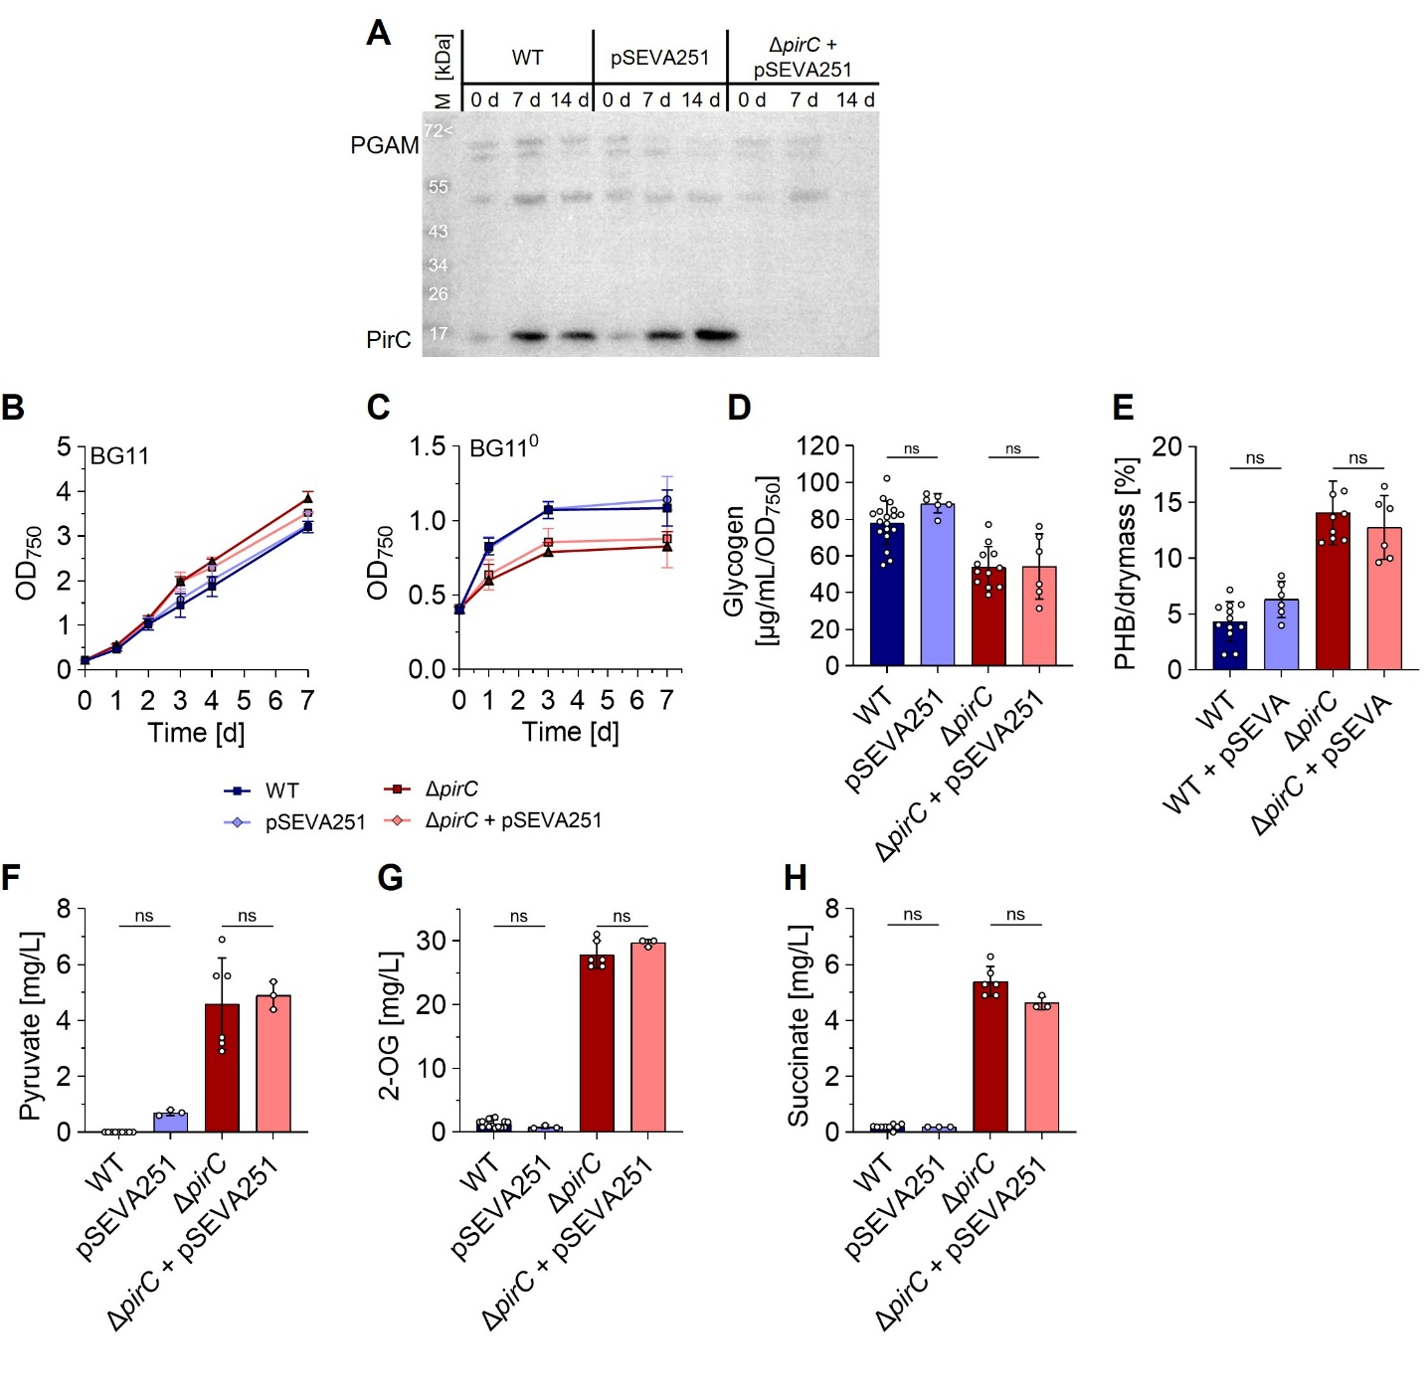
Figure S2: Empty pSEVA251 plasmid has no effect on growth, glycogen and PHB level. A: Immunoblots against PGAM and PirC in vegetative conditions (0 d) and 7 days into nitrogen starvation (7 d). B-C: Vegetative growth (B) and OD₇₅₀ under nitrogen starvation (C) with at least three biological replicates. D-E: Quantification of glycogen with method A (D) and PHB (E) 7 days in nitrogen starvation. F-I: Extracellular metabolites were quantified with HPLC-MS from the supernatant of 7-day nitrogen-depleted cell cultures. Each dot represents a biological replicate. Dunn’s multiple comparisons test was used (ns = P > 0.05, * = P ≤ 0.05, ** = P ≤ 0.01, *** = P≤ 0.001).

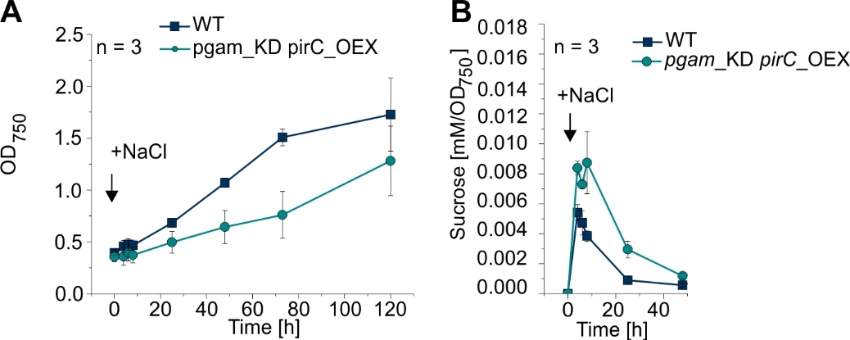
Figure S3: Kinetics of sucrose accumulation in strain pgam_KD/pirC_OEX upon salt shock. Salt shock was performed by adding crystalline NaCl to a final concentration of 500 mM 24 h after the induction of the strains with copper ions. A: Growth in presence of 500 mM NaCl. B: Sucrose content at different time points after salt shock.

Supplementary References
1. Orthwein T, Alford JT, Becker NS, Fink P, Forchhammer K. Structural elements of cyanobacterial co-factor-independent phosphoglycerate mutase that mediate regulation by PirC. mBio. 2025;16:e03378-24. https://doi.org/10.1128/mbio.03378-24
2. Silva-Rocha R, Martínez-García E, Calles B, Chavarría M, Arce-Rodríguez A, de Las Heras A, et al. The Standard European Vector Architecture (SEVA): a coherent platform for the analysis and deployment of complex prokaryotic phenotypes. Nucleic Acids Res. 2013;41:D666-675. https://doi.org/10.1093/nar/gks1119
3. Rana A, Gomes LC, Rodrigues JS, Yacout DMM, Arrou-Vignod H, Sjölander J, et al. A combined photobiological–photochemical route to C10 cycloalkane jet fuels from carbon dioxide via isoprene. Green Chem. The Royal Society of Chemistry; 2022;24:9602–19. https://doi.org/10.1039/D2GC03272D
4. Orthwein T, Scholl J, Spät P, Lucius S, Koch M, Macek B, et al. The novel PII-interactor PirC identifies phosphoglycerate mutase as key control point of carbon storage metabolism in cyanobacteria. Proc Natl Acad Sci U S A. 2021;118. https://doi.org/10.1073/pnas.2019988118

