Supplemental Information
belonging to the manuscript

Application of a Microdroplet Array Platform for High-Throughput Analysis of Growth and Natural Product Biosynthesis of Streptomyces
Sten Hagen^{1,2}, Maximilian Breitfeld³, Claudius L. Dietsche³, Bowien van Leijden¹, Isabela Fernandes de Oliveira¹, Petra S. Dittrich³, Gilles P. van Wezel^{2,4, *}, Bart J.F. Keijser^{1, *}

¹Microbiology and Systems Biology, The Netherlands Organization for Applied Scientific Research (TNO), Leiden, Netherlands.
²Molecular Biotechnology, Institute of Biology, Leiden University, Sylviusweg 72, 2333 BE, Leiden, Netherlands
³Department of Biosystems Science and Engineering, ETH Zürich, Klingelbergstrasse 48, Basel, CH-4056, Switzerland
⁴Netherlands Institute of Ecology (NIOO-KNAW), Wageningen, Netherlands
Keywords: Streptomyces, Antibiotics, Drug Discovery, High-Throughput Screening, Droplet Microfluidics, Microdroplet Arrays

* Corresponding authors: g.wezel@biology.leidenuniv.nl; bart.keijser@TNO.nl

Table S1. Averaged final mean brightfield intensity values of Streptomyces strains grown in TSB media and their standard deviation. Final Y-axis intensity values were averaged and their standard deviation were calculated across 55 replicate droplets.
Strain | Average Y-intensity value | Standard deviation
S. coelicolor | 4.903,96 | 698,93
S. coelicolor ΔmatAB | 5.087,92 | 824,45
MBT27 | 5.407,10 | 650,76
S. griseus | 5.688,02 | 581,03
S. rimosus | 2.180,13 | 664,07
S. albus | 5.055,89 | 539,32
S. venezuelae | 3.882,63 | 2.985,13
S. lividans | 5.688,41 | 1.260,39
S. lividans ΔmatAB | 5.764,21 | 980,48

Table S2. Averaged final mean brightfield intensity values of Streptomyces strains grown in MMMP media and their standard deviation. Final Y-axis intensity values were averaged and their standard deviation were calculated across 55 replicate droplets.
Strain | Average Y-intensity value | Standard deviation
S. coelicolor | 23,53 | 777,88
S. coelicolor ΔmatAB | 2,29 | 605,87
MBT27 | 2.459,33 | 1.372,38
S. griseus | 2.972,59 | 833,61
S. rimosus | 2.194,16 | 418,77
S. albus | 2.963,30 | 1.248,61
S. venezuelae | 49,53 | 745,93
S. lividans | -110,96 | 473,09
S. lividans ΔmatAB | -179,99 | 938,61

Fig. S1. Morphology of S. venezuelae grown in TSB in droplet and shake-flask cultures. Cultures were grown in TSB for 24 h. (A) Nanodroplets showing heterogeneous morphology, including both pellet formation and fragmented growth. (B) Brightfield images of bulk cultures grown in shake flasks with or without a metal coil.

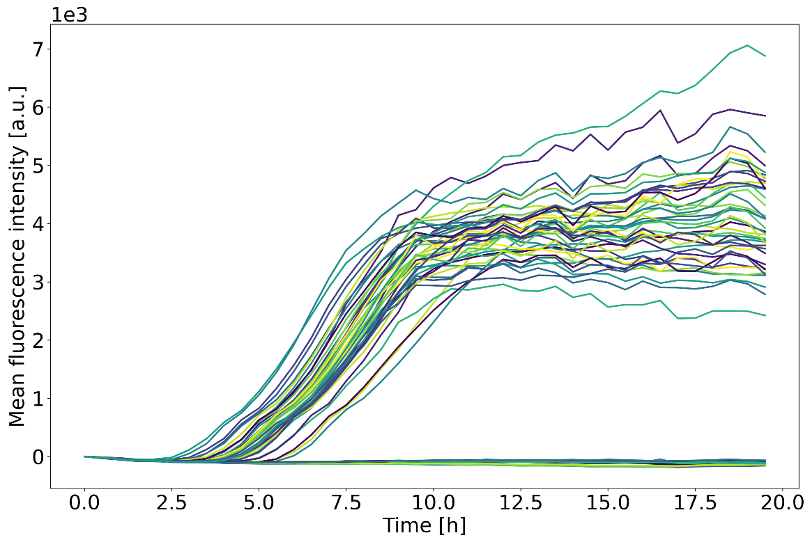
Fig. S2. Growth curves of 55 B. subtilis droplets in TSB, showing high droplet-to-droplet similarity. Some droplets remained empty and thus show a non-growth event, resulting in the observed flat lines.
Fig. S3. Comparison of normalized peak areas of antibiotic-associated features between MMMP and TSB conditions. Red indicates crude extracts from strains grown in MMMP and blue indicates crude extracts from TSB. Data were processed in MZmine, and normalized and analyzed in MetaboAnalyst. Statistical analysis using a Student’s t-test demonstrated a significant increase in metabolite production in MMMP relative to TSB.
Fig. S4. Growth of Streptomyces in nanolitre droplets in minimal medium (StrepMM). Representative brightfield images of single droplets showing growth over time (0–120 h).

Fig. S5. MALDI-TOF MS spectrum of actinomycin X2 detected from a single droplet containing MBT27 grown for 120 h in StrepMM.
Fig. S6. MALDI-TOF MS spectrum of putative rimocidin detected from a single droplet containing S. rimosus grown for 120 h in StrepMM.

