Supplementary information
Metabolic impact of redox perturbations on recombinant protein production in Komagataella phaffii under methanolic growth conditions
Eric Antón, Sergi Monforte^{ǂ}, Ane Quesada-Ganuza§, Joan Albiol, Pau Ferrer*
Author information:
Department of Chemical, Biological and Environmental Engineering, Universitat Autònoma de Barcelona, Catalonia, Spain
§ Current affiliation: Viralgen, Basque Country, Spain
ǂ Current affiliation: Centrident Pharmaceuticals, Catalonia, Spain
*Corresponding author

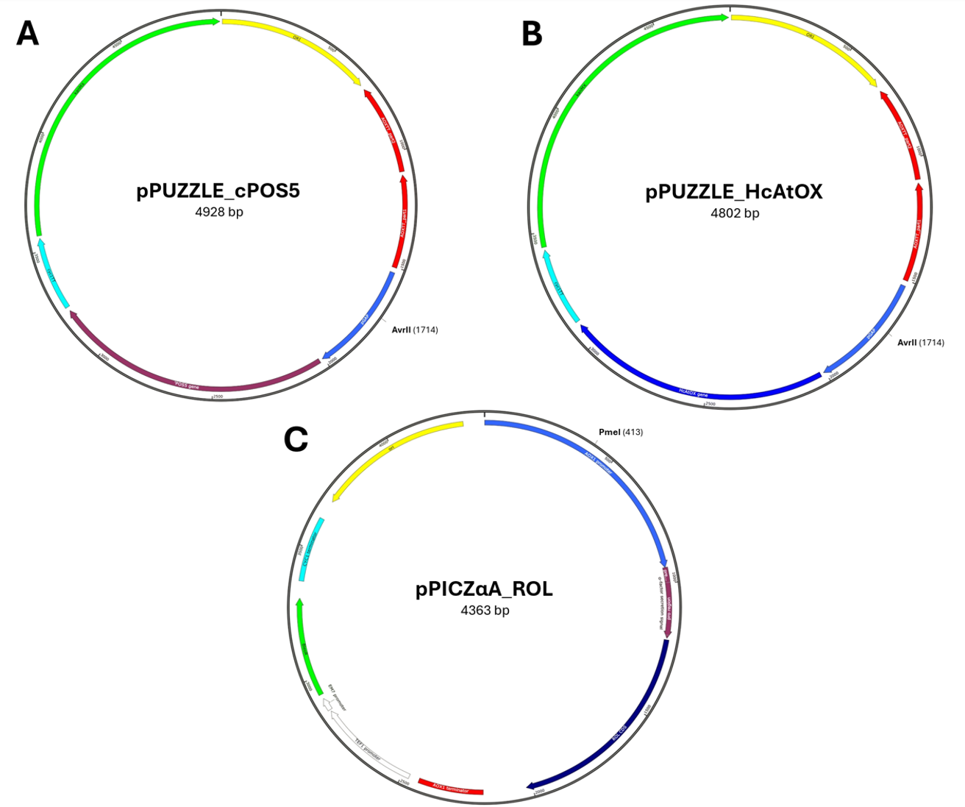Supplementary figure 1. Plasmid maps of pPUZZLE_cPOS5 (A) and pPUZZLE_AtOX (B) and pPICZαA_ROL. The restriction enzymes AvrII and PmeI used for plasmid linearization cuts in the middle of pGAP and pAOX respectively. pPUZZLE contains the kanMX gene for kanamycin resistance in bacteria (Escherichia coli) and geneticin G418 resistance in yeast (Komagataella phaffii) while pPICZα the resistance marker Zeocin (BleoR).
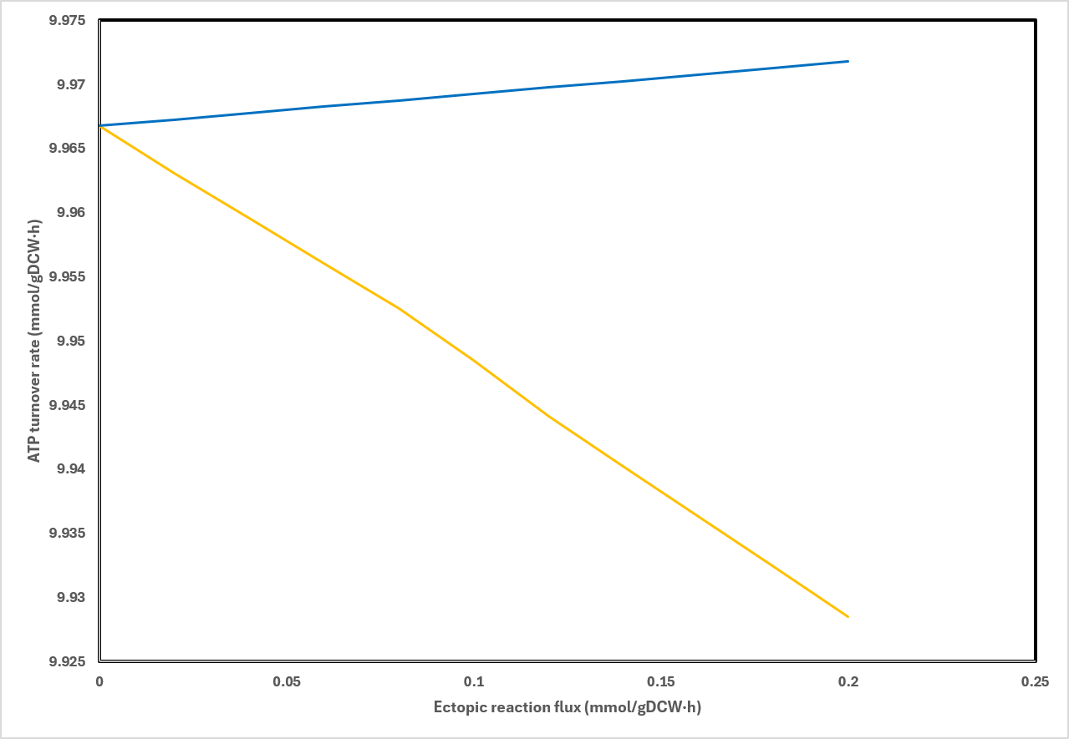
Supplementary figure 2. In silico predicted ATP turnover rate variation caused by NADH kinase (blue line) or alternative oxidase (yellow line) overexpression.

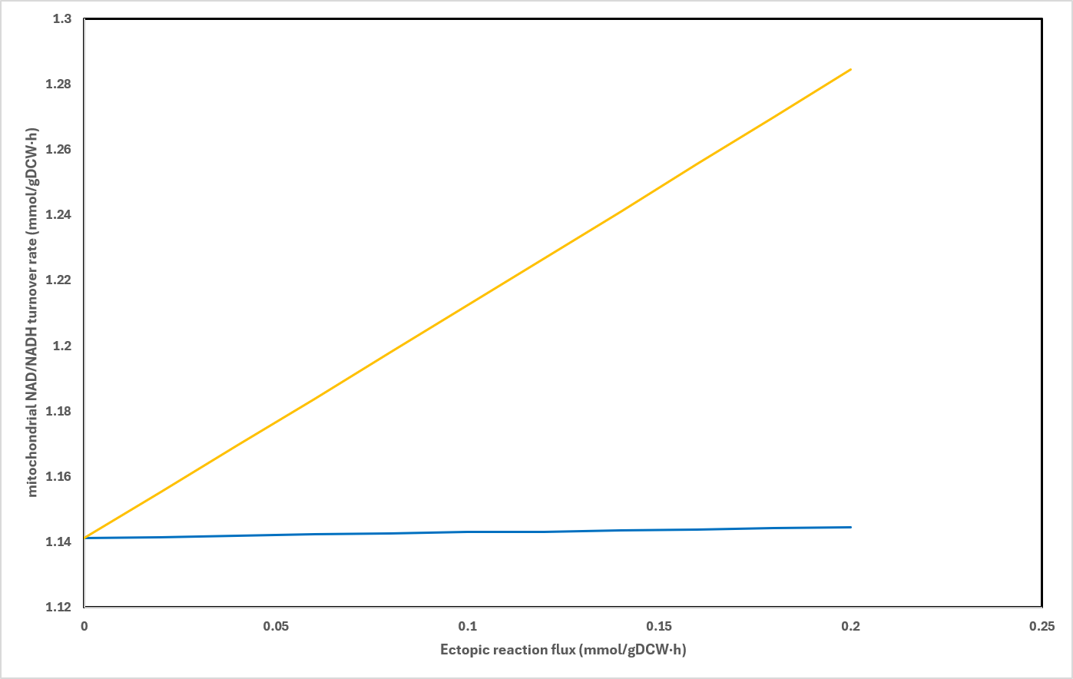Supplementary figure 3. In silico predicted mitochondrial NADH/NAD⁺ turnover rate variation caused by NADH kinase (blue line) or alternative oxidase (yellow line) overexpression.

Supplementary table 1. Primers used in this study.
Primer | Sequence (5’-3’) | Purpose
pGAP_seq_fw | AGGTCGTGTACCCGACCTAG | cPCR check cPOS5 integration
POS5_seq_rev | GAAGATGTCCAAGTTAGTCAAGTGTG | cPCR check cPOS5 integration
HcAtOX_fw | CTTGAGAAGAATGAAGAGAGACAACGG | cPCR check HcAtOX integration
HcAtOX_rv | CTGAGCCAACTTCAAGAAAGACAACAAG | cPCR check HcAtOX integration
ACT1_fw | TGTCCGGTGGTACTATGTTCC | cPOS5 gene copy number determination through ddPCR
ACT1_rev | GATTCGTCGTACTCTTGCTTTGA | cPOS5 gene copy number determination through ddPCR
POS5_dd_fw | GGAGTGTCATTGAAGAAGAA | cPOS5 gene copy number determination through ddPCR
POS5_dd_rev | CGTCAGCAGTAGTTCTAC | cPOS5 gene copy number determination through ddPCR

Supplementary table 2. ddPCR analysis results to determine POS5 kinase gene copy number on HcAtOX1 + cPOS5 co-expressing clones (POSNOX) and cPOS5 clones. POS5 copy number was determined in triplicate.
Strain | POS5 Copy Number
POSNOX c1 | 0.71 ± 0.01
POSNOX c2 | 1.13 ± 0.02
POSNOX c3 | 2.05 ± 0.63
POSNOX c6 | 3.35 ± 0.02
POSNOX c10 | 2.05 ± 0.16
POSNOX c13 | 2.06 ± 0.63
POSNOX c16 | 3.55 ± 0.01
POSNOX c20 | 12.22 ± 0.00
cPOS5 c1 | 1.95 ± 0.17
cPOS5 c2 | 1.19 ± 0.01
cPOS5 c3 | 0.97 ± 0.01
cPOS5 c4 | 1.24 ± 0.02

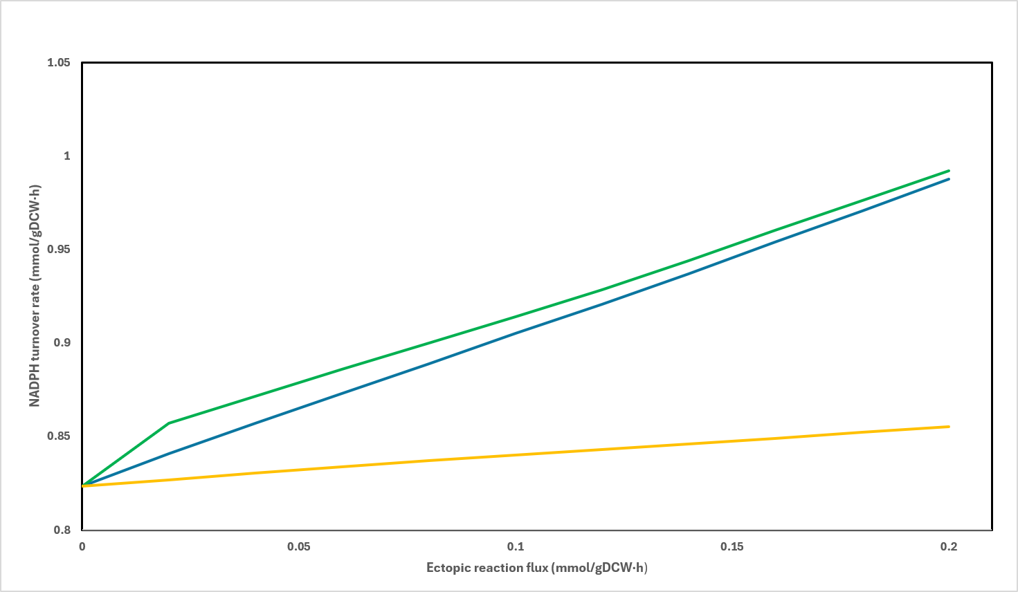
Supplementary figure 4. In silico predicted cytosolic NADPH turnover rate variation caused by NADH kinase (blue line) or alternative oxidase (yellow line) overexpression or the combination of both ectopic genes (green line). For the combined mutant simulation, the alternative reaction flux was fixed to (0.1 mmol/(gDCW·h)) and progressively augmenting the Pos5 reaction flux.
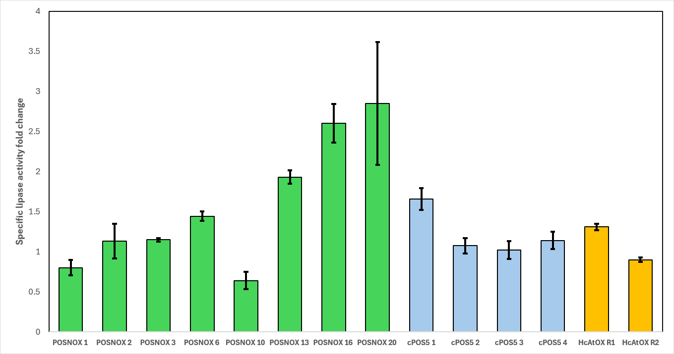
Supplementary figure 5. Lipase activity levels (expressed as specific lipase fold change) of cPOS5 and HcAtOX1 + cPOS5 (POSNOX) co-expressing clones with the X-33 Rol strain as reference in small scale cultivations using methanol as carbon source.

Supplementary table 3. Growth data from small scale cultivations in BMM. Strains marked with an X were selected for further strain characterization in bioreactor.
