Efficient bioproduction of 5-aminolevulinic acid from renewable bioresources by engineered Saccharomyces cerevisiae
Kunqiang Hong†,‡#*, Huimin Chen†,‡#, Xiaomeng Fu§#, Zizhen Liu†,‡, Dan Mo†,‡, Xinrui Sun†,‡, Zhijian Tan¶, Xuewu Guo⊥,*
†College of Food Science and Engineering, Wuhan Polytechnic University, Wuhan, 430023, P. R. CHINA.
‡Key Laboratory for Deep Processing of Major Grain and Oil, Ministry of Education, Wuhan Polytechnic University, Wuhan, 430023, P. R. CHINA. §College of Food Science and Technology, Wuhan business University, Wuhan 430056, Hubei, P. R. China
¶Institute of Bast Fiber Crops，Chinese Academy of Agricultural Sciences，Changsha 410221，Hunan，China
⊥Key Laboratory of Industrial Fermentation Microbiology, Ministry of Education, Tianjin Key Laboratory of Industrial Microbiology, Tianjin University of Science and Technology, Tianjin, 300457, P.R.China
#These authors contributed equally to this work.
*Corresponding author: Kun-Qiang Hong, hongkq@whpu.edu.cn; Xue-Wu Guo, guoxuewu@tust.edu.cn; Other authors’ addresses: Huimin Chen, 1527636320@qq.com; Xiaomeng Fu: fuxiaomeng@tju.edu.cn; Zizhen Liu, 15342929166@163.com; Dan Mo: 19971858016@163.com; Xinrui Sun, 1115761646@qq.com; Zhijian Tan, tanzhijian@caas.cn.

S. cerevisiae strains construction Strain Regardless of the method used to construct the strains, an initial screening was first conducted on SC-Ura medium, then the transformants were transferred to YPD medium for cultivation, followed by molecular verification. Correct transformants were transferred to liquid YPD medium to remove the plasmid carrying the URA3 gene, and then plated on SC-5-FOA plates for selection. The resulting single colonies were transferred to YPD medium for further molecular verification before proceeding to the next gene modification.
Constitutive expression of ALAS in multicopy sites rDNA via two-step integration method The YIPlac211-rDNA-kpHEM1 plasmid were linearized with restriction enzyme EcoNI and integrated using the same lithium acetate transformation method. Following SC-Ura was used for preliminary screening the transformants, then transformer was transferred to a YPD plate for culturing the strain. Primer pairs of YIP-CK1/ rDNA -CK2, rDNA -CK3/YIP-CK4 were used to verify the first-step integration.
Then, transformants obtained from the first-step integration were cultured, spread onto SC-5-FOA plates and verified by colony PCR using primer pairs of rDNA -CK1/ rDNA -CK2.
Analytical methods
Glycine detection Glycine detection was conducted according to the method reported by Chen et al¹. Glycine was analyzed by HPLC. Prior to HPLC analysis, samples were derivatized using the Fmoc-Cl method: a 50 μL aliquot of sample solution (concentration ≤10 mM) was mixed with 250 μL of 100 mM borate buffer (pH 9.0), followed by addition of 300 μL of 10 mM Fmoc-Cl solution in acetone. The mixture was immediately vortexed for 10 s to ensure thorough homogenization and allowed to react for 30 min at ambient temperature in the dark. The reaction was quenched by adding 600 μL of 250 mM sodium borate solution containing 25% acetonitrile. The derivatized sample was centrifuged at 12,000 rpm for 2 min to remove precipitates, and the resulting supernatant was filtered through a 0.22 μm membrane prior to injection. Chromatographic separation was performed on an Agilent C18 reversed-phase column (5 μm, 250 mm × 4.6 mm) maintained at 50 °C, with a flow rate of 1.0 mL/min and an injection volume of 10 μL. The mobile phase consisted of mobile phase A (ultrapure water containing 0.1% trifluoroacetic acid) and B (acetonitrile supplemented with 0.1% TFA). The following gradient elution program was employed: 0−5 min, linear gradient from 50% to 90%.
B: 5−9 min, isocratic elution at 90% B; 9−12 min, linear gradient from 90% to 50% B; 12−15 min, column re-equilibration at 50% B. Detection was performed at a wavelength of 254 nm.
Glutamate detection Glutamate in the fermentation broth was analyzed via HPLC (Agilent-1260)², using an Agilent ZORBAX Eclipse AAA 4.6 × 150 mm refractive index detector. KH₂PO₄ solution (5.44 g/L, pH7.2) was used as the eluent with a flow rate of 1 mL/min at 40 °C.
α-amino nitrogen content detecting method Take an appropriate amount of sample (e.g., 1 mL of hydrolysate) into a 100 mL volumetric flask and dilute to volume with distilled water. The dilution factor should be adjusted according to the estimated amino nitrogen content so that the final reaction solution concentration falls within the linear range of the standard curve (e.g., 1–3 mg/L). Pipette 2.00 mL of distilled water (blank control), the diluted standard solution, and the diluted sample solution into separate stoppered test tubes. Add 1.00 mL of color reagent to each test tube (dissolve 10 g Na₂HPO₄·12H₂O, 6 g KH₂PO₄, 0.5 g indophenol hydrate, and 0.3 g fructose in water and dilute to 100 mL), and mix thoroughly. Place in a boiling water bath and heat precisely for 16 minutes. After heating, immediately transfer the test tubes to a 20°C constant-temperature water bath and cool for 20 minutes to stabilize the colored product. Add 5.00 mL of diluted potassium iodate solution to each cooled test tube and mix well. Using the blank control tube as reference, measure the absorbance (A) of the standard and sample solutions at 570 nm with a spectrophotometer. Plot a standard curve with the various dilutions of standard glycine solution (corresponding to known α-amino nitrogen concentrations).
Detection of reducing sugars using Fehling's reagent method.
Analysis of CoA and acetyl‑CoA The separation of the CoA compounds was performed with a thermos separation product HPLC system (Agilent Technologies, Beijing, China) equipped with a Spectrasystem P4000 pump, UV2000 detector, and a 5 mm octyldecyl silane column (Cell Technologies, Inc., Houston, TX). The two mobile phase solvents used were buffer A (0.2 M sodium phosphate, pH 5.0) and buffer B (acetonitrile) at a flowrate of 1 mL/min (VbufferA:VbufferA = 1:9). The method of quantifying intracellular CoA and acetyl-CoA was modified as
previously described³.
Figure S1 5-ALA production and OD₆₀₀ of six yeast strains in YPD medium. Different lowercase letters indicate significant differences. Data are presented as the means and standard deviations of three independent experiments.

Figure S2 5-ALA production of AY12a-ura3 expressing different ALAS in XI 3.3 site. Different lowercase letters indicate significant differences. Data are presented as the means and standard deviations of three independent experiments.

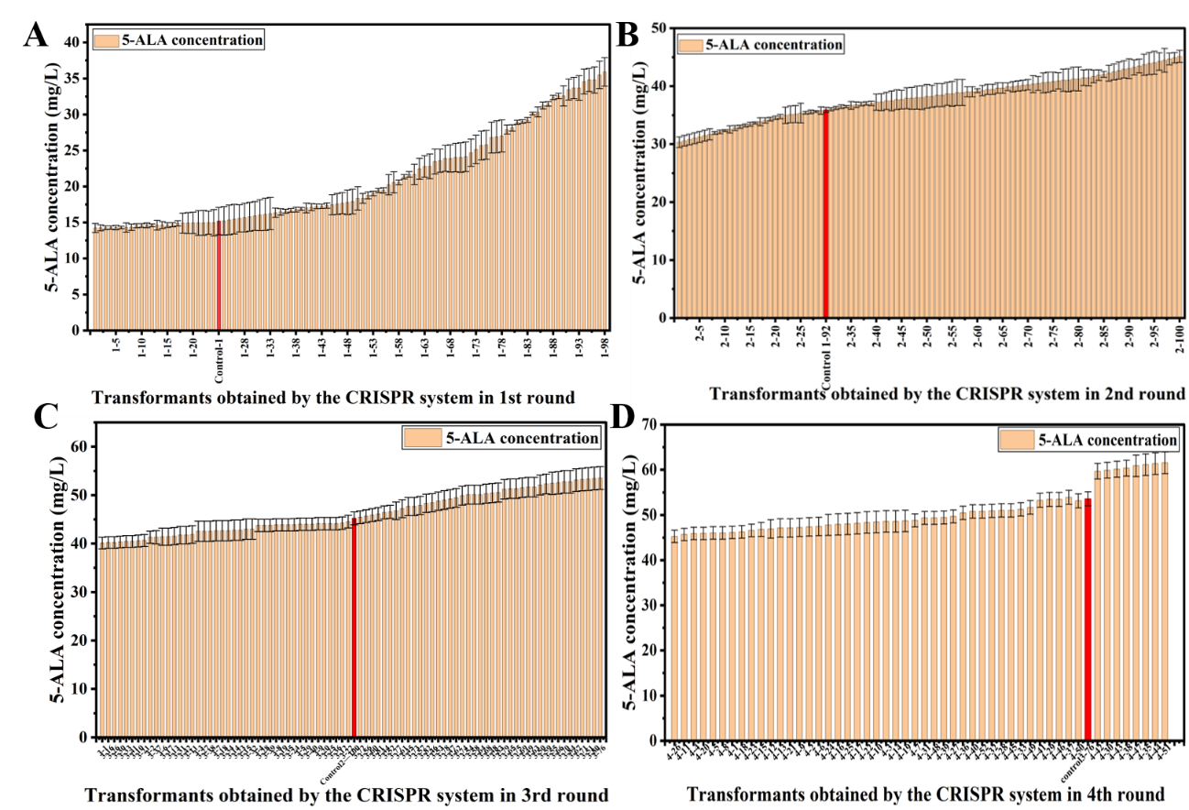
Figure S3 5-ALA production of transformants from CRISPR-Cas9 system. Data are presented as the means and standard deviations of three independent experiments.

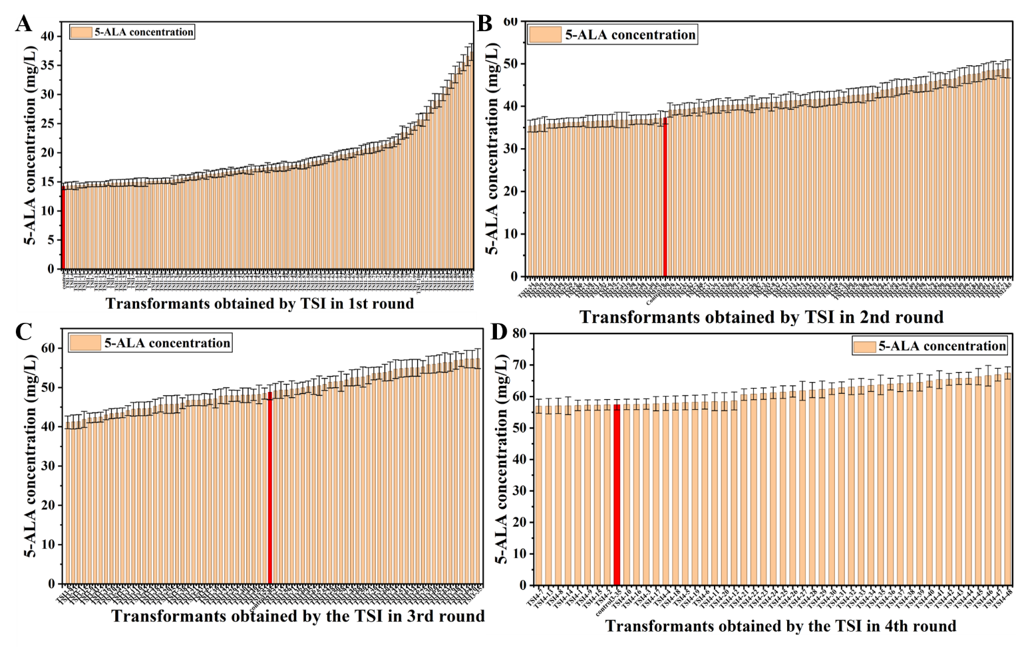
Figure S4 5-ALA production of transformants from two-step recombination method. All experiments were conducted in three independent replicates. Data are presented as the means and standard deviations of three independent experiments.

Figure S5 5-ALA production of AY12a expressing different ALAS in XI-3.3 locus site. All experiments were conducted in three independent replicates.

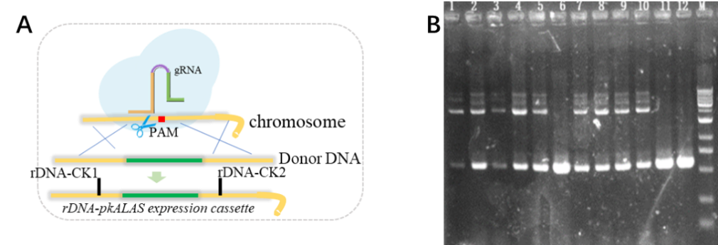
Figure S6 Transformants from CRISPR-Cas9 system were verified by PCR with primers rDNA-CK1/ rDNA -CK2. Lines 1-10: transformants, 11-12: control-AY12a, M: 1Kb plus DNA marker.

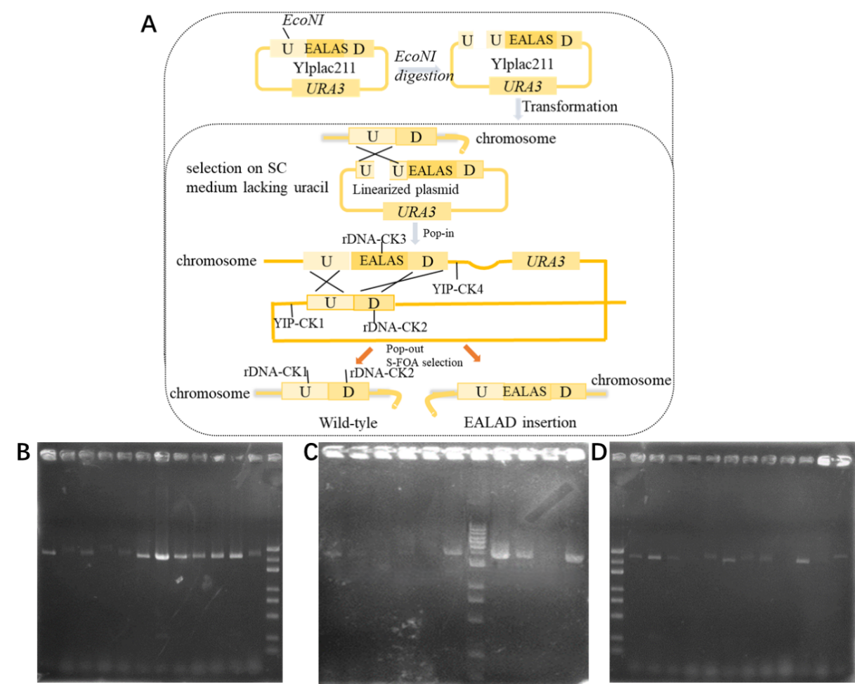
Figure S7 Transformants from two-step homologous recombination method were verified by PCR with primers YIP-CK1/ rDNA -CK2 (B), rDNA-CK3/ YIP-CK4(C), and rDNA-CK1/ rDNA -CK2. 5000 bp DNA marker in Figure S7B and S7D, 1Kb plus DNA marker in Figure S7C.

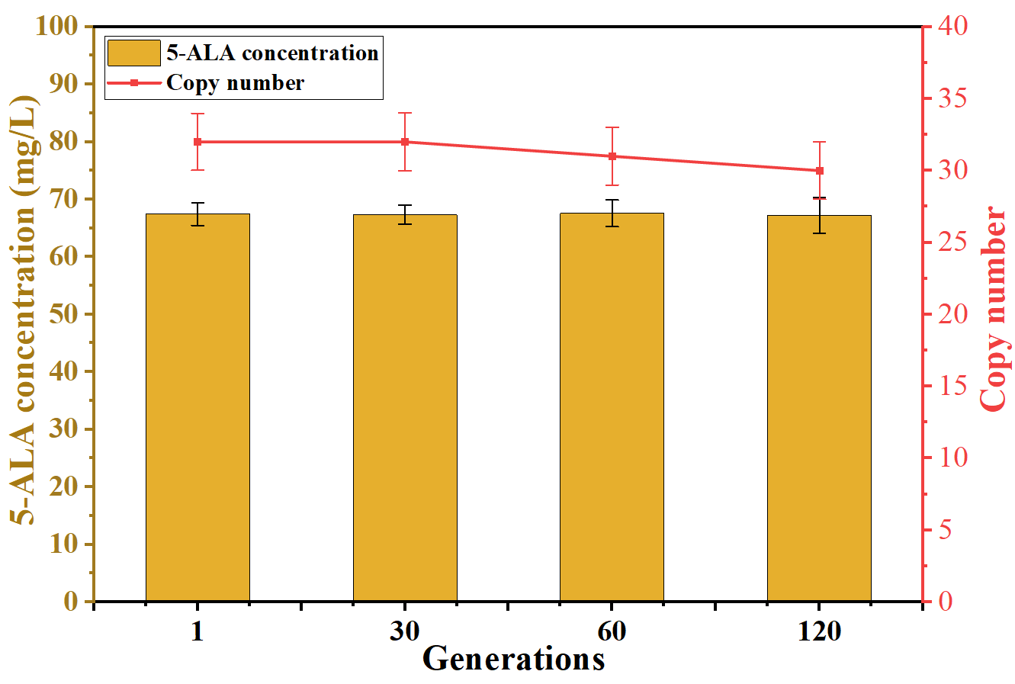
Figure S8 5-ALA production and kpHEM1 gene copy number of the strain TSI4-48 sub-cultured in YPD medium for 30, 60 and 120 generations. All experiments were conducted in three independent replicates. Data are presented as the means and standard deviations of three independent experiments.

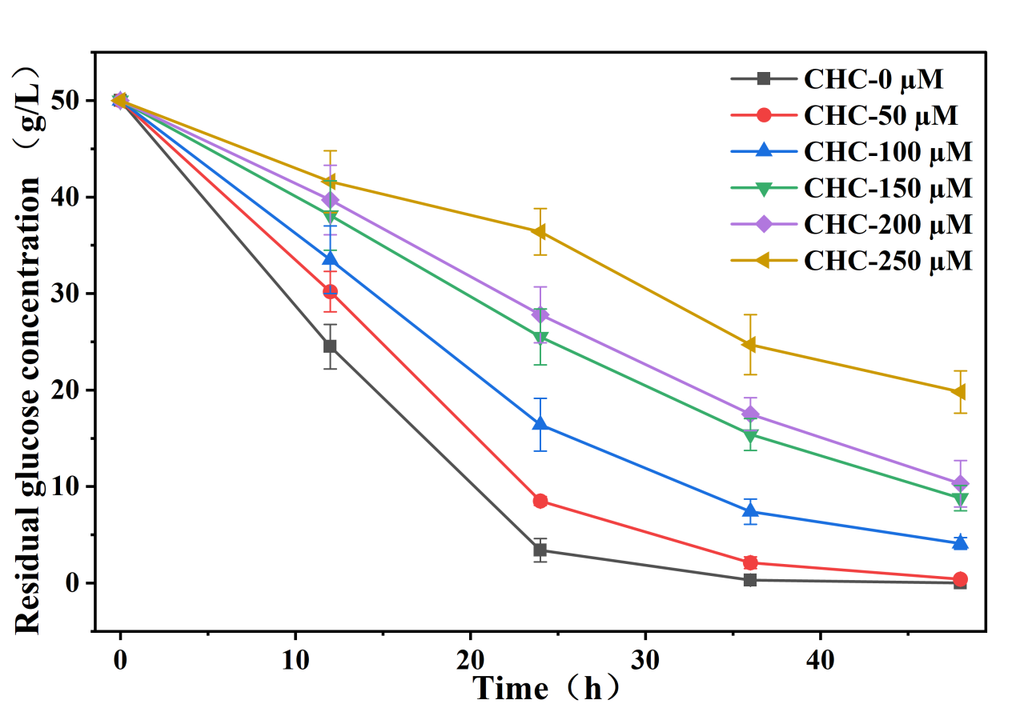
Figure S9 Residual glucose concentration of ALA-1 cultured in YPD medium with different concentration CHC. Data are presented as the means and standard deviations of three independent experiments.

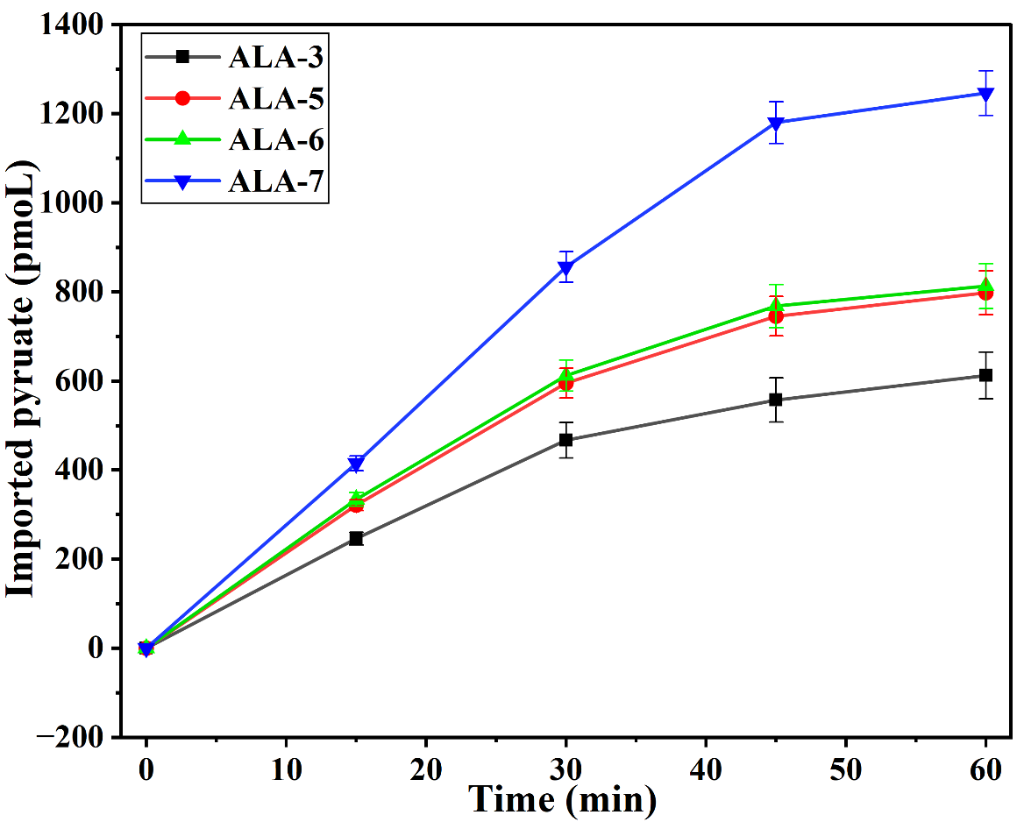
Figure S10 Pyruvate uptake of four engineered strains. Data are presented as the means and standard deviations of three independent experiments.

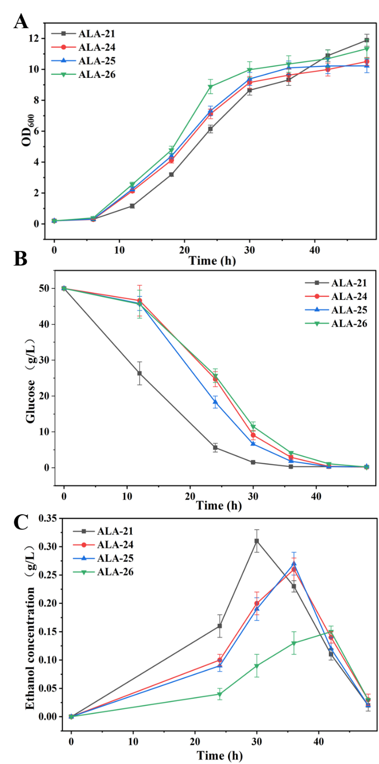
Figure S11 The OD₆₀₀ value (A), glucose concentration (B), and ethanol concentration (C) of strain ALA-21, ALA-24, ALA-25, and ALA-26. Different lowercase letters indicate significant differences. Data are presented as the means and standard deviations of three independent experiments.
Figure S12 5-ALA production of ALA-27 strain in three hydrolysates without adding extra glucose. Different lowercase letters indicate significant differences. Data are presented as the means and standard deviations of three independent experiments.

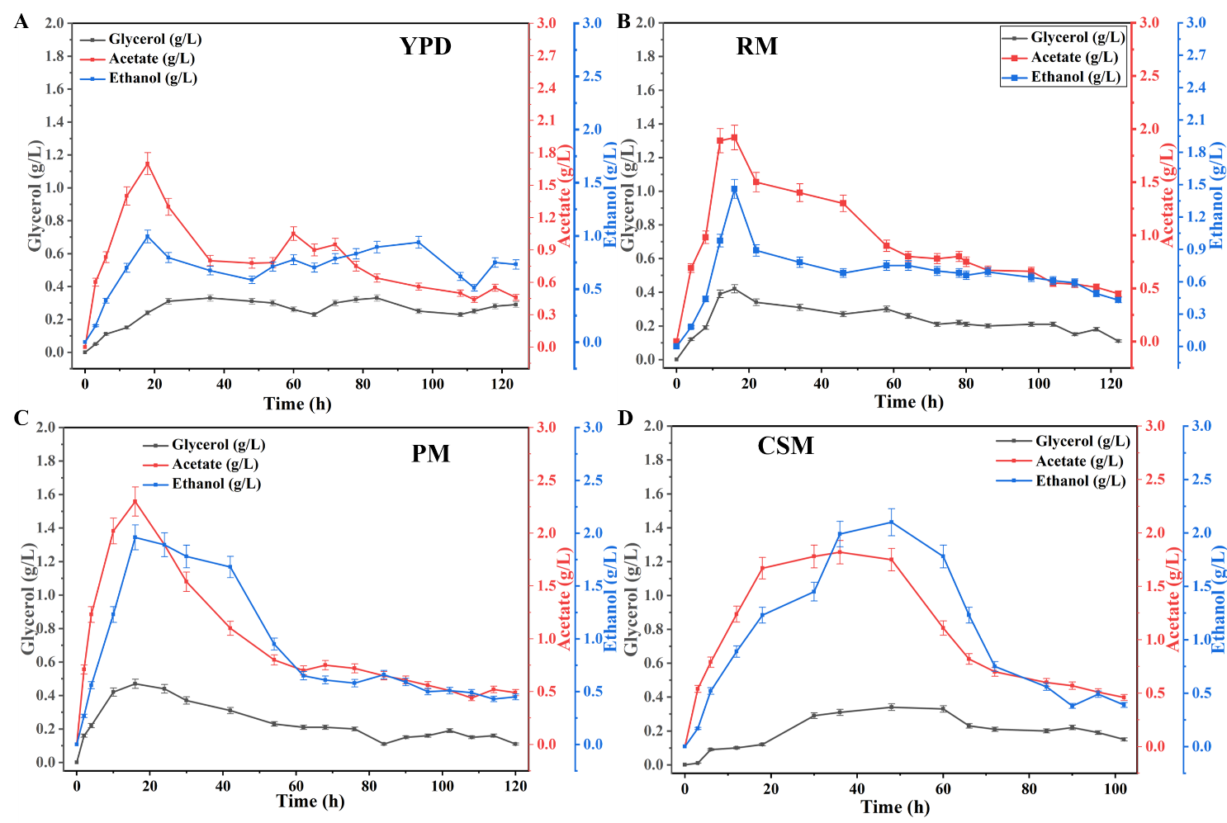
Figure S13 By-product of acetate, ethanol, and glycerol of strain ALA-27 in (A) YPD medium, (B) rapeseed meal hydrolysates, (C) peanut meal hydrolysates, and (D) camellia seed meal hydrolysates. Different lowercase letters indicate significant differences. Data are presented as the means and standard deviations of three independent experiments.

Table S1 Strains and plasmids used in this study
Strain | Genotype
BY4741 | MATa his3Δ1 leu2Δ0 met15Δ0 ura3Δ0 | Laboratory storage
BY4742 | MATα his3Δ1 leu2Δ0 lys2Δ0 ura3Δ0 | Laboratory storage
w303-1A | MATa ade2-1 can1-100 his3-11,15 leu2-3,112 trp1-1 ura3-52 | Laboratory storage
CEN.PK 113-5D | MATa ura3-52 HIS3 LEU2 TRP1 MAL2-8^c SUC2 | Laboratory storage
AY12a | MATa | Angel Yeast Co., Ltd. (Wuhan, China)
AY12α | MATα | Angel Yeast Co., Ltd. (Wuhan, China)
AY12a-ura3 | MATa Δura3 | Laboratory storage
AY12a-SCH | AY12a-ura3,XI3.3::PGK1p-ScHEM1-PGK1t | This study
AY12a-KPH | AY12a-ura3,XI3.3::PGK1p-KpHEM1-PGK1t | This study
AY12a-SSH | AY12a-ura3,XI3.3::PGK1p-SsHEM1-PGK1t | This study
AY12a-YLH | AY12a-ura3,XI3.3::PGK1p-YlHEM1-PGK1t | This study
AY12a-MAH | AY12a-ura3,XI3.3::PGK1p-MaHEM1-PGK1t | This study
AY12a-CAH | AY12a-ura3,XI3.3::PGK1p-CaHEM1-PGK1t | This study
CRSIPR1-84 | AY12a-ura3,rDNA::PGK1p-KpHEM1-PGK1t (1st transformation via pCAS9-rDNA ) | This study
CRSIPR2-75 | AY12a-ura3,rDNA::PGK1p-KpHEM1-PGK1t (2nd transformation via pCAS9-rDNA) | This study
CRSIPR3-76 | AY12a-ura3,rDNA::PGK1p-KpHEM1-PGK1t (3rd transformation via pCAS9-rDNA) | This study
CRSIPR4-54 | AY12a-ura3,rDNA::PGK1p-KpHEM1-PGK1t (4th transformation via pCAS9-rDNA) | This study
TSI1-90 | AY12a-ura3,rDNA::PGK1p-KpHEM1-PGK1t (1st transformation via YIplac211-KpHEM1 ) | This study
TSI2-85 | AY12a-ura3,rDNA::PGK1p-KpHEM1-PGK1t (2nd transformation via YIplac211-KpHEM1 ) | This study
TSI3-35 | AY12a-ura3,rDNA::PGK1p-KpHEM1-PGK1t (3rd transformation via YIplac211-KpHEM1 ) | This study
TSI4-48 (ALA-1) | AY12a-ura3,rDNA::PGK1p-KpHEM1-PGK1t (4th transformation via YIplac211-KpHEM1 ) | This study
ALA-2 | ALA-1,GLT1::TDH3p-GLT1-GLT1t | This study
ALA-3 | ALA-2,XII5.5::TEF1p-EChemA-TEF1t-HXT7p-EChemL-HXT7p | This study
ALA-4 | ALA-2,XII5.5::TEF1p-BShemA-TEF1t-HXT7p-BShemL-HXT7p | This study
ALA-5 | ALA-3,MPC1p::TDH1p | This study
ALA-6 | ALA-3,MPC2p::TDH1p | This study
ALA-7 | ALA-5,MPC2p::TDH1p | This study
ALA-8 | ALA-7,Δadh1 | This study
ALA-9 | ALA-7,Δadh4 | This study
ALA-10 | ALA-7,Δpdc1 | This study
ALA-11 | ALA-7,Δpdc5 | This study
ALA-12 | ALA-7,Δpdc6 | This study
ALA-13 | ALA-8,Δadh4 | This study
ALA-14 | ALA-13,Δpdc1 | This study
ALA-15 | ALA-14,Δgpd1,Δgpd2 | This study
ALA-16 | ALA-14,GPD2:TEF1p-seACS-TEF1t | This study
ALA-17 | ALA-16,Δsdh5 | This study
ALA-18 | ALA-16,Δlsc1 | This study
ALA-19 | ALA-16,Δlsc2 | This study
ALA-20 | ALA-18,Δlcs2 | This study
ALA-21 | ALA-19,LSC2::PGK1p-CAB1-PGK1t | This study
ALA-22 | ALA-19,LSC2::PGK1p-CAB2-PGK1t | This study
ALA-23 | ALA-19,LSC2::PGK1p-CAB3-PGK1t | This study
ALA-24 | ALA-21,MTH1::TDH1p-MTH1(A81D)-MTH1t | This study
ALA-25 | ALA-21,MED2::TEF1p-MED2(432Y)-MED2t | This study
ALA-26 | ALA-24,MED2::TEF1p-MED2(432Y)-MED2t | This study
ALA-27 | ALA-26,ura3::URA3 | This study
plasmid
pRS426 | Ampr, URA3 | Laboratory storage
pRS426-SCHEM1 | pRS426-PGK1p-ScHEM1-PGK1t | This study
pRS426-KPHEM1 | pRS426-PGK1p-KpHEM1-PGK1t | This study
pRS426-SSHEM1 | pRS426-PGK1p-SsHEM1-PGK1t | This study
pRS426-YLHEM1 | pRS426-PGK1p-YlHEM1-PGK1t | This study
pRS426-MAHEM1 | pRS426-PGK1p-MaHEM1-PGK1t | This study
pRS426-CAHEM1 | pRS426-PGK1p-CaHEM1-PGK1t | This study
YIplac211 | Ampr URA3 | Laboratory storage
YIplac211-rDNA-KpHEM1 | YIplac211-rDNA-PGK1p-KpHEM1-PGK1t | This study
pCAS9 | Ampr, URA3, TEF1p-iCas9 SNR52p | Laboratory storage
pCAS9-rDNA | pCAS9, containg rDNA 20bp targeting sequences before PAM | This study
pCAS9-GLT1p | pCAS9, containg GLT1 promoter region 20bp targeting sequences before PAM | This study
pCAS9-XII5.5 | pCAS9, containg XII5.5 20bp targeting sequences before PAM | This study
pCAS9-MPC1p | pCAS9, containg MPC1 promoter region 20bp targeting sequences before PAM | This study
pCAS9-MPC2p | pCAS9, containg MPC2 promoter region 20bp targeting sequences before PAM | This study
pCAS9-ADH1 | pCAS9, containg ADH1 20bp targeting sequences before PAM | This study
pCAS9-ADH4 | pCAS9, containg ADH4 20bp targeting sequences before PAM | This study
pCAS9-PDC1 | pCAS9, containg PDC1 20bp targeting sequences before PAM | This study
pCAS9-PDC5 | pCAS9, containg PDC5 20bp targeting sequences before PAM | This study
pCAS9-PDC6 | pCAS9, containg PDC6 20bp targeting sequences before PAM | This study
pCAS9-GPD1 | pCAS9, containg GPD1 20bp targeting sequences before PAM | This study
pCAS9-GPD2 | pCAS9, containg GPD1 20bp targeting sequences before PAM | This study
pCAS9-SDH5 | pCAS9, containg SDH5 20bp targeting sequences before PAM | This study
pCAS9-LSC1 | pCAS9, containg LSC1 20bp targeting sequences before PAM | This study
pCAS9-LSC2 | pCAS9, containg LSC2 20bp targeting sequences before PAM | This study
pCAS9-XI3.3 | pCAS9, containg XI3.3 20bp targeting sequences before PAM | This study
pCAS9-MTH1 | pCAS9, containg MTH1 20bp targeting sequences before PAM | This study
pCAS9-MED2 | pCAS9, containg MED2 20bp targeting sequences before PAM | This study

Table S2 gRNA sequences used in this studyª
Gene Target | 20bp Targeting Sequences before PAM
rDNA | TGAACGCACATTGCGCCCCT
GLT1p | agttcttcaaaataaataaa
XII-5 | TTGTCACAGTGTCACATCAG
MPC1 | AATAGATTATCGGTGGAGAA
MPC2 | TTCCTATTGCGCGCATGACT
ADH1 | GGGGGCGACTTGGGCCAAGT
ADH4 | GAAGAAAAGAAAATCAAGA
PDC1 | ttgttccagacacgacgtca
PDC5 | tacccaaagaccagtctact
PDC6 | tgtcccctctatctccgctc
GPD1 | GGGCAAGGACGTCGACCATA
GPD2 | TGTCTAAAAGGGTTCGAGTT
SDH5 | CTGCATGGTCGTGCGGTCGT
LSC1 | ttagttgggcccaactgccc
LSC2 | tggcggcttctaccagcccc
XI-3.3 | agcgtgcgtctgatttctac
MTH1 | ACGCCCGTTACAGAGAATGT
MED2 | GGATTGGAAACAACGGTCGT
ªgRNAs used in this study were predicted by the website: https://atum.bio/eCommerce/cas9/input.
Table S3 Growth rate, Glucose consumption rate, and Ethanol maximum concentration of ALA-21, ALA-24, ALA-25, and ALA-26.
Strain | μ_{max} (h⁻¹) | Glucose consumption rate (g/L/h) | Ethanol maximum concentration（g/L）
ALA-21 | 0.37±0.02 | 1.62±0.15 | 0.31±0.02
ALA-24 | 0.43±0.06 | 1.31±0.11 | 0.26±0.02
ALA-25 | 0.44±0.07 | 1.34±0.09 | 0.27±0.03
ALA-26 | 0.53±0.03 | 1.16±0.12 | 0.15±0.01

Table S4 α-Amino nitrogen, reducing sugar, glutamate, and glycine content in three hydrolysates.
Medium | α-Amino nitrogen content (g/L) | Reducing sugar content (g/L) | Glutamate(g/L) | Glycine (g/L)
RM hydrolysate without adding extra glucose | 21.54±1.25 | 18.69±2.44 | 4.61±0.65 | 1.32±0.22
PM hydrolysate without adding extra glucose | 26.35±3.11 | 19.52±1.21 | 7.83±0.96 | 2.11±0.32
CSD hydrolysate without adding extra glucose | 8.5±0.69 | 21.22±2.57 | 0.86±0.19 | 1.32±0.35

Table S5 Raw material price
Items | CAS No. | Unit cost# | Reference
Glucose | 50-99-7 | $0.85/kg | https://china.guidechem.com/cas/50.html
Yeast extract | 2232731 | $3.00/kg | https://china.guidechem.com/15829/
Peptone | 91079-46-8 | $89.00/kg | https://china.guidechem.com/product/listc_keys--1438354.html?
Peanut Meal | NA | $0.22/kg | https://www.1688.com/jiage/-.html?spm=a261b.12436309.searchbar0.0&keywords=%E8%8A%B1%E7%94%9F%E7%B2%95
Rapeseed meal | NA | $0.25/kg | https://detail.1688.com/offer/1071012933202.html?spm=a261b.12436309.ul20190116.55.5e06493a7wkKSN
Camellia seed meal | NA | $0.30/kg | https://detail.1688.com/offer/680414313661.html?spm=a261b.12436309.ul20190116.1.38246ab75dxu9L
Glycine | 56-40-6 | $1.75/kg | https://china.guidechem.com/cas/150.html
L-Glutamic acid | 56-86-0 | $3.12/kg | https://china.guidechem.com/cas/164.html
Levulinic acid | 123-76-2 | $5.22/kg | https://china.guidechem.com/cas/2722.html
Protease | 9001-92-7 | $11.01/kg | https://china.guidechem.com/cas/371820.html
Cellulase | 9012-54-8 | $8.14/kg | https://china.guidechem.com/cas/277281.html
α-Amylase | 9000-90-2 | $13.35/kg | https://china.guidechem.com/cas/201058.html
Glucoamylase | 9032-08-0 | $8.00/kg | https://china.guidechem.com/cas/199177.html
Deionized Water | 7732-18-5 | $0.68/kg | https://china.guidechem.com/cas/15456.html
Trace Elements (100X) | MBD0056 | $157.00 / 50mL | https://www.sigmaaldrich.cn/CN/zh/product/sigma/mbd0056
vitamin solution | ZY6SL0110 | $54.3 / 100mL | https://china.guidechem.com/product/listc_keys-vitamin+solution-p1.html
Table S6 Fermentation cost estimation
Compose of Medium | Amount consumed in YPD | Amount consumed in PM | Amount consumed in RM | Amount consumed in CSM | Cost of YPD | Cost of PM medium | Cost of RM medium | Cost of CSM medium
Glucose | 612g | 592 g | 613 | 496 | 0.5202 | 0.5032 | 0.52105 | 0.4216
Yeast extract | 20 g | 0 | 0 | 0 | 0.06 | 0 | 0 | 0
Peptone | 40 g | 0 | 0 | 0 | 0.0704 | 0 | 0 | 0
Glycine | 30 g | 0 | 0 | 0 | 2.67 | 0 | 0 | 0
L-Glutamic acid | 30 g | 0 | 0 | 0 | 0.0936 | 0 | 0 | 0
Levulinic acid | 11 mL | 11 mL | 11 | 11 | 0.05742 | 0.05742 | 0.05742 | 0.05742
Protease | 0 | 2.5g | 2.5 | 2.5 | 0 | 0.027525 | 0.027525 | 0.027525
Cellulase | 0 | 7.5g | 7.5 | 15 | 0 | 0.06105 | 0.06105 | 0.1221
α-Amylase | 0 | 2.5g | 2.5 | 2.5 | 0 | 0.033375 | 0.033375 | 0.033375
Deionized Water | 3L | 3L | 3 | 3 | 0.0017 | 0.00204 | 0.00204 | 0.00204
Peanut Meal | 0 | 250g | 250 | 250 | 0 | 0.055 | 0.0625 | 0.075
Trace Elements (100X) | 0.2mL | 0 | 0 | 0 | 0.628 | 0 | 0 | 0
vitamin solution | 24mL | 0 | 0 | 0 | 13.032 | 0 | 0 | 0
Total cost ($) |  |  |  |  | 17.133 | 0.740 | 0.765 | 0.739
$/(g/L 5-ALA) |  |  |  |  | 5.909 | 0.225 | 0.263 | 0.279
Reference
(1) Chen, L.; Zheng, Z.; Chen, F.; Wang, W.; Huo, S.; Li, X.; Zhang, A.; Chen, K., Efficient production of glycine from glucose via a two-stage biosynthetic strategy. Microb. Cell Fact. 2026.
(2) Wei, A.; Liu, J.; Tang, Y.; Meng, G.; Zhao, C.; Su, H.; Wu, H.; Ma, Q.; Xie, X., RuBisCO-based CO2 fixation improves glutamate production in Corynebacterium glutamicum. Frontiers in Bioengineering and Biotechnology 2026, Volume 14 - 2026.
(3) Hong, K.-Q.; Fu, X.-M.; Dong, S.-S.; Xiao, D.-g.; Dong, J., Modulating acetate ester and higher alcohol production in Saccharomyces cerevisiae through the cofactor engineering. J. Ind. Microb. Biotech. 2019, 46 (7), 1003-1011.

