Taxonomic, biochemical, and genome-guided characterization of Halomonas elongata N1T reveals its potential as a sustainable microbial cell factory for human lectin-binding exopolysaccharide production

Authors
Diana Ghevondyan^{1,2}, Ilaria Finore^{3*}, Fabrizio Chiodo^{3,4}, Yvette van Kooyk⁴, Ani Chakhoyan⁵, Lusine Sahakyan⁶, Annarita Poli³, Hovik Panosyan^{6*}

*Corresponding authors. Email addresses and telephones: hpanosyan@ysu.am, +374 94 719590 (H. Panosyan); ilaria.finore@cnr.it, +390818675118 (I. Finore).

Affiliations
¹Department of Biochemistry, Microbiology and Biotechnology, Yerevan State University, Alex Manoogian 1, 0025, Yerevan, Armenia
²Research Institute of Biology, Biology Faculty, Yerevan State University, Alex Manoogian 1, 0025, Yerevan, Armenia
³Institute of Biomolecular Chemistry, National Council of Research (C.N.R.), Via Campi Flegrei 34, 80078, Pozzuoli, Naples, Italy
⁴Department of Molecular Cell Biology and Immunology, Amsterdam UMC, Vrije Universiteit Amsterdam, Amsterdam, The Netherlands
⁵Department of Pharmtechnology and Pharmacy Economics and Management, Institute of Pharmacy, Yerevan State University, Alex Manoogian 1, 0025, Yerevan, Armenia
⁶Department of Biomedical Sciences, Institute of Pharmacy, Yerevan State University, Alex Manoogian 1, 0025, Yerevan, Armenia

Table S1. Interpretation of biochemical tests of the strain N1T on API 20E strip.
API 20E | Results
ONPG | +
ADH | +
LDC | +
ODC | +
CIT | +
H₂S | -
URE | +
TDA | -
IND | -
VP | -
GEL | -
GLU | +
MAN | +
INO | +
SOR | +
RHA | +
SAC | +
MEL | +
AMY | +
ARA | +

Table S2. DDH values of H. elongata strain N1T and other strains belonging to genus Halomonas.
Strain | DDH (%) | G+C difference (%)
N1T | 100 | 0
Halomonas elongata DSM 2581^{T} | 90.9 | 0.02
Halomonas eurihalina DSM 5720^{T} | 50.9 | 0.61
Halomonas nitroreducens DSM 23437^{T} | 24.0 | 3.92
Halomonas getboli JCM 35085^{T} | 24.0 | 4.52
Halomonas aquamarine DSM 5425^{T} | 21.1 | 6.67
Halomonas alkaliphila DSM 16354^{T} | 18.8 | 11.06
Halomonas rhizosphaerae KCTC 8016^{T} | 22.4 | 3.01
Halomonas stenophila CECT 7744^{T} | 24.8 | 3.98
Halomonas sinaiensis DSM 18067^{T} | 34.7 | 0.01
Halomonas smyrnensis DSM 21644^{T} | 23.9 | 4.23
Halomonas qinghailakensis ZZQ-149^{T} | 19.6 | 11.68
Halomonas aquatica KACC 23729^{T} | 21.7 | 1.45
Halomonas koreensis DSM 23530^{T} | 24.4 | 6.1
Halomonas caseinilytica DSM 23509^{T} | 34.5 | 0.23
Halomonas maura DSM 13445^{T} | 24.5 | 4.24

Table S3. Genetic determinants of Exopolysaccharide synthesis pathways in H. elongata strain N1T.

Peg. numbers | Gene product
Transporters
200, 2243,3537 | ABC transporter, permease protein 2 (cluster 1, maltose/g3p/polyamine/iron)
201 | Glucose ABC transport system, inner membrane component 1
202, 1599,2205, 2245 | ABC transporter, substrate-binding protein (cluster 1, maltose/g3p/polyamine/iron)
434 | Efflux ABC transporter, permease/ATP-binding protein slr2019
630 | D-xylose ABC transporter, substrate-binding protein XylF
631 | D-xylose ABC transporter, ATP-binding protein XylG
632 | D-xylose ABC transporter, permease protein XylH
782 | ABC transporter, substrate-binding protein YnjB
783 | ABC transporter, permease protein YnjC
784 | ABC transporter, ATP-binding protein YnjD
1068 | ABC transporter, permease protein (cluster 2, ribose/xylose/arabinose/galactose)
1069 | ABC transporter, ATP-binding protein (cluster 2, ribose/xylose/arabinose/galactose) / ABC transporter, ATP-binding protein (cluster 2, ribose/xylose/arabinose/galactose)
1070 | ABC transporter, substrate-binding protein (cluster 2, ribose/xylose/arabinose/galactose)
1388 | Uncharacterized efflux ABC transporter, ATP-binding protein YadG
1389 | Uncharacterized efflux ABC transporter, permease protein YadH
1411 | ABC transporter, RND-adapter-like protein
1637 | Uncharacterized ABC1 family protein
1663 | Efflux ABC transporter, permease protein
1664 | Efflux ABC transporter, ATP-binding protein
42, 561, 828, 1525, 1661, 2812, 3368 | Transporter, LysE family
159, 185, 195, 248, 320, 321, 979, 1053, 1156, 1202, 1821, 1871, 2351, 2390, 2401, 2533, 2846, 3360, 3476 | Uncharacterized MFS-type transporter
234, 872 | RND efflux system, inner membrane transporter
235, 873, 3088 | RND efflux system, membrane fusion protein
3052 | Efflux ABC transporter, permease/ATP-binding protein Atu2242
1775 | BCCT transporter
1993 | MgtC/SapB transporter
2089 | Putative preQ0 transporter YhhQ
1586, 1988 | MATE efflux family protein
2860 | Type I secretion system ATPase
2861 | Type I secretion membrane fusion protein, HlyD family
2862 | Type I secretion outer membrane protein, TolC family
144 | TonB system biopolymer transport component; Chromosome segregation ATPase
141 | Biopolymer transport protein ExbD/TolR
1948 | Tol biopolymer transport system, TolR protein
Sugar utilization
1674, 1954 | UDP-glucose 6-dehydrogenase (EC 1.1.1.22)
1742 | UDP-N-acetylglucosamine 2-epimerase (EC 5.1.3.14)
1743 | UDP-N-acetyl-D-mannosamine dehydrogenase (EC 1.1.1.336)
2452 | UDP-glucuronate 5'-epimerase (EC 5.1.3.12)
1753 | dTDP-glucose 4,6-dehydratase (EC 4.2.1.46)
1754, 3381 | dTDP-4-dehydrorhamnose reductase (EC 1.1.1.133)
624,1755 | Glucose-1-phosphate thymidylyltransferase (EC 2.7.7.24)
1756 | dTDP-4-dehydrorhamnose 3,5-epimerase (EC 5.1.3.13)
1742 | UDP-N-acetylglucosamine 2-epimerase (EC 5.1.3.14)
1743 | UDP-N-acetyl-D-mannosamine dehydrogenase (EC 1.1.1.336)
2452 | UDP-glucuronate 5'-epimerase (EC 5.1.3.12)
1753 | dTDP-glucose 4,6-dehydratase (EC 4.2.1.46)
1754, 3381 | dTDP-4-dehydrorhamnose reductase (EC 1.1.1.133)
624,1755 | Glucose-1-phosphate thymidylyltransferase (EC 2.7.7.24)
1756 | dTDP-4-dehydrorhamnose 3,5-epimerase (EC 5.1.3.13)
1953 | UTP-glucose-1-phosphate uridylyltransferase (EC 2.7.7.9)
2692, 3115 | Glucose-6-phosphate isomerase (EC 5.3.1.9)
811, 822, 2304 | Maltodextrin glucosidase (EC 3.2.1.20), Alpha-glucosidase (EC 3.2.1.20)
3580 | Glucose dehydrogenase, PQQ-dependent (EC 1.1.5.2)
210 | N-acetylglucosamine-6-phosphate deacetylase (EC 3.5.1.25)
770 | Glucose-6-phosphate 1-dehydrogenase (EC 1.1.1.49)
1521 | Pyrophosphate-dependent fructose 6-phosphate-1-kinase (EC 2.7.1.90)
1749, 2497 | Glutamine-fructose-6-phosphate aminotransferase [isomerizing] (EC 2.6.1.16)
2220 | Fructose-bisphosphate aldolase class I (EC 4.1.2.13)
2223 | Fructose-bisphosphate aldolase class II (EC 4.1.2.13)
833 | 1-phosphofructokinase (EC 2.7.1.56)
1953 | UTP-glucose-1-phosphate uridylyltransferase (EC 2.7.7.9)
2692, 3115 | Glucose-6-phosphate isomerase (EC 5.3.1.9)
811, 822, 2304 | Maltodextrin glucosidase (EC 3.2.1.20), Alpha-glucosidase (EC 3.2.1.20)
3580 | Glucose dehydrogenase, PQQ-dependent (EC 1.1.5.2)
210 | N-acetylglucosamine-6-phosphate deacetylase (EC 3.5.1.25)
770 | Glucose-6-phosphate 1-dehydrogenase (EC 1.1.1.49)
1521 | Pyrophosphate-dependent fructose 6-phosphate-1-kinase (EC 2.7.1.90)
1749, 2497 | Glutamine-fructose-6-phosphate aminotransferase [isomerizing] (EC 2.6.1.16)
2220 | Fructose-bisphosphate aldolase class I (EC 4.1.2.13)
2223 | Fructose-bisphosphate aldolase class II (EC 4.1.2.13)
833 | 1-phosphofructokinase (EC 2.7.1.56)
1298 | D-arabinose-5-phosphate isomerase (EC 5.3.1.13)
1100 | L-rhamnose-1-dehydrogenase ( EC 1.1.1.173)
1102 | L-rhamnose mutarotase (EC 5.1.3.32)
1146 | Phosphoglucosamine mutase (EC 5.4.2.10)
1756 | dTDP-4-dehydrorhamnose 3,5-epimerase (EC 5.1.3.13)
1262 | Ribose-5-phosphate isomerase B (EC 5.3.1.6)
2437 | Ribose-5-phosphate isomerase A (EC 5.3.1.6)
1930, 3108 | ADP-ribose pyrophosphatase (EC 3.6.1.13)
3260 | Ribose-phosphate pyrophosphokinase (EC 2.7.6.1)
2496 | N-acetylglucosamine-1-phosphate uridyltransferase (EC 2.7.7.23) / Glucosamine-1-phosphate N-acetyltransferase (EC 2.3.1.157)
2239, 3324 | D-xylose proton-symporter XylE
2247 | Xylose-responsive transcription regulator, ROK family
Assembly of Repeating Units
213 | Putative glycosyltransferase
391 | Putative lipopolysaccharide biosynthesis glycosyltransferase protein
1911 | Glycosyltransferase
728 | Glycosyl transferase, group 1 family protein
1765 | Glycosyl transferase, group 2 family
2967 | Glycosyl transferase, family 9
Capsular polysaccharide export proteins
1737 | Capsular polysaccharide export system periplasmic protein KpsD
1777 | Capsular polysaccharide biosynthesis fatty acid synthase WcbR
1778 | Capsular polysaccharide biosynthesis protein WcbQ
1780 | Capsular polysaccharide export system protein KpsS
1781 | Capsular polysaccharide export system protein KpsC
1738 | Capsular polysaccharide ABC transporter, permease protein KpsM
1739 | Capsular polysaccharide ABC transporter, ATP-binding protein KpsT
1740 | Capsular polysaccharide export system inner membrane protein KpsE
1298 | D-arabinose-5-phosphate isomerase (EC 5.3.1.13) kpsF
Polymer acetylation
20, 25, 245, 287, 288, 329, 706, 1477, 2224, 2813 | Acetyltransferase, GNAT family
175 | GNAT family acetyltransferase YjcF
1647 | Uncharacterized N-acetyltransferase YedL
303 | Uncharacterized deacetylase
841 | O-acetyl-ADP-ribose deacetylase
1343 | UDP-3-O-[3-hydroxymyristoyl] N-acetylglucosamine deacetylase (EC 3.5.1.108)
2278, 2740 | NAD-dependent protein deacetylase of SIR2 family
210 | N-acetylglucosamine-6-phosphate deacetylase (EC 3.5.1.25)
Transcriptional regulators
24, 186, 308, 315, 322, 370, 473, 606, 1035, 1090, 1104, 1200, 1360, 1573, 1777, 1908, 1933, 1965, 2215, 2298, 2349, 2394, 2623, 2637, 2638, 2653, 2669, 2743, 2837, 2848, 2849, 2856, 2863, 2894, 2920, 2940, 2941, 2974, 2979, 2993, 3022, 3062, 3231, 3543 | Transcriptional regulator, LysR family
35, 194, 429, 583, 601, 827, 1092, 1673, 1976, 2200, 2407, 2414, 2805, 2953, 3058, 3185, 3383, 3538, 3548, 3675 | Transcriptional regulator, AraC family
36, 2507 | Putative transcriptional regulatory protein
48 | Transcriptional regulator KdgR, KDG operon repressor
95, 278, 317, 405 | Transcriptional regulator, LacI family
205, 1027, 3489 | Two-component transcriptional response regulator, OmpR family
211 | Predicted transcriptional regulator of N-Acetylglucosamine utilization, GntR family
232, 1006, 1045, 1234, 1468, 1682, 1707, 1844, 2095, 2197, 2410, 2861, 2897 | Transcriptional regulator, AcrR family
359 | Response regulators consisting of a CheY-like receiver domain and a winged-helix DNA-binding domain
368, 990, 2933, 3376 | Transcriptional regulator, MerR family
669, 1488 | Transcriptional regulator, AsnC family
693, 3242, 3443 | Two-component transcriptional response regulator, LuxR family
826 | Response regulator BaeR
878 | Regulatory protein RecX
969 | Transcriptional regulator SlmA, TetR family
1192, 2807, 3633 | Transcriptional regulator, MarR family
1215 | Lactate-responsive regulator LldR in Enterobacteria, GntR family
1402 | regulatory protein GntR, HTH:GntR, C-terminal
1855 | Transcriptional regulator, DeoR family
1939 | Probable transcriptional regulatory protein YebC
2000 | Predicted transcriptional regulator
43, 289,2328, 2416, 2858, 2988, 3004, 3327, 3541 | Transcriptional regulator, GntR family
2591 | Positive regulator of CheA protein activity (CheW)
2779 | Regulator of nucleoside diphosphate kinase
2970 | Two-component system response regulator QseB
3018 | Transcriptional response regulatory protein GlrR
3059 | Two-component transcriptional response regulator, OmpR family
3095 | response regulator receiver domain protein (CheY-like)
3236 | Transcriptional regulator BetI, TetR family
3293 | Transcriptional regulator IlvY, LysR family

Table S4. Functional annotation data of proteins potentially involved in EPS production and transport in H. elongata strain N1T, identified using RAST and BLASTp.

Features identified by RAST | Features identified by BLASTp | Strain | Identity  (%) | Accession number
Outer membrane porin | Carbohydrate porin | H. elongata | 99,61 | WP_328716552.1
Maltodextrin ABC transporter, substrate-binding protein MdxE | ABC transporter substrate-binding protein | H. elongata | 100 | WP_013333430.1
Maltodextrin ABC transporter, permease protein MdxF | Carbohydrate ABC transporter permease | H.elongata | 99.69 | WP_065241522.1
Maltodextrin ABC transporter, permease protein MdxG | MULTISPECIES: carbohydrate ABC transporter permease | Halomonas sp. | 99.28 | WP_275286321.1
Maltodextrin glucosidase (EC 3.2.1.20) | Alpha-glucosidase family protein | H.elongata | 99.10 | WP_193343871.1
Maltose/maltodextrin transport ATP-binding protein MalK (EC 3.6.3.19) | ABC transporter ATP-binding protein | H.elongata | 94.57 | WP_275286319.1
Maltose/maltodextrin transport ATP-binding protein MalK (EC 3.6.3.19) | sn-glycerol-3-phosphate ABC transporter ATP-binding protein UgpC | Halomonas sp. | 94.05 | WP_315618481.1
Hypothetical protein | MalM family protein | H. elongata | 99.34 | WP_193343868.1
Maltoporin (maltose/maltodextrin high-affinity receptor, phage lambda receptor protein) | Maltoporin | Halomonas sp. | 99.05 | WP_273143486.1
Maltodextrin ABC transporter, permease protein MdxG | Maltose ABC transporter permease MalG | Vreelandella aquamarina | 99.66 | WP_074210959.1
Maltodextrin ABC transporter, permease protein MdxF | Maltose ABC transporter permease MalF | V.aquamarina | 97.14 | WP_089675349.1
Maltodextrin ABC transporter, substrate-binding protein MdxE | Maltose/maltodextrin ABC transporter substrate-binding protein MalE | H. elongata | 99.24 | WP_408943232.1
Transcriptional activator of maltose regulon, MalT | HTH-type transcriptional regulator MalT | H.elongata | 99.46 | WP_112050420.1
Maltodextrin glucosidase (EC 3.2.1.20) | Alpha-amylase family glycosyl hydrolase | H.elongata | 91.26 | WP_275286311.1
Transcriptional regulator, AraC family | AraC family transcriptional regulator | H.caseinilytica | 91.64 | WP_064699549.1
Sulfate permease, Trk-type | SLC13 family permease | H.caseinilytica | 93.70 | WP_069383563.1
Capsular polysaccharide export system periplasmic protein KpsD | Polysaccharide biosynthesis/export family protein, partial | H. elongata | 97.79 | WP_112051120.1
Capsular polysaccharide ABC transporter, permease protein KpsM | ABC transporter permease | Halomonas sp. | 91.14 | WP_315617896.1
Capsular polysaccharide ABC transporter, ATP- binding protein KpsT | ABC transporter ATP-binding protein | Halomonas sp. | 92.08 | WP_315617895.1
Capsular polysaccharide export system inner membrane protein KpsE | Chain-length determining protein | H.elongata | 99.45 | WP_193343658.1
UDP-N-acetylglucosamine 2-epimerase (EC 5.1.3.14) | Non-hydrolyzing UDP-N-acetylglucosamine 2-epimerase | H.organivorans | 91.06 | WP_183388977.1
UDP-N-acetyl-D-mannosamine dehydrogenase (EC 1.1.1.336) | UDP-N-acetyl-D-mannosamine dehydrogenase | H.elongata | 99.53 | WP_193343660.1
Hypothetical protein | Glycosyltransferase | H.elongata | 100 | WP_444623851.1
Hypothetical protein | Glycosyltransferase | H. elongata | 100 | WP_444623854.1
Glutamine--fructose-6-phosphate aminotransferase [isomerizing] (EC 2.6.1.16) | Glutamine--fructose-6-phosphate transaminase (isomerizing) | H. piscis | 94.77 | WP_311945501.1
Hypothetical protein | Glycosyltransferase family 2 protein | H.elongata | 97.55 | WP_225884379.1
Hypothetical protein | Glycosyltransferase | H. elongata | 99.05 | WP_193343669.1
dTDP-glucose 4,6-dehydratase (EC 4.2.1.46) | dTDP-glucose 4,6-dehydratase | H. caseinilytica | 92.76 | WP_064701653.1
dTDP-4-dehydrorhamnose reductase (EC 1.1.1.133) | dTDP-4-dehydrorhamnose reductase | H.elongata | 97.62 | WP_193343671.1
Glucose-1-phosphate thymidylyltransferase (EC 2.7.7.24) | Glucose-1-phosphate thymidylyltransferase rfba | H.elongata | 98.67 | WP_193343672.1
dTDP-4-dehydrorhamnose 3,5-epimerase (EC 5.1.3.13) | dTDP-4-dehydrorhamnose 3,5-epimerase | H. caseinilytica | 94.51 | WP_064701650.1
Hypothetical protein | Rhamnan synthesis F family protein | H.caseinilytica | 93.02 | WP_064701648.1
Glycosyl transferase, group 2 family | Glycosyltransferase family 2 protein | H.caseinilytica | 94.12 | WP_139180703.1
Hypothetical protein | Glycosyltransferase family protein | H..elongata | 99.42 | WP_193343683.1
Mll5128 protein | CocE/NonD family hydrolase | H.elongata | 99.11 | MBW5799016.1
BCCT transporter | BCCT family transporter | H.elongata | 99.42 | WP_041602001.1
Capsular polysaccharide biosynthesis fatty acid synthase WcbR | Type I polyketide synthase | H. elongata | 99.28 | WP_112049228.1
Capsular polysaccharide biosynthesis protein WcbQ | LTA synthase family protein | H.elongata | 99.24 | WP_353460409.1
Capsular polysaccharide export system protein KpsS | Capsular biosynthesis protein | H.elongata | 99.27 | MBW5799021.1
Capsular polysaccharide export system protein KpsC | Capsular polysaccharide biosynthesis protein | H.elongata | 99.56 | WP_414736199.1
Mannosyltransferase OCH1 and related enzymes | Glycosyltransferase family 32 protein | H.elongata | 99.64 | WP_013332174.1
Predicted transcriptional regulator LiuR of leucine degradation pathway, MerR family | MerR family transcriptional regulator | H.elongata | 95.97 | WP_408942784.1
Ribose-5-phosphate isomerase A (EC 5.3.1.6) | Ribose-5-phosphate isomerase rpia | H.caseinilytica | 95.98 | WP_064699889.1
3-deoxy-D-manno-octulosonic acid transferase (EC 2.4.99.12)(EC 2.4.99.13) | Lipid IV(A) 3-deoxy-D-manno-octulosonic acid transferase | H.elongata | 98.14 | WP_193344372.1
D-glycero-beta-D-manno-heptose 1-phosphate adenylyltransferase (EC 2.7.7.70) / D-glycero-beta-D-manno- heptose-7-phosphate kinase (EC 2.7.1.167) | Bifunctional D-glycero-beta-D-manno-heptose-7-phosphate kinase/D-glycero-beta-D-manno-heptose 1-phosphate adenylyltransferase hlde | H.stenophila | 91.16 | WP_183383081.1
ADP-heptose--lipooligosaccharide heptosyltransferase II | Glycosyltransferase family 9 protein | H.caseinilytica | 93.47 | WP_064699892.1
3-deoxy-D-manno-octulosonic acid kinase (EC 2.7.1.166) | 3-deoxy-D-manno-octulosonic acid kinase | H.elongata | 97.46 | WP_353461227.1
Glycosyl transferase, group 1 | Glycosyltransferase family 4 protein | H. elongata | 99.74 | WP_232519607.1
ADP-heptose--lipooligosaccharide heptosyltransferase II | Glycosyltransferase family 9 protein | H. elongata | 98.61 | WP_013330773.1
Glycosyl transferase, family 2 | Glycosyltransferase family 2 protein | H. elongata | 100 | WP_193344370.1
Phosphatidylglycerol--membrane-oligosaccharide glycerophosphotransferase (EC 2.7.8.20) | Sulfatase-like hydrolase/transferase | H.elongata | 98.01 | WP_408944087.1
ADP-heptose--lipooligosaccharide heptosyltransferase II | Lipopolysaccharide heptosyltransferase II | H.caseinilytica | 92.86 | WP_064699897.1
ADP-L-glycero-D-manno-heptose-6-epimerase (EC 5.1.3.20) | ADP-glyceromanno-heptose 6-epimerase | H. elongata | 94.97 | WP_275288084.1
Glycosyl transferase, group 1 | Glycosyltransferase | H.elongata | 97.74 | WP_353461232.1
Glycosyl transferase, group 1 | Glycosyltransferase | H.elongata | 99.72 | WP_328716879.1
UDP-glucuronate 5'-epimerase (EC 5.1.3.12) | NAD-dependent epimerase | H.elongata | 99.40 | WP_408944081.1
D-glycero-beta-D-manno-heptose-1,7-bisphosphate 7-phosphatase (EC 3.1.3.82);  Histidinol-phosphatase (EC 3.1.3.15) | D-glycero-beta-D-manno-heptose 1,7-bisphosphate 7-phosphatase | H. elongata | 99.46 | WP_013330763.1

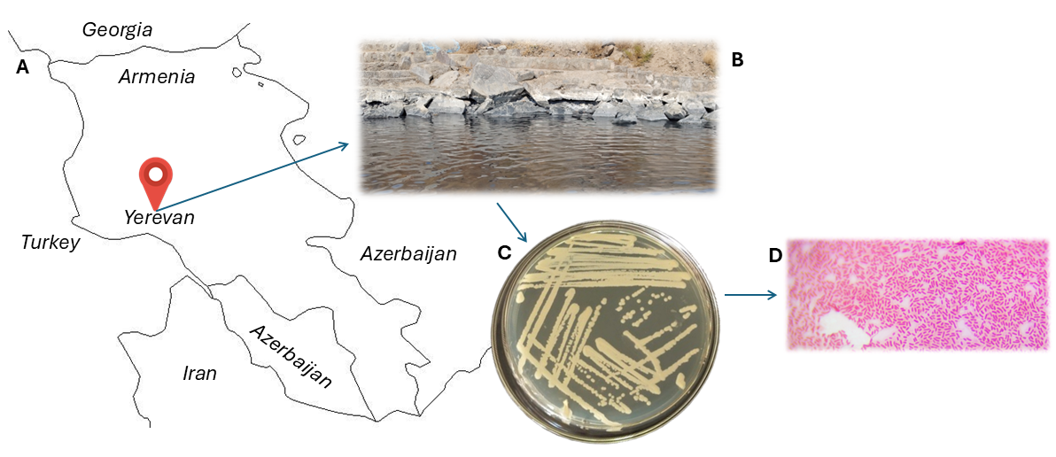
Fig. S1. Map of Armenia showing the location of the saline lake marked in red (A). Close-up photograph of the lake (B). Colonies of strain N1T grown on solid medium after 96 hours of cultivation (C). Light micrograph (×1,000 magnification) of the strain (D).

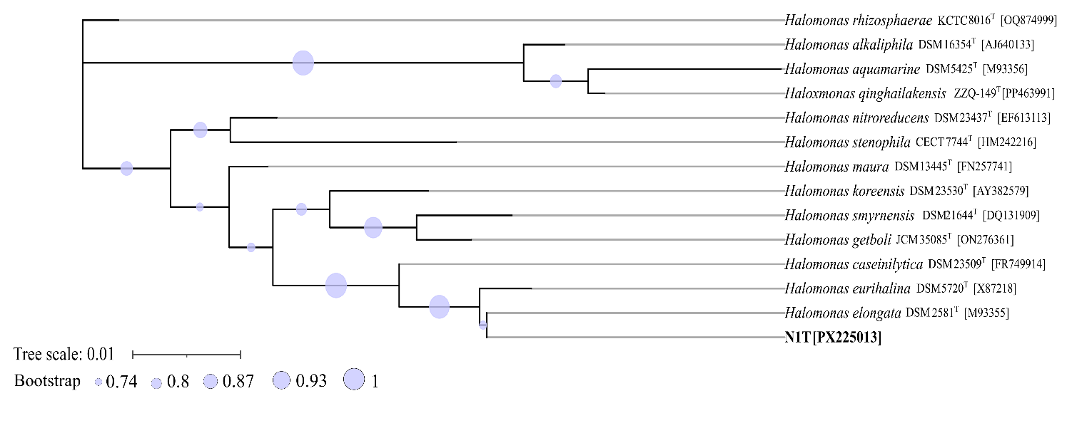

Fig. S2. Phylogenetic tree of strain N1T and related Halomonas taxa based on 16S rRNA gene sequences, constructed using the Maximum Likelihood method. Bootstrap values were calculated from 1000 replicates and are represented by circles at the corresponding nodes, with circle size proportional to bootstrap support. GenBank/NCBI accession numbers for each strain are provided in brackets. Strain N1T is shown in bold. Evolutionary analyses were conducted using MEGA 12 with up to four parallel computing threads. The scale bar represents 0.01 substitutions per site.

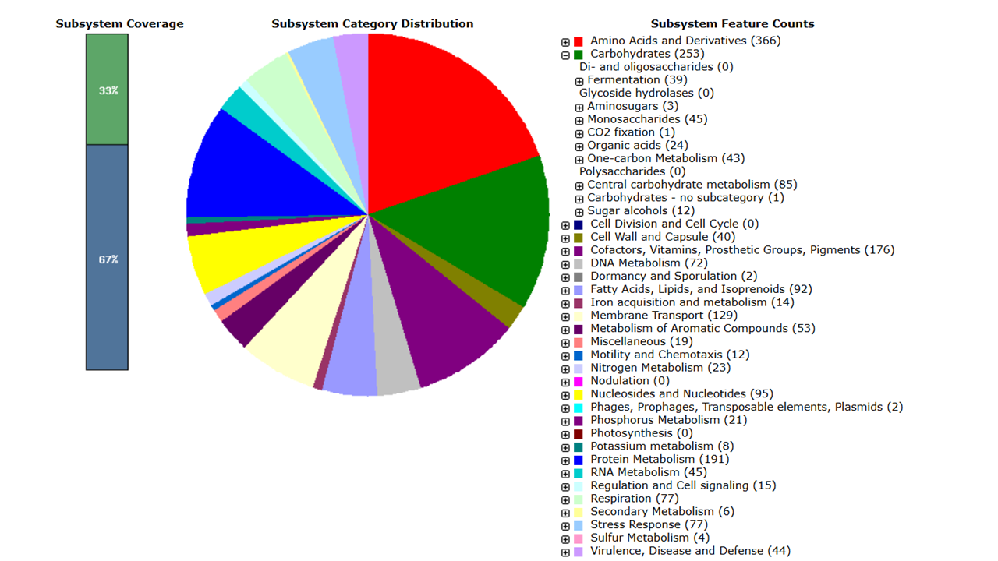
Fig. S3. H. elongata N1T genome representation showing the distribution of coding sequences (CDSs) among subsystem categories, generated using the RASTtk pipeline. The number of CDSs assigned to each subsystem is indicated in parentheses. The Carbohydrates category was expanded to display its corresponding subcategories.

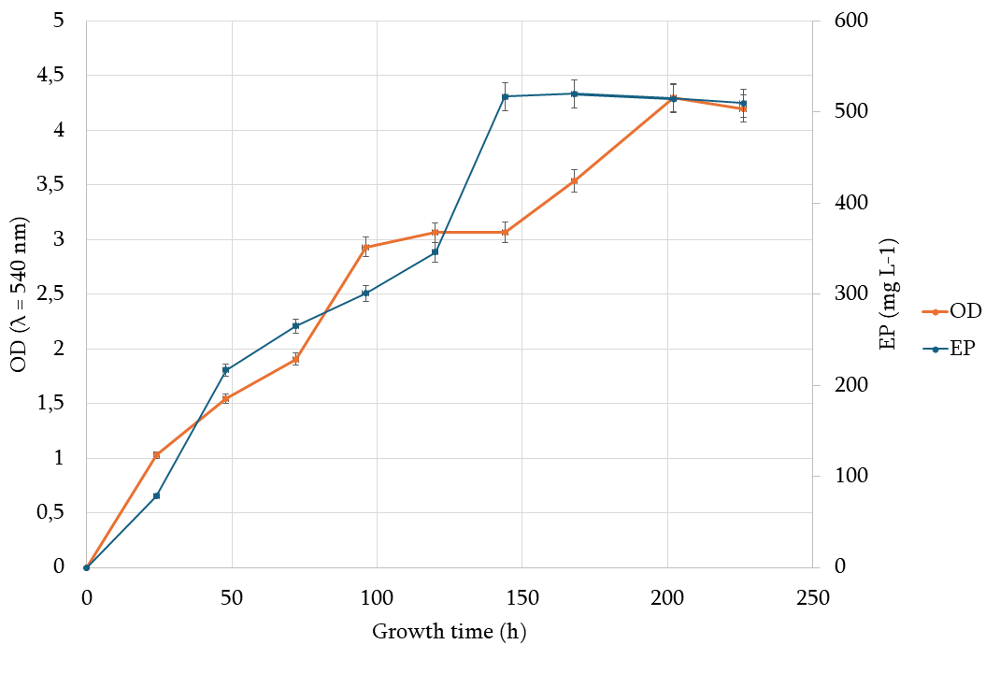

Fig. S4. Time course of growth and EP production by strain N1T in sucrose-based media at 35 °C. Samples were taken in 24 h intervals and assayed for growth (orange line) and EP content (blue line).

