Additional file

Bursopentin (BP5) induces G1 phase cell cycle arrest and endoplasmic reticulum stress/mitochondria-mediated caspase-dependent apoptosis in human colon cancer HCT116 cells

Jing Li^{1, 2}, Tian-xiang Li³, Yao Ma^{1, 2}, Yong Zhang^{1, 2}, De-yuan Li⁴ *, Hai-rong Xu ^{1, 2, 5} *

Additional file 1

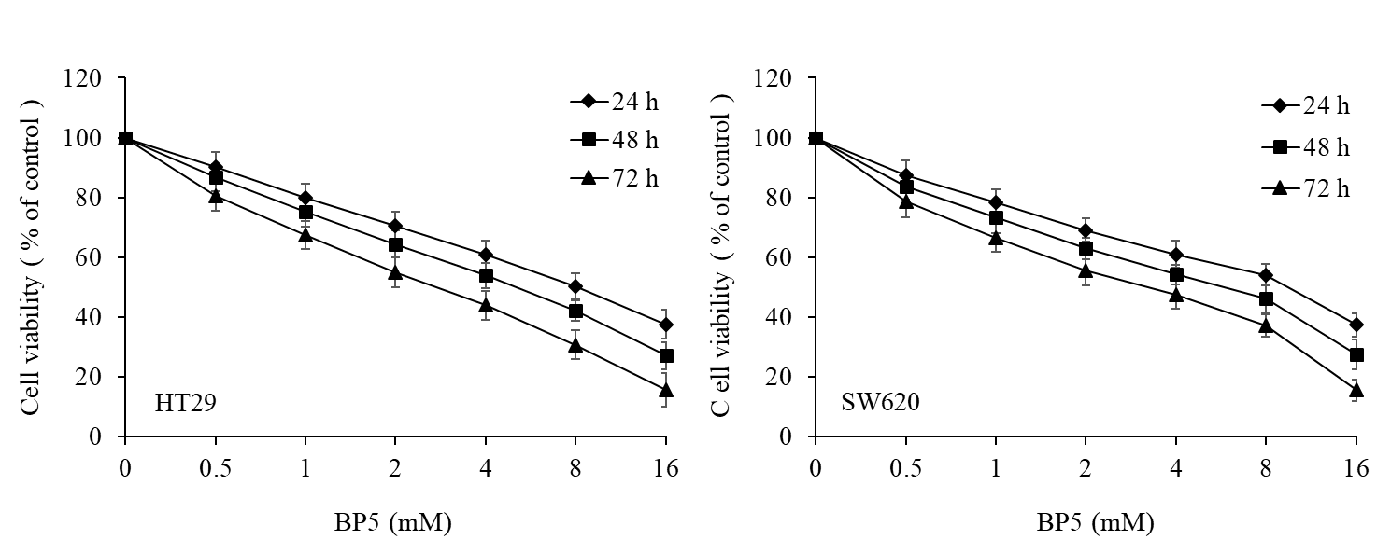

Figure S1. BP5 inhibited the growth of the human colon cancer cell lines HT29 and SW620. Cells of HT29 and SW620 were incubated with the indicated concentrations of BP5 for 24 h, 48 h and 72 h, then a CCK-8 assay was performed to detect the cell viability. Data represent the mean ± SD of three independent experiments.

