Additional file 1

Figure S1. Representative immunochemistry stains for CTHRC1, VEGF and CD34. Representative image of a 0, b 0-10%, c 11-50%, d 51-75% and e >75% of cancer cells stained for CTHRC1 IHC staining and f-j for five cancer cells stained categories for VEGF IHC staining in LUAD tissue samples. k-o IHC staining of different MVDs in LUAD tissue arrays. Scale bar: 50 um. CTHRC1, collagen triple helix repeat containing 1; VEGF, vascular endothelial growth factor; MVD, microvessel density; IHC, immunochemistry; LUAD, lung adenocarcinoma.

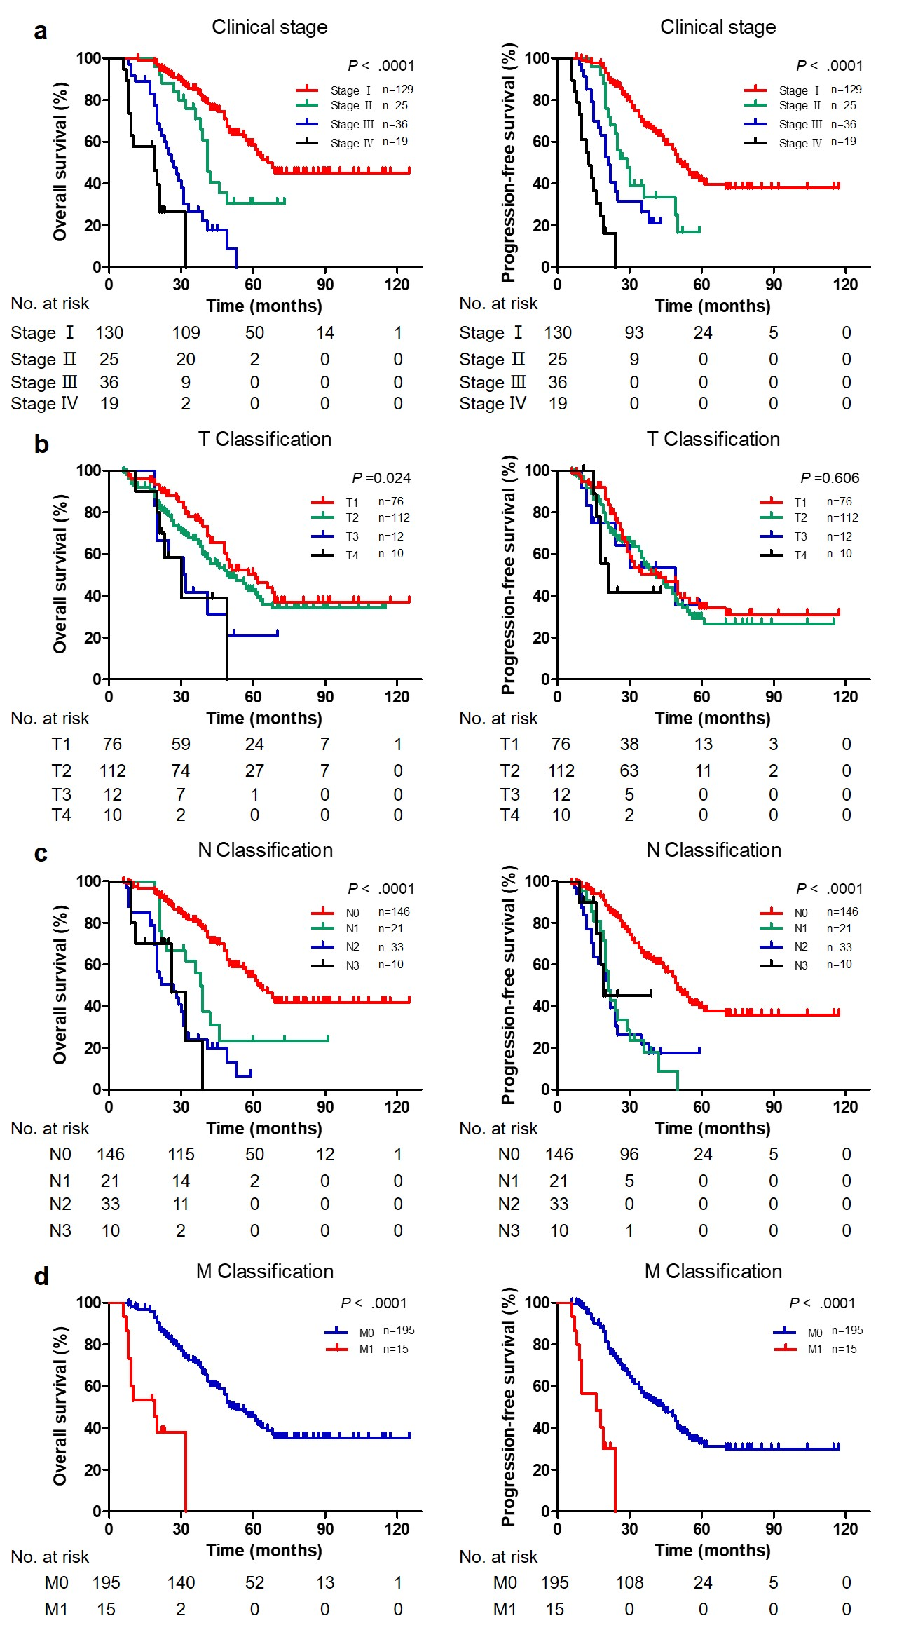

Figure S2. Advanced clinical stage determined the worse prognosis in LUAD. Kaplan-Meier survival curves for OS and PFS according to a clinical stage, b T, c N, and d M classification. Vertical tick marks censored subjects. Bonferroni correction was used to adjust the statistical significance level (Table S1-3). CTHRC1, collagen triple helix repeat containing 1; VEGF, vascular endothelial growth factor; MVD, microvessel density; LUAD, lung adenocarcinoma; OS, overall survival; PFS, progression-free survival.

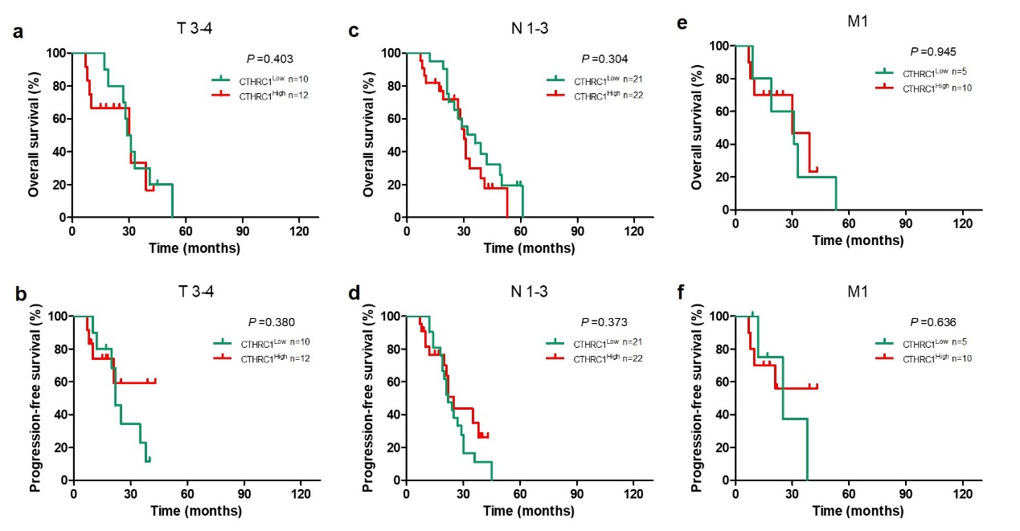

Figure S3. No significant difference was observed between CTHRC1-High group and CTHRC1-Low group in a, b T 3-4, c, d N 1-3 and e, f M1 subgroups.

