Additional figure legends
Figure S1. Effects of UEV1C and MMS2 overexpression on the ATK pathway in breast cancer cells. AKT and its phosphorylation were monitored by western blot in pcDNA4.0/TO/HA(+) vector (CK), UEV1C or MMS2 stably transfected (A) MDA-MB-231-TR cells treated with doxycycline or (B) MCF7 cells. The expression levels of ectopic Uev1C and Mms2 were monitored by an anti-HA antibody.

Figure S2. Colony formation assay under serum-deprived conditions. 1x10⁵ cells were seeded in 6-well culture plates. The cells were cultured for 7 days with serum-free medium. Colonies were fixed with methonol, stained with trypan blue (0.4% w/v) and counted using a microscope. Each sample was measured in triplicate and repeated at least 2 times. * P<0.05.

Figure S3. Growth curve of Uev1A depleted breast cancer cells under serum-supplemented conditions. (A) Growth curve of non-specific target (shCK) and shUEV1 MDA-MB-231 cell lines (shUEV1-1 and shUEV1-2) under serum-supplemented conditions. Then cells were harvested by trypsinization at different time point and stained with trypan blue. Viable cells were counted using a hematocytometer and an inverted microscope. (B) Growth curve of non-specific target (shCK) and shUEV1 MCF7 cell line (shUEV1-8) under serum-supplemented conditions. Experimental conditions were as described in Fig. S3A. Each sample was measured in triplicate and repeated 2 times. * P<0.05.

Figure S4. UEV1A transcript levels in shUEV1 restored UEV1A breast cell lines. (A) Two shUEV1 MDA-MB-231 cell lines were transfected with the pcDNA4.0/TO/HA(+) vector expressing UEV1A (shUEV1-1+UEV1A and shUEV1-2+UEV1A). Non-specific shRNA targeted MDA-MB-231 cells were also transfected with the pcDNA4.0/TO/HA(+) vector to serve as a control. UEV1A transcript levels in shCK and shUEV1 lines were determined by qRT-PCR. (B) The MCF7 shUEV1-8 cell line was transfected with pcDNA4.0/TO/HA(+) vector expressing UEV1A (shUEV1-8+UEV1A). The non-specific shRNA targeted MCF7 cells were transfected with the vector alone (shCK+CK). The UEV1A transcript levels in shCK and shUEV1 line were determined by qRT-PCR. ** P<0.01.

Figure S5. Uev1A promotes cell survival under serum starvation conditions through the AKT pathway in breast cancer cells. (A) UEV1A overexpressed MDA-MB-231-TR cells were treated with Perifosine. After 24 hrs, the AKT pathway proteins were examined by western blot in the whole-cell extract (WCE) or nuclear fraction (N) in UEV1A overexpressed cells alone (UEV1A) or treated with 5 μM Perifosine (1A+Pe), or vector only (CK). The expression levels of ectopic Uev1A were monitored by an anti-HA antibody. (B,C) Growth curve of control (CK) and UEV1A-overexpressed MDA-MB-231-TR (B) and MCF7 (C) cells under serum-deprived conditions. Experimental conditions were as described in Fig. 2C except that cells were treated with 5 μM Perifosine (Pe+). Each sample was measured in triplicate and repeated at least 2 times. * P<0.05; ** P<0.01

Figure S6. Inhibition of NF-κB pathway by Bay11-7082 treatment. Cells were treated with or without 40 μM Bay11-7082 for 4 hours. Then whole-cell extract (WCE) or nuclear fraction (N) were prepared for western blotting analysis using an anti-p65 antibody to assess the protein level of p65 in whole-cell extract or nuclear fraction.

Figure S7. Effects of Uev1 depletion on chemoresistance of breast cancer cells. (A,B) Non-specific (shCK) and shUEV1 MDA-MB-231 cells were seeded onto 6-well culture plates. After a 4-hr exposure to various doses of Paclitaxel (A) or Doxorubicin (B), the cells were cultured for an additional 7 days with drug-free medium containing 10% FBS. Cell viability was determined and presented as described in Figure 6. (C,D) Non-specific target (shCK) and shUEV1 MCF7 cells were seeded onto 6-well culture plates. After a 4-hr exposure to Paclitaxel (C) or Doxorubicin (D), the cells were cultured for an additional 7 days with drug-free medium containing 10% FBS. Cell viability assay was as described in Figure 6. * P<0.05; ** P<0.01.

Figure S8. Uev1A inhibits apoptosis through the AKT pathway in breast cancer cells.
MDA-MB-231 (A,B) or MCF7 (C,D) cells were per-treated with 5 µM Perifosine (Pe) for 12 hours and then exposed to Paclitaxel (A,C) or Doxorubicin (B,D), harvested at different time points and the protein levels of total PARP and cleaved-PARP were detected by western blot. The ectopic Uev1A was monitored by an anti-HA antibody.

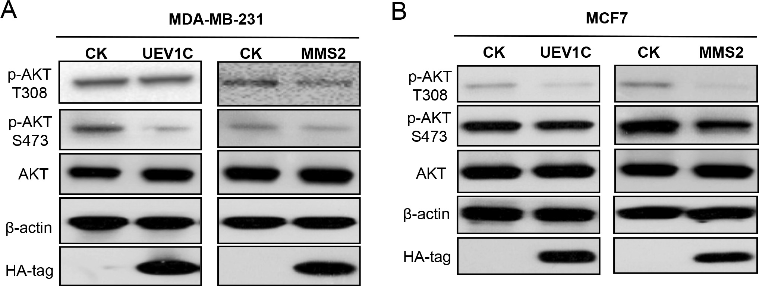
Figure S1
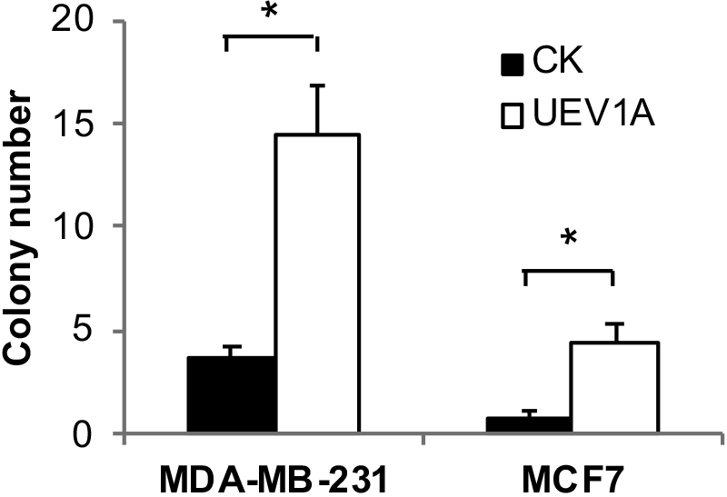
Figure S2
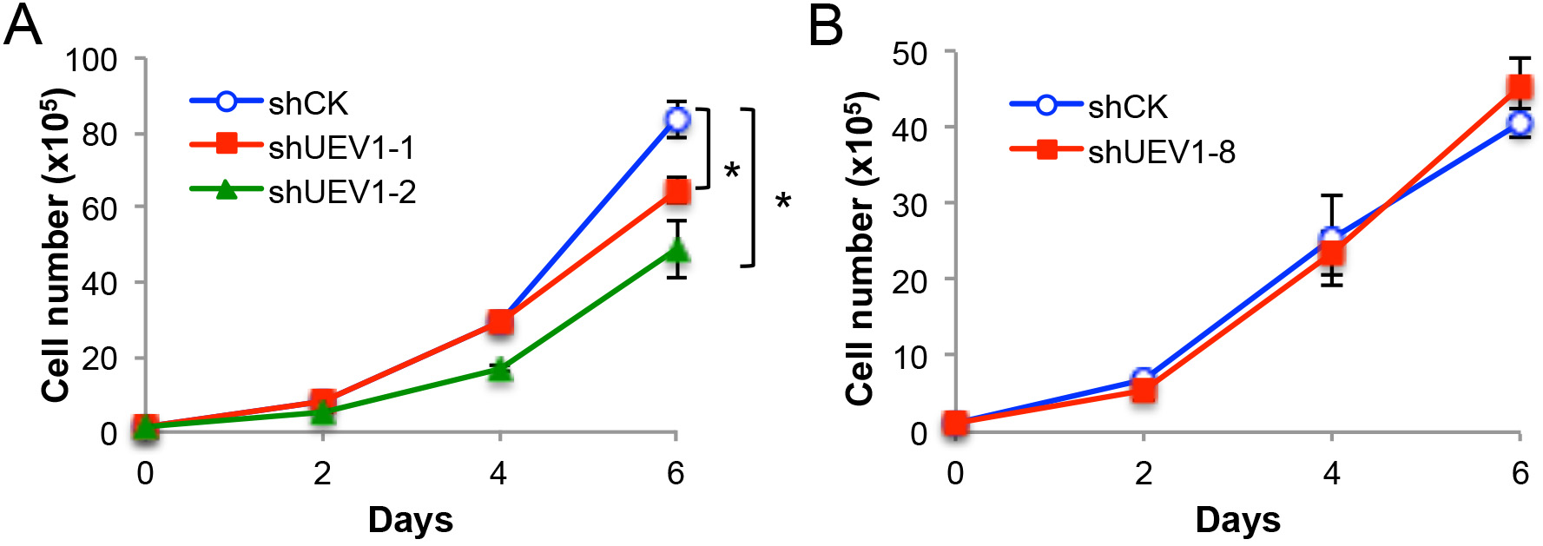
Figure S3
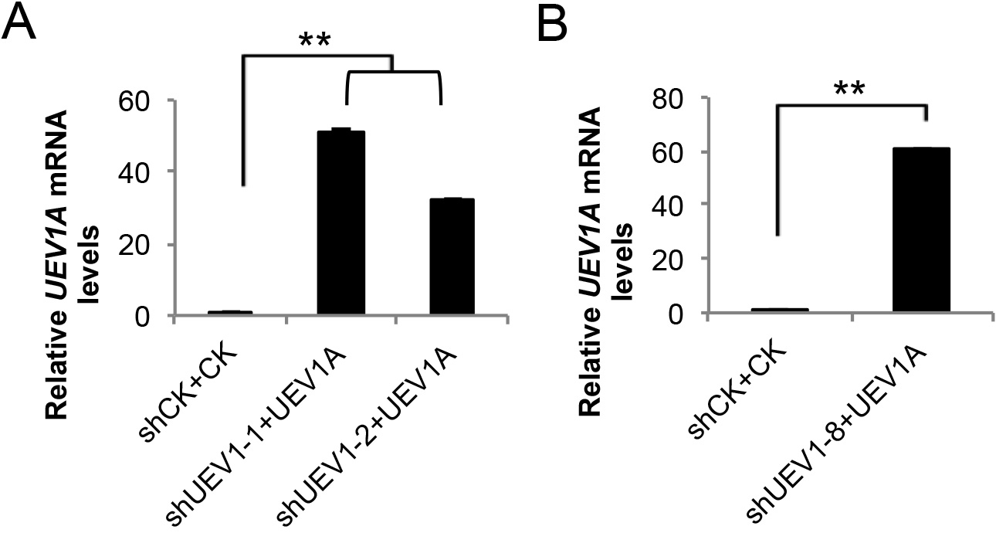
Figure S4
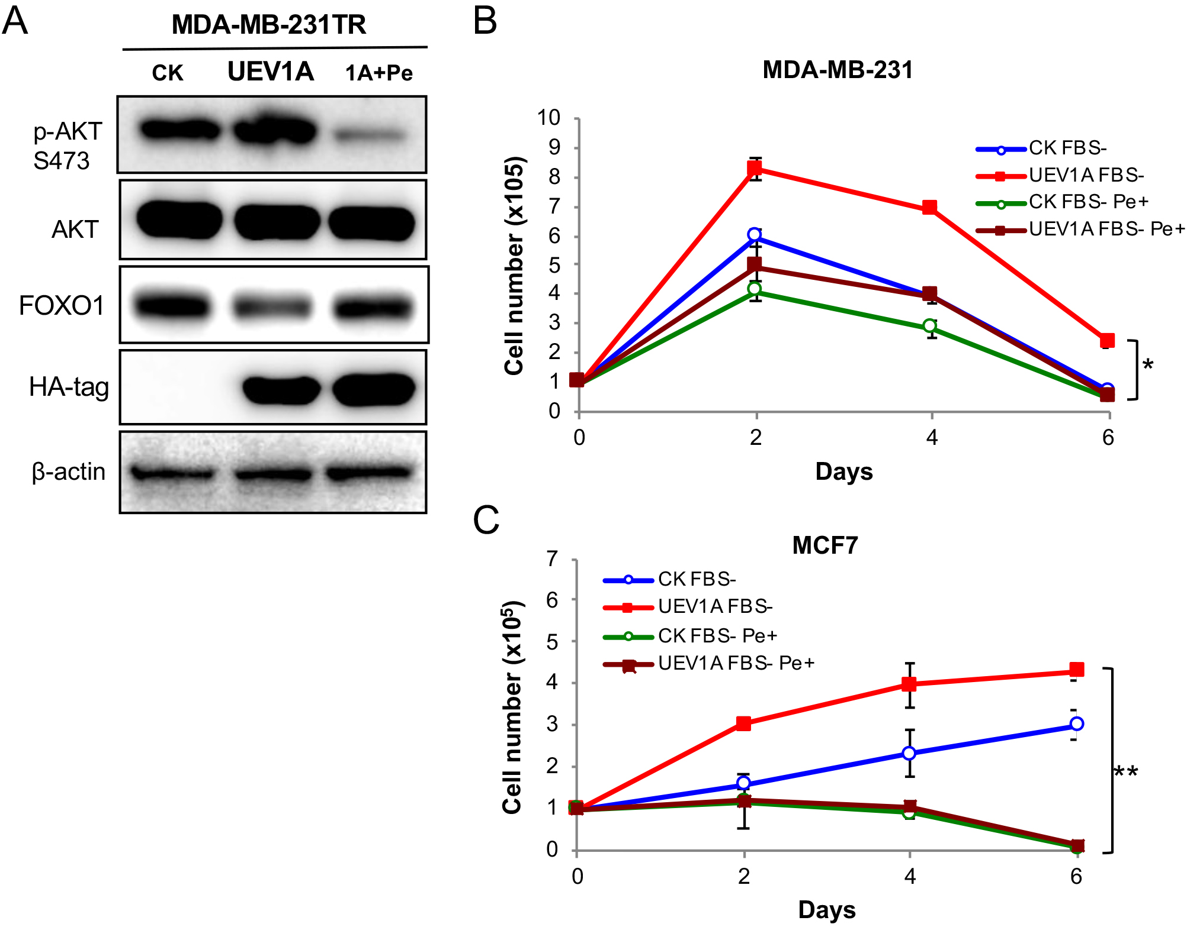
Figure S5
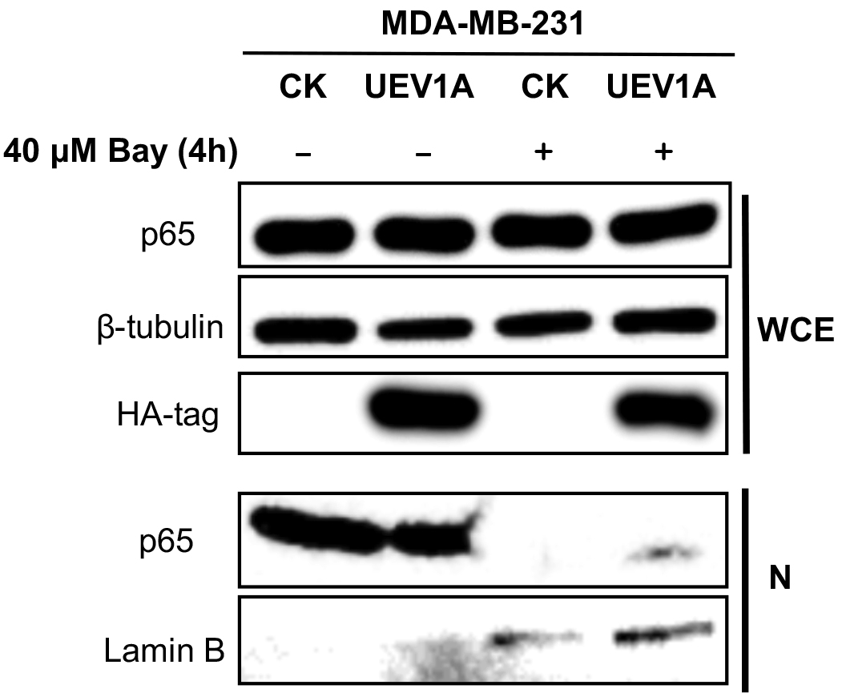
Figure S6
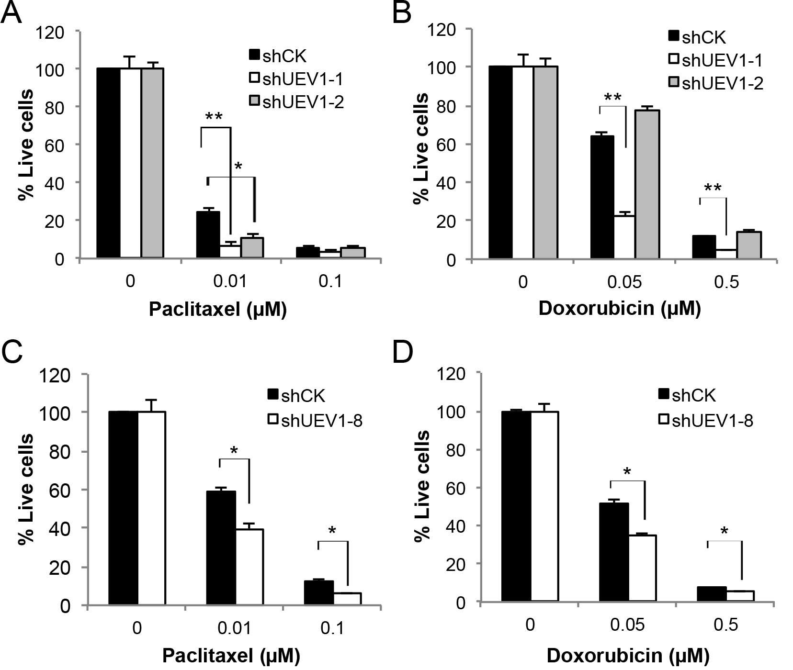
Figure S7
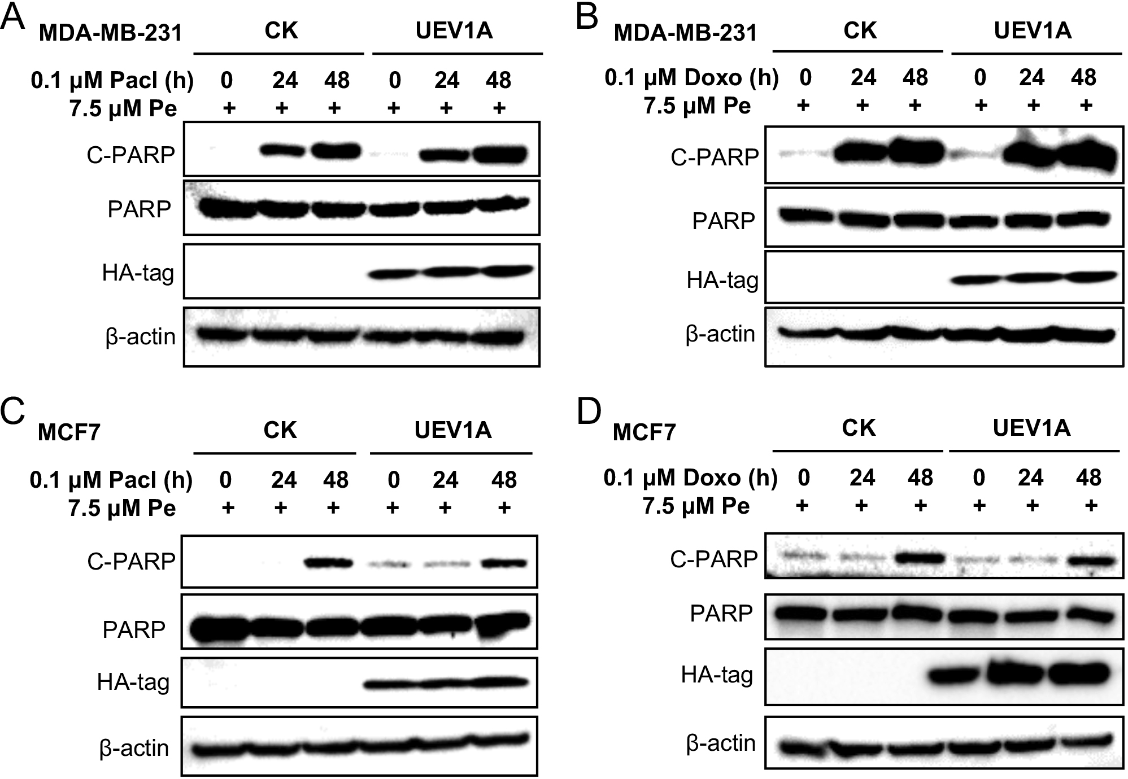
Figure S8

