Additional Figure legends
Additional Figure S1. Successful construction of recombinant LNK-shRNA plasmids. (A) LNK mRNA expression in LNK-shRNA cells (sh1#, sh2#, sh3# and sh4#) and control cells (PLKO.1) were measured by Real-time PCR analysis. (B) Western blot analysis was used to examine the protein expression of LNK-shRNA cells and control cells.

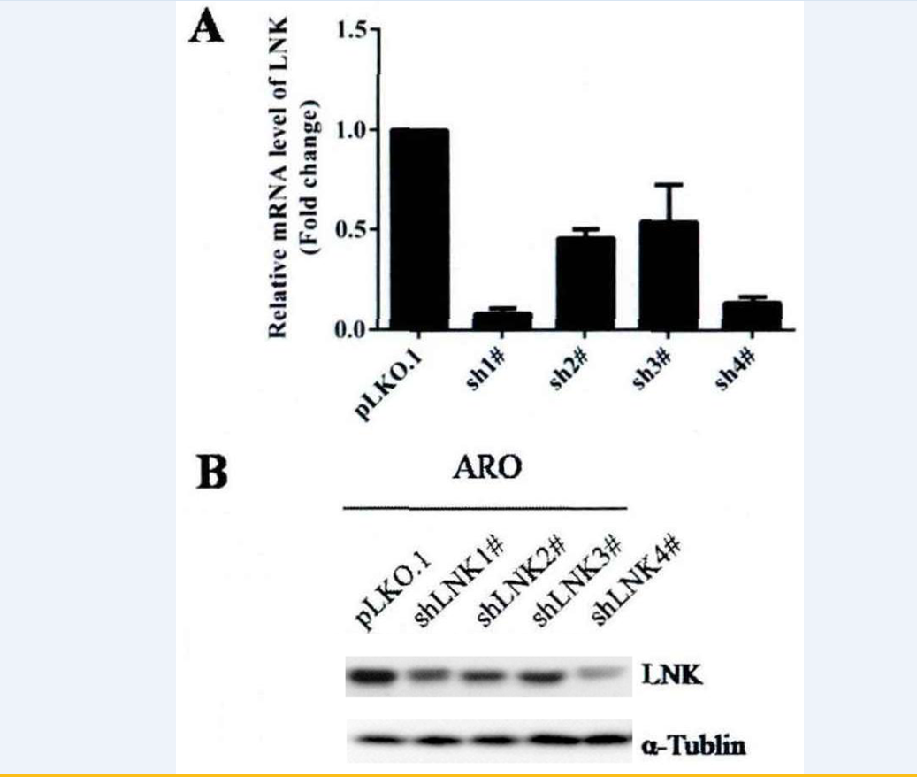

Additional Figure S2. LNK knockdown increased cell apoptosis in ARO cells. Annexin V-PI apoptosis assays were used to examine the cell apoptosis level in ARO-PLKO.1 (A) and LNK-shRNA cells (B and C).
