Additional file

CircRNA hsa_circRNA_0000069 promotes the proliferation, migration and invasion of cervical cancer through miR-873-5p/TUSC3 axis

Shuaisai Zhang ^{1,†}, Chenzheng Li^{2,†}, Jin-xue Sun ^{3,†}, Na An ^{4,*}, Qinghua Xi ^{5,*}
¹Department of Gynecology, Nantong maternal and Child Health Hospital Affiliated to Nantong University, Nantong 226018, Jiangsu, China.
²First Hospital of Hebei Medical University, Hebei Medical University, No. 89 Donggang Road, Shijiazhuang 050032, Hebei, China.
³Clinical Laboratory Shandong Provincial Third Hospital, Jinan 250031, Shandong, China.
⁴Department of Gynecology, Shengli Oilfield Central Hospital, No. 31, Jinan Road, Dongying 257034, Shandong, China.
⁵Department of Gynecology, Affiliated Hospital of Nantong University, Nantong 226001, Jiangsu, China.

†These authors contributed equally to this work.

*To whom correspondence should be addressed:
Na An
E-mail: yunnanpuer1@163.com

Qinghua Xi
E-mail: shuiqingqin@yeah.net

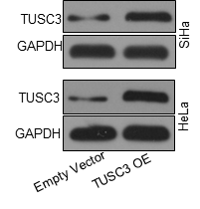
Additional file 1: Fig. 1. Effect of TUSC3 overexpression in SiHa and Hela cells. Western blots analysis of SiHa and Hela cells transiently transfected with vector or pcDNA3.1-TUSC3.

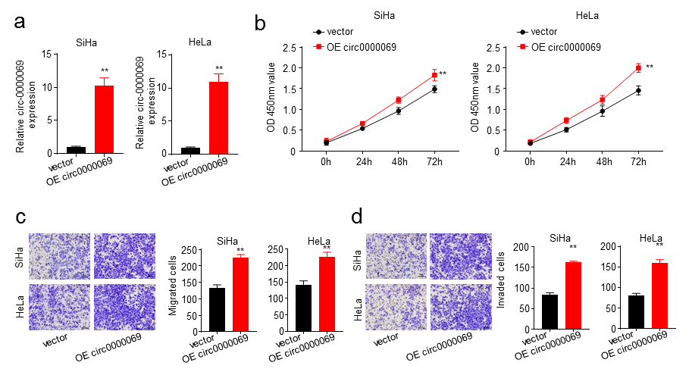
Additional file 1: Fig. 2. a. qRT-PCR analysis of hsa_circ_0000069 expression in SiHa and HeLa cells transfected with vector or pcDNA3.1-TUSC3. b. Cell counting kit-8 assays were used to measure the proliferation ability of siHa and HeLa cells transfected with vector or pcDNA3.1-TUSC3. c and d Transwell assays were used to determine the cell migration and invasion of hsa_circ_0000069 in SiHa and HeLa cells transfected with vector or pcDNA3.1-TUSC3. All data is representative of three independent experiments and expressed as mean ± SD. P value in Figure 2b was determined by a one-way ANOVA, and the others were determined by two-tailed Student’s unpaired t-test, **P < 0.01.

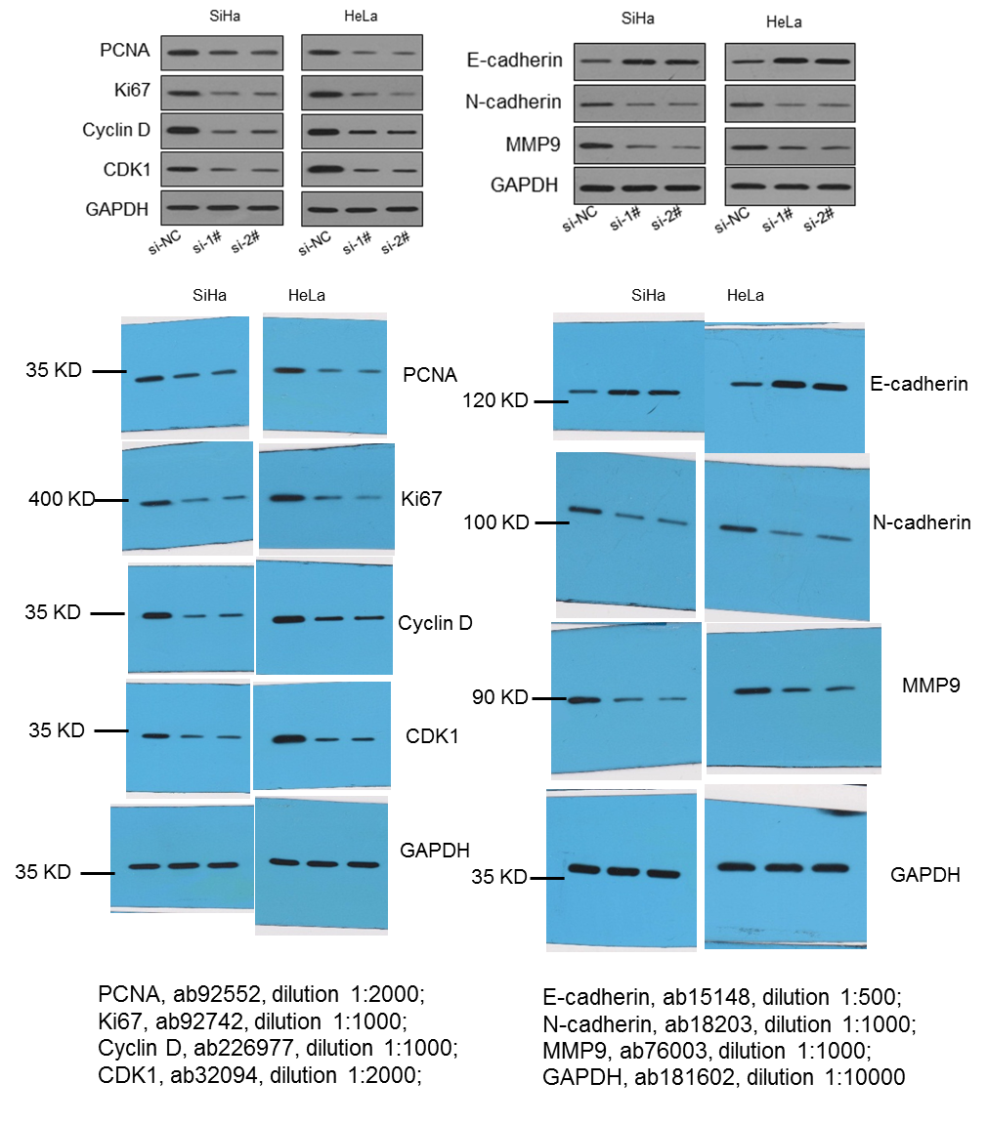
Additional file 1: Fig. 3. Full uncropped immunoblot images of Fig. 2f with molecular weight markers and details of the antibodies with dilution.

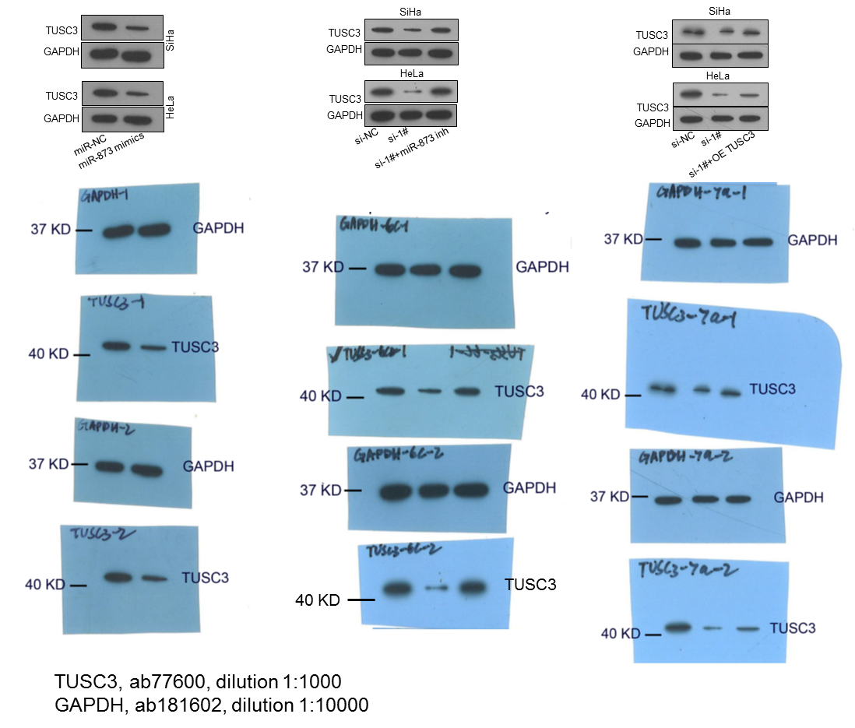
Additional file 1: Fig. 4. Full uncropped immunoblot images of Fig.6b (left), Fig.6c (middle), and Fig.7a (right) with molecular weight markers and details of the antibodies with dilution.

