Figure legends
Fig. 1.1 Forest plots of sensitivity estimates for acoustic analysis of EBV-DNA in the diagnosis of NPC.
Fig. 1.2 Forest plots of specificity estimates for acoustic analysis of EBV-DNA in the diagnosis of NPC.
Fig. 1.3 Forest plots of positive likelihood estimates for acoustic analysis of EBV-DNA in the diagnosis of NPC.
Fig. 1.4 Forest plots of negative likelihood estimates for acoustic analysis of EBV-DNA in the diagnosis of NPC.
Fig. 1.5 Forest plots of DOR estimates for acoustic analysis of EBV-DNA in the diagnosis of NPC.
Fig. 1.6 Summary receiver operating characteristic curve of EBV-DNA in the diagnosis of NPC.
Fig. 1.7 Deek’s funnel plot of EBV-DNA.
Fig. 2.1 Forest plots of sensitivity estimates for acoustic analysis of EA-IgA in the diagnosis of NPC.
Fig. 2.2 Forest plots of specificity estimates for acoustic analysis of EA-IgA in the diagnosis of NPC.
Fig. 2.3 Forest plots of positive likelihood estimates for acoustic analysis of EA-IgA in the diagnosis of NPC.
Fig. 2.4 Forest plots of negative likelihood estimates for acoustic analysis of EA-IgA in the diagnosis of NPC.
Fig. 2.5 Forest plots of DOR estimates for acoustic analysis of EA-IgA in the diagnosis of NPC.
Fig. 2.6 Summary receiver operating characteristic curve of EA-IgA in the diagnosis of NPC.
Fig. 2.7 Deek’s funnel plot of EA-IgA.
Fig. 3.1 Forest plots of sensitivity estimates for acoustic analysis of VCA-IgA in the diagnosis of NPC.
Fig. 3.2 Forest plots of specificity estimates for acoustic analysis of VCA-IgA in the diagnosis of NPC.
Fig. 3.3 Forest plots of positive likelihood estimates for acoustic analysis of VCA-IgA in the diagnosis of NPC.
Fig. 3.4 Forest plots of negative likelihood estimates for acoustic analysis of VCA-IgA in the diagnosis of NPC.
Fig. 3.5 Forest plots of DOR estimates for acoustic analysis of VCA-IgA in the diagnosis of NPC.
Fig. 3.6 Summary receiver operating characteristic curve of VCA-IgA in the diagnosis of NPC.
Fig. 3.7 Deek’s funnel plot of VCA-IgA.
Fig. 4.1 Forest plots of sensitivity estimates for acoustic analysis of EBNA1-IgA in the diagnosis of NPC.
Fig. 4.2 Forest plots of specificity estimates for acoustic analysis of EBNA1-IgA in the diagnosis of NPC.
Fig. 4.3 Forest plots of positive likelihood estimates for acoustic analysis of EBNA1-IgA in the diagnosis of NPC.
Fig. 4.4 Forest plots of negative likelihood estimates for acoustic analysis of EBNA1-IgA in the diagnosis of NPC.
Fig. 4.5 Forest plots of DOR estimates for acoustic analysis of EBNA1-IgA in the diagnosis of NPC.
Fig. 4.6 Summary receiver operating characteristic curve of EBNA1-IgA in the diagnosis of NPC.
Fig. 4.7 Deek’s funnel plot of EBNA1-IgA.
Fig. 5.1 Forest plots of sensitivity estimates for acoustic analysis of Rta-IgG in the diagnosis of NPC.
Fig. 5.2 Forest plots of specificity estimates for acoustic analysis of Rta-IgG in the diagnosis of NPC.
Fig. 5.3 Forest plots of positive likelihood estimates for acoustic analysis of Rta-IgG in the diagnosis of NPC.
Fig. 5.4 Forest plots of negative likelihood estimates for acoustic analysis of Rta-IgG in the diagnosis of NPC.
Fig. 5.5 Forest plots of DOR estimates for acoustic analysis of Rta-IgG in the diagnosis of NPC.
Fig. 5.6 Summary receiver operating characteristic curve of Rta-IgG in the diagnosis of NPC.
Fig. 5.7 Deek’s funnel plot of Rta-IgG.

Fig. 1.1

Fig. 1.2
Fig. 1.3

Fig. 1.4
Fig. 1.5

Fig. 1.6
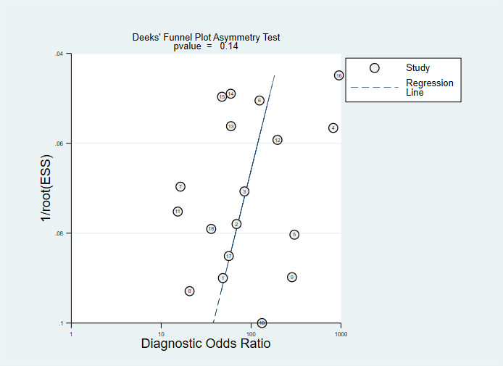
Fig. 1.7

Fig. 2.1

Fig. 2.2

Fig. 2.3

Fig. 2.4

Fig. 2.5

Fig. 2.6

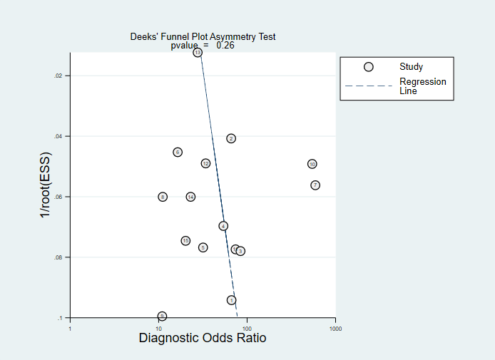
Fig. 2.7

Fig. 3.1

Fig. 3.2

Fig. 3.3

Fig. 3.4

Fig. 3.5

Fig. 3.6

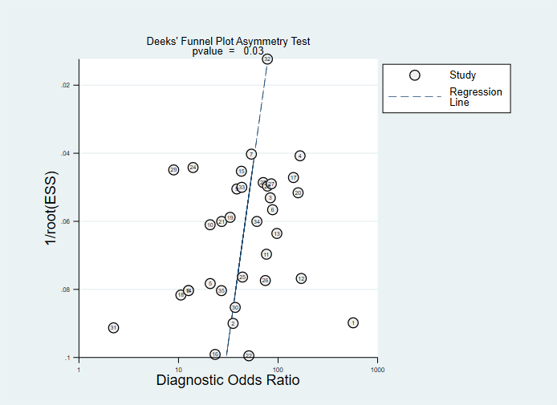
Fig. 3.7

Fig. 4.1

Fig. 4.2

Fig. 4.3

Fig. 4.4

Fig. 4.5

Fig. 4.6

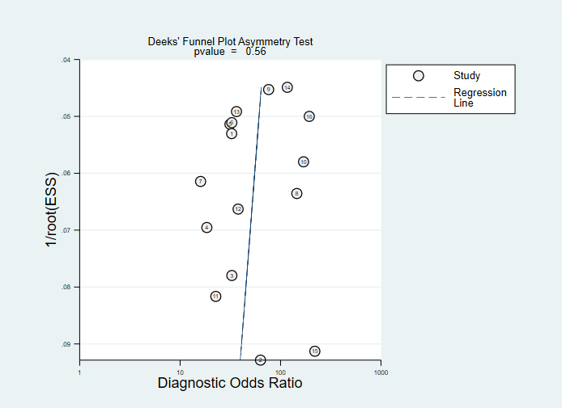
Fig. 4.7

Fig. 5.1

Fig. 5.2

Fig. 5.3

Fig. 5.4

Fig. 5.5

Fig. 5.6

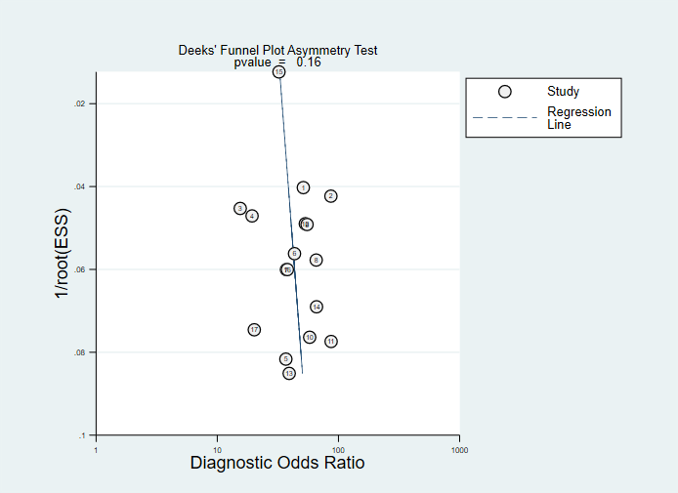
Fig. 5.7

