Figure S1. Dysplasia/cancer risk among patients with IIM when compared with CIM: sensitivity analysis.

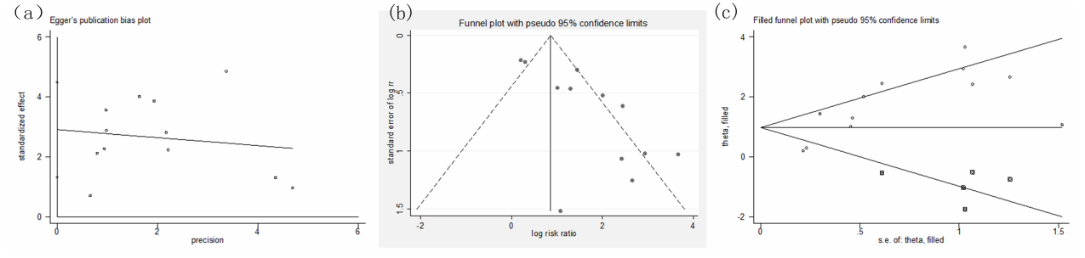
Figure S2. Dysplasia/cancer risk among patients with IIM when compared with CIM: Egger’s publication bias plot (a), funnel plot (b), and filed funnel plot(c) after adding 5 more studies (inside the box) by trim and fill method.
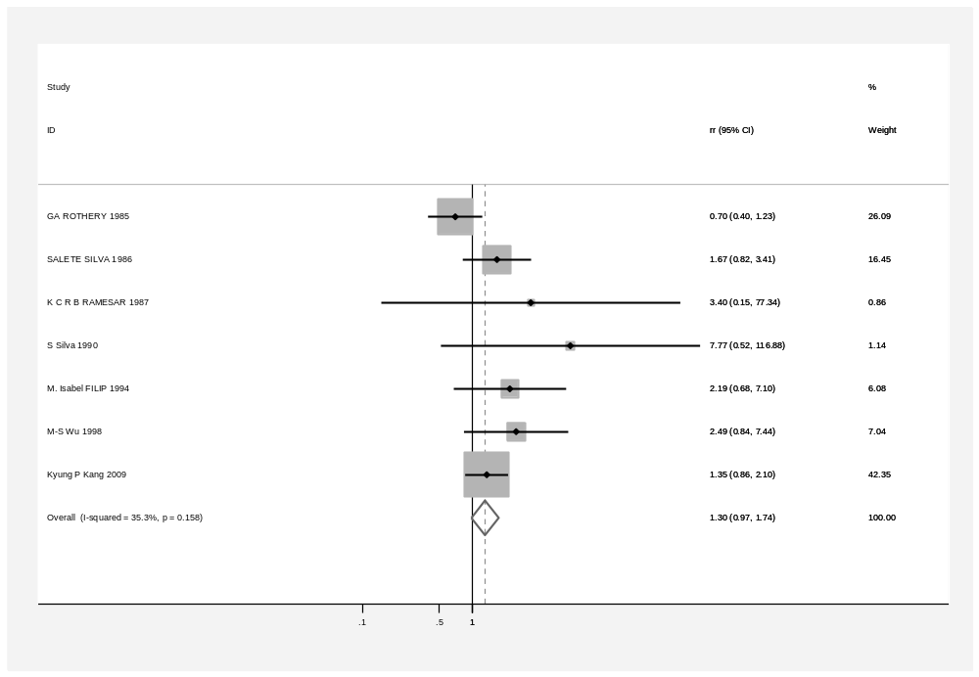
Figure S3. Forest plots for dysplasia/cancer risk among patients with type II IM when compared with type I IM (before sensitivity analysis).

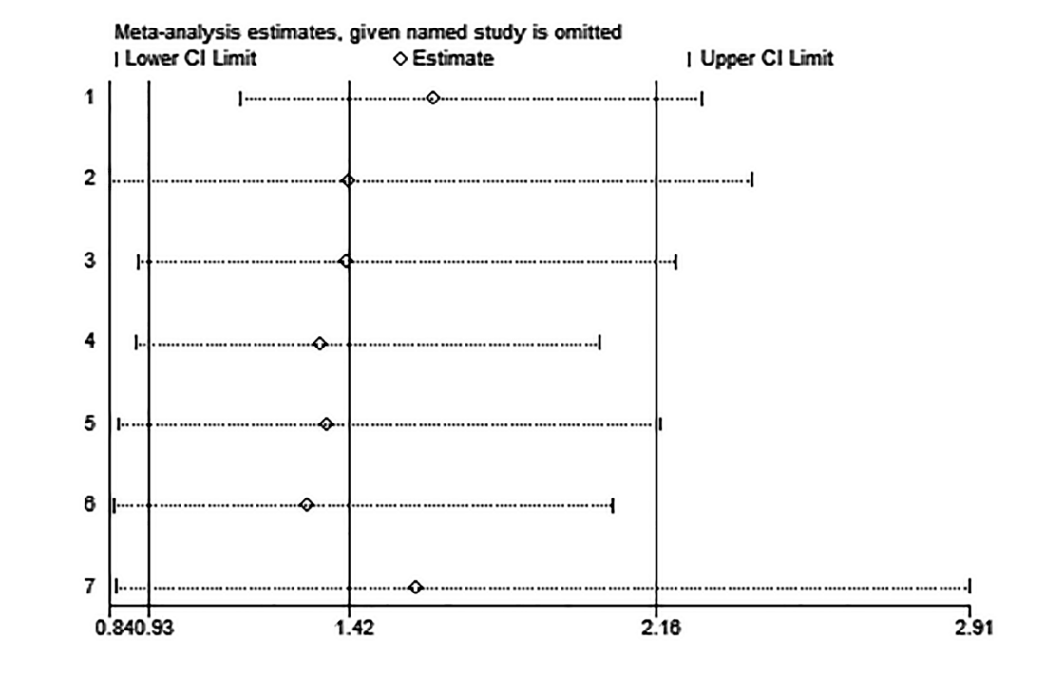

Figure S4. Dysplasia/cancer risk among patients with type II IM when compared with type I IM: sensitivity analysis.

Table S1. Dysplasia/cancer risk among patients with IIM when compared with CIM: sensitivity analysis.
Study omitted | Estimate | [95% Conf. Interval]
1 | 4.2599592 | 2.3497031 | 7.7232113
2 | 4.2599254 | 2.3579731 | 7.6960011
3 | 4.8604665 | 2.5525551 | 9.2550917
4 | 4.0910387 | 2.2819293 | 7.3344073
5 | 5.4102325 | 2.9153223 | 10.040268
6 | 3.9994516 | 2.229542 | 7.1743946
7 | 4.2087851 | 2.2989712 | 7.7051301
8 | 4.6777091 | 2.4718034 | 8.8522263
9 | 3.8772688 | 2.2097368 | 6.8031688
10 | 4.5719614 | 2.5104167 | 8.3264389
11 | 4.6343923 | 2.417491 | 8.8842487
12 | 5.464726 | 2.8388612 | 10.51944
Combined | 4.4824573 | 2.502451 | 8.0290978

Table S2. Dysplasia/cancer risk among patients with IIM when compared with CIM: publication bias (Egger's test).

Std_Eff | Coef. | Std. Err. | t | P>|t| | [95% Conf. Interval]
slope | -.1334982 | .2890785 | -0.46 | 0.654 | -.7776052 | .5106088
bias | 2.907853 | .7079506 | 4.11 | 0.002 | 1.330441 | 4.485266

Table S3. Dysplasia/cancer risk among patients with IIM when compared with CIM: sensitivity analysis: trim and fill method.

Before trim and fill method |  |  |  |  |  |  | After trim and fill method
Method | Pooled RR | 95% CI |  | Asymptotic |  | No. Of studies | Method | Pooled RR | 95% CI |  | Asymptotic |  | No. Of studies
 |  | Lower | Upper | z_value | p_value |  |  |  | Lower | Upper | z_value | p_value
Fixed | 2.372 | 1.883 | 2.988 | 7.327 | <0.001 | 12 | Fixed | 2.080 | 1.666 | 2.596 | 6.469 | <0.001 | 17
Random | 4.482 | 2.502 | 8.029 | 5.044 | <0.001 | 12 | Random | 2.664 | 1.546 | 4.591 | 3.530 | <0.001 | 17

Table S4. Dysplasia/cancer risk among patients with type II IM when compared with type I IM: sensitivity analysis.
Study omitted | Estimate | [95% Conf. Interval]
1 | 1.6185008 | 1.1552687 | 2.2674768
2 | 1.4145175 | .83824575 | 2.386961
3 | 1.4122201 | .90579295 | 2.2017896
4 | 1.3480884 | .8999626 | 2.0193529
5 | 1.3644542 | .85971808 | 2.165518
6 | 1.31813 | .8468163 | 2.0517635
7 | 1.5765162 | .85391533 | 2.9105968
Combined | 1.4171046 | .9313212 | 2.156276

