Supplementary Materials
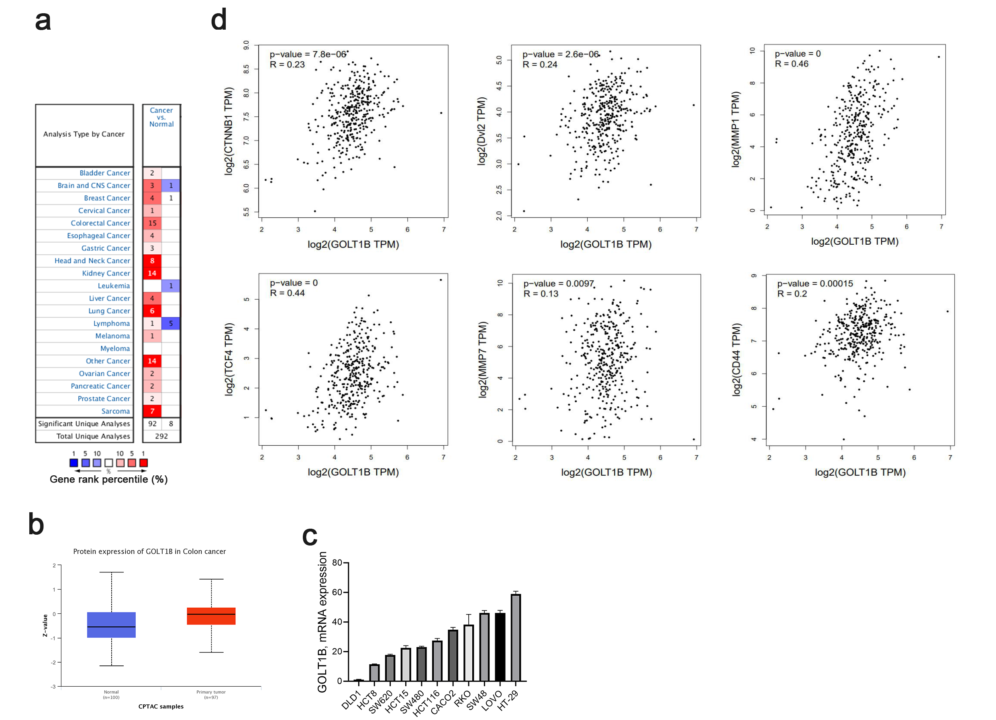
Supplementary Figure.S1 GOLT1B is highly expressed in colorectal cancer and regulates cancer cell metastasis through WNT signaling pathway. a. GOLT1B is generally highly expressed in various tumors. b. CPTAC (clinical proteomic tumor analysis consortium) database analysis find that GOLT1B is highly expressed in CRC. c. QPCR analysis of GOLT1B expression in 11 common colorectal cancer cell lines. d. GEPIA2 database analyzes the correlation between GOLT1B and wnt signaling pathway related proteins.

