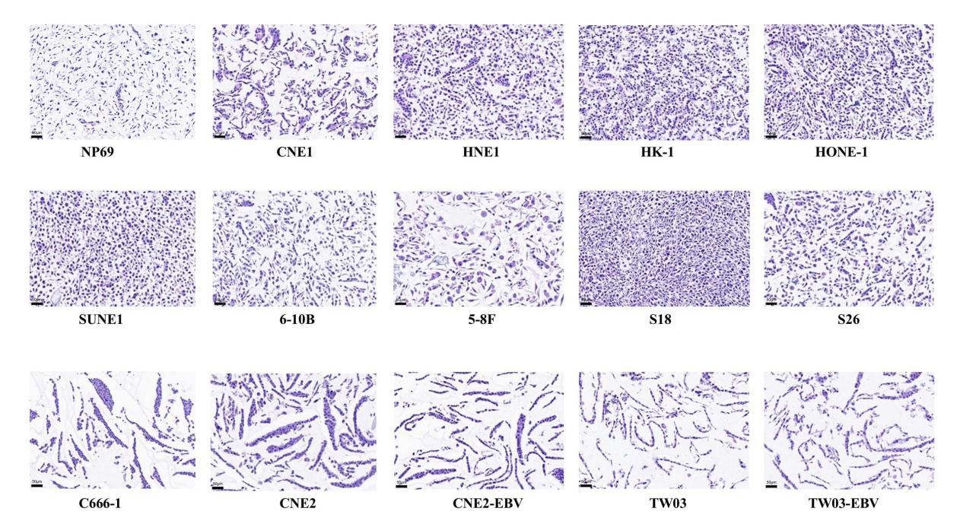
Figure S1. Hematoxylin-eosin (HE) staining of all 15 NPC cell lines (×20). Scale bars: 50μm.

