LncRNA LBX2-AS1 Promotes Colorectal Cancer Progression and 5-Fluorouracil Resistance

Figure S1
(A) HCT116 and SW480 cells treated with DMSO, 5-AZA or TSA as indicated were subjected to qPCR analysis of LBX2-AS1 level. (B) HCT116 and SW480 cells transfected with si-Dicer or si-Control as indicated were subjected to r qPCR analysis of LBX2-AS1 level. (C)HCT116 and SW480 cells transfected with the indicated siRNA (si-METTL3, si-METTL14, si-WTAP, si-FTO, si-ALKBH5 or si-Control) were subjected to qPCR assay. (D)The m6A methylation level of Postion-1 and -2 in HCT116 and SW480 cells by m6A-qPCR. (E)HCT116 and SW480 cells transfected with the indicated siRNA (si- IGF2BP-1/-2/-3, si-YTHDF-1/-2/-3 or si-Control) were subjected to qPCR assay. For A-E mean±s.e.m. were derived from n=3 independent experiments ∗P<0.05; Student’s t-test.
Figure S2
(A and B) LBX2-AS1 was predominantly located in the cytoplasm of HCT116 (A) and SW480 (B) cells. Mean±s.e.m. were derived from n=3 independent experiments.
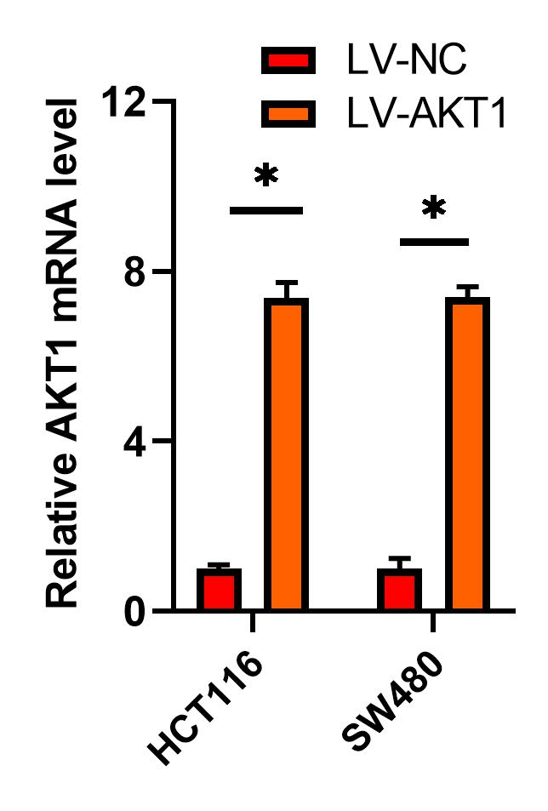

Figure S3
HCT116 and SW480 cells transfected with LV-AKT or LV-NC were subjected to qPCR assay. Mean±s.e.m. were derived from n=3 independent experiments ∗P<0.05; Student’s t-test

Table S1 Sequences of primers used in this study
Gene symbol | Forward primer | Reverse primer
GAPDH | CCACATCGCTCAGACACCAT | TGACAAGCTTCCCGTTCTCA
LBX2-AS1 | TTCCCAAGAAGGTTCGATTG | TGCAGACTCCTGCTGTTGTT
METTL3 | GATAGTTGTGATCGCCTCACC | GTCCTCTGAGTCGAAGCTGTC
METTL14 | CCCCTGTGGCTAACAGTTACA | AGGTAGCTTTTAAGGCTTGACTC
WTAP | GGGTGACATCGGGAGAACG | CTGAACAGGCTTCGTAACTCAT
FTO | CGATGGAACTTCGACTTTGTCA | GCACAAGGGTACAAGACAGTG
ALKBH5 | AACGTGCGAGTGTCTAACGG | CCCTCTAGGGGTTTGTGATTCT
IGF2BP1 | TCCAGCATAGCTTTAGCTTTGC | GGTCATCGGCGCTCAGAATAG
IGF2BP2 | GCTCAGTGTAGCATTAAGCAGG | CGAGGAAGCGTAACTCGGC
IGF2BP3 | ATCACTCGTGTGTCCTTC | GACTTAATACTCGCAGACAACC
YTHDF1 | CTTCAGCGACTTCGGCGTA | ATCATAACTGTTGCTAGGTGACG
YTHDF2 | TCATCGTGGTAGGCTATGACC | CCAGGCTGACAAAACAACTCA
YTHDF3 | TTCCGTCTGATGAAGGTTGGC | GCGCATTAAAGTAACTCCACAGT
P-gp | AGGATGGGTCTGAACGACTTT | GCCCTTTCCGATCACTTTCAAG
MRP1 | CCATAGCCGAGCAGACTGG | GGATACGTGGCGTAAAATGAAGT
BCRP | CGCATTTCGGCAAGTTGGAG | TCCTGCTTGAATCAGCCAGAC
AKT1 | AGCAATGGGGAGTGTAAAGAGG | CCCAGTCTTGTACTCAGCAAC
MiR-422a | CGCAACGTCTGCAAGTTCG | TGGAGGCGCATCCTTTTCC
U6 | GACCTTGCCAGAATAATCACAGC | GGGTGTGGATAATGTCTCCGT
Pistion1-MeRIP | TGGGGAAACCCTGCTGAGACC | TCAAAATTCAGAGTCCAACCAACACG
Pistion2-MeRIP | CCCCAGGCTCGTGGACTAGTC | AATCCTGCCTTTCCTGGGTCCTC

Table S2 Target sequences of siRNAs or shRNAs used in this work.
Gene symbol | Target sequence
shMETTL3#1 | 5‘-GCAGUUCUUUAACCAAUGUTT-3’
shMETTL3#2 | 5‘-CGGACCCAUAUUAUCAUAU-3’
shMETTL14#1 | 5‘-GCCCACACCAAUCUUAGAAGCAA
shMETTL14#2 | 5‘-CCACAUGUCUCAGCUAUAUTT-3’
shWTAP#1 | 5‘-GCUUUGGAGGGCAAGUACATT-3’
shWTAP#2 | 5‘-GGUUCGAUUGAGUGAAAAU-3’
shFTO#1 | 5‘-GCCCACACCAAUCUUAGAATT-3’
shFTO#2 | 5‘-CCACAUGUCUCAGCUAUACAG-3’
shALKBH5#1 | 5‘-CGGACCCAUAUUAUCAUGGAT-3’
shALKBH5#2 | 5‘-GCAGUUCUUUAACCAAUUGCU-3’
shIGF2BP1#1 | 5‘-CCTTCAAATTGGATCCATGGATC-3’
shIGF2BP1#2 | 5‘-CATACATACAACTCCAAAAAGT-3’
shIGF2BP2#1 | 5‘-CCAAGAGTGTGCTAAAGAATT-3’
shIGF2BP2#2 | 5‘-GCAGAACCATAAAGATGGTCCA-3’
shIGF2BP3#1 | 5‘-GACTTCATAAGGCGCATGCAGA-3’
shIGF2BP3#2 | 5‘-GGAATGCAGCTGAAAGATTCC-3’
shYTHDF1#1 | 5‘-UCCATCCGAAACTCUAUUCAATGC-3’
shYTHDF1#2 | 5‘-AACCATCACACUCUUACCAAAA-3’
shYTHDF2#1 | 5‘-TGACCAAAUAUUAUCAGGACCA-3’
shYTHDF2#2 | 5‘-ATACUCAGGGCACTATTGGT-3’
shYTHDF3#1 | 5‘-TGAAAGUGAAGATGGGACCCAA-3’
shYTHDF3#2 | 5‘-AGTTUGAAAAAUCAAAAGAATTG-3’
shNC | 5‘-UUCUCCGAACGUGUCACGUTT-3’
si-LBX2-AS1#1 | 5‘-AGGAATGTTTGCTGAATTAATGG-3’
si-LBX2-AS1#2 | 5‘-CCCAAGTTATAAAACTATAATGC-3’
si-LBX2-AS1#3 | 5‘-TTGGGAAATCAAGTTTAGGAGAG-3’
si-NC | 5‘-UUCUCCGAACGUGUCACGUTT-3’

