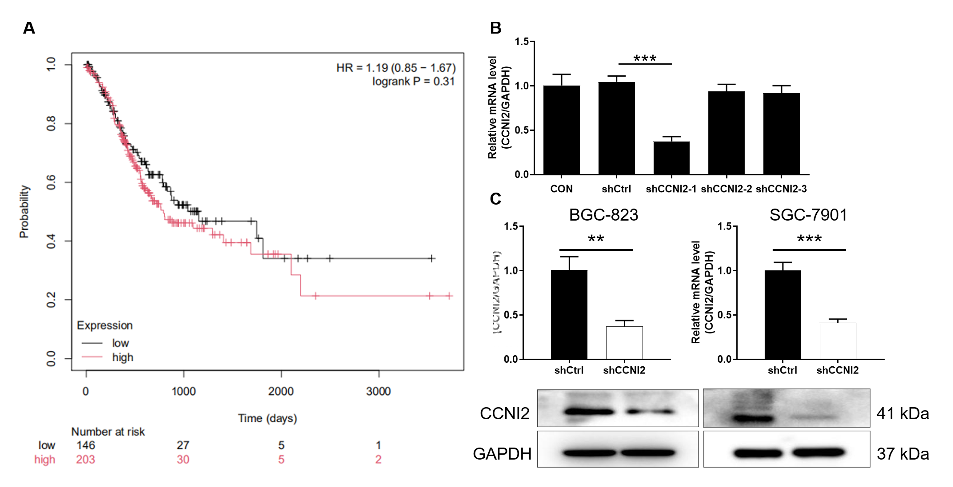
Fig. S1 (A) The correlation between the expression level of CCNI2 in gastric cancer tissues and clinical prognosis was analyzed. (B) The expression level of CCNI2 was detected in 3 different shRNAs against CCNI2 sequences. (C) The specificity and validity of the lentivirus-mediated shRNA knockdown of CCNI2 expression was verified by qPCR and WB. The data were presented as the mean ± SD (n ≥ 3), *P<0.05, **P<0.01, ***P<0.001.

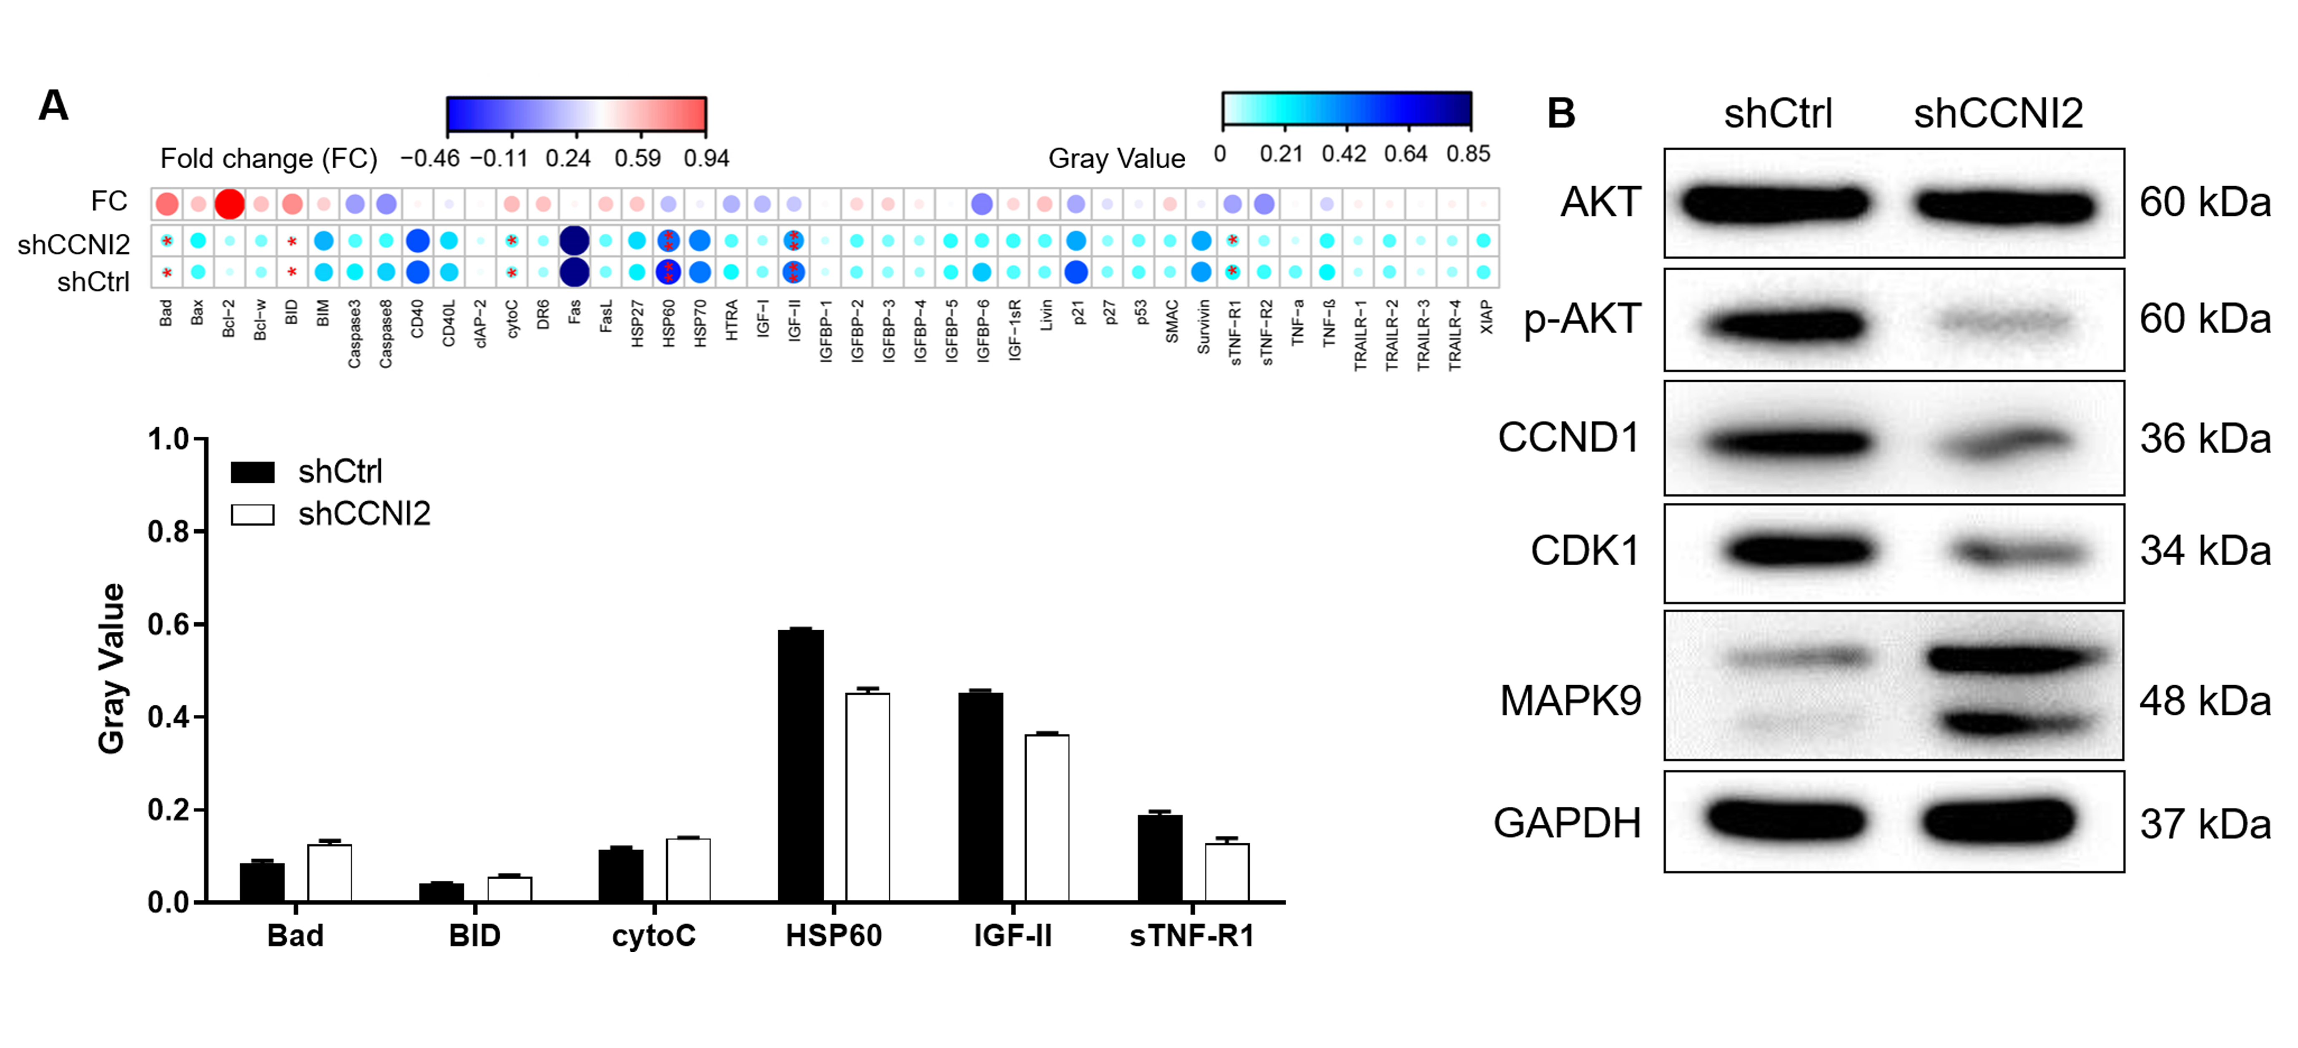
Fig. S2 (A) The expression of 43 apoptosis-related regulators of BGC-823 cells after knockdown of CCNI2 was detected using apoptotic antibody array kit (n = 2). (B) The protein expression of AKT, p-AKT, CCND1 and PIK3CA of BGC-823 cells after knockdown of CCNI2 was measured by WB.

Fig. S3 Interaction network diagram among DEGs was analyzed after knockdown of CCNI2 in BGC-823 cells by IPA.

Table S1. Primer sequence for PCR.
Gene | Upstream primer sequence | Downstream primer sequence | Amplified fragment size  (bp)
GAPDH | AAATACCAGCCCAGGAAGCA | AAACTGAGGCTCTGGGGACA | 121
CCNI2 | CCAGGGAGTATGAATGAATGTT | TTGGGATAAGCCTGGGAAGTT | 209
HMGA1 | AGCCCAGCGAAGTGCCAACA | CCTCCTCTTCCTCCTTCTCCAGTTTT | 150
SKA1 | TCCCATTTGCCTCAAGTAACAG | GGAGGCTTCTTTACGGGTTC | 107
SCIN | ACAACATCTGCGTTCCTGACTG | GCTCTTTGCCTTGGGAGACT | 85
HDGF | AGCCCAACAAGAGGAAAGGG | ACTGATAGCCGGAAGCCTTG | 81
E2F1 | CACTTTCGGCCCTTTTGCTC | GTGCTCTCACCGTCCTACAC | 128
CD24 | TGCTCCTACCCACGCAGATT | GGTGGTGGCATTAGTTGGATTT | 113
CDKN1A | TCTTGTACCCTTGTGCCTCG | GAAATCTGTCATGCTGGTCTGC | 105
ALPPL2 | AAGCAGGAAAGTCAGTGGGAGTGGTAA | AGGCACGTCGGCATCCGAGTA | 113
RDM1 | GCCCATCCTGGTTTCTATGC | GGCTTGATGTTGAACTGCCTTA | 150
TRIM29 | CAAGGAGACCACCCAGAAGAA | GGGCAGGTCATTGTCAGAGTT | 112
HMGB3 | ACCGTCTGGATTCTTCCTGTT | GATGTAAGGCTGCTTTTCACTG | 142
MMP7 | GACTTCCAAAGTGGTCACCTACA | CAGTTCCCCATACAACTTTCCT | 143
PRSS23 | GAAGGAAGCGGCAGATTTATGG | TGATGTTGAGAAAGGGTAGTTGAGC | 86
EGFR | ATGAGGACATAACCAGCCACC | AGGCACGAGTAACAAGCTCAC | 177
MUC13 | GTTGCTTCCAGTCTCAAGTGTCC | CAGTTCCCATTAGCATCTTCCTG | 128
ALDH3A1 | TGGAGCTGGGAGGGAAGAGTC | GAGGGGTCACAGAGGATGTAGTCA | 139
KIF15 | CTCTCACAGTTGAATGTCCTTG | CTCCTTGTCAGCAGAATGAAG | 114
FAM111B | CCAGACAATTCCCAGGATTAGA | TAGCATACCGCCTACCCAGA | 110
E2F8 | TGACGAAGTGGCAGAGGAAC | CATCATAATCTGCTCGGCGTA | 196
TRIB3 | AGCGGTTGGAGTTGGATGA | TTGCACGATCTGGAGCAGTAG | 129

Table S2. Antibodies used in western blot and Co-IP.
Primary antibodies | Dilution in WB | Source species | Company | Catalog No.
CCNI2 | 1:1000 | Rabbit | Abcam | ab97767
AKT | 1:1000 | Rabbit | CST | 4685
p-AKT | 1:500 | Rabbit | R&D | AF887-sp
CCND1 | 1:1000 | Rabbit | CST | 2978
CDK1 | 1:3000 | Rabbit | Abcam | ab133327
MAPK9 | 1:3000 | Rabbit | Abcam | ab76125
E2F1 | 1:1000 | Rabbit | Abcam | ab179445
HDGF | 1:1000 | Rabbit | Abcam | ab128921
KIF15 | 1:1000 | Rabbit | fine test | FNab04551
RDM1 | 1:1000 | Rabbit | biorbyt | orb352658
GAPDH | 1:3000 | Rabbit | Bioworld | AP0063
Primary antibodies | Dilution in Co-IP | Source species | Company | Catalog No.
DYKDDDDK Tag | 1:50/1:1000 | Rabbit | CST | 14793S
CCNI2 | 1:2000 | Rabbit | Abcam | ab97767
HDGF | 1:1000 | Rabbit | Abcam | ab128921
GAPDH | 1:30000 | Rabbit | Bioworld | AP0063
Secondary antibody | Dilution |  | Company | Catalog No.
HRP Goat Anti-Rabbit IgG (western blot) | 1:3000 |  | Beyotime | A0208
HRP Goat Anti-Rabbit IgG (Co-IP) | 1:3000 |  | Beyotime | A0216

