1. The primer used to amplify the gene of YTHDF2 is as follows.
 | qRT-PCR Primers
Gene | Forward Sequence(5′-3′) | Reverse sequence(5′-3′)
YTHDF2 | TAGCCAACTGCGACACATTC | CACGACCTTGACGTTCCTTT

2. Plasmid construction
(1)YTHDF2-KD
sh-1-F
GATCCCCGCTACTCTGAGGACGATATTCTTCAAGAGAGAATATCGTCCTCAGAGTAGCTTTTTA
sh-1-R
AGCTTAAAAAGCTACTCTGAGGACGATATTCTCTCTTGAAGAATATCGTCCTCAGAGTAGCGGG
- YTHDF2

3.IGF1(Recombinant human IGF1 protein(Active)) (ab270062) (abcam, United Kingdom)
Sequence:
GP ETLCGAELVD ALQFVCGDRG FYFNKPTGYG SSSRRAPQTG IVDECCFRSC DLRRLEMYCA PLKPAKSA

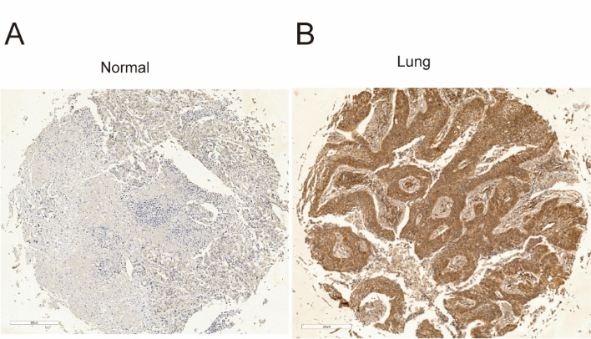
Figure S1. Immunohistochemical staining of LUSC tissue sections demonstrating YTHDF2. (A) The corresponding normal lung tissue specimen with low expression of YTHDF2. (B) Lung squamous cell carcinoma specimen with high expression of YTHDF2.

