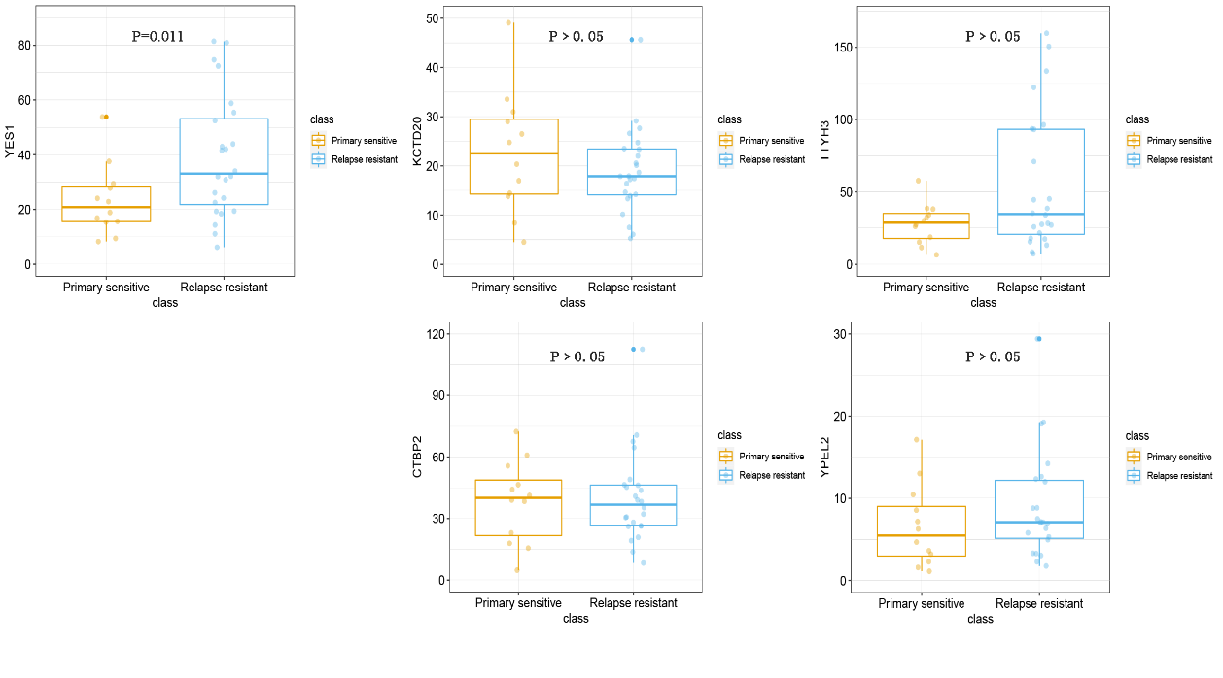
Figure S1. The expression levels of YES1, KCTD20,TTYH3,CTBP2 and YPEL2 between primary ovarian cancer and recurrent ovarian cancer groups from the RNA sequencing data of ICGC dataset analysis.
Among the 5 potential genes, only the YES1 expression level was increase in the relapse group compared with the primary sensitive group.
Figure S2. The interference efficiency of five YES1 siRNAs with different targeting sequences.
The siRNA2 sequence showed highest interference efficiency.

si1 | GTCATTATTTCCTCTTATC
si2 | ACCACGAAAGTAGCAATCA
si3 | GCAAGGTTAATTGAAGACA
si4 | AGACTCAAGGTCTAGCAAA
si5 | GTGACAATGTGAAACACTA
NC ATGCGGCCTATGCGTTGAG
Table 1. Interfering RNA (siRNA) sequences for YES1.

