Supplemental Information

Targeted blocking of CCR2 and CXCR2 improves the efficacy of transarterial chemoembolization of hepatocarcinoma

Zhiqiang Tian1, 4, *, Xiaojuan Hou1, 2, *, Wenting Liu1, 2, *, Changchun Shao1, 2, Lu Gao1,

2, Jinghua Jiang1, 2, Li Zhang3, #, Zhipeng Han1, 2, #, Lixin Wei1, 2, #

Supplemental Figures and Tables

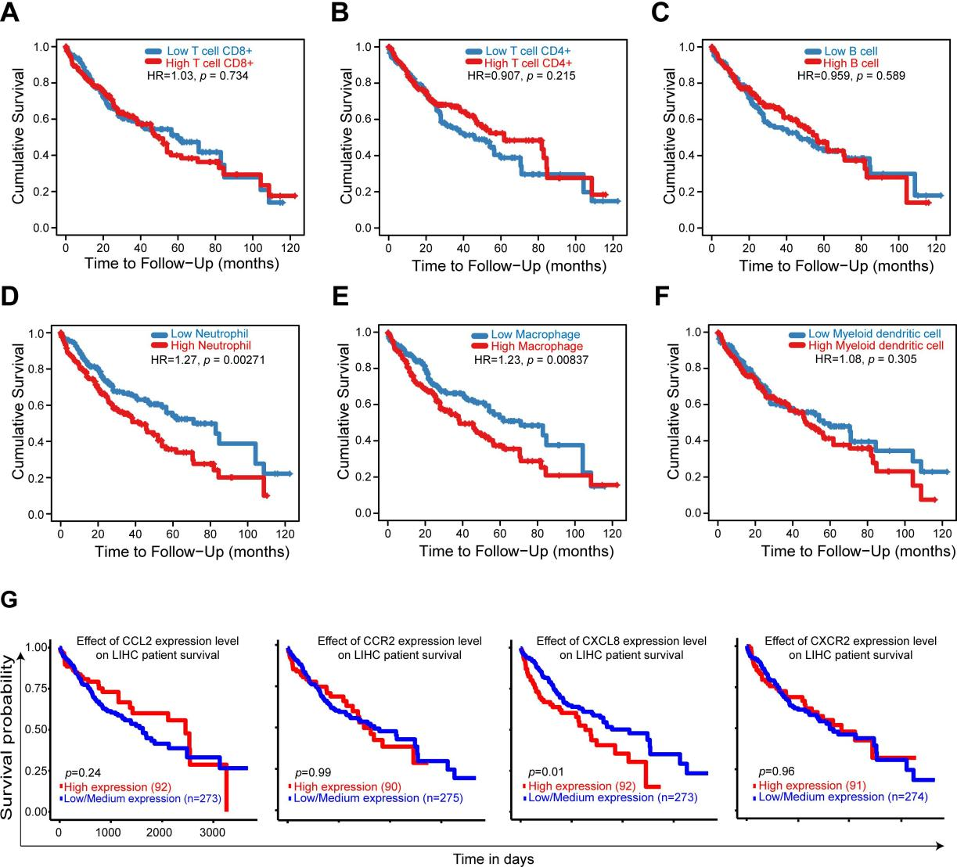

Supplementary Figure 1: Neutrophil and macrophage infiltration and CXCL8
expression are associated with poor prognosis. （A-F）TIMER2.0 is a comprehensive database for systematical analysis of the abundances of different immune infiltrates across 32 cancer types from TCGA. We explored the correlation between six immune subsets (CD8+ T cells, CD4+ T cells, B cells, Neutrphils, Macrophages and Dendritic cells) and survival rate of HCC patients. The Kaplan- Meier plots were drawn with TIMER2.0 for immune infiltrates and HCC to visualize the survival differences. Immune cells infiltrate levels are divided into low- and high- level groups by the split percentage of patients 50%. The hazard ratio (HR) for the Cox model and the log-rank p-value for Kaplan–Meier curves are shown. (G) The expression levels of CCL2, CCR2, CXCL8 and CXCR2 in HCC tissues were explored with RNA sequencing data from the TCGA liver cancer dataset, and analyzed by the UALCAN web server (http://ualcan.path.uab.edu/index.html). Kaplan-Meier OS curves are shown according to low and high expression of CCL2, CCR2, CXCL8, and CXCR2. p < 0.05 was considered as statistically significant.

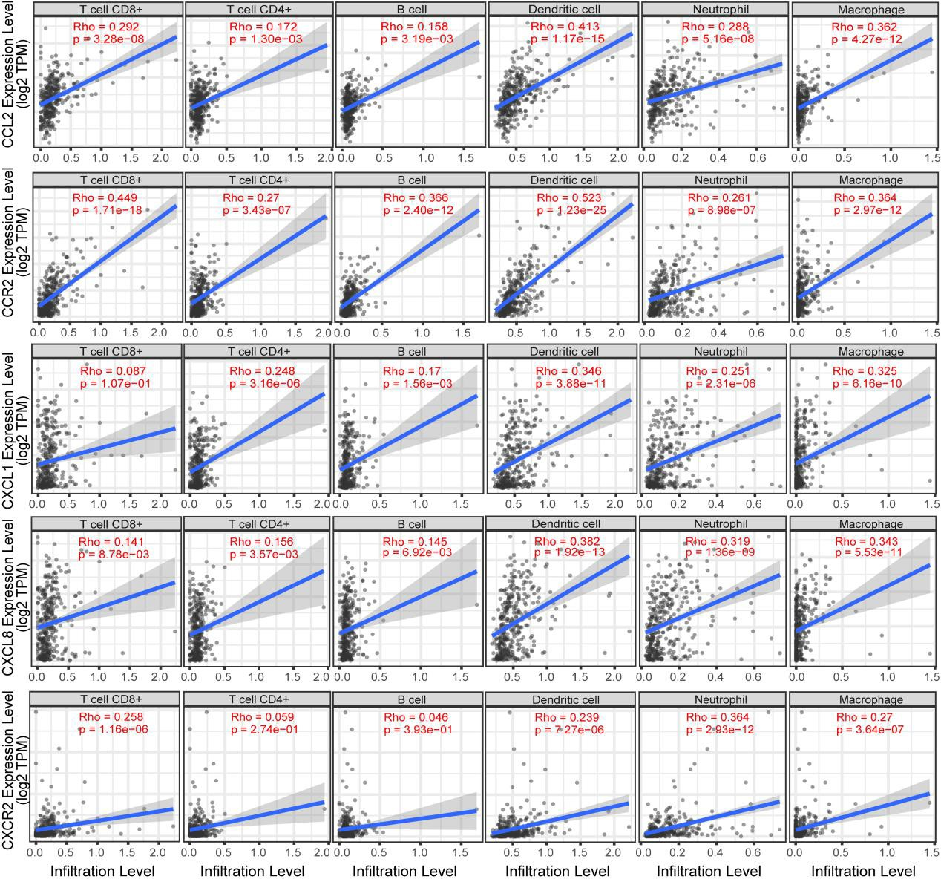
Supplementary Figure 2: Correlation of CCL2/CCR2 and CXCLs/CXCR2 genes’ expression with immune infiltration level in HCC. The correlation between genes expression of CCL2/CCR2 and CXCLs/CXCR2 and immune infiltrates were evaluated via the TIMER 2.0 web server in the TCGA liver cancer cohort. TIMER2.0 is freely available at http://timer.cistrome.org. Scatter plots show the relationship between gene (CCL2, CCR2, CXCL1, CXCL8, and CXCR2) expression level and six infiltrating immune cells (CD8+ T cells, CD4+ T cells, B cells, dendritic cells, neutrophils, and macrophages) estimation value by TIMER algorithm based on RNA-Seq expression profiles data.

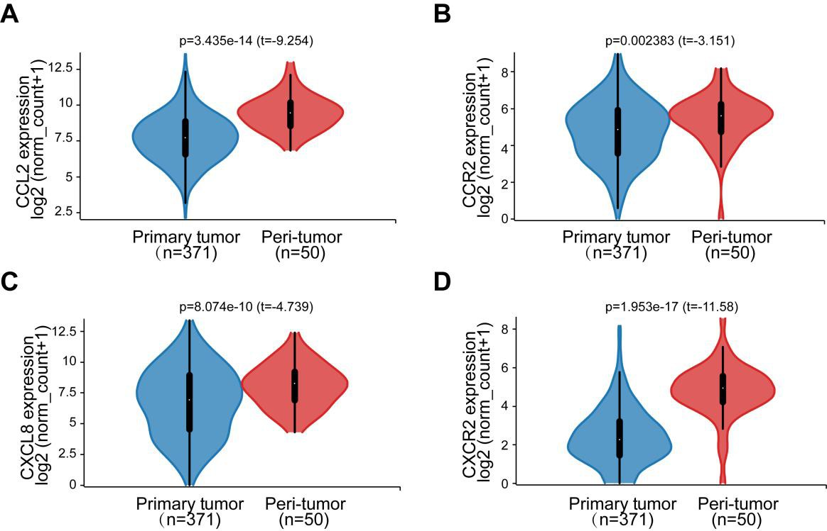

Supplementary Figure 3: Compare CCL2/CCR2 and CXCLs/CXCR2 genes’ expression of tumor and adjacent normal tissues in HCC. The UCSC Xena browser (https://xenabrowser.net) was utilized to obtain the corresponding violin plots of the mRNA expression levels of CCL2/CCR2 and CXCL8/CXCR2 between tumor and adjacent normal tissues of TCGA liver cancer database. (A) Different expression of CCL2 between HCC and adjacent normal tissues (p = 3.435e-14). (B) Different expression of CCR2 between HCC and adjacent normal tissues (p = 0.002). (C) Different expression of CXCL8 between HCC and adjacent normal tissues (p = 0.000008). (D) Different expression of CXCR2 between HCC and adjacent normal tissues (p = 1.953e-17). Primary tumor (n=371), adjacent normal tissue(n=50). Welch's t test, p value <0.05.

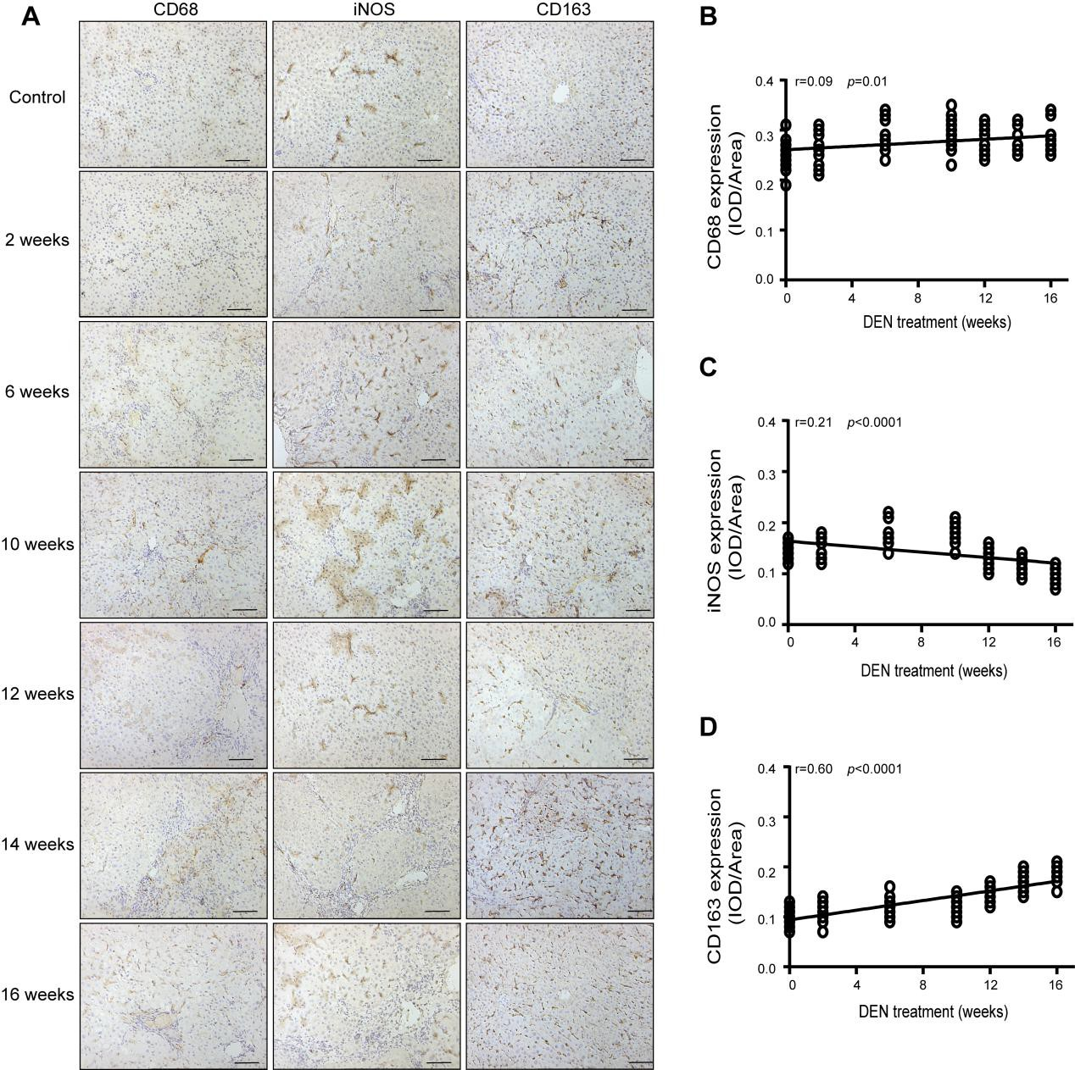

Supplementary Figure 4: Macrophage phenotypic switched correlated with hepatocarcinogenesis progression in primary rat HCC model. Sprague Dawley rats were treated with DEN. The rats were sacrificed to observe the development of HCC. To understand the phenotypes of infiltrated macrophages in rat hepatocarcinogenesis progression, the expression of CD68 (a general macrophage marker), iNOS (a surface marker for M1 macrophage phenotype), and CD163 (a surface marker for M2 macrophage phenotype) were detected by immunohistochemical. The stained sections were evaluated by IOD, and then the correlation of the gene expression level and DEN treatment times was analyzed by the

Pearson’s correlation. Pearson’s correlation analysis provided correlation coefficient

(r) and p-value. (A) Representative immunohistochemical images of CD68, iNOS, and CD163 staining in rat liver tissue of the indicated groups were shown. (B) Pearson's correlation analysis between CD68 and DEN treatment times (r = 0.09, p = 0.01). (C) Pearson's correlation analysis between iNOS and DEN treatment times (r = 0.21, p < 0.0001). (D) Pearson's correlation analysis between CD163 and DEN treatment times (r = 0.60, p < 0.0001).

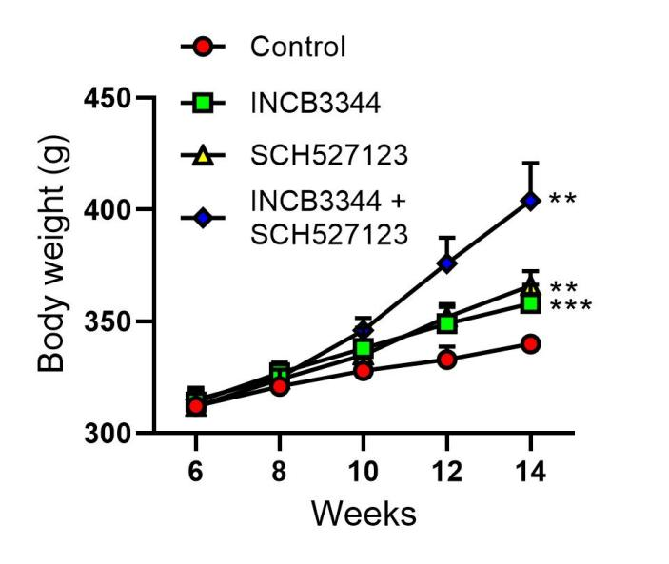

Supplementary Figure 5: Intraperitoneal administration of CCR2 and CXCR2 antagonists prevents hepatocarcinogenesis in the primary HCC model. After 8 weeks of diethylnitrosamine (DEN) treatment, Sprague Dawley rats were intraperitoneally injected with the CCR2 antagonist INCB3344 (60 μg/g body weight) in 200 μl saline, the CXCR2 antagonist SCH527123 (10 μg/g body weight) in 200 μl saline, INCB3344 (60 μg/g) + SCH527123 (10 μg/g) in 200 μl saline, or 200 μl of blank saline. Injections were continued twice every week for 6 weeks. After 14 weeks, the rats were sacrificed to observe the development of HCC. The body weight of the rats was recorded. Data are presented as mean ± SD. **p < 0.01, ***p < 0.001.

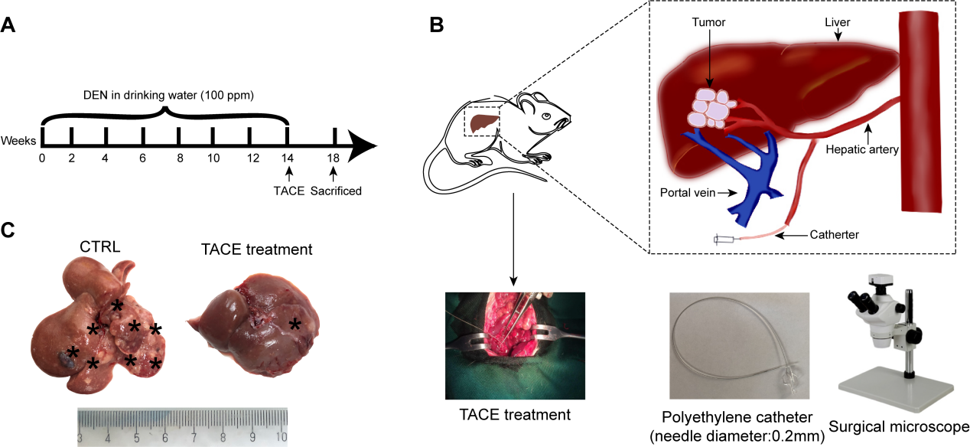

Supplementary Figure 6: TACE in primary rat HCC model. (A) Sprague Dawley rats with DEN-induced HCC were used to simulate human liver cancer. TACE procedure was performed in rat after 14 weeks DEN treatment. (B) TACE procedure was modified in the primary rat HCC model. Briefly, a polyethylene catheter (PE-10) with a 0.6-mm outside diameter connected to one end of a needle (inner diameter: 0.2mm) was used for catheterization under laparotomy. After exposure of the liver tumor, the needle was inserted retrogradely into the gastroduodenal artery by using a binocular operative microscope. The mentioned agents were injected through the catheter to the hepatic artery. The hepatic artery was then ligated. (C) Representative images of rat livers of the control and TACE treatment group, the typical tumor nodes were shown by the asterisks.

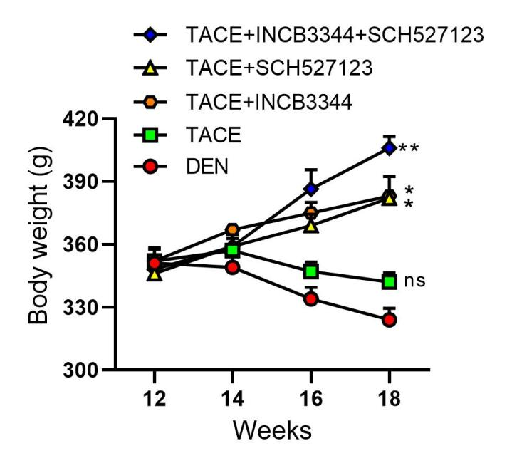

Supplementary Figure 7: Blockade of CCL2/CCR2 and CXCL1/CXCR2 enhances the antitumor effect of TACE in the HCC model. Sprague Dawley rats were treated with diethylnitrosamine (DEN) for 14 weeks, then subjected to the modified TACE procedure. The chemotherapeutic drug cisplatin (3 mg/kg body weight) was administered to the TACE-treated rats with or without the CCR2 antagonist INCB3344 (60 μg/g body weight) and the CXCR2 antagonist SCH527123 (10 μg/g body weight). Control animals received the TACE procedure and administered 0.5ml normal saline. The body weight of the rats was recorded. Data are presented as mean ± SD. ns, not statistically significant, *p < 0.05, **p < 0.01.

Supplementary Table 1. HCC-associated chemokine families and their functions in immune infiltrates

HCC‑associated chemokine receptors | HCC‑associated chemokines | Functions in immune infiltrates
CCR1 | CCL3, CCL5, CCL14, CCL23 | T cells, Monocytes
CCR2 | CCL2 | Macrophages
CCR3 | CCL24 | Eosinophils
CCR4 | CCL17, CCL22 | T cells, Monocytes
CCR5 | CCL4, CCL5 | Macrophages, T cells
CCR6 | CCL20 | Dendritic cells, T cells CD4+
CCR7 | CCL19 | T cells
CCR8 | CCL1 | T cells
CCR9 | CCL25 | T cells
CCR10 | CCL27, CCL28 | B cells
CXCR1 | CXCL6, CXCL8 | Neutrophils
CXCR2 | CXCL1, CXCL2, CXCL3, CXCL5, CXCL8 | Neutrophils
CXCR3 | CXCL9, CXCL10, CXCL11 | T cells
CXCR4, CXCR7 | CXCL12 | B cells
CXCR5 | CXCL13 | B cells
CXCR6 | CXCL16 | T cells
XCR1 | XCL1, XCL2 | Tregs
CX3CR1 | CX3CL1 | Natural killer cells

Supplementary Table 2. The relationship between HCC-associated chemokine expression and the infiltrate estimation value for CD8+ T cells in the TCGA LIHC dataset

HCC‑associated chemokines | infiltrates estimation value | rho | p | adjustment p
CCR1 | T cell CD8+_TIMER | 0.494 | 1.20E-22 | 1.60E-21
CCL3 | T cell CD8+_TIMER | 0.419 | 4.33E-16 | 4.12E-15
CCL5 | T cell CD8+_TIMER | 0.578 | 4.44E-32 | 1.54E-31
CCL14 | T cell CD8+_TIMER | 0.048 | 0.379 | 0.569
CCL23 | T cell CD8+_TIMER | 0.250 | 2.59E-06 | 1.30E-05
CCR2 | T cell CD8+_TIMER | 0.449 | 1.71E-18 | 6.69E-18
CCL2 | T cell CD8+_TIMER | 0.292 | 3.28E-08 | 2.43E-07
CCR3 | T cell CD8+_TIMER | 0.152 | 0.005 | 0.013
CCL24 | T cell CD8+_TIMER | 0.217 | 4.74E-05 | 0.001
CCR4 | T cell CD8+_TIMER | 0.400 | 1.09E-14 | 5.01E-14
CCL17 | T cell CD8+_TIMER | 0.212 | 7.14E-05 | 0.0003
CCL22 | T cell CD8+_TIMER | 0.268 | 4.33E-07 | 1.77E-06
CCR5 | T cell CD8+_TIMER | 0.542 | 8.80E-28 | 3.45E-27
CCL4 | T cell CD8+_TIMER | 0.589 | 1.36E-33 | 8.91E-33
CCR6 | T cell CD8+_TIMER | 0.026 | 0.624 | 0.710
CCL20 | T cell CD8+_TIMER | 0.001 | 0.988 | 0.995
CCR7 | T cell CD8+_TIMER | 0.403 | 7.09E-15 | 2.55E-14
CCL19 | T cell CD8+_TIMER | 0.255 | 1.58E-06 | 3.89E-06
CCR8 | T cell CD8+_TIMER | 0.388 | 7.15E-14 | 3.67E-13
CCL1 | T cell CD8+_TIMER | 0.034 | 0.532 | 0.665
CCR9 | T cell CD8+_TIMER | 0.196 | 0.0003 | 0.001
CCL25 | T cell CD8+_TIMER | 0.065 | 0.228 | 0.324
CCR10 | T cell CD8+_TIMER | 0.091 | 0.092 | 0.226
CCL27 | T cell CD8+_TIMER | 0.038 | 0.479 | 0.834
CCL28 | T cell CD8+_TIMER | 0.168 | 0.002 | 0.016
CXCR1 | T cell CD8+_TIMER | 0.145 | 0.007 | 0.035
CXCL6 | T cell CD8+_TIMER | 0.091 | 0.090 | 0.215
CXCR2 | T cell CD8+_TIMER | 0.258 | 1.16E-06 | 2.32E-05
CXCL1 | T cell CD8+_TIMER | 0.087 | 0.107 | 0.247
CXCL2 | T cell CD8+_TIMER | 0.083 | 0.122 | 0.339
CXCL3 | T cell CD8+_TIMER | 0.162 | 0.003 | 0.019
CXCL5 | T cell CD8+_TIMER | 0.038 | 0.484 | 0.686
CXCL8 | T cell CD8+_TIMER | 0.141 | 0.009 | 0.032
CXCR3 | T cell CD8+_TIMER | 0.446 | 2.88E-18 | 7.16E-18
CXCL9 | T cell CD8+_TIMER | 0.505 | 1.09E-23 | 3.90E-23
CXCL10 | T cell CD8+_TIMER | 0.466 | 5.79E-20 | 2.27E-19
CXCL11 | T cell CD8+_TIMER | 0.496 | 8.94E-23 | 4.70E-22
CXCR4 | T cell CD8+_TIMER | 0.416 | 7.53E-16 | 4.18E-15
CXCR7 | T cell CD8+_TIMER | 0.113 | 0.036 | 0.091
CXCL12 | T cell CD8+_TIMER | 0.195 | 0.0003 | 0.001

CXCR5 | T cell CD8+_TIMER | 0.286 | 6.18E-08 | 1.52E-07
CXCL13 | T cell CD8+_TIMER | 0.258 | 1.15E-06 | 2.19E-06
CXCR6 | T cell CD8+_TIMER | 0.572 | 2.01E-31 | 6.70E-31
CXCL16 | T cell CD8+_TIMER | 0.107 | 0.047 | 0.088
XCR1 | T cell CD8+_TIMER | 0.314 | 2.48E-09 | 1.13E-08
XCL1 | T cell CD8+_TIMER | 0.294 | 2.66E-08 | 7.19E-08
XCL2 | T cell CD8+_TIMER | 0.395 | 2.38E-14 | 5.74E-14
CX3CR1 | T cell CD8+_TIMER | 0.282 | 1.00E-07 | 9.79E-07
CX3CL1 | T cell CD8+_TIMER | 0.215 | 5.67E-05 | 0.0003
The bold text means positive correlation (Spearman’s p < 0.05, p > 0), the others mean not
significant (Spearman’s p > 0.05).

Supplementary Table 3. The relationship between HCC-associated chemokines expression and the infiltrate estimation value for CD4+ T cells in the TCGA LIHC dataset

HCC-associated chemokines | infiltrates estimation value | rho | p | adjustment p
CCR1 | T cell CD4+_TIMER | 0.086 | 0.111 | 0.171
CCL3 | T cell CD4+_TIMER | -0.105 | 0.052 | 0.122
CCL5 | T cell CD4+_TIMER | 0.131 | 0.015 | 0.029
CCL14 | T cell CD4+_TIMER | -0.046 | 0.398 | 0.559
CCL23 | T cell CD4+_TIMER | 0.065 | 0.230 | 0.399
CCR2 | T cell CD4+_TIMER | 0.270 | 3.43E-07 | 1.52E-06
CCL2 | T cell CD4+_TIMER | 0.172 | 0.001 | 0.006
CCR3 | T cell CD4+_TIMER | 0.082 | 0.127 | 0.281
CCL24 | T cell CD4+_TIMER | 0.048 | 0.374 | 0.591
CCR4 | T cell CD4+_TIMER | 0.234 | 1.08E-05 | 3.93E-05
CCL17 | T cell CD4+_TIMER | 0.270 | 3.42E-07 | 3.77E-06
CCL22 | T cell CD4+_TIMER | 0.371 | 1.09E-12 | 1.81E-11
CCR5 | T cell CD4+_TIMER | 0.295 | 2.38E-08 | 1.02E-07
CCL4 | T cell CD4+_TIMER | -0.044 | 0.418 | 0.494
CCR6 | T cell CD4+_TIMER | 0.479 | 3.42E-21 | 7.19E-20
CCL20 | T cell CD4+_TIMER | 0.284 | 8.26E-08 | 2.17E-06
CCR7 | T cell CD4+_TIMER | 0.256 | 1.43E-06 | 6.95E-06
CCL19 | T cell CD4+_TIMER | 0.256 | 1.41E-06 | 8.74E-06
CCR8 | T cell CD4+_TIMER | 0.234 | 1.09E-05 | 4.42E-05
CCL1 | T cell CD4+_TIMER | 0.234 | 1.09E-05 | 4.42E-05
CCR9 | T cell CD4+_TIMER | 0.185 | 0.001 | 0.003
CCL25 | T cell CD4+_TIMER | 0.079 | 0.145 | 0.294
CCR10 | T cell CD4+_TIMER | 0.287 | 5.78E-08 | 1.14E-06
CCL27 | T cell CD4+_TIMER | 0.044 | 0.418 | 0.670
CCL28 | T cell CD4+_TIMER | 0.227 | 2.04E-05 | 0.0003
CXCR1 | T cell CD4+_TIMER | 0.042 | 0.436 | 0.698
CXCL6 | T cell CD4+_TIMER | 0.165 | 0.002 | 0.018
CXCR2 | T cell CD4+_TIMER | 0.059 | 0.274 | 0.471
CXCL1 | T cell CD4+_TIMER | 0.248 | 3.16E-06 | 7.38E-05
CXCL2 | T cell CD4+_TIMER | -0.028 | 0.607 | 0.809

CXCL3 | T cell CD4+_TIMER | 0.246 | 3.82E-06 | 6.17E-05
CXCL5 | T cell CD4+_TIMER | 0.206 | 0.0001 | 0.001
CXCL8 | T cell CD4+_TIMER | 0.156 | 0.004 | 0.016
CXCR3 | T cell CD4+_TIMER | 0.279 | 1.45E-07 | 6.96E-07
CXCL9 | T cell CD4+_TIMER | 0.024 | 0.652 | 0.721
CXCL10 | T cell CD4+_TIMER | -0.044 | 0.415 | 0.501
CXCL11 | T cell CD4+_TIMER | -0.057 | 0.29 | 0.379
CXCR4 | T cell CD4+_TIMER | 0.328 | 4.20E-10 | 4.34E-09
CXCR7 | T cell CD4+_TIMER | 0.062 | 0.248 | 0.462
CXCL12 | T cell CD4+_TIMER | 0.282 | 1.00E-07 | 9.74E-07
CXCR5 | T cell CD4+_TIMER | 0.347 | 3.49E-11 | 3.54E-10
CXCL13 | T cell CD4+_TIMER | 0.072 | 0.179 | 0.274
CXCR6 | T cell CD4+_TIMER | 0.19 | 0.0004 | 0.001
CXCL16 | T cell CD4+_TIMER | 0.282 | 9.62E-08 | 1.29E-06
XCR1 | T cell CD4+_TIMER | 0.156 | 0.004 | 0.012
XCL1 | T cell CD4+_TIMER | 0.157 | 0.003 | 0.014
XCL2 | T cell CD4+_TIMER | 0.091 | 0.09 | 0.156
CX3CR1 | T cell CD4+_TIMER | 0.22 | 3.77E-05 | 0.0002
CX3CL1 | T cell CD4+_TIMER | 0.223 | 2.80E-05 | 0.0003
The bold text means positive correlation (Spearman’s p < 0.05, p > 0), the others mean not significant (Spearman’s p > 0.05).

Supplementary Table 4. The relationship between HCC-associated chemokine expression and the infiltrate estimation value for B cells in the TCGA LIHC dataset

HCC‑associated chemokines | infiltrates estimation value | rho | p | adjustment p
CCR1 | B cell_TIMER | 0.241 | 6.25E-06 | 3.23E-05
CCL3 | B cell_TIMER | 0.169 | 0.002 | 0.007
CCL5 | B cell_TIMER | 0.345 | 4.47E-11 | 2.48E-10
CCL14 | B cell_TIMER | -0.291# | 3.89E-08# | 3.53E-07#
CCL23 | B cell_TIMER | 0.002 | 0.969 | 0.988
CCR2 | B cell_TIMER | 0.366 | 2.40E-12 | 1.24E-11
CCL2 | B cell_TIMER | 0.158 | 0.003 | 0.012
CCR3 | B cell_TIMER | 0.171 | 0.001 | 0.009
CCL24 | B cell_TIMER | 0.127 | 0.019 | 0.079
CCR4 | B cell_TIMER | 0.305 | 7.64E-09 | 3.40E-08
CCL17 | B cell_TIMER | 0.192 | 0.0003 | 0.001
CCL22 | B cell_TIMER | 0.294 | 2.73E-08 | 1.49E-07
CCR5 | B cell_TIMER | 0.462 | 1.12E-19 | 1.12E-18
CCL4 | B cell_TIMER | 0.281 | 1.15E-07 | 6.66E-07
CCR6 | B cell_TIMER | 0.378 | 3.69E-13 | 2.05E-12
CCL20 | B cell_TIMER | 0.229 | 1.69E-05 | 0.0003
CCR7 | B cell_TIMER | 0.309 | 4.32E-09 | 1.42E-08
CCL19 | B cell_TIMER | 0.250 | 2.46E-06 | 6.57E-06
CCR8 | B cell_TIMER | 0.337 | 1.25E-10 | 9.01E-10
CCL1 | B cell_TIMER | 0.161 | 0.003 | 0.017
CCR9 | B cell_TIMER | 0.080 | 0.137 | 0.234
CCL25 | B cell_TIMER | 0.097 | 0.073 | 0.137
CCR10 | B cell_TIMER | 0.243 | 5.01E-06 | 4.49E-05
CCL27 | B cell_TIMER | 0.064 | 0.238 | 0.624
CCL28 | B cell_TIMER | 0.055 | 0.313 | 0.544
CXCR1 | B cell_TIMER | -0.043 | 0.422 | 0.689
CXCL6 | B cell_TIMER | 0.128 | 0.017 | 0.107
CXCR2 | B cell_TIMER | 0.046 | 0.393 | 0.646
CXCL1 | B cell_TIMER | 0.170 | 0.002 | 0.014
CXCL2 | B cell_TIMER | -0.009 | 0.861 | 0.959
CXCL3 | B cell_TIMER | 0.249 | 2.97E-06 | 8.92E-05
CXCL5 | B cell_TIMER | 0.161 | 0.003 | 0.025
CXCL8 | B cell_TIMER | 0.145 | 0.007 | 0.031
CXCR3 | B cell_TIMER | 0.423 | 2.11E-16 | 1.29E-15
CXCL9 | B cell_TIMER | 0.343 | 6.10E-11 | 3.94E-10
CXCL10 | B cell_TIMER | 0.250 | 2.69E-06 | 1.54E-05
CXCL11 | B cell_TIMER | 0.242 | 5.71E-06 | 3.64E-05
CXCR4 | B cell_TIMER | 0.478 | 4.41E-21 | 6.78E-20
CXCR7 | B cell_TIMER | -0.015 | 0.777 | 0.873
CXCL12 | B cell_TIMER | 0.135 | 0.012 | 0.036
CXCR5 | B cell_TIMER | 0.435 | 2.30E-17 | 1.00E-16
CXCL13 | B cell_TIMER | 0.252 | 2.10E-06 | 5.58E-06
CXCR6 | B cell_TIMER | 0.428 | 8.97E-17 | 6.65E-16
CXCL16 | B cell_TIMER | 0.348 | 2.93E-11 | 7.32E-10
XCR1 | B cell_TIMER | 0.186 | 0.001 | 0.002
XCL1 | B cell_TIMER | 0.260 | 9.83E-07 | 5.96E-06
XCL2 | B cell_TIMER | 0.310 | 3.86E-09 | 2.03E-08
CX3CR1 | B cell_TIMER | 0.190 | 0.0004 | 0.002
CX3CL1 | B cell_TIMER | 0.244 | 4.40E-06 | 4.98E-05
The bold text means positive correlation (Spearman’s p < 0.05, p > 0), the symbol # means negative correlation (Spearman’s p < 0.05, p < 0), the others mean not significant (Spearman’s p > 0.05).

Supplementary Table 5. The relationship between HCC-associated chemokine expression and the infiltrate estimation value for neutrophils in the TCGA LIHC dataset

HCC‑associated chemokines | infiltrates estimation  value | rho | p | adjustment p
CCR1 | Neutrophil_TIMER | 0.376 | 5.36E-13 | 4.13E-12
CCL3 | Neutrophil_TIMER | 0.233 | 1.18E-05 | 7.85E-05
CCL5 | Neutrophil_TIMER | 0.239 | 7.46E-06 | 5.09E-05
CCL14 | Neutrophil_TIMER | -0.198# | 0.0002# | 0.002#
CCL23 | Neutrophil_TIMER | 0.069 | 0.202 | 0.413
CCR2 | Neutrophil_TIMER | 0.261 | 8.98E-07 | 5.65E-06
CCL2 | Neutrophil_TIMER | 0.288 | 5.16E-08 | 3.85E-07
CCR3 | Neutrophil_TIMER | 0.338 | 1.08E-10 | 1.07E-09
CCL24 | Neutrophil_TIMER | 0.088 | 0.102 | 0.219
CCR4 | Neutrophil_TIMER | 0.328 | 4.40E-10 | 3.63E-09
CCL17 | Neutrophil_TIMER | 0.118 | 0.029 | 0.131
CCL22 | Neutrophil_TIMER | 0.237 | 8.48E-06 | 5.96E-05
CCR5 | Neutrophil_TIMER | 0.299 | 1.43E-08 | 1.07E-07
CCL4 | Neutrophil_TIMER | 0.308 | 5.16E-09 | 3.62E-08
CCR6 | Neutrophil_TIMER | 0.087 | 0.108 | 0.229
CCL20 | Neutrophil_TIMER | 0.118 | 0.029 | 0.055
CCR7 | Neutrophil_TIMER | 0.266 | 5.53E-07 | 4.89E-06
CCL19 | Neutrophil_TIMER | 0.116 | 0.031 | 0.093
CCR8 | Neutrophil_TIMER | 0.312 | 3.24E-09 | 2.76E-08
CCL1 | Neutrophil_TIMER | 0.108 | 0.044 | 0.251
CCR9 | Neutrophil_TIMER | 0.181 | 0.001 | 0.006
CCL25 | Neutrophil_TIMER | -0.178# | 0.001# | 0.007#
CCR10 | Neutrophil_TIMER | 0.261 | 9.17E-07 | 4.38E-05
CCL27 | Neutrophil_TIMER | 0.017 | 0.755 | 0.980
CCL28 | Neutrophil_TIMER | 0.178 | 0.001 | 0.006
CXCR1 | Neutrophil_TIMER | 0.249 | 2.91E-06 | 8.18E-06
CXCL6 | Neutrophil_TIMER | 0.203 | 0.0001 | 0.001
CXCR2 | Neutrophil_TIMER | 0.364 | 2.93E-12 | 1.31E-11
CXCL1 | Neutrophil_TIMER | 0.251 | 2.31E-06 | 1.12E-05
CXCL2 | Neutrophil_TIMER | -0.018 | 0.737 | 0.800
CXCL3 | Neutrophil_TIMER | 0.293 | 2.79E-08 | 3.33E-07
CXCL5 | Neutrophil_TIMER | 0.216 | 5.32E-05 | 0.0002
CXCL8 | Neutrophil_TIMER | 0.319 | 1.36E-09 | 5.89E-09
CXCR3 | Neutrophil_TIMER | 0.187 | 0.0005 | 0.002
CXCL9 | Neutrophil_TIMER | 0.318 | 1.49E-09 | 1.43E-08
CXCL10 | Neutrophil_TIMER | 0.213 | 6.94E-05 | 0.0004
CXCL11 | Neutrophil_TIMER | 0.265 | 5.84E-07 | 3.87E-06
CXCR4 | Neutrophil_TIMER | 0.400 | 1.08E-14 | 1.52E-13
CXCR7 | Neutrophil_TIMER | 0.323 | 7.71E-10 | 2.01E-08
CXCL12 | Neutrophil_TIMER | 0.182 | 0.001 | 0.004
CXCR5 | Neutrophil_TIMER | 0.218 | 4.52E-05 | 0.0003
CXCL13 | Neutrophil_TIMER | 0.179 | 0.001 | 0.004
CXCR6 | Neutrophil_TIMER | 0.208 | 9.62E-05 | 0.001
CXCL16 | Neutrophil_TIMER | 0.099 | 0.066 | 0.122
XCR1 | Neutrophil_TIMER | 0.232 | 1.36E-05 | 7.58E-05
XCL1 | Neutrophil_TIMER | 0.130 | 0.015 | 0.061
XCL2 | Neutrophil_TIMER | 0.097 | 0.073 | 0.170
CX3CR1 | Neutrophil_TIMER | 0.290 | 4.25E-08 | 4.07E-07
CX3CL1 | Neutrophil_TIMER | 0.133 | 0.013 | 0.041
The bold text means positive correlation (Spearman’s p < 0.05, p > 0), the symbol # means negative correlation (Spearman’s p < 0.05, p < 0), the others mean not significant (Spearman’s p > 0.05).

Supplementary Table 6. The relationship between HCC-associated chemokine expression and infiltrate estimation value for macrophages in the TCGA LIHC dataset

HCC‑associated chemokines | infiltrates estimation  value | rho | p | adjustment p
CCR1 | Macrophage_TIMER | 0.529 | 2.81E-26 | 1.03E-25
CCL3 | Macrophage_TIMER | 0.227 | 2.09E-05 | 3.94E-05
CCL5 | Macrophage_TIMER | 0.299 | 1.56E-08 | 3.25E-08
CCL14 | Macrophage_TIMER | -0.133# | 0.013# | 0.033#
CCL23 | Macrophage_TIMER | 0.176 | 0.001 | 0.002
CCR2 | Macrophage_TIMER | 0.364 | 2.97E-12 | 8.83E-12
CCL2 | Macrophage_TIMER | 0.362 | 4.27E-12 | 1.76E-11
CCR3 | Macrophage_TIMER | 0.276 | 1.80E-07 | 9.83E-07
CCL24 | Macrophage_TIMER | 0.072 | 0.181 | 0.275
CCR4 | Macrophage_TIMER | 0.375 | 6.18E-13 | 2.69E-12
CCL17 | Macrophage_TIMER | 0.239 | 7.15E-06 | 3.73E-05
CCL22 | Macrophage_TIMER | 0.325 | 6.27E-10 | 2.58E-09
CCR5 | Macrophage_TIMER | 0.450 | 1.29E-18 | 3.57E-18
CCL4 | Macrophage_TIMER | 0.346 | 3.85E-11 | 9.48E-11
CCR6 | Macrophage_TIMER | 0.294 | 2.67E-08 | 1.36E-07
CCL20 | Macrophage_TIMER | 0.221 | 3.38E-05 | 0.0001
CCR7 | Macrophage_TIMER | 0.222 | 3.14E-05 | 6.56E-05
CCL19 | Macrophage_TIMER | 0.121 | 0.024 | 0.041
CCR8 | Macrophage_TIMER | 0.370 | 1.19E-12 | 4.40E-12
CCL1 | Macrophage_TIMER | -0.023 | 0.669 | 0.775
CCR9 | Macrophage_TIMER | 0.132 | 0.014 | 0.039
CCL25 | Macrophage_TIMER | -0.020 | 0.710 | 0.817
CCR10 | Macrophage_TIMER | 0.299 | 1.56E-08 | 3.61E-07
CCL27 | Macrophage_TIMER | 0.093 | 0.085 | 0.357
CCL28 | Macrophage_TIMER | 0.411 | 1.78E-15 | 2.67E-13
CXCR1 | Macrophage_TIMER | 0.166 | 0.002 | 0.009
CXCL6 | Macrophage_TIMER | 0.342 | 7.12E-11 | 3.88E-09
CXCR2 | Macrophage_TIMER | 0.270 | 3.64E-07 | 2.01E-06
CXCL1 | Macrophage_TIMER | 0.325 | 6.16E-10 | 7.25E-09
CXCL2 | Macrophage_TIMER | 0.026 | 0.636 | 0.735
CXCL3 | Macrophage_TIMER | 0.345 | 4.47E-11 | 6.54E-10
CXCL5 | Macrophage_TIMER | 0.289 | 4.88E-08 | 5.05E-07
CXCL8 | Macrophage_TIMER | 0.343 | 5.53E-11 | 6.56E-10
CXCR3 | Macrophage_TIMER | 0.316 | 1.99E-09 | 4.88E-09
CXCL9 | Macrophage_TIMER | 0.209 | 9.02E-05 | 0.0002
CXCL10 | Macrophage_TIMER | 0.143 | 0.008 | 0.011
CXCL11 | Macrophage_TIMER | 0.190 | 0.000 | 0.001
CXCR4 | Macrophage_TIMER | 0.544 | 6.25E-28 | 9.15E-27
CXCR7 | Macrophage_TIMER | 0.208 | 0.0001 | 0.0006
CXCL12 | Macrophage_TIMER | 0.256 | 1.39E-06 | 5.22E-06
CXCR5 | Macrophage_TIMER | 0.252 | 2.13E-06 | 6.99E-06
CXCL13 | Macrophage_TIMER | 0.115 | 0.032 | 0.048
CXCR6 | Macrophage_TIMER | 0.332 | 2.65E-10 | 5.97E-10
CXCL16 | Macrophage_TIMER | 0.274 | 2.32E-07 | 6.29E-07
XCR1 | Macrophage_TIMER | 0.214 | 6.31E-05 | 0.0002
XCL1 | Macrophage_TIMER | 0.255 | 1.57E-06 | 5.45E-06
XCL2 | Macrophage_TIMER | 0.225 | 2.38E-05 | 4.83E-05
CX3CR1 | Macrophage_TIMER | 0.336 | 1.58E-10 | 9.45E-10
CX3CL1 | Macrophage_TIMER | 0.254 | 1.82E-06 | 1.27E-05
The bold text means positive correlation (Spearman’s p < 0.05, p > 0), the symbol # means negative correlation (Spearman’s p < 0.05, p < 0), the others mean not significant (Spearman’s p > 0.05).

Supplementary Table 7. The relationship between HCC-associated chemokine expression and infiltrate estimation value for dendritic cells in the TCGA LIHC dataset
chemokines
CCR1 | Myeloid dendritic | 0.596 | 1.27E-34 | 1.36E-33
 | cell_TIMER
CCL3 | Myeloid dendritic | 0.435 | 2.28E-17 | 1.75E-16
 | cell_TIMER
CCL5 | Myeloid dendritic | 0.504 | 1.29E-23 | 6.75E-23
 | cell_TIMER
CCL14 | Myeloid dendritic | -0.363# | 3.44E-12# | 5.70E-11#
 | cell_TIMER
CCL23 | Myeloid dendritic | 0.119 | 0.028 | 0.052
 | cell_TIMER
CCR2 | Myeloid dendritic | 0.523 | 1.23E-25 | 7.44E-25
 | cell_TIMER
CCL2 | Myeloid dendritic | 0.413 | 1.17E-15 | 8.61E-15
 | cell_TIMER
CCR3 | Myeloid dendritic | 0.351 | 2.04E-11 | 2.08E-10
 | cell_TIMER
CCL24 | Myeloid dendritic | 0.218 | 4.56E-05 | 0.0003
 | cell_TIMER
CCR4 | Myeloid dendritic | 0.439 | 1.10E-17 | 5.82E-17
 | cell_TIMER
CCL17 | Myeloid dendritic | 0.300 | 1.25E-08 | 5.24E-08
 | cell_TIMER
CCL22 | Myeloid dendritic | 0.454 | 6.32E-19 | 3.35E-18
 | cell_TIMER
CCR5 | Myeloid dendritic | 0.670 | 3.29E-46 | 2.67E-45
 | cell_TIMER
CCL4 | Myeloid dendritic | 0.561 | 5.34E-30 | 4.34E-29
 | cell_TIMER
CCR6 | Myeloid dendritic | 0.410 | 2.17E-15 | 1.29E-14
 | cell_TIMER
CCL20 | Myeloid dendritic | 0.326 | 5.47E-10 | 7.51E-09
 | cell_TIMER
CCR7 | Myeloid dendritic | 0.419 | 4.41E-16 | 2.06E-15
 | cell_TIMER
CCL19 | Myeloid dendritic | 0.306 | 6.16E-09 | 2.08E-08
 | cell_TIMER
CCR8 | Myeloid dendritic | 0.550 | 1.11E-28 | 9.85E-28
 | cell_TIMER
CCL1 | Myeloid dendritic | 0.181 | 0.001 | 0.003
 | cell_TIMER
CCR9 | Myeloid dendritic | 0.141 | 0.009 | 0.028
 | cell_TIMER
CCL25 | Myeloid dendritic | -0.019 | 0.727 | 0.843
 | cell_TIMER
CCR10 | Myeloid dendritic | 0.407 | 3.57E-15 | 2.03E-13
 | cell_TIMER
CCL27 | Myeloid dendritic | 0.130 | 0.016 | 0.167
 | cell_TIMER
CCL28 | Myeloid dendritic | 0.281 | 1.06E-07 | 4.22E-06
 | cell_TIMER
CXCR1 | Myeloid dendritic | 0.114 | 0.034 | 0.110
 | cell_TIMER
CXCL6 | Myeloid dendritic | 0.309 | 4.32E-09 | 1.07E-07
 | cell_TIMER
CXCR2 | Myeloid dendritic | 0.239 | 7.27E-06 | 5.08E-05
 | cell_TIMER
CXCL1 | Myeloid dendritic | 0.346 | 3.88E-11 | 7.01E-10
 | cell_TIMER
CXCL2 | Myeloid dendritic | -0.001 | 0.980 | 0.997
 | cell_TIMER

HCC‑associated infiltrates estimation value rho p adjustment p

CXCL3 | Myeloid dendritic | 0.440 | 9.13E-18 | 6.06E-16
 | cell_TIMER
CXCL5 | Myeloid dendritic | 0.345 | 4.38E-11 | 9.38E-10
 | cell_TIMER
CXCL8 | Myeloid dendritic | 0.382 | 1.92E-13 | 5.10E-12
 | cell_TIMER
CXCR3 | Myeloid dendritic | 0.537 | 4.11E-27 | 2.55E-26
 | cell_TIMER
CXCL9 | Myeloid dendritic | 0.394 | 3.10E-14 | 1.18E-13
 | cell_TIMER
CXCL10 | Myeloid dendritic | 0.247 | 3.36E-06 | 8.35E-06
 | cell_TIMER
CXCL11 | Myeloid dendritic | 0.315 | 2.24E-09 | 9.02E-09
 | cell_TIMER
CXCR4 | Myeloid dendritic | 0.649 | 1.06E-42 | 4.67E-41
 | cell_TIMER
CXCR7 | Myeloid dendritic | 0.211 | 7.66E-05 | 0.001
 | cell_TIMER
CXCL12 | Myeloid dendritic | 0.315 | 2.28E-09 | 1.57E-08
 | cell_TIMER
CXCR5 | Myeloid dendritic | 0.469 | 2.78E-20 | 1.94E-19
 | cell_TIMER
CXCL13 | Myeloid dendritic | 0.287 | 5.89E-08 | 2.07E-07
 | cell_TIMER
CXCR6 | Myeloid dendritic | 0.530 | 2.38E-26 | 1.24E-25
 | cell_TIMER
CXCL16 | Myeloid dendritic | 0.306 | 6.74E-09 | 3.89E-08
 | cell_TIMER
XCR1 | Myeloid dendritic | 0.276 | 1.80E-07 | 8.86E-07
 | cell_TIMER
XCL1 | Myeloid dendritic | 0.429 | 7.48E-17 | 8.76E-16
 | cell_TIMER
XCL2 | Myeloid dendritic | 0.427 | 9.57E-17 | 5.60E-16
 | cell_TIMER
CX3CR1 | Myeloid dendritic | 0.377 | 4.17E-13 | 3.60E-12
 | cell_TIMER
CX3CL1 | Myeloid dendritic | 0.360 | 5.12E-12 | 8.31E-11
 | cell_TIMER
The bold text means positive correlation (Spearman’s p < 0.05, p > 0), the symbol # means negative correlation (Spearman’s p < 0.05, p < 0), the others mean not significant (Spearman’s p > 0.05).

Supplementary Table 8. The relationship between HCC-associated chemokine expression and immune infiltrate estimation values in the TCGA LIHC dataset

HCC‑associated
chemokines
T cell CD8+
T cell CD4+ B cell Neutrophi
l
Macrophag e
Myeloid dendritic cell

CCR1 | 0.494 | 0.086 | 0.241 | 0.376 | 0.529 | 0.596
CCL3 | 0.419 | -0.105 | 0.169 | 0.233 | 0.227 | 0.435
CCL5 | 0.578 | 0.131 | 0.345 | 0.239 | 0.299 | 0.504
CCL14 | 0.048 | -0.046 | -0.291# | -0.198# | -0.133# | -0.363#
CCL23 | 0.250 | 0.065 | 0.002 | 0.069 | 0.176 | 0.119
CCR2 | 0.449 | 0.270 | 0.366 | 0.261 | 0.364 | 0.523
CCL2 | 0.292 | 0.172 | 0.158 | 0.288 | 0.362 | 0.413
CCR3 | 0.152 | 0.082 | 0.171 | 0.338 | 0.276 | 0.351
CCL24 | 0.217 | 0.048 | 0.127 | 0.088 | 0.072 | 0.218
CCR4 | 0.400 | 0.234 | 0.305 | 0.328 | 0.375 | 0.439
CCL17 | 0.212 | 0.270 | 0.192 | 0.118 | 0.239 | 0.300
CCL22 | 0.268 | 0.371 | 0.294 | 0.237 | 0.325 | 0.454
CCR5 | 0.542 | 0.295 | 0.462 | 0.299 | 0.450 | 0.670
CCL4 | 0.589 | -0.044 | 0.281 | 0.308 | 0.346 | 0.561
CCR6 | 0.026 | 0.479 | 0.378 | 0.087 | 0.294 | 0.410
CCL20 | 0.001 | 0.284 | 0.229 | 0.118 | 0.221 | 0.326
CCR7 | 0.403 | 0.256 | 0.309 | 0.266 | 0.222 | 0.419
CCL19 | 0.255 | 0.256 | 0.250 | 0.116 | 0.121 | 0.306
CCR8 | 0.388 | 0.234 | 0.337 | 0.312 | 0.370 | 0.550
CCL1 | 0.034 | 0.234 | 0.161 | 0.108 | -0.023 | 0.181
CCR9 | 0.196 | 0.185 | 0.080 | 0.181 | 0.132 | 0.141
CCL25 | 0.065 | 0.079 | 0.097 | -0.178# | -0.020 | -0.019
CCR10 | 0.091 | 0.287 | 0.243 | 0.261 | 0.299 | 0.407
CCL27 | 0.038 | 0.044 | 0.064 | 0.017 | 0.093 | 0.130
CCL28 | 0.168 | 0.227 | 0.055 | 0.178 | 0.411 | 0.281
CXCR1 | 0.145 | 0.042 | -0.043 | 0.249 | 0.166 | 0.114
CXCL6 | 0.091 | 0.165 | 0.128 | 0.203 | 0.342 | 0.309
CXCR2 | 0.258 | 0.059 | 0.046 | 0.364 | 0.270 | 0.239
CXCL1 | 0.087 | 0.248 | 0.170 | 0.251 | 0.325 | 0.346
CXCL2 | 0.083 | -0.028 | -0.009 | -0.018 | 0.026 | -0.001
CXCL3 | 0.162 | 0.246 | 0.249 | 0.293 | 0.345 | 0.440
CXCL5 | 0.038 | 0.206 | 0.161 | 0.216 | 0.289 | 0.345
CXCL8 | 0.141 | 0.156 | 0.145 | 0.319 | 0.343 | 0.382
CXCR3 | 0.446 | 0.279 | 0.423 | 0.187 | 0.316 | 0.537
CXCL9 | 0.505 | 0.024 | 0.343 | 0.318 | 0.209 | 0.394
CXCL10 | 0.466 | -0.044 | 0.250 | 0.213 | 0.143 | 0.247
CXCL11 | 0.496 | -0.057 | 0.242 | 0.265 | 0.190 | 0.315
CXCR4 | 0.416 | 0.328 | 0.478 | 0.400 | 0.544 | 0.649
CXCR7 | 0.113 | 0.062 | -0.015 | 0.323 | 0.208 | 0.211
CXCL12 | 0.195 | 0.282 | 0.135 | 0.182 | 0.256 | 0.315
CXCR5 | 0.286 | 0.347 | 0.435 | 0.218 | 0.252 | 0.469
CXCL13 | 0.258 | 0.072 | 0.252 | 0.179 | 0.115 | 0.287
CXCR6 | 0.572 | 0.190 | 0.428 | 0.208 | 0.332 | 0.530
CXCL16 | 0.107 | 0.282 | 0.348 | 0.099 | 0.274 | 0.306
XCR1 | 0.314 | 0.156 | 0.186 | 0.232 | 0.214 | 0.276
XCL1 | 0.294 | 0.157 | 0.260 | 0.130 | 0.255 | 0.429
XCL2 | 0.395 | 0.091 | 0.310 | 0.097 | 0.225 | 0.427
CX3CR1 | 0.282 | 0.220 | 0.190 | 0.290 | 0.336 | 0.377
CX3CL1 | 0.215 | 0.223 | 0.244 | 0.133 | 0.254 | 0.360
The bold text means positive correlation (Spearman’s p < 0.05, p > 0), the symbol # means negative correlation (Spearman’s p < 0.05, p < 0), the others mean not significant (Spearman’s p > 0.05).

