Additional Material

Additional Figures and Tables

Additional Figures

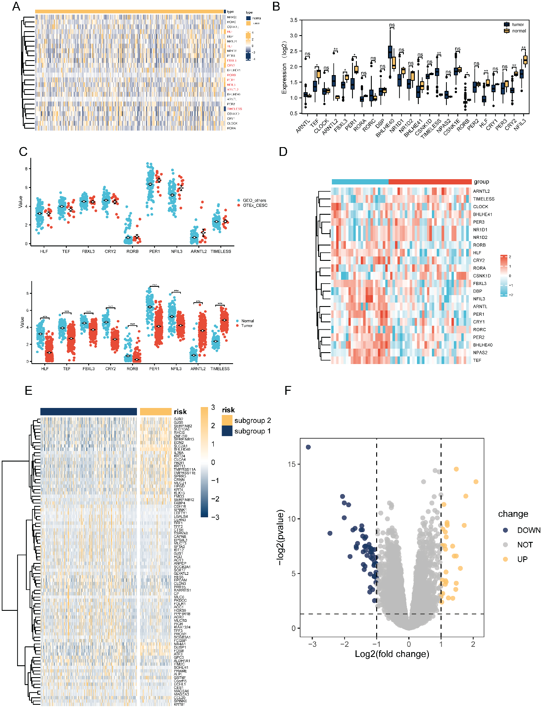
Additional Figure 1. Differential gene analysis of circadian subgroups. (A) heat map of differential expression of circadian rhythm genes in normal group (13) and tumor group (304) ; (B) box plot of differential expression of circadian rhythm genes in normal group (13) and tumor group (304); (C) is the dotplot of expression of selected circadian genes between GEO-collected normal cervical tissues (101) and GTEx normal cervical tissues (13) (upper), and integration analysis of normal cervical tissues (114) compared with TCGA-CESC tumor tissues (304) (down); (D) is the heatmap of circadian candidate genes from a validation dataset GSE9750 (normal=23,tumor=33); (E). Differential gene heatmap between high and low-risk groups; (F). Differential gene volcano map between high and low-risk groups.

Additional Figure 2. Prognostic value of KRT24 in cases of OS or PFS. (A) is time-dependent AUC analysis of KRT24 in OS, with each broken line represents the change of the AUC value at the indicated time point; (B) is time-dependent AUC analysis of KRT24 in PFS; (C) is time-dependent ROC analysis of KRT24 for 1, 3 and 5 years’ PFS.

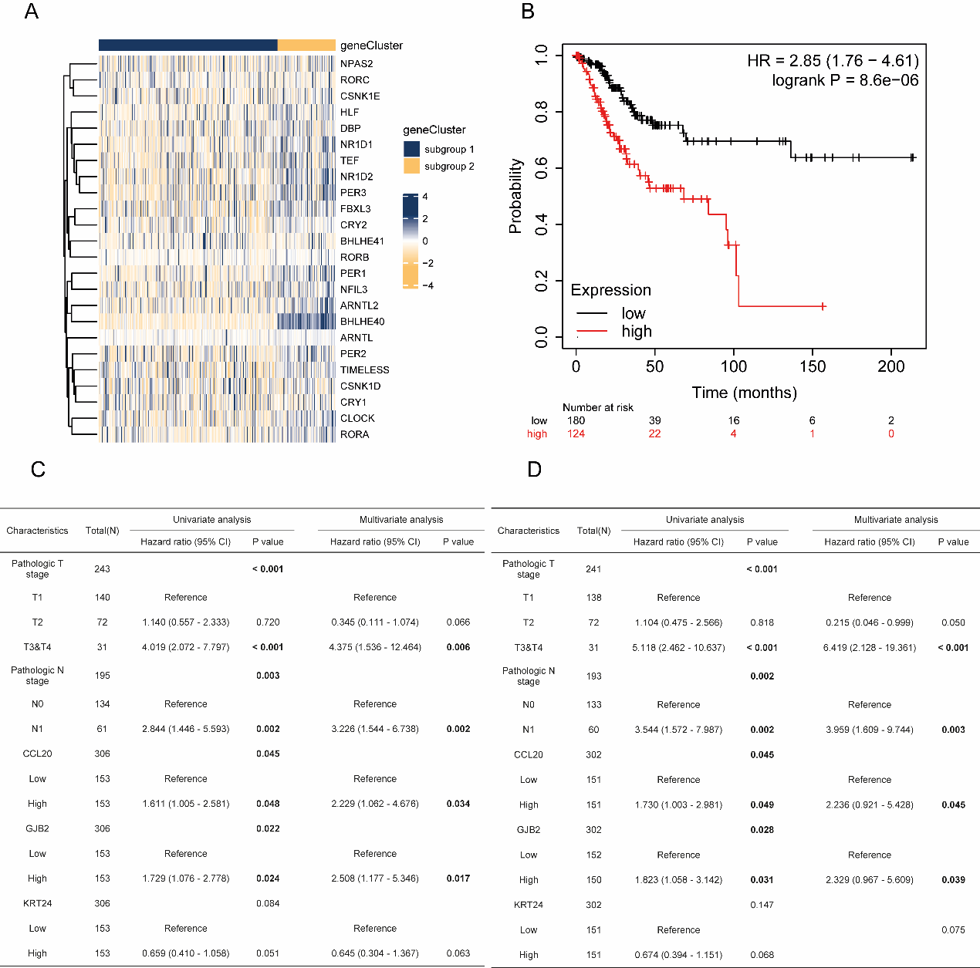
Additional Figure 3. (A) Circadian gene expression between high and low risk groups; (B) is the survival plot of patient separated by the risk model in TCGA-CESC; (C-D) are multivariate cox analysis of OS and DSS (disease free survival) of patients in TCGA-CESC by TNM stages, CCL20, KRT24 and GNB2.

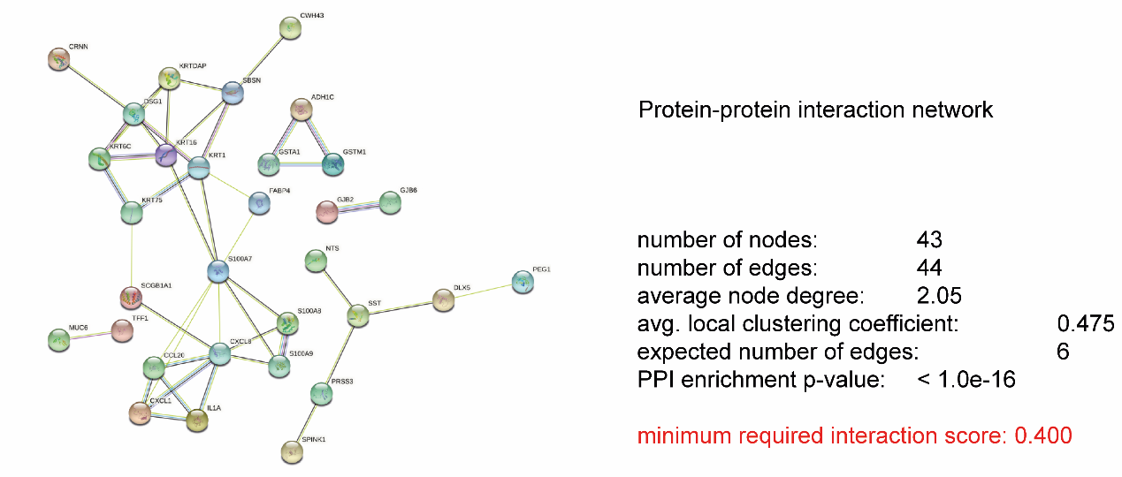
Additional Figure 4. PPI network of core genes derived from transcriptome DEG analysis between high-risk and low-risk groups.

Additional Figure 5.Validation of CCL20-OE U14 cell lines.(A) Immunocytochemistry (ICC) of CCL20 expression for U14 cell lines of NC (NC-CCL20) (left) or overexpression (OE-CCL20) (right); (B) is western blot (WB) plot of NC (left) or OE (right), with HSP90 as the loading control; (C) is the flow cytometry plot of NC-CCL20 (left) or OE-CCL20 (right); (D) is the qRT-PCR results of CCL20 with blue indicating NC-CCL20 and red indicading OE-CCL20.

Additional Tables
Characteristic | levels | Overall
n |  | 279
Age, n (%) | <60 | 221 (79.2%)
 | >=60 | 58 (20.8%)
pStage, n (%) | Miss | 6 (2.2%)
 | Stage I | 150 (53.8%)
 | Stage II | 63 (22.6%)
 | Stage III | 39 (14%)
 | Stage IV | 21 (7.5%)
event, n (%) | Alive | 216 (77.4%)
 | Death | 63 (22.6%)
survtime, n (%) | <5 year | 239 (85.7%)
 | >=5 year | 40 (14.3%)
Table S1 Baseline data of TCGA-CESC patients in TCGA database
symbol | a_total | d_total | a_hete | d_hete | a_homo | d_homo | entrez
ARNTL | 4.40678 | 34.57627 | 4.40678 | 34.57627 | 0 | 0 | 406
ARNTL2 | 18.64407 | 13.89831 | 17.9661 | 13.55932 | 0.677966 | 0.338983 | 56938
BHLHE40 | 12.54237 | 36.27119 | 11.86441 | 35.25424 | 0.677966 | 1.016949 | 8553
BHLHE41 | 18.64407 | 13.89831 | 17.9661 | 13.55932 | 0.677966 | 0.338983 | 79365
CLOCK | 6.779661 | 27.45763 | 5.762712 | 27.45763 | 1.016949 | 0 | 9575
CRY1 | 15.9322 | 7.457627 | 15.9322 | 7.457627 | 0 | 0 | 1407
CRY2 | 6.779661 | 27.79661 | 6.101695 | 27.45763 | 0.677966 | 0.338983 | 1408
CSNK1D | 21.35593 | 15.9322 | 21.01695 | 15.25424 | 0.338983 | 0.677966 | 1453
CSNK1E | 11.86441 | 24.40678 | 11.52542 | 24.40678 | 0.338983 | 0 | 1454
DBP | 28.47458 | 12.20339 | 27.45763 | 12.20339 | 1.016949 | 0 | 1628
FBXL3 | 17.9661 | 25.42373 | 16.27119 | 25.08475 | 1.694915 | 0.338983 | 26224
HLF | 20.67797 | 9.152542 | 20 | 9.152542 | 0.677966 | 0 | 3131
NFIL3 | 17.62712 | 18.64407 | 17.28814 | 18.30508 | 0.338983 | 0.338983 | 4783
NPAS2 | 12.88136 | 10.84746 | 12.20339 | 10.84746 | 0.677966 | 0 | 4862
NR1D1 | 15.59322 | 11.18644 | 14.91525 | 11.18644 | 0.677966 | 0 | 9572
NR1D2 | 11.18644 | 37.9661 | 10.84746 | 37.28814 | 0.338983 | 0.677966 | 9975
PER1 | 4.745763 | 36.61017 | 4.745763 | 36.61017 | 0 | 0 | 5187
PER2 | 4.067797 | 41.69492 | 3.728814 | 37.62712 | 0.338983 | 4.067797 | 8864
PER3 | 27.79661 | 13.22034 | 27.79661 | 12.20339 | 0 | 1.016949 | 8863
RORA | 18.64407 | 18.64407 | 18.64407 | 18.30508 | 0 | 0.338983 | 6095
RORB | 16.94915 | 18.64407 | 16.94915 | 17.9661 | 0 | 0.677966 | 6096
RORC | 53.22034 | 2.372881 | 50.16949 | 2.372881 | 3.050848 | 0 | 6097
TEF | 10.84746 | 27.11864 | 10.16949 | 26.44068 | 0.677966 | 0.677966 | 7008
TIMELESS | 17.28814 | 5.423729 | 16.27119 | 5.423729 | 1.016949 | 0 | 8914
Table S2. CNVs of 24 circadian gene signatures in TCGA-CESC

class | ID | Descrption | Pvalue | Qvalue
Cellular Component | GO:0005576 | extracellular region | 1.54E-14 | 2.52E-12
Cellular Component | GO:0044421 | extracellular region part | 7.56E-13 | 6.20E-11
Cellular Component | GO:0005615 | extracellular space | 1.21E-12 | 6.64E-11
Cellular Component | GO:0031982 | vesicle | 1.34E-07 | 5.48E-06
Cellular Component | GO:0070062 | extracellular exosome | 3.43E-07 | 9.47E-06
Cellular Component | GO:1903561 | extracellular vesicle | 3.99E-07 | 9.47E-06
Cellular Component | GO:0043230 | extracellular organelle | 4.04E-07 | 9.47E-06
Biological Process | GO:0032496 | response to lipopolysaccharide | 3.02E-08 | 3.34E-05
Biological Process | GO:0002237 | response to molecule of bacterial origin | 4.77E-08 | 3.34E-05
Biological Process | GO:0070268 | cornification | 1.52E-07 | 7.11E-05
Biological Process | GO:0009617 | response to bacterium | 2.15E-07 | 7.54E-05
Biological Process | GO:0071621 | granulocyte chemotaxis | 2.79E-07 | 7.81E-05
Biological Process | GO:0030855 | epithelial cell differentiation | 6.54E-07 | 0.0001348
Biological Process | GO:0019730 | antimicrobial humoral response | 6.74E-07 | 0.0001348
Biological Process | GO:0097530 | granulocyte migration | 7.91E-07 | 0.0001385
Molecular Function | GO:0050786 | RAGE receptor binding | 1.22E-06 | 0.0001561
Molecular Function | GO:0005504 | fatty acid binding | 1.83E-06 | 0.0001561
Biological Process | GO:0042119 | neutrophil activation | 1.04E-06 | 0.000162
Biological Process | GO:0036230 | granulocyte activation | 1.17E-06 | 0.0001636
Biological Process | GO:0006959 | humoral immune response | 1.47E-06 | 0.0001695
Table S3 Top20 significant GO analysis
Pathway ID | KEGG_class | Pathway | Pvalue
ko04657 | Immune system | IL-17 signaling pathway | 1.86E-07
ko00982 | Xenobiotics biodegradation and metabolism | Drug metabolism - cytochrome P450 | 0.0008978
ko05323 | Immune diseases | Rheumatoid arthritis | 0.0010327
ko00980 | Xenobiotics biodegradation and metabolism | Metabolism of xenobiotics by cytochrome P450 | 0.0010976
ko05204 | Cancers | Chemical carcinogenesis | 0.0016308
ko04061 | Signaling molecules and interaction | Viral protein interaction with cytokine and cytokine receptor | 0.0025847
ko04915 | Endocrine system | Estrogen signaling pathway | 0.0065999
ko05418 | Cardiovascular diseases | Fluid shear stress and atherosclerosis | 0.0067302
ko04060 | Signaling molecules and interaction | Cytokine-cytokine receptor interaction | 0.0087577
ko05134 | Infectious diseases | Legionellosis | 0.0110204
ko05150 | Infectious diseases | Staphylococcus aureus infection | 0.0115547
ko00480 | Metabolism of other amino acids | Glutathione metabolism | 0.0121393
ko05164 | Infectious diseases | Influenza A | 0.0126692
ko05120 | Infectious diseases | Epithelial cell signaling in Helicobacter pylori infection | 0.0157805
ko04062 | Immune system | Chemokine signaling pathway | 0.0163765
ko01524 | Drug resistance | Platinum drug resistance | 0.017982
ko04971 | Digestive system | Gastric acid secretion | 0.0188972
ko05133 | Infectious diseases | Pertussis | 0.0193621
ko00983 | Xenobiotics biodegradation and metabolism | Drug metabolism - other enzymes | 0.0203045
ko04933 | Endocrine and metabolic diseases | AGE-RAGE signaling pathway in diabetic complications | 0.0324866
Table S4 Top20 significant KEGG analysis

Description | setSize | NES | pvalue | FDR
KEGG_NOD_LIKE_RECEPTOR_SIGNALING_PATHWAY | 61 | 2.06 | 2.97E-03 | 6.72E-02
KEGG_FRUCTOSE_AND_MANNOSE_METABOLISM | 33 | 1.74 | 1.16E-02 | 1.16E-01
KEGG_DRUG_METABOLISM_OTHER_ENZYMES | 51 | 1.71 | 9.06E-03 | 1.00E-01
KEGG_PPAR_SIGNALING_PATHWAY | 69 | 1.69 | 6.17E-03 | 8.63E-02
KEGG_OLFACTORY_TRANSDUCTION | 373 | 1.66 | 5.88E-03 | 8.63E-02
KEGG_PENTOSE_PHOSPHATE_PATHWAY | 27 | 1.56 | 3.12E-02 | 1.99E-01
KEGG_GALACTOSE_METABOLISM | 26 | 1.55 | 3.06E-02 | 1.98E-01
KEGG_RIG_I_LIKE_RECEPTOR_SIGNALING_PATHWAY | 69 | 1.53 | 1.85E-02 | 1.51E-01
KEGG_HISTIDINE_METABOLISM | 28 | 1.49 | 5.10E-02 | 2.58E-01
KEGG_EPITHELIAL_CELL_SIGNALING_IN_HELICOBACTER_PYLORI_INFECTION | 68 | 1.47 | 2.80E-02 | 1.89E-01
KEGG_COMPLEMENT_AND_COAGULATION_CASCADES | 69 | 1.46 | 3.09E-02 | 1.98E-01
KEGG_CYTOKINE_CYTOKINE_RECEPTOR_INTERACTION | 261 | 1.45 | 1.84E-02 | 1.51E-01
KEGG_STARCH_AND_SUCROSE_METABOLISM | 51 | 1.43 | 3.93E-02 | 2.25E-01
KEGG_TOLL_LIKE_RECEPTOR_SIGNALING_PATHWAY | 102 | 1.42 | 2.11E-02 | 1.62E-01
KEGG_APOPTOSIS | 87 | 1.34 | 4.51E-02 | 2.40E-01
KEGG_JAK_STAT_SIGNALING_PATHWAY | 155 | 1.27 | 3.42E-02 | 2.11E-01
KEGG_TGF_BETA_SIGNALING_PATHWAY | 85 | -1.39 | 3.92E-02 | 2.25E-01
KEGG_PROTEASOME | 43 | -1.39 | 5.40E-02 | 2.61E-01
KEGG_T_CELL_RECEPTOR_SIGNALING_PATHWAY | 107 | -1.42 | 2.81E-02 | 1.89E-01
KEGG_INTESTINAL_IMMUNE_NETWORK_FOR_IGA_PRODUCTION | 46 | -1.42 | 4.27E-02 | 2.32E-01
Table S5 GSEA analysis results

