Additional file 1

Table S1. The sequences of primers used for the amplification of HPV16 and HPV18 E6 gene
Reference | Product size (bp) | Nucleotide Positions * | Sequences (5’ to 3’) | Primer Name
(24) | 584 | 57-78 | CCGGTTAGTATAAAAGCAGACA | HPV16-E6-F
(24) | 584 | 640-619 | GCTCATAACAGTAGAGATCAGT | HPV16-E6-R
(22) | 667 | 80-100 | GATGTGAGAAACRCACCACAA | HPV18-E6-F
(22) | 667 | 746-726 | GTCGGGCTGGTAAATGTTGAT | HPV18-E6-R
(26) | 483 | 7525–7544 | ACTTGTACGTTTCCTGCTTG | HPV16-LCR-F
(26) | 483 | 85–103 | TGCAGTTCTCTTTTGGTGC | HPV16-LCR-R
R=A or G; *the numbers refer to the position of the nucleotides according to the reference sequence (GenBank accession number K02718 for HPV16 and GenBank accession number AY262282.1 for HPV18).

Table S2. HPV16 sublineages based on distinguishing positions in E6 gene region
Sublineage | Nucleotide position |  |  |  |  |  |  |  |  |  |  |  |  |  |  |  |  |  |  | Accession Number
Sublineage | 83 | 109 | 131 | 132 | 135 | 137 | 143 | 145 | 178 | 276 | 285 | 286 | 289 | 295 | 335 | 350 | 403 | 433 | 532 | Accession Number
A1 | A | T | A | G | A | T | C | G | T | A | C | T | A | T | C | T | A | G | A | K02718
A2 | - | - | G | - | - | - | - | - | - | - | - | - | - | - | - | G | - | - | - | AF536179
A3 | - | - | - | - | - | - | - | - | - | G | - | - | - | - | - | - | - | - | - | HQ644236
A4 | - | - | - | - | - | - | - | - | G | - | - | - | - | - | - | - | - | - | - | AF534061
B1 | C | - | - | C | - | - | G | T | - | - | - | A | G | - | T | - | - | - | - | AF536180
B2 | - | - | G | - | - | - | G | T | - | - | - | A | G | - | T | - | - | - | - | HQ644298
B3 | C | - | - | - | - | - | G | T | - | - | - | A | G | G | T | - | - | - | - | KU053910
B4 | - | - | G | - | - | - | G | T | - | - | - | A | G | G | T | G | - | - | - | KU053914
C1 | - | C | - | T | - | - | G | T | - | - | - | A | G | - | T | - | G | - | - | AF472509
C2 | - | - | - | - | - | A | G | T | - | - | G | A | G | - | T | - | - | - | - | HQ644244
C3 | - | - | - | - | - | - | G | T | - | - | - | A | G | - | T | - | - | - | - | KU053921
C4 | - | - | - | - | - | - | G | T | - | - | - | A | G | - | T | - | - | - | - | KU053922
D1 | - | - | - | - | - | - | - | T | - | - | - | A | G | - | T | G | - | - | - | HQ644257
D2 | - | - | - | - | - | - | - | T | - | - | - | A | G | - | T | G | - | - | G | AY686579
D3 | - | - | - | - | - | - | - | T | - | - | - | A | G | - | T | G | - | A | G | AF402678
D4 | - | - | - | - | - | - | - | T | - | - | - | A | G | - | T | G | - | - | - | KU053933
Nucleotide sequence variations of E6 gene region among HPV16 sublineages according to the reference sequences of each variant accessioned by NCBI nucleotide database.

Table S3. HPV18 sublineages based on distinguishing positions in E6 gene region
Sublineage | Nucleotide position |  |  |  |  |  |  |  |  |  |  |  |  |  |  |  |  |  |  |  | Accession Number
Sublineage | 104 | 149 | 153 | 232 | 251 | 266 | 287 | 317 | 342 | 374 | 377 | 382 | 437 | 485 | 491 | 548 | 549 | 551 | 554 | 593 | Accession Number
A1 | T | T | C | A | T | G | G | T | C | G | A | T | G | T | C | A | C | A | C | C | AY262282.1
A2 | - | - | - | - | - | - | - | - | - | - | - | - | - | C | - | - | A | - | - | - | EF202146
A3 | C | - | - | G | - | - | - | - | - | - | - | - | - | C | - | - | A | - | - | - | EF202147
A4 | C | - | - | - | - | - | - | - | - | - | - | - | - | C | - | - | A | - | - | - | EF202151
A5 | C | C | - | - | - | - | - | - | - | - | G | - | - | C | - | - | A | - | - | - | GQ180787
B1 | - | - | - | - | C | A | - | C | T | A | - | - | - | C | A | G | A | G | - | T | EF202155
B2 | - | - | - | - | C | A | - | - | - | A | - | - | - | C | A | G | A | - | - | T | KC470225
B3 | - | - | - | - | C | A | - | - | - | A | - | - | - | C | A | G | A | - | - | T | EF202152
C1 | - | - | - | - | C | A | - | - | - | A | - | - | A | C | - | G | A | - | - | T | KC470229
Nucleotide sequence variations of E6 gene region among HPV18 sublineages according to the reference sequences of each variant accessioned by NCBI nucleotide database.

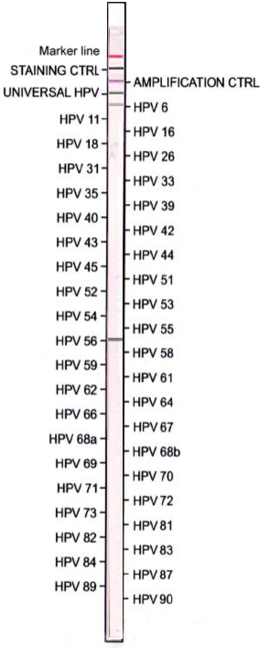

Fig S1. A representative reverse line blot HPV genotyping test strip using AMPLIQUALITY HPV-TYPE EXPRESS kit showing colored bands corresponding to HPV6 and 56. The strip is coated with a staining control band, an amplification control of the housekeeping thiosulfate sulfurtransferase (TST) gene band, and a universal HPV band
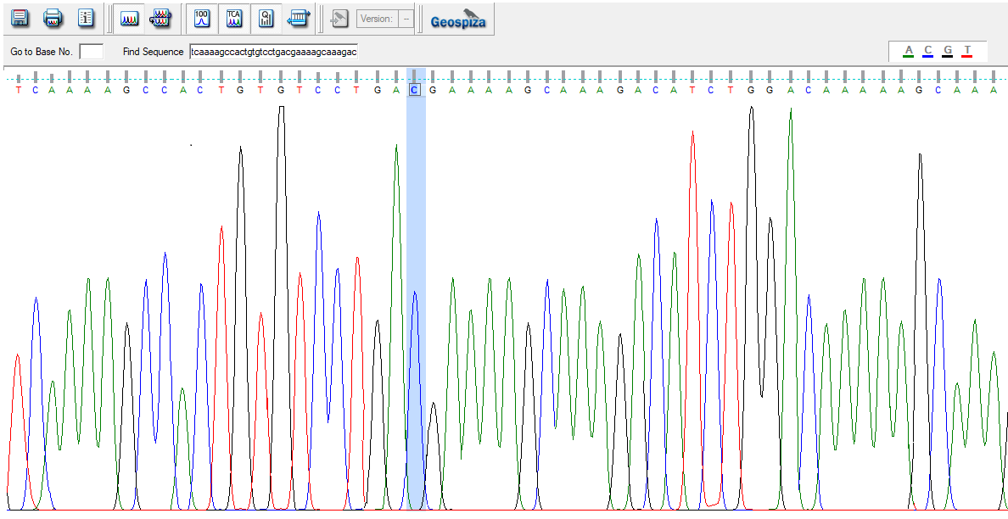
Fig S2. Direct DNA Sanger sequencing chromatogram showing a sequence polymorphism (highlighted in blue) in E6 gene region of HPV16 lineage A1 isolate HAM14 (GenBank accession Number: OP572428)

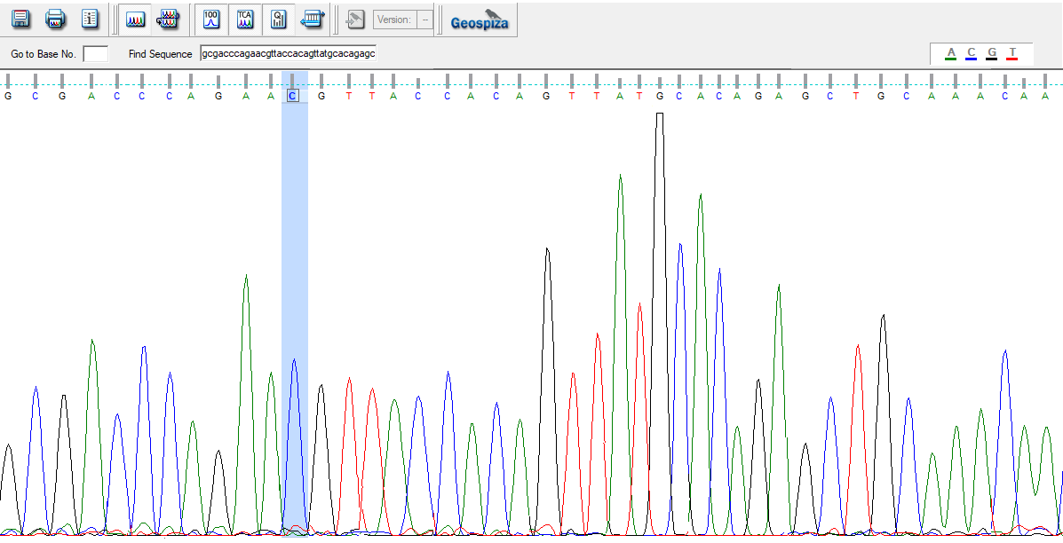
Fig S3. Direct DNA Sanger sequencing chromatogram showing a sequence polymorphism (highlighted in blue) in E6 gene region of HPV16 lineage A4 isolate HAM27 (GenBank accession Number: OP572441)

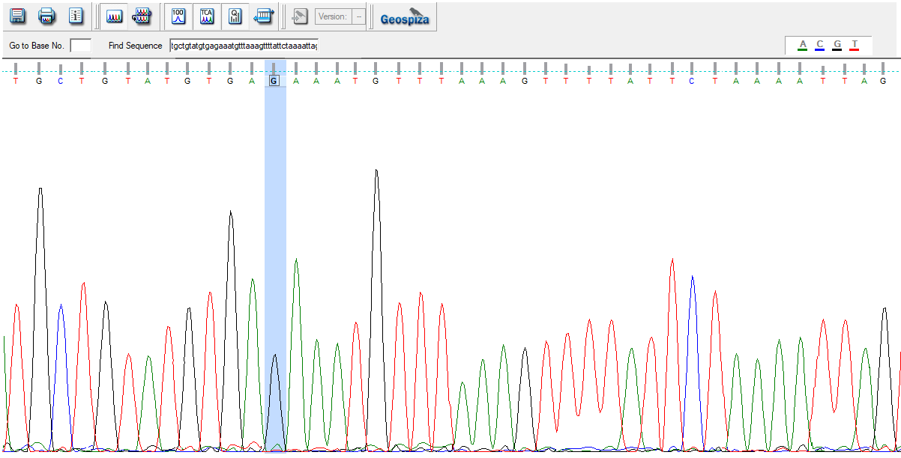
Fig S4. Direct DNA Sanger sequencing chromatogram showing a sequence polymorphism (highlighted in blue) in E6 gene region of HPV16 lineage A2 isolate HAM40 (GenBank accession Number: OP572454)

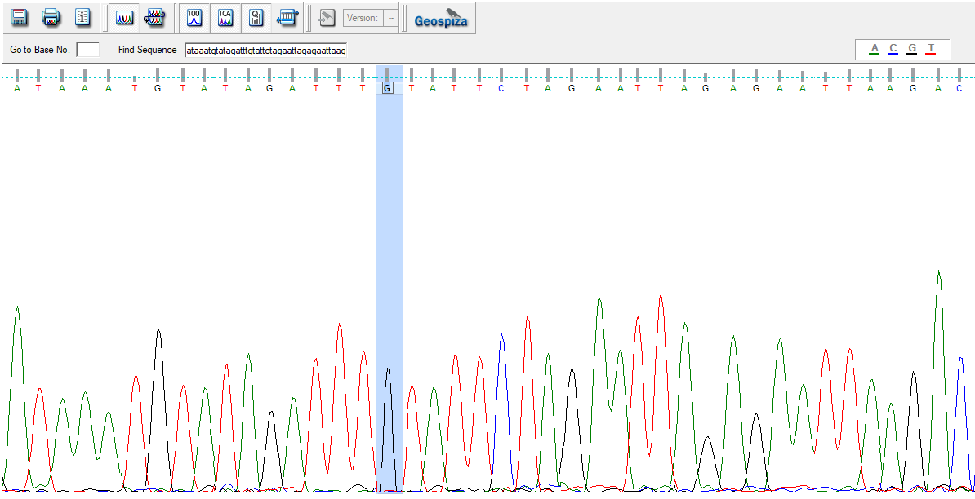
Fig S5. Direct DNA Sanger sequencing chromatogram showing a sequence polymorphism (highlighted in blue) in E6 gene region of HPV18 lineage A1 isolate HAM62 (GenBank accession Number: OP572476)

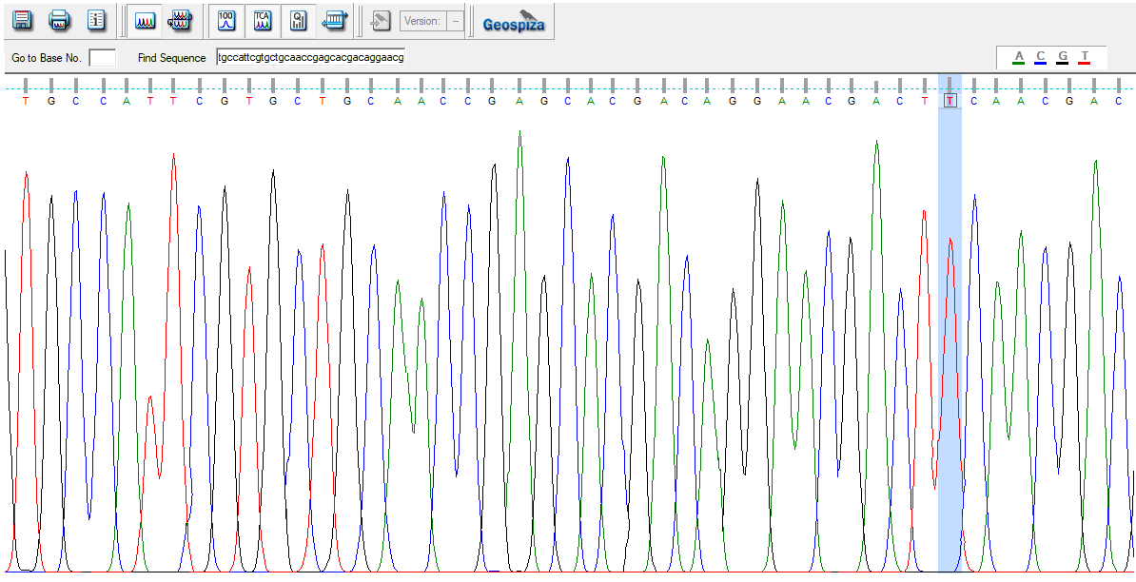
Fig S6. Direct DNA Sanger sequencing chromatogram showing a sequence polymorphism (highlighted in blue) in E6 gene region of HPV18 lineage A1 isolate HAM77 (GenBank accession Number: OP572491)

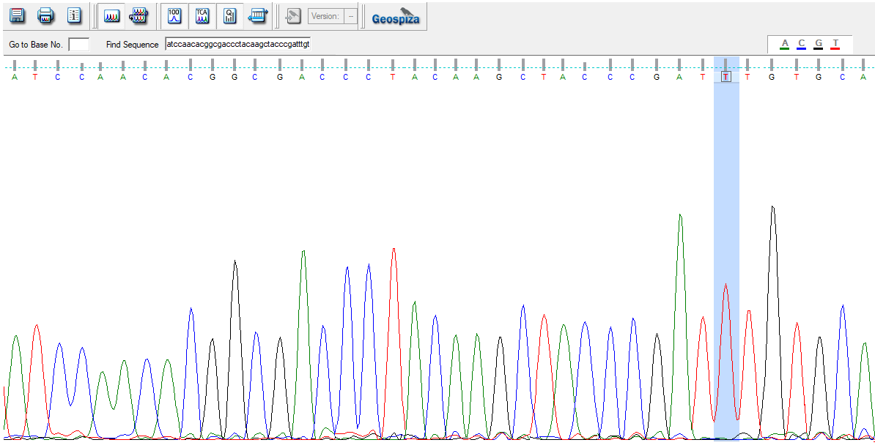
Fig S7. Direct DNA Sanger sequencing chromatogram showing a sequence polymorphism (highlighted in blue) in E6 gene region of HPV18 lineage A5 isolate HAM95 (GenBank accession Number: OP572509)

